Hypothesis Testing

Hypothesis
An assumption we make about a population parameter.

Test of significance or test of a hypothesis
Significance test or test of a hypothesis is a statistical procedure of reaching a decision.

Null hypothesis
The statistical hypothesis which is picked up for the test is known as null hypothesis. The null hypothesis is usually denoted by .

Example :Let us consider a normal distribution with mean and variance. Then the hypothesis that the normal distribution has specified mean 270 i., e., is known as null hypothesis.

Alternative hypothesis
Any hypothesis other than the null hypothesis is known as alternative hypothesis. It is usually denoted by or .

Example :Let us consider a normal distribution with mean and variance. We are going to test the hypothesis,. Then the alternative hypothesis may be
Or
Or

Rejection Regions
Suppose that. We can draw the appropriate picture and find the score for and. We call the outside regions the rejection regions.
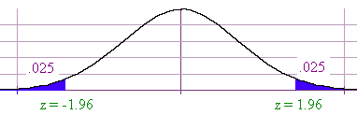
We call the blue areas the rejection region since if the value of falls in these regions, we can say that the null hypothesis is very unlikely so we can reject the null hypothesis.

Types of Test
A body of rules which leads to the decision regarding acceptance or rejection of the hypothesis is called a test. The statistic which is usually used to test the parameter of a population is known as test statistic.

Test may be classified as
- One tailed test
- Two tailed test

One tailed test
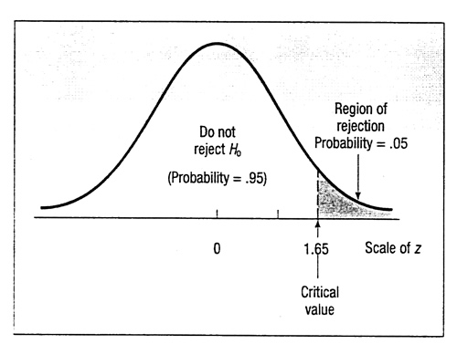
A test for which the entire rejection region lies in only of two tails either in the right tail or in the left tail of the sampling distribution of the test statistic is called one tailed. If we are interested to test the hypothesis vs then we should use right tailed test. If we test vs then we should use right tailed test.
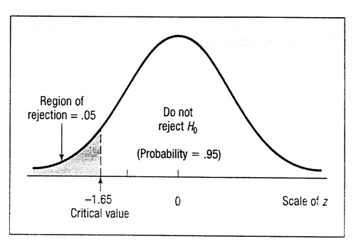
Fig: Sampling Distribution of the Statistic z, Right and Left-Tailed Test, 0.05 Level of Significance.

Two tailed test
A test for which the rejection region is divided equally between two tails of the sampling distributions of the test statistics is called a two tailed test. If we are interested to test the
vs then we should use two tailed test.
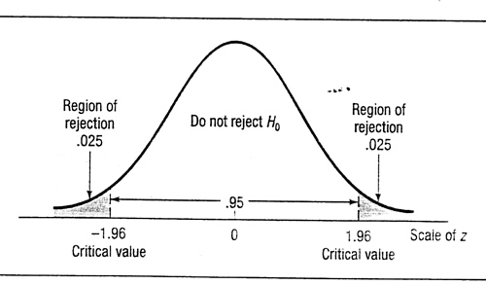
Fig: Regions of Non-rejection and Rejection for a Two-Tailed Test, 0.05 Level of Significance.

Critical value
The value of the standard statistic ( or ) beyond which we reject the null hypothesis; the boundary between the acceptance and rejection regions.

Error
When using probability to decide whether a statistical test provides evidence for or against our predictions, there is always a chance of driving the wrong conclusions. One may rejects the null hypothesis when it was actually correct. This is called Type I error, represented by the Greek letter. The probability of a type I error is called the significance level.
It is possible to err in the opposite way if one fails to reject the null hypothesis when it is, in fact, incorrect. This is called Type II error, represented by the Greek letter . These two errors are represented in the following chart.
Table: Types of error
Type of decision | H₀ true | H₀ false
Reject H₀ | Type I error () | Correct decision (1-)
Accept H₀ | Correct decision (1-) | Type II error ()

P-values
the p-value is the lowest significance level such that we will still reject Ho. For a two tailed test, we use twice the table value to find p, and for a one tailed test, we use the table value.

Steps in Hypothesis Testing

Step 1: Identify the null hypothesis and the alternate hypothesis .
Step 2: Choose .

Step 3: Select the test statistic and determine its value from the sample data. This value is called the observed value of the test statistic.

Step 4: Compare the observed value of the statistic to the critical value obtained for the chosen.

Step 5: Make a decision.

If the test statistic falls in the critical region: Reject in favour of .
If the test statistic does not fall in the critical region: Conclude that there is not enough evidence to reject .

Important tests of significance

The important tests of significance in statistics can be classified broadly as
- Normal test

- test

c) test
d) test.

Test of significance about mean

Case 1: is known or estimated from a large sample .

Case 2 is unknown and the sample is small.

Case 1 Case 2

Hypothesis Hypothesis

Test statistic Test statistic
with .
Where, and

Example 1

The mean life time of a sample of 100 light tubes produced by a company is found to be 1570 hours with standard deviation of 80 hours. Test the hypothesis that the mean life time of the tubes produced by the company is 1600 hours (consider 5% significance level).

Solution

  - Hypothesis

We consider the following hypothesis

vs

2. Significance level

Given that the significance level

3. Test statistic

In order to test the hypothesis we consider the following test statistic

We have, , , .

4. Critical value
The critical value or tabulated value is 1.96.

5. Making decision
Since the calculate value is greater than the tabulated value, so we reject the null hypothesis. So that, the mean life time of the tubes produced by the company is not 1600 hours.

Example 2
A sample of 400 male students is found to have a mean height 67.47 inches. Can it be reasonably regarded as a sample from a large population with mean height 67.39 inches and standard deviation 1.30 inches? Test at 5% level of significance.

Example 3
Suppose that it is known from experience that the standard deviation of the weight of 8 ounces packages of cookies made by a certain bakery is 0.16 ounces. To check its production is under control on a given day, the true average of the packages is 8 ounces, they select a random sample of 40 packages and find their mean weight is 8.122 ounces. Test whether the production is under control or not at 5% level of significance.

Case 2: is unknown and the sample is small

Example
A random sample of 10 boys had the following I. Q’s:

70, 120, 110, 101, 88, 83, 95, 98, 107, 100

Do these data support the assumption of a population mean I. Q. of 100?

Solution

- Hypothesis
We consider the following hypothesis

vs

2. Significance level

Given that the significance level

3. Test statistic
In order to test the hypothesis we consider the following test statistic

We have, ,
, .

4. Critical value

The critical value or tabulated value of for is 2.2622.

5. Making decision

Since the calculate value is less than the tabulated value, so we accept the null hypothesis. So that, the data support that the population mean I. Q is 100.

