Beating-up

Beating-up:
It is the third primary motion in weaving. It is a process of pushing the newly inserted weft yarn to the already woven fabric at a point known as the “fell of the cloth” with the help of a reed fixed in the sley. The sley is given a sudden and quick movement towards the fell of the cloth by the cranks in the crank shaft.

Purposes of beating-up:
The main purposes of beating up are:-
- To push the newly inserted weft yarn to the “fell of the cloth”.
- To produce compact fabric.

Classification of beating-up:
Beating-up may be classified in many ways. Some of those are mentioned below:
- According to the no. of beat-up:
  - Single beat-up
  - Double beat-up
- According to the movement of the cloth fell:
  - Fixed fell
  - Moving fell
- According to the movement of reed:
  - False or variable beat-up
  - Real beat-up
- According to beat-up mechanism:
  - Conventional beat-up (Crank & crank arm)
  - Modern beat-up (Cam beat-up)
- According beat-up development:
  - Traditional/ Normal beat-up
  - Special beat-up

Single beat-up mechanism:

In single beat-up mechanism the newly inserted pick is pushed by reed. In producing most fabrics which are not so compact, single beat-up is used.

Construction

The lower end of the sley sword is pivoted to the rocking shaft. The sley race is connected to the sley sword.

A connecting rod or crank arm is connected to the back of sley race by a pin called sword pin and its other end fastens round the bend in the crank shaft, which is known as cranks. Reed is joined with sley race with the help of reed cover.

Working principle

For beating up process, the sley sword must reciprocate. They sley sword is connected to rocking shaft for this purpose.

When the crank of the crank shaft rotates and comes in forward position, then it pushes the crank arm forward. Thus crank arm gives to & fro movement.

As the crank arm is connected to the sley race and reed is situated above the reed race, reed also moves forward as the crank arm move forwards. The reed pushes the weft in the fell of the cloth. Thus single beat-up continuous.
In this mechanism, one beat up is done for every picking.
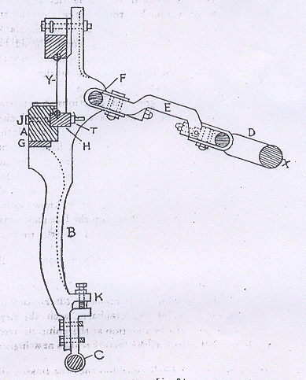

Double beat-up mechanism

If after inserting a pick, two beat up occurs successively by one revolution of crank shaft it is called double beat up.
To produce very compact fabric (e.g. - canvas/triple/tent), double beat-up is used.
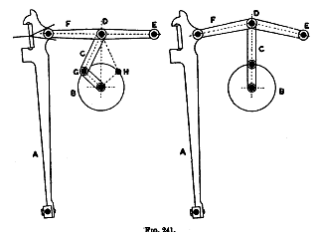

Construction:
Constructed by a sley sword, a crank, a connecting arm, two arms, one of end of arm is hinged with framing and the other end is attached to sley by connecting pin. Between the two arms there is a knuckle joint which can be bent and can be straight.
Working principle:
In one drawing the arms E & F are straight, but when the crank moves to the top centre it is pushed up and E & F are bent.
When the crank moves downwards, the knuckle joint is also moved downwards and there comes a stage when the arm becomes straight & a beat-up is done by the system.
When the crank again moves up, the knuckle joint is also moves up and again the arms become straight and cause the beat-up.
Hence the two beat-up is done for a pick.
Sley Eccentricity ratio:
The ratio of radius of crank circle and the length of crank arm is called Sley Eccentricity ratio.
ie: Sley eccentricity ratio, e= r/l
Where, r= Radius of crank circle
L= Length of crank arm.

