

Directed Learning Activity
Topic: Using Transitions

Course: English B

STUDENT LEARNING OUTCOME (SLO): Paragraphs should be logically organized and focused.

DLA OBJECTIVE/PURPOSE: Student will be able to use transitions to emphasize organization of major and supporting ideas in a paragraph.

TIME NEEDED TO COMPLETE: 30-45 minutes (You’ll need to complete the independent activity IN THE WRITING CENTER, so be sure you’ve allotted enough time to do so.)

INSTRUCTIONS: Get DLA handout, look over directions, go to a work station (computer, desk) to complete the independent activity, and then sign up with a tutor to review the activity.

INDEPENDENT ACTIVITY (20-30 minutes):

- Review the attached handout USING TRANSITIONS.

- Practice using what you’ve learned by completing Transition Exercise #1 and Transition

Exercise #2.

REVIEW WITH TUTOR: (10-15 minutes)

- Go over your answers to the Transition Exercises #1 and #2 with the tutor. With assistance from the tutor, identify and review any of the transitions that might still be giving you problems.

- If you have an essay from class, circle transitions that you’ve used. If you think you need additional transitions, add them. Explain to the tutor how each transition functions in your essay to signal what’s coming up next or to stress the organization of your ideas.

Student Name __________________________________________________________

Date _________________ Tutor Signature ___________________________________

IMPORTANT NOTE: You must complete all of the items in the Independent Activity portion of this DLA before meeting with a tutor for the Review. If your instructor wants evidence of this completed DLA, return this form to him or her with the tutor’s signature included.

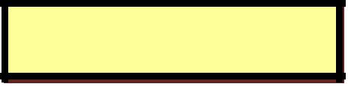
Correction Symbol: trans
USING TRANSITIONS

Transitions are words that help the reader move smoothly from one idea to another. A transition acts like a road sign or signal flag to let readers know where they are and to tell readers what to expect coming up next in a paragraph or essay.
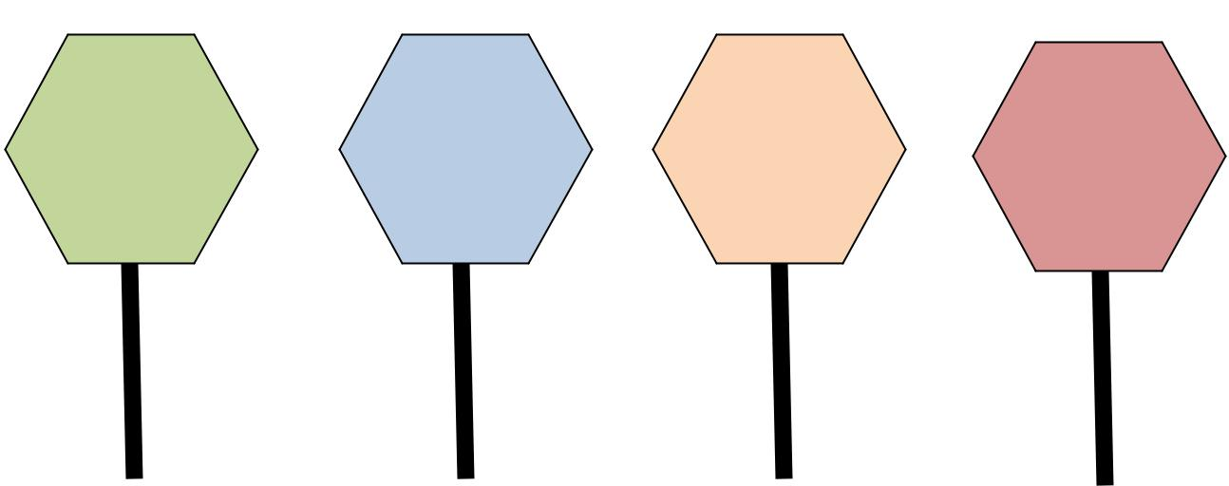

First, Next, | For example, | In addition, | In conclusion,
For one thing, | For instance, | Also, | All in all,
For another | That is, | Moreover, | Truly,
thing, |  | Furthermore | Yes,

Signals a major |  | Signals an |  | Signals another |  | Signals the
point will follow |  | example |  | similar example |  | concluding
 |  | coming up |  | or idea to follow |  | point

UsesofofTransitions:ons:

- To Toemphasizeemphasizethetheorganizationonf yourofyourideasideas(least(Examples:importantleastto mostomostimportantimportantreasons,reasons,timetime orderorderof anof event,anevenetc).. ).

- To Toemphasizeemphasizethetherelationshipof oneofoneideaideato anothertoanother(major(majorpoint,point,exampleexampleto illustrateratetopoint,apoint,

similarsimilaror oppositerideateideato thetothepreviouspreviousone)one)

Transitions to show overall ORGANIZATION of ideas:

Words to show main points:

First, Second, Third, Finally

First, Next, Last

For one thing, For another thing, Finally

First, More significant (important), Most significant (important)

First, Even worse (better), Worst (Best) of all

Words to show examples:
For example,
For instance,
Also, in addition, (to add another example)
Another (to add another example)
Words to show conclusion
Truly,

All in all,
In conclusion,
As you can see,
On the whole,

Transitions to show RELATIONSHIPS:

Words that Compare (show how things are alike): in the same way, and, also, in addition, as well as, both, each of, either, like, similarly, the same, too
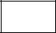

Example: Like Enrique, Sylvia is a huge fan of hip hop music.

Words that Contrast or Show Exception (give a different or opposite example or idea): although, whereas, but, however, on the other hand, instead, in contrast, yet, unlike, conversely, nevertheless, still
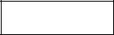

Example: Although Mike loves to watch sports, Jonathan would rather be playing them.

Words that Add (give another similar example or idea): furthermore, in addition, moreover, besides, and, also

Example: Melanie is taking a full load of classes this semester; moreover, she is working two jobs.

Words that show Time: first, then, next, at the same time, meanwhile, afterwards, subsequently

Example: First we picked up drinks and chips from 7-11; then, we bought sandwiches from Subway.

Words that show Direction or Location: here, there, over there, beyond, nearly, opposite, under, above, behind, to the left, to the right, in the distance

Example: Behind the football field was an empty lot where the neighborhood kids liked to play.

Words that show Cause and Effect: because, as a result, consequently, therefore

Example: Marcy needed one more unit to qualify for a discount on her car insurance; consequently, she enrolled in an Academic Strategies class.
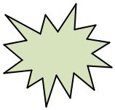

TIP | When a transition is used to join two words groups that could stand alone as sentences,
TIP | it’s preceded by a semi colon and followed by a comma.

Sentence One: Jolene wanted an “A” in the course.
Sentence Two: She didn’t want to work too hard for it.

Sentences joined by a transition: Jolene wanted an “A” in the course; however, she didn’t want to work too hard for it.
Transition Exercise #1

- Look at the following outline for a one-paragraph essay that tells why Oktoberfest is the writer’s favorite holiday. Each major point in the outline—a reason why the writer likes this holiday--is indicated by a Roman numeral (I, II, III). Each major point is illustrated by 3 specific examples/pieces of information, labeled A, B, and C.

Paragraph Outline:

Topic Sentence: Oktoberfest is my favorite holiday.

I. Big Bear Tradition

    - Family always goes up to Big Bear Lake and rents a cabin

    - Oktoberfest parties at Convention Center

    - Activities for children and adults – everyone can enjoy
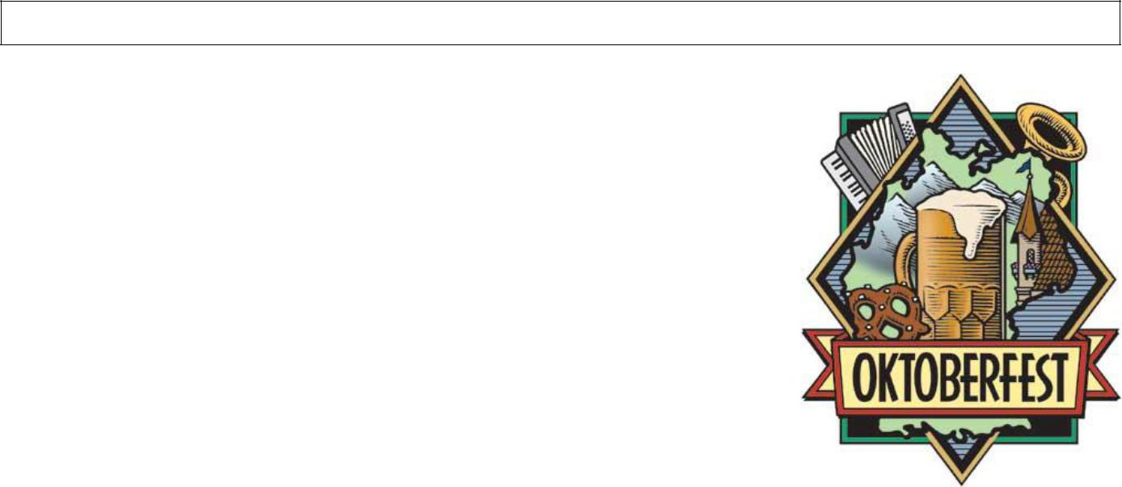

- Crazy costumes

  - German costumes – men in lederhosen, women dressed as Bavarian beer garden waitresses

  - Crazy hats – chicken hats, alpine hats with a feather, beer hats

  - Silly necklaces
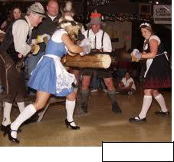

- Entertainment

  - German band

  - Dances – polka, chicken dance, pizza hut dance

  - Contests – beer drinking, log sawing, stein holding

© LA Times

- Now look at the following paragraph based on the outline. Notice how the transitions serve to emphasize the organization and relationships between the points and examples.

Key to Paragraph with Transitions Identified: Transitions that indicate major points (I, II, III on outline) are enclosed in boxes. Transitions that indicate examples and additional examples to illustrate the major points are underlined. The transition that identifies the conclusion is circled.

A Unique Holiday

Oktoberfest is my favorite holiday. One thing that I love about Oktoberfest is my family’s tradition of going to Big Bear Lake for a weekend every October. We rent a cabin there so that we can attend the Oktoberfest activities that go on at the Big Bear Convention Center all month. The center has activities for children and adults, so everyone from my little cousins to my grandparents can find something to enjoy. For example, German games, music, foods and drinks are featured. Another thing that I love about Oktoberfest is the costumes people wear. For instance, men and boys will dress up in lederhosen, which are leather shorts with built-in suspenders to hold them up. Girls and women like to dress up as Bavarian beer garden waitresses, like the woman on the St. Pauli beer label. People who don’t have a costume wear crazy hats: chicken hats, alpine hats with a feather, and even hats with beer cans on them. Also, people can purchase silly necklaces to wear. Last year, for example, my sister bought a necklace with a rubber chicken hanging from it. The best thing about Oktoberfest is the entertainment. For example, at least one band actually comes from Germany each year to play music at the Convention Center, and even local bands play “oompah” music. Dancing to this music is a lot of fun. Of course there is the traditional polka dancing; in addition, the chicken dance and the Pizza Hut dance are very popular. Another source of entertainment is the contests. For instance, there are beer drinking, log sawing, and stein holding contests for women and men. All in all, the family tradition, costumes, and entertainment make Oktoberfest a unique holiday experience that I look forward to every year.
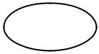

C. Refer to the paragraph above to fill in the blanks.

- List the three transitions that signal a major idea:

_______________________ _______________________ ____________________

- List two transitions that signal an example:

________________________ _________________________

  - List two transitions that signal an additional example:

________________________ _________________________

  - List the transition that signals a conclusion.

________________________

- The outline and paragraph that follow identify three types of sources that students can use to help them develop a writing assignment. Each type is illustrated by 3 examples. Look at the outline to help you identify which ideas are main points and which are examples.

Paragraph Outline

Topic Sentence: Students can draw on a variety of sources to help them with writing assignments.

- Personal experiences
  - conversations with others
  - electronic communications
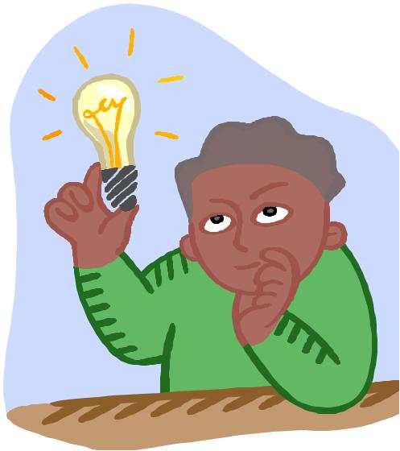
 | C. | college skills
II. | Experiences of others
 | A. | interviews
 | B. | overhead conversations
 | C. | television shows
III. | Research
 | A. | articles and books
 | B. | internet
 | C. | librarian

List of transitions:
Major ideas: |  | first, | second , | for one thing, |  | for another thing, finally,
Examples: |  | for example, |  | for instance,
Additional examples: |  |  | in addition, also, |  | additionally, moreover
Conclusions: |  | all in all, on the whole, as one can see,


Instructions: In the following paragraph, transitions have been removed. A list of possible transitions appears above this box. Write an appropriate transition from the list in each of the blanks in the paragraph. Be sure to capitalize the first word if it begins a sentence. You don’t have to use all of the transitions listed, and you may use some of the transitions more than once, but try to use a variety of them. Two have been done for you. (Hint: Look for clues below the blanks.)
Sources for College Writing

Students can draw on a variety of sources to help them with writing assignments.

_____________________, they can draw on personal experiences. __________________,

first major idea example

for an assignment about communication skills, a writer might think about the way he or she communicates through conversations with others while at work or at home. _________________, a writer might look at ways he or she communicates with others
additional example

electronically via email or texting or Facebook. Students might _________________ find

additional example

examples of written communication skills by looking at skills they’ve learned for previous writing assignments. _________________________, student writers can look for ideas
second major idea

from other people’s experiences. _______________________, writers can interview other

example

students or even family members. ______________________, a writer may have heard

additional example
others talk about this topic, maybe in class. ___^{Another}______ source would be

additional example

television shows on the topic of communication. __________________, college writers may

third major idea

find that they need to do some research to complete an assignment. __________________,

example

lots of experts have written articles or books on the topic of communication skills.

______________________, a search of “communication skills” on the internet might

additional example
provide useful information; ____^{moreover}___, reference librarians can help students

additional example

find research materials in special collections or databases. ______________, college writers need to be able to draw on a combination of personal experience, observations of others, and research materials to develop their written assignments.

Paragraph adapted from John Langan’s

Exploring Writing: Sentences and

Paragraphs, 2E.
Transition Exercise #2

The following paragraph contrasts the writer’s two cousins. Three major differences are identified, and each of these is illustrated with several specific examples.

- Read the paragraph and circle any transitions.
- Then write the transitions in the appropriate blanks below.

Opposites

My cousins Joanne and Mary couldn’t be more different. First, Joanne is a total nonconformist. For one thing, Joanne’s appearance is bizarre. For example, her hair is partially shaved and dyed pink, and she’s covered in tattoos. In addition, her favorite clothes are ripped and have pictures on them of things like skulls. Furthermore, Joanne has a wild personality. For instance, she’ll do outrageous things, like the time she got her nose pierced. Another time, she hitchhiked to San Francisco at 2:00 a.m. Finally, when it comes to interests, Joanne is really into music. She plays the guitar in a punk rock band, and she loves to go to clubs and concerts to check out other bands. In contrast, Mary is the total opposite of Joanne. For one thing, Mary’s appearance is very conservative. For instance, her naturally blond hair is usually in a ponytail, and her favorite clothes are sweats or a soccer uniform. Unlike Joanne, Mary is the type of person who likes to follow the rules. For example, she’s never missed a day of school, and she can be relied on to be the designated driver any time she goes out to a party. Finally, Mary is a jock. She plays almost every sport, but soccer is her favorite. When she’s not playing sports, she’s watching them on television or in person. Truly, if I didn’t already know that Joanne and Mary are cousins, I would never guess that they’re related to each other because they’re complete opposites.

- What three transitions introduce Joanne’s character traits: nonconformist, wild personality, interests?

_____________________ ___________________ ______________________

- List two transitions used in describing Mary that show contrast:

______________________ _______________________

- List two transitions used to introduce examples:

______________________ _______________________

- List two transitions used to add another example:

______________________ _______________________

- What transition is used to signal the conclusion? ________________________________

