 Daffodil International University (DIU)

Department of Electrical and Electronic Engineering

EEE 422: Measurement and Instrumentation Laboratory

#### EXPERIMENT NO: 12

**NAME OF THE EXPERIMENT: STUDY OF UNIVERSAL HIGH RESISTIVE VOLTMETER.**

**Objective:**

The voltage to current converter using op-amp can be used as a universal voltmeter. The objective of this experiment is to learn about dc and ac measurement using universal high resistive voltmeter and evaluate the performance of such meter.

**Theory:**

The voltage to current converter of Figure-1 can be used to measure positive or negative dc voltage or the rms, peak, or peak-to-peak (p-p) value of sine wave. A dc meter movement measures the average value of current. To change from one type of voltmeter to another, it is necessary to change only a single resistor.

The voltage to be measured (Ei) is applied to the op-amp’s positive input terminal. Therefore, the meter has high resistance.

When voltage to be measured (Ei) is positive, current flows through the meter movement and diodes D3 and D4.When voltage to be measured (Ei) is negative, current flows in the same direction through the meter and diodes D1 and D2.

Thus meter current direction is same whether Ei is positive or negative.

Neither meter resistance nor diode voltage drops affect meter current. Only Ri and Ei determine average and dc meter current.

The value of resistor is calculated according to the application from one of the following equations.

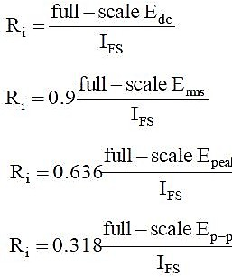Dc voltmeter:

RMS ac voltmeter (sine wave only):

Peak reading voltmeter (sine wave only):

Peak-to-peak ac voltmeter (sine wave only):

Where IFS is the meter’s full-scale current rating in amperes.

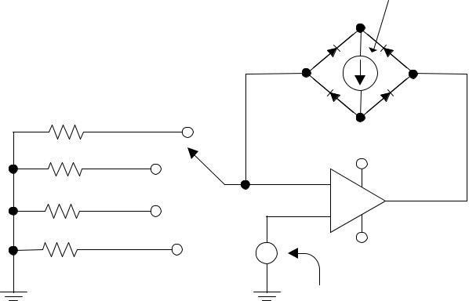**Circuit Diagram:**

|  |  |  |  |
| --- | --- | --- | --- |
|  |  |  | Ammeter |
|  |  | D1 | D3 |
| Ria | dc | D4 | D2 |
| Rib | rms | +Vcc | |
| Ric | peak | - |  |
|  |  | + |  |
| Rid | p-p |  |  |
|  |  | -Vcc | |
|  |  | Unknown |  |
|  |  | Voltage |  |

Fig.1: High resistive universal voltmeter circuit

**List of Equioment:**

1. IC741

1. Trainer board
2. Oscilloscope
3. Ammeter
4. 10K to 500K pot

**Procedure:**

1. Note the full deflection current of your ammeter.
2. Calculate the value of resistance Ria for 10V dc, Rib for 5V rms, Ric for 5V peak and Rid for 5V p-p voltmeter
3. Make the universal voltmeter as shown in figure-1 for each type of voltmeter.
4. Now for various input voltages take the reading on your ammeter for each setting and record it.
5. Draw the calibration curve from the data obtained for each of the voltmeter and comment on

the curve.

**Report:**

1. What are the advantages of a universal voltmeter?
2. Why is this called high resistive voltmeter?
3. How the voltage drop across the diodes affect the measurement of such meter?
4. A basic meter movement is rated at 50uA for full-scale deflection. Design a simple switching arrangement and select resistors to indicate full scale deflection when the voltage to be measured is
5. 5V dc
6. 5V rms

c. 5V peak

d. 5V p-p