Polyester

Polyester is a term often defined as “long-chain polymers chemically composed of at least 85% by weight of an ester and a dihydric alcohol and a terephthalic acid”. In other words, it means the linking of several esters within the fibers. Reaction of alcohol with carboxylic acid results in the formation of esters.

Polyester also refers to the various polymers in which the backbones are formed by the “esterification condensation of poly functional alcohols and acids”.

Polyester can also be classified as saturated and unsaturated polyesters.

Saturated polyesters refer to that family of polyesters in which the polyester backbones are saturated. They are thus not as reactive as unsaturated polyesters. They consist of low molecular weight liquids used as plasticizers and as reactants in forming urethane polymers, and linear, high molecular weight thermoplastics such as polyethylene terephthalate (Dacron and Mylar). Usual reactants for the saturated polyesters are a glycol and an acid or anhydride.

Unsaturated polyesters refer to that family of polyesters in which the backbone consists of alkyl thermosetting resins characterized by vinyl unsaturation. They are mostly used in reinforced plastics. These are the most widely used and economical family of resins.

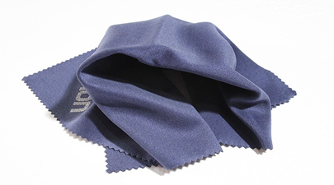

**Characteristics of Polyester**

* Polyester fabrics and fibers are extremely strong.
* Polyester is very durable: resistant to most chemicals, stretching and shrinking, wrinkle resistant, mildew and abrasion resistant.
* Polyester is hydrophobic in nature and quick drying. It can be used for insulation by manufacturing hollow fibers.
* Polyester retains its shape and hence is good for making outdoor clothing for harsh climates.
* It is easily washed and dried.

**Uses of Polyester**

The most popular and one of the earliest uses of polyester was to make polyester suits – all the rage in the 70s. Polyester clothes were very popular. Due to its strength and tenacity polyester was also used to make ropes in industries. PET bottles are today one of the most popular uses of polyester.

**Polyester care tips**

Taking care of polyester clothing is really easy and very time efficient.

* Polyester clothing can be machine washed and dried. Adding a fabric softener generally helps. Dry the fabric at low temperatures to get maximum usage from the clothing.
* Though polyester does not require much ironing, if you must, then iron warm.
* Polyester can be dry-cleaned with no hassles.

Having learned a little something about polyester and how popular it has become, one could never imagine the history of polyester to be quite so illustrious. The manufacturing process also deserves a more detailed description. The revival and success of polyester is without doubt something that is here to stay.

**Raw Materials**

Polyester is a chemical term which can be broken into poly, meaning many, and ester, a basic organic chemical compound. The principle ingredient used in the manufacture of polyester is ethylene, which is derived from petroleum. In this process, ethylene is the polymer, the chemical building block of polyester, and the chemical process that produces the finished polyester is called polymerization.

**The Manufacturing Process**

Polyester is manufactured by one of several methods. The one used depends on the form the finished polyester will take. The four basic forms are filament, staple, tow, and fiberfill. In the filament form, each individual strand of polyester fiber is continuous in length, producing smooth-surfaced fabrics. In staple form, filaments are cut to short, predetermined lengths. In this form polyester is easier to blend with other fibers. Tow is a form in which continuous filaments are drawn loosely together. Fiberfill is the voluminous form used in the manufacture of quilts, pillows, and outerwear. The two forms used most frequently are filament and staple.

**Major producing countries of polyester**

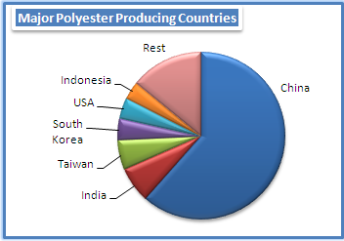

Polyester staple fibre production grew 3.4% in 2009 to million tons. The growth regions were Africa, Asia, and Central and East Europe. Net capacity addition globally was tons during the year, with Asia alone adding tons. Other regions witnessed capacity derating, tons in Middle East, tons in Central and East Europe and tons in South America. Thus, Asia ac-counts for almost 88% of World polyester staple fibre capacity and supplies. Since 2000, production of PSF in Asia trended an annual growth of 7.6% up to 2008, taking its share from 71% in 2000 to over 88% in 2009.

China’s PSF capacity although remained stable in 2009, accounted for 60% of global capacity while production grew 4%, implying rise in capacity utilization. India, the second largest producer, increased its volumes by 26%, producing tons during the year. Taiwan managed to lift output as well by 13% while output declined in South Korea by close to 3%. North Americas, the distant second largest PSF producing region, led by USA and to a smaller extent by Mexico.

**Polyester production**

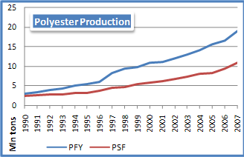

Polyester production has grown rapidly since 1990 with none of the years recording a decline. During the pre-ATC period (1990-1994) capacity addition increased 6.1% per annum which further accelerated to 10% during the ATC period (1995-2004). However, post WTO the rate of expansion dropped to less than 6% between 2005 and 2007. During the past 17 years large capacities were added every alternate year as huge additions were seen in 1992, 1995, 1997, 1999, 2002, 2004 and 2007.

With rapid expansion in capacity, production has been growing between 9-10% per annum since 1990. Although marginal deceleration was seen over the period, the growth has been robust. Over the last 17-year period, polyester production has seen a double-digit growth rates on five occasions; 1992 (11%), 1994 (13%), 1996 (10%), 1997 (32%) and 2007 (13%). And on all these three occasions the growth was driven by polyester filament yarn segment.

China, India, Taiwan, South Korea and Indonesia were the top five PFY producing countries in 2007. In case of PSF, USA and Pakistan rank among the top five along with China, India and South Korea. China has been the leader in polyester industry worldwide, accounting for more than half of global capacity and production. In 1995, China accounted for only 16% of global polyester supply which expanded significantly to 57% in PFY and 47% in PSF. It has recorded a growth of nearly 20% per annum since 1995, the ATC.

**World fiber production**

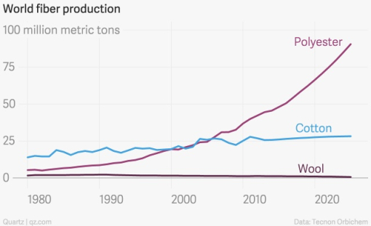

**Reference:**

[*https://en.wikipedia.org*](https://en.wikipedia.org)

[*www.whatis****polyester****.com/*](http://www.whatispolyester.com/)

schwartz.eng.auburn.edu/**polyester**/uses.html

[*www.dictionary.com/browse/****polyester***](http://www.dictionary.com/browse/polyester)