OOP

What is OPP ?

**Object-oriented programming:** As the name suggests, Object-Oriented Programming or OOPs refers to languages that uses objects in programming. The main aim of OOP is to bind together the data and the functions that operate on them so that no other part of the code can access this data except that function.

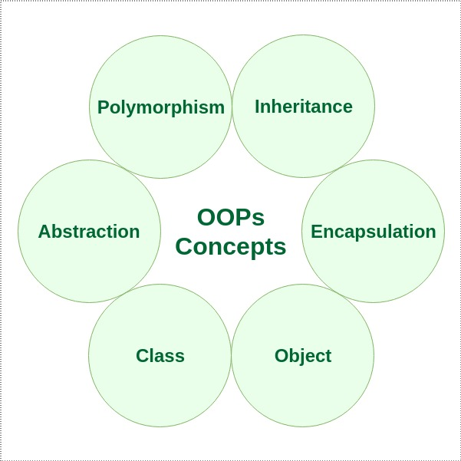

**What are the advantages of OOP?**

From the above features of OOP, it is evident that OOP languages focus on data-driven approach than logic-driven. The programmers who use OOP language are essentially looking to achieve

* Data privacy
* Code reusability
* Data redundancy
* Efficiency

Class : A class is a user defined blueprint or prototype from which objects are created.  It represents the set of properties or methods that are common to all objects of one type.

Object: OBJECT is an instance of a class. An object is nothing but a self-contained component which consists of methods and properties to make a particular type of data useful.

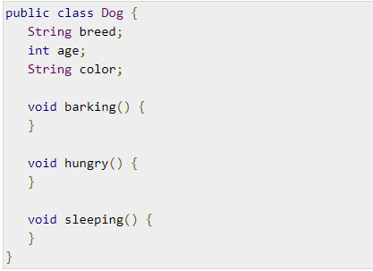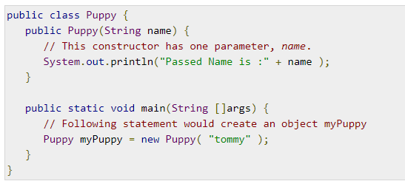

It is a basic unit of Object Oriented Programming and represents the real life entities.  A typical Java program creates many objects, which as you know, interact by invoking methods. An object consists of :

1. **State**: It is represented by attributes of an object. It also reflects the properties of an object.
2. **Behavior**: It is represented by methods of an object. It also reflects the response of an object with other objects.
3. **Identity**: It gives a unique name to an object and enables one object to interact with other objects.

