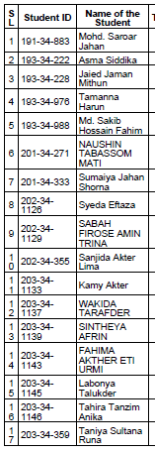 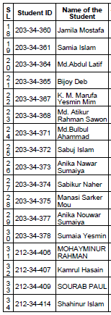 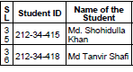

|  |  |
| --- | --- |
| **Group** | **Topics** |
| **Group-1: Serial no. 1-4** | Arsenic Pollution |
| **Group-2: Serial no. 5-8** | Ozone Depletion |
| **Group-3: Serial no. 9-12** | Filtration and ultrafiltration in water treatment |
| **Group-4: Serial no. 13-16** | Environmental Laws |
| **Group-5: Serial no. 17-20** | Water softening |
| **Group-6: Serial no. 21-24** | Greenhouse effect |
| **Group-7: Serial no. 25-28** | Bio gas production from wastes |
| **Group-8: Serial no. 29-32** | Air pollution in food processing industry |
| **Group-9: Serial no. 33-36** | Global Warming |

* **Each group will have maximum 10 minutes for their presentation.**