Assignment-02
Course Code: TE 417, Course Title: Apparel Manufacturing III
Semester: Spring’2021, Section: A,B, EVE
Set A
Questions | Students’ ID  (from-to)
- From the following graph describe the changes of tearing strength for different wash on non-denim twill garments.  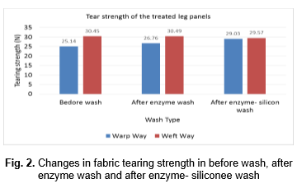  - The bleaching and softening treatment have a great influence on the mechanical and color properties of denim fabric. It is clear that, the bleaching and softening treatment has a lot influence on the mechanical and color properties of the denim. The fading effect can be increased by the bleaching but bleaching also reduces the fabric weight, tensile strength and seam strength which might reduce the serviceability of the garments. So an optimum bleaching action is required to get the required fading effect and softness without compensating some important properties of denim.  Question from above paragraph no. 3: How bleaching affects different properties including fading, softening of denim garments?  - Please find the below image and share your thoughts regarding popularity of different trends of denim garments-  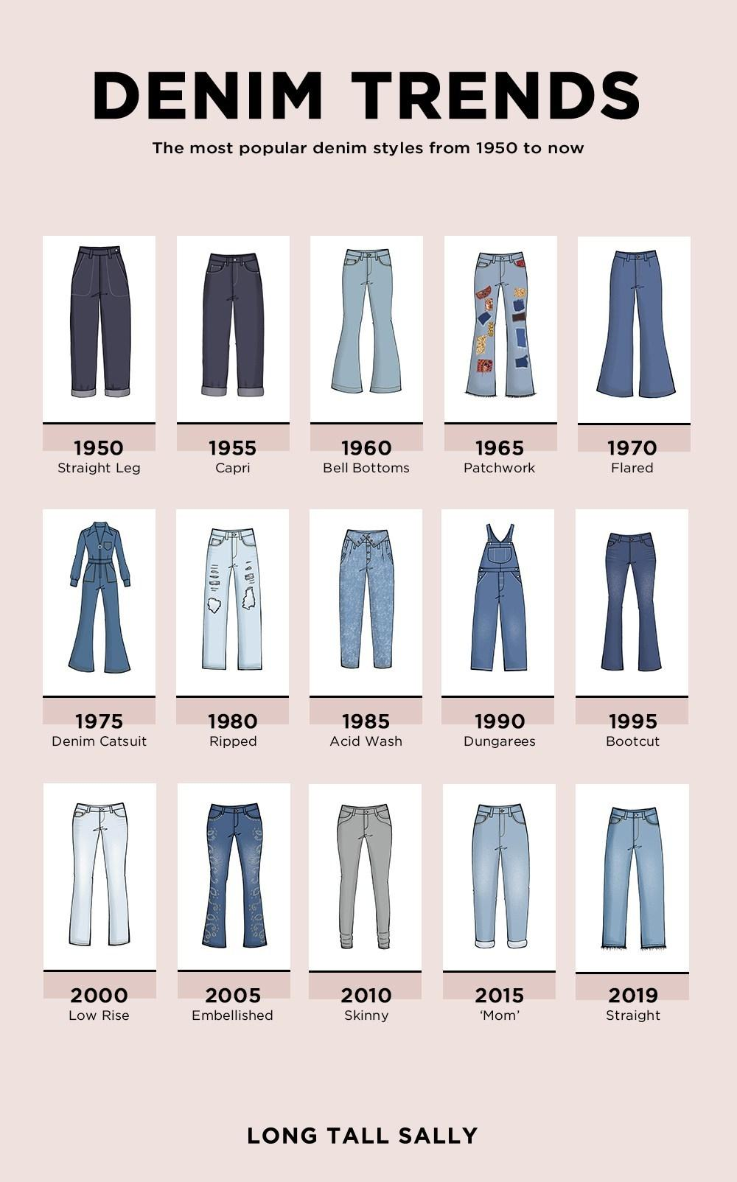  - Draw full processing curve for garments dyeing with reactive dyes.  - Differentiate (any six) between the below images-  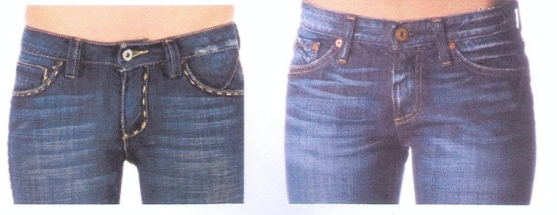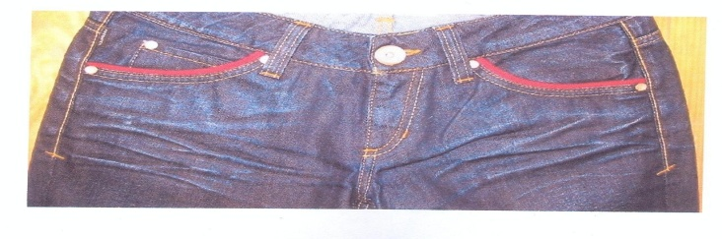 | 191-23-562 191-23-564 191-23-573 191-23-592 191-23-593 191-23-594 191-23-597 191-23-600 191-23-603 191-23-620
Set B
Questions | Students’ ID  (from-to)
- From the following graph describe the changes of tearing strength for different wash on non-denim twill garments.  - This article deals with some unconventional but eco-friendly processes for creating fading effect on denim garment dyed with natural indigo dye. Three different methods namely a) fading by UV radiation of sunlight [Method I], b) fading by calcium hydroxide [Method II] and c) fading by stitched with extra fabric [Method III] were followed for during experiment. Based on the results obtained, it can be concluded that the highest degree of fading occurred in Method III as the stitched fabric acts as a barrier and restricts the penetration of dye molecules on fabric surface. All though Method I show less degree of fading but yet it is an ecological process where no harmful chemicals were used but occupied more time than other methods. In case of Method II, the use of Ca(OH)2 makes the sample stiffer with moderate fading effect. Among the three methods, Method-III is not only easy to perform, eco-friendly & economical but also effective as showed in the result of fading percentage, drape co-efficient, fabric stiffness, fabric strength and elongation and fabric fastness properties.  Question above paragraph no. 4: Among three methods used for fading on denim garments suggest which one is best and why?  - Make a timeline for the history of denim and jeans.  - Draw full processing curve for garments dyeing with pigment dyes.  - What does below image mean to us regarding sustainability and eco friendly washing? Relate those terms with the image.  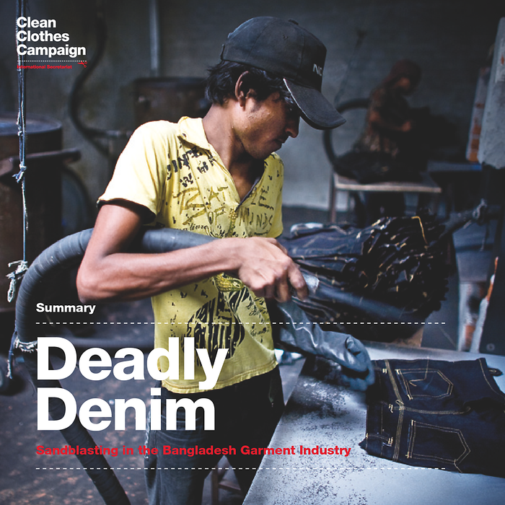 | 191-23-621 191-23-633 191-23-642 191-23-650 191-23-662 191-23-683 191-23-685 192-23-714 192-23-715 192-23-722
Set C
Questions | Students’ ID  (from-to)
- From the following table illustrate the effects for using different proportional enzyme in enzyme-stone washing on stiffness of garments. 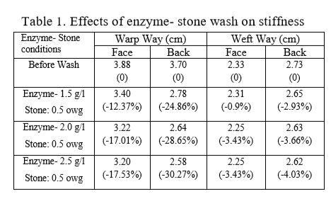  - Full world is now in COVID-19 pandemic as we are also; during this situation one of us often have to go outside the home to fulfill the basic needs of family members. Hopefully we are going with required precautions by wearing garments, gloves, mask, socks, shoes etc. But rightly after coming back from outside how we can care (washing, ironing, drying, bleaching and dry cleaning-mention only for required care/s) about those wearable garments, gloves, mask socks and shoes to protect from COVID-19? Additionally, you are encouraged to add which you are practicing or being practiced in your home.  - Draw full processing curve for garments dyeing with direct dyes.  - Please find the below images and suggest how and by which tools or processes the effects are produced on denim garments-  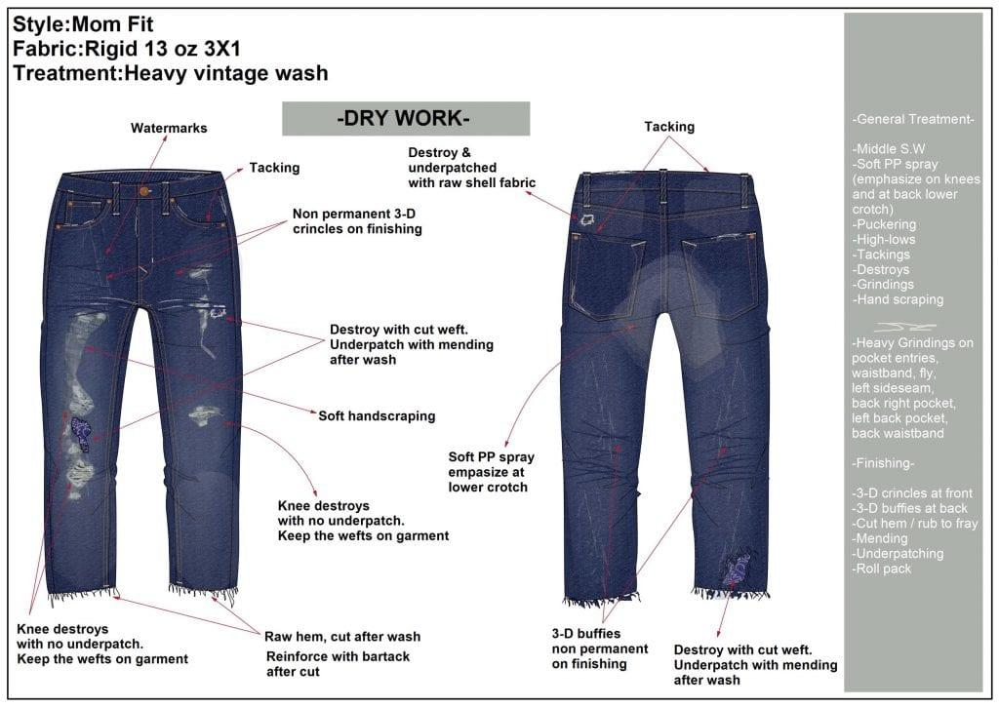  - Directly wearing, more profit and shrinkage-how those factors are considered as advantages of the garments washing? | 191-23-656  191-23-651  191-23-5495  191-23-5482  191-23-5484  191-23-5485  191-23-5489  191-23-5491  191-23-5493  191-23-5497
Set D
Questions | Students’ ID  (from-to)
- Exemplify the first two row of the below table-  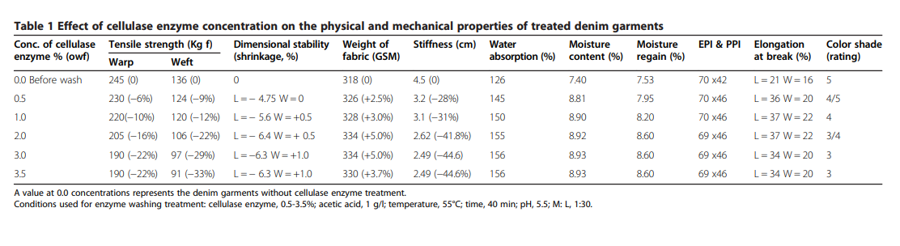  - Describe the below dyeing curve-  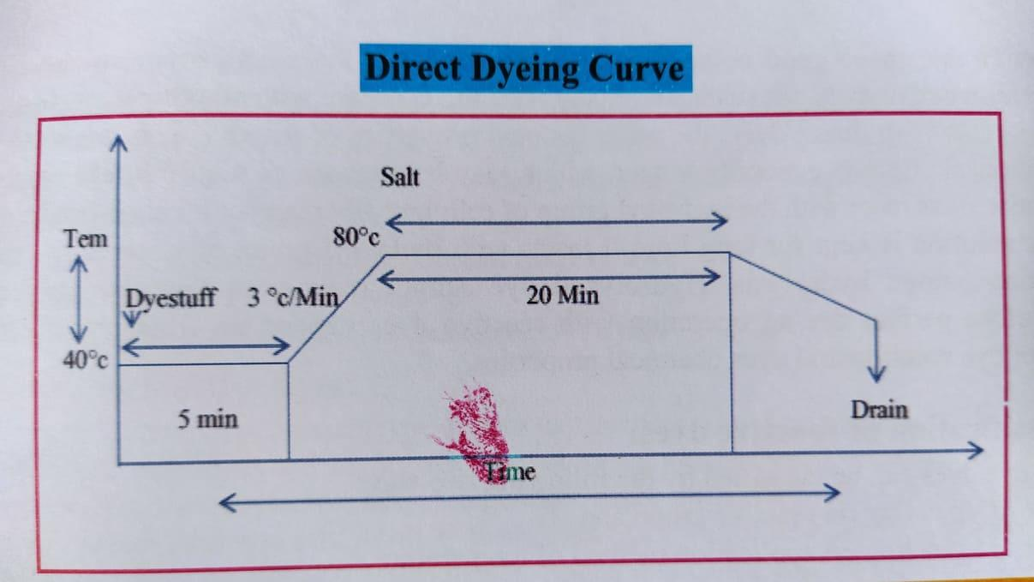  - What kinds of precautionary approach should be taken before garments wet wash processes in terms of raw materials, processing and chemicals?  - Suggest how we can produce the effects of following image –  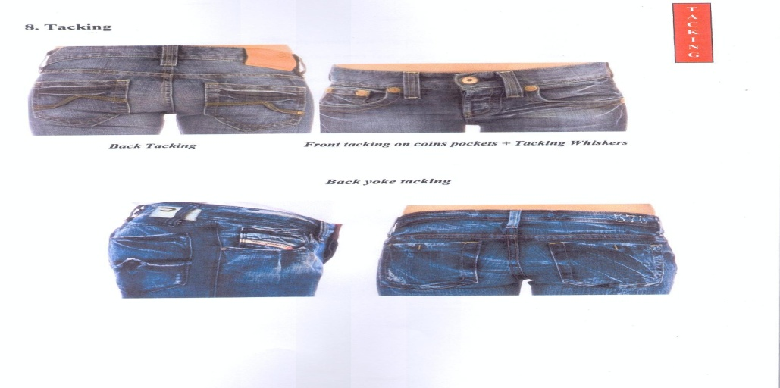  - Make a table in which you will suggest one in general acceptable range for the following tests required for garments order-  - Pilling resistance test  - Dimensional stability test  - Color Fastness Test  - Tensile and tearing strength  - Seam slippage properties | 191-23-5499  191-23-5500  191-23-5502  191-23-5503  191-23-5505  191-23-5514  191-23-5618  191-23-5519  191-23-5522  191-23-5523

Set E
Questions | Students’ ID  (from-to)
- Examine the costing behavior of dry processes of garments washing from the below graph-  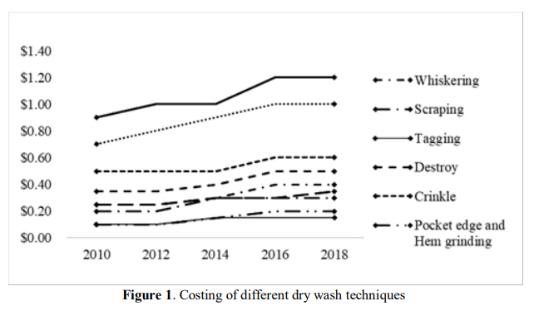  - Compare between below two images of garments dyeing machine and suggest which one is mostly used in Bangladesh?  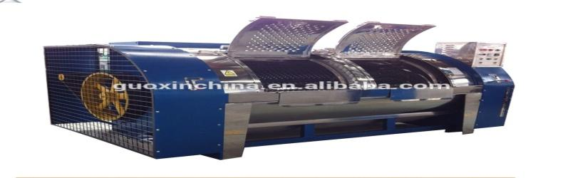  - What kind of effect is produced in the below images and how? Suggest a short overview-  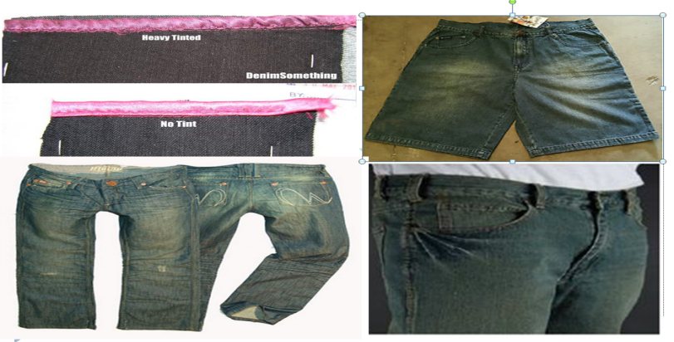  - What is the information given below in the Tech Pack of a garment order? Make a list.    - Full world is now in COVID-19 pandemic as we are also; during this situation one of us often have to go outside the home to fulfill the basic needs of family members. Hopefully we are going with required precautions by wearing garments, gloves, mask, socks, shoes etc. But rightly after coming back from outside how we can care (washing, ironing, drying, bleaching and dry cleaning-mention only for required care/s) about those wearable garments, gloves, mask socks and shoes to protect from COVID-19? Additionally, you are encouraged to add which you are practicing or being practiced in your home. | 191-23-5524  191-23-5535  191-23-5540  191-23-5541  191-23-5547  191-23-5549  191-23-5553  191-23-5555  191-23-5556  191-23-5558
Set F
Questions | Students’ ID  (from-to)
- Examine the costing behavior of wet processes of garments washing from the below graph-  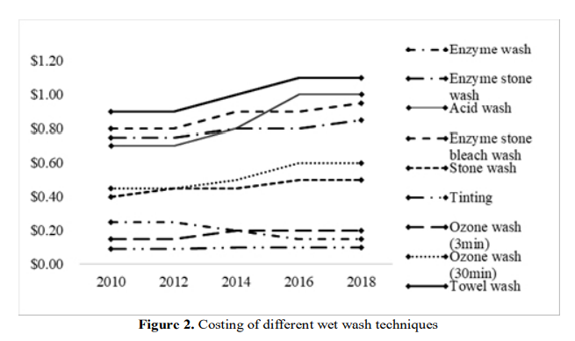  - Differentiate among the four picture of the below image and suggest which one is associated with washing also.  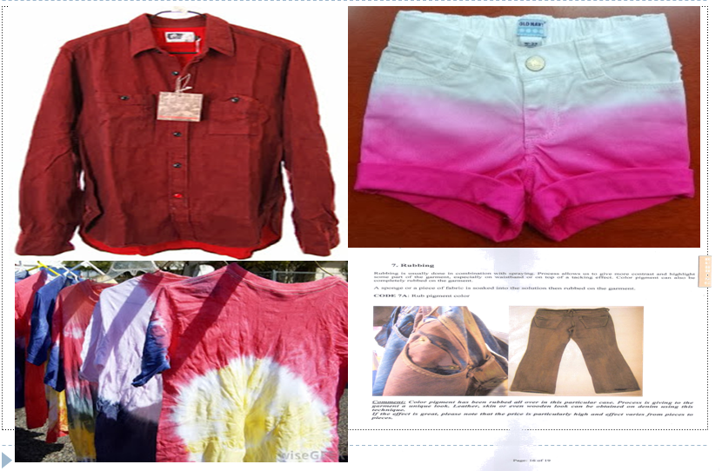  - What kinds of problem are shown in the image regarding interlining? Suggest with probable solution.  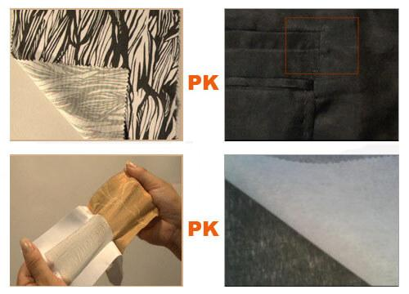  - From below two images of garments dyeing machine suggest which one is mostly used in Bangladesh and why?  - Garments washing sector is the next promising sector of Bangladesh for job market-What do you think? Show your arguments based on your answer. | 191-23-5559  191-23-5564  191-23-5574  191-23-5577  191-23-5578  191-23-5599  191-23-5632  191-23-5637  191-23-5647  182-23-5384

