Session 2: Perform to design output primitives using OpenGL

Intended Learning Outcome:

- Able to demonstrate effective OpenGL programs to solve graphics programming issues including different shapes.
- Able to appreciate the knowledge along axis (X,Y).

Expected Skills:

b. Make some design using OpenGL.

Tools Required:

- CodeBlocks

- OpenGL and GLUT using CodeBlocks.

Session Detail:
Code for designing colorful star:

#include <GL/gl.h>

#include <GL/glut.h>

void display(void)

{

/* clear all pixels */

glClear (GL_COLOR_BUFFER_BIT);

/* draw white polygon (rectangle) with corners at

- (0.25, 0.25, 0.0) and (0.75, 0.75, 0.0) */

///1st body

glColor3f (1.0, 1.0, 1.0);

glBegin(GL_POLYGON);

glVertex3f (0.53, 0.42, 0.0);

glVertex3f (0.56, 0.34, 0.0);

glVertex3f (0.59, 0.42, 0.0);

glVertex3f (0.67, 0.45, 0.0);

glVertex3f (0.59, 0.48, 0.0);

glVertex3f (0.56, 0.56, 0.0);

glVertex3f (0.53, 0.48, 0.0);

glVertex3f (0.45, 0.45, 0.0);

glEnd();

///2nd body

glColor3f (1.0, 0.0, 0.0);

glBegin(GL_POLYGON);

glVertex3f (0.31, 0.42, 0.0);
glVertex3f (0.34, 0.34, 0.0);

glVertex3f (0.37, 0.42, 0.0);

glVertex3f (0.45, 0.45, 0.0);

glVertex3f (0.37, 0.48, 0.0);

glVertex3f (0.34, 0.56, 0.0);

glVertex3f (0.31, 0.48, 0.0);

glVertex3f (0.23, 0.45, 0.0);

glEnd();

///2nd body

glColor3f (0.0, 1.0, 0.0);

glBegin(GL_POLYGON);

glVertex3f (0.42, 0.53, 0.0);

glVertex3f (0.45, 0.45, 0.0);

glVertex3f (0.48, 0.53, 0.0);

glVertex3f (0.56, 0.56, 0.0);

glVertex3f (0.48, 0.59, 0.0);

glVertex3f (0.45, 0.67, 0.0);

glVertex3f (0.42, 0.59, 0.0);

glVertex3f (0.34, 0.56, 0.0);

glEnd();

///2nd body

glColor3f (0.0, 0.0, 1.0);

glBegin(GL_POLYGON);

glVertex3f (0.42, 0.31, 0.0);

glVertex3f (0.45, 0.23, 0.0);

glVertex3f (0.48, 0.31, 0.0);

glVertex3f (0.56, 0.34, 0.0);

glVertex3f (0.48, 0.37, 0.0);

glVertex3f (0.45, 0.45, 0.0);

glVertex3f (0.42, 0.37, 0.0);

glVertex3f (0.34, 0.34, 0.0);

glEnd();

/* don't wait!

- start processing buffered OpenGL routines */

glFlush ();

}

void init (void)

{

/* select clearing (background) color */ glClearColor (0.0, 0.0, 0.0, 0.0);

/* initialize viewing values */ glMatrixMode(GL_PROJECTION);
glLoadIdentity();

glOrtho(0.0, 1.0, 0.0, 1.0, -1.0, 1.0);

}

/*

- Declare initial window size, position, and display mode

- (single buffer and RGBA). Open window with "hello"

- in its title bar. Call initialization routines.

- Register callback function to display graphics.

- Enter main loop and process events.

*/

int main(int argc, char** argv)

{

glutInit(&argc, argv);

glutInitDisplayMode (GLUT_SINGLE | GLUT_RGB);

glutInitWindowSize (500, 500);

glutInitWindowPosition (100, 100);

glutCreateWindow ("Star Designing");

init ();

glutDisplayFunc(display);

glutMainLoop();

return 0; /* ISO C requires main to return int. */

}

Sample input:

No sample input is needed.

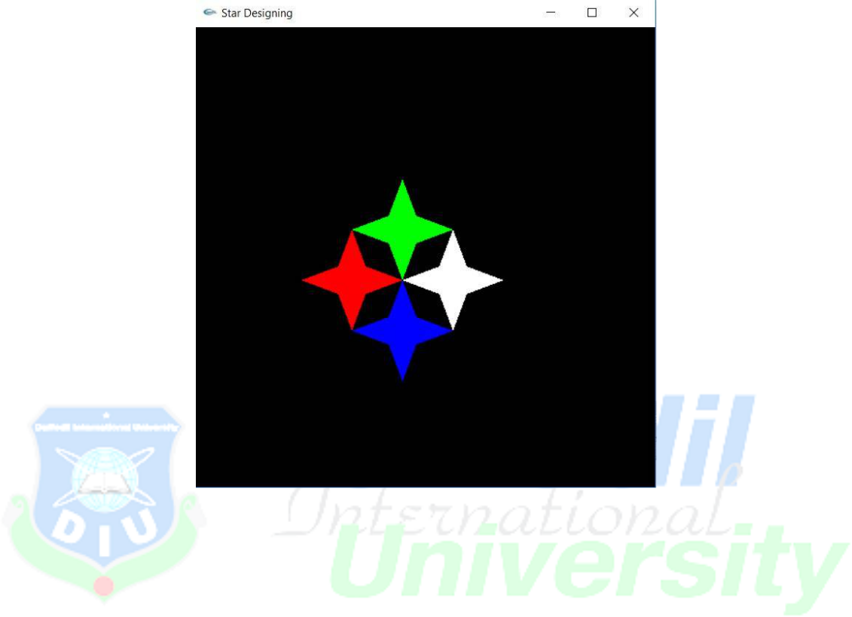
Sample output:

