**Agenda :**

1. **What is data structure?**
2. **Why we need data structure?**
3. **Different types of data structure and their application**

Data Structures

A **data structure** is a particular way of organizing data in a computer so that it can be used effectively

Why we need data structure?

**Types of data structure:**

* [Linked List](https://www.geeksforgeeks.org/data-structures/linked-list/)
* [Stack](https://www.geeksforgeeks.org/stack/)
* [Queue](https://www.geeksforgeeks.org/queue/)
* Tree
* Graph

Linked list : A linked list consists of nodes where each node contains a data field and a reference(link) to the next node in the list:

1. Singly linked list
2. Doubly linked list
3. Circular linked list

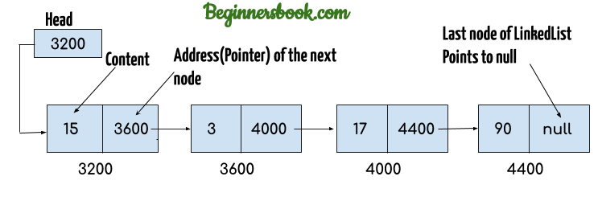

Application:

* 1. **Used to** implement stacks, queues, and other abstract data types
  2. Linked lists are useful for dynamic memory allocation.
  3. Checking history in web browser.

Stack: Stack is a linear data structure which follows a particular order in which the operations are performed. The order is LIFO(Last In First Out)

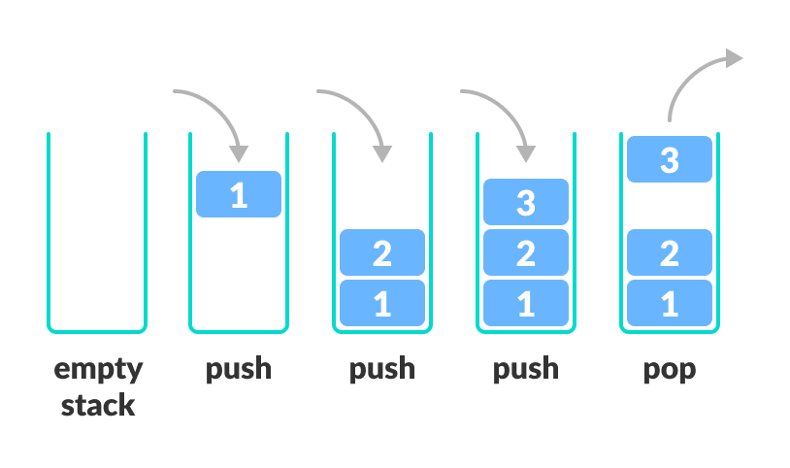

Application:

1. **Parenthesis Checking:** Stack is used to check the proper opening and closing of parenthesis.

**2. String Reversal**

Stack is used to reverse a string. We push the characters of string one by one into stack and then pop character from stack.

**3. Function Call**

Stack is used to keep information about the active functions or subroutines.

4. Undo/Redo : Undo /Redo mechanism in text editiors

Queue:

A Queue is a linear structure which follows a particular order in which the operations are performed. The order is First In First Out (FIFO).

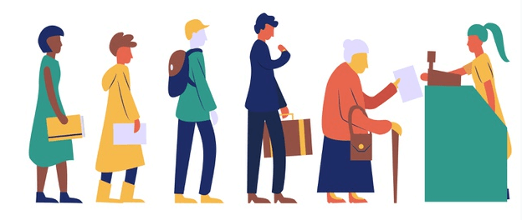

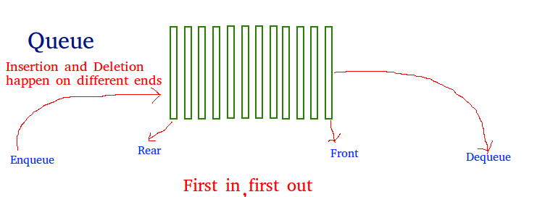

Application:

1. Serving requests on a single shared resource, like a printer, CPU task scheduling etc.
2. In real life scenario, Call Center phone systems uses Queues to hold people calling them in an order, until a service representative is free.

Tree: Tree represents the nodes connected by edges

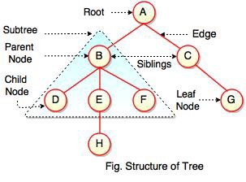

Application:

* Represent organization
* Represent computer file systems

Graph: A Graph is a non-linear data structure consisting of nodes and edges. The nodes are sometimes also referred to as vertices and the edges are lines or arcs that connect any two nodes in the graph

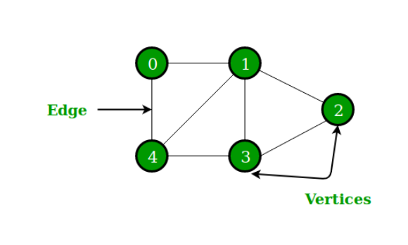

Application:

**Google maps** uses graphs for building transportation systems

Facebook’s Friend suggestion algorithm uses graph theory.