**What is mitosis?**

**Mitosis** is a type of cell division in which one cell (the **mother**) divides to produce two new cells (the **daughters**) that are genetically identical to itself. In this process DNA of the cell's nucleus is split into **two equal sets** of chromosomes. The great majority of the cell divisions that happen in your body involve mitosis. During development and growth, mitosis populates an organism’s body with cells, and throughout an organism’s life, it replaces old, worn-out cells with new ones.

**Phases of mitosis**

Mitosis consists of four basic phases: prophase, metaphase, anaphase, and telophase. Some textbooks list five, breaking prophase into an early phase (called prophase) and a late phase (called prometaphase). These phases occur in strict sequential order.

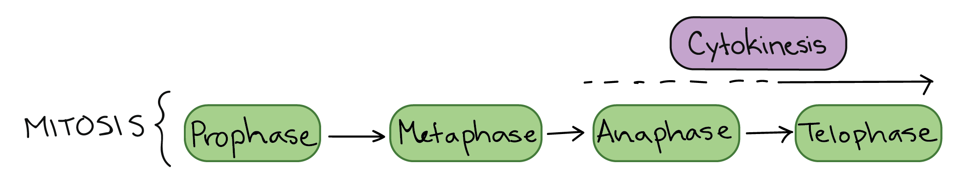

**Stages of mitosis:** prophase,prometaphase, metaphase, anaphase, telophase.

Cytokinesis is the process of dividing the cell contents to make two new cells - starts in anaphase or telophase.

**1. Prophase**

The mitotic spindle starts to form, the chromosomes start to condense, and the nucleolus disappears.In early **prophase**, the cell starts to break down some structures and build others up, setting the stage for division of the chromosomes.

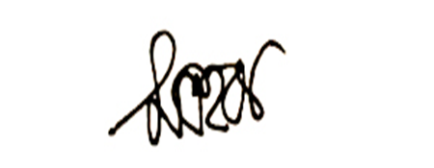

The chromosomes start to condense (making them easier to pull apart later on).

* It is the first stage of mitosis cell division
* Condensation of chromatin into chromosomes.
* spindle fibers appear
* the nuclear envelope and nucleoli disappear

**2. Prometaphase (late prophase)**

The nuclear envelope breaks down and the chromosomes are fully condensed.

The mitotic spindle begins to capture and organize the chromosomes. The chromosomes finish condensing, so they are very compact.

The nuclear envelope breaks down, releasing the chromosomes. The mitotic spindle grows more, and some of the microtubules start to “capture” chromosomes.

Once the nuclear envelope is gone, some of the spindle microtubules attach to chromosomes, throwing them into an agitated motion

**3. Metaphase.** Chromosomes line up at the metaphase plate, under tension from the mitotic spindle. The two sister chromatids of each chromosome are captured by microtubules from opposite spindle poles.

The stage when chromosomes line up in a straight line midway between the centrioles.

Before proceeding to anaphase, the cell will check to make sure that all the chromosomes are at the metaphase plate with their kinetochores correctly attached to microtubules.

**4. Anaphase.** The sister chromatids separate from one another and are pulled towards opposite poles of the cell. The microtubules that are not attached to chromosomes push the two poles of the spindle apart, while the kinetochore microtubules pull the chromosomes towards the poles.

In **anaphase**, the sister chromatids separate from each other and are pulled towards opposite ends of the cell.

**5. Telophase: The** spindle disappears, a nuclear membrane re-forms around each set of chromosomes, and a nucleolus reappears in each new nucleus. The chromosomes also start to decondense.

In **telophase**, the cell is nearly done dividing, and it starts to re-establish its normal structures as cytokinesis (division of the cell contents) takes place.

The mitotic spindle is broken down into its building blocks. Two new nuclei form, one for each set of chromosomes. Nuclear membranes and nucleoli reappear. The chromosomes begin to decondense and return to their “stringy” form.

* much like prophase in reverse
* a nuclear envelope and nucleoli reappear, and
* the chromosomes unwind, forming thread like chromatin.

**Cytokinesis**, the division of the cytoplasm to form two new cells, overlaps with the final stages of mitosis. It may start in either anaphase or telophase, depending on the cell, and finishes shortly after telophase.

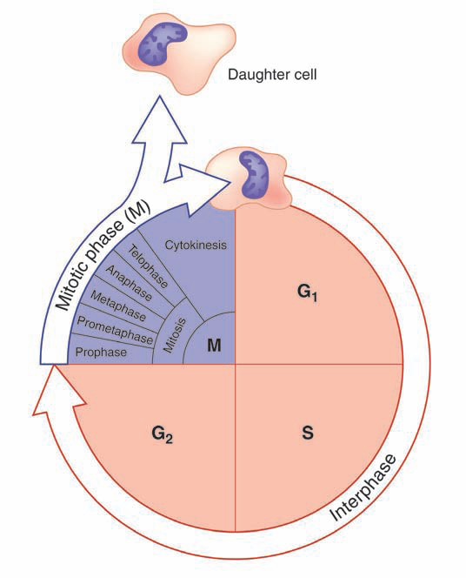

**G1**: Cell growth phase

**S:** DNA Synthesis phase

**G2:** More cell growth phase

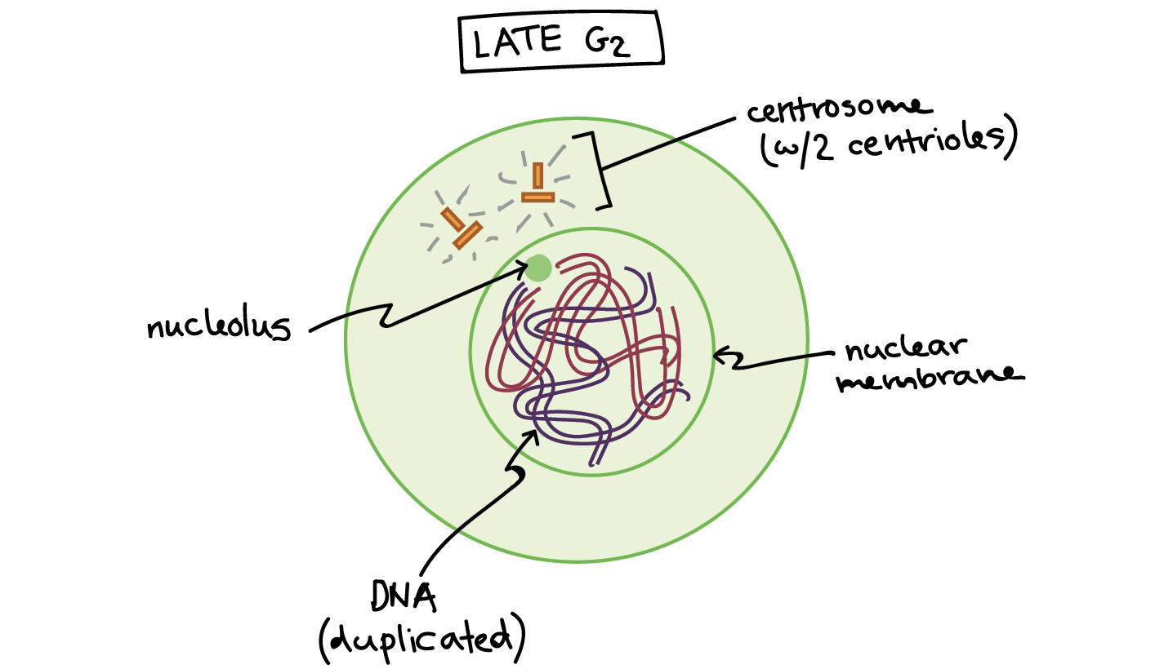

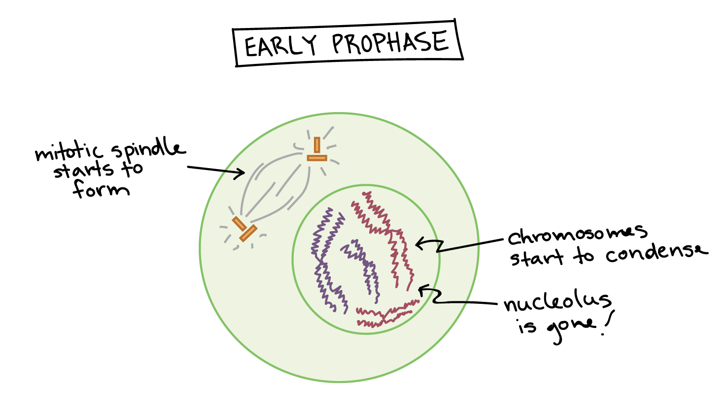

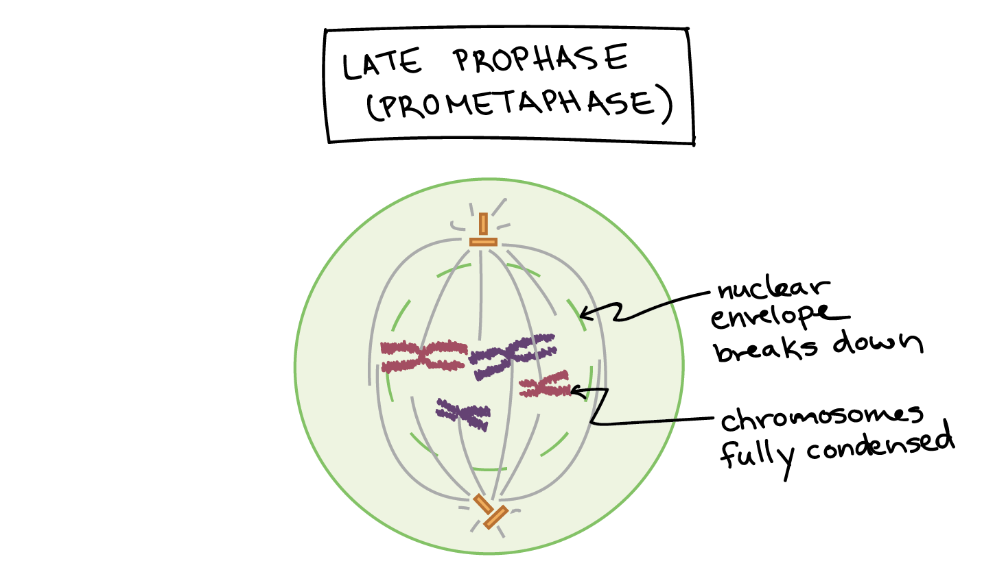

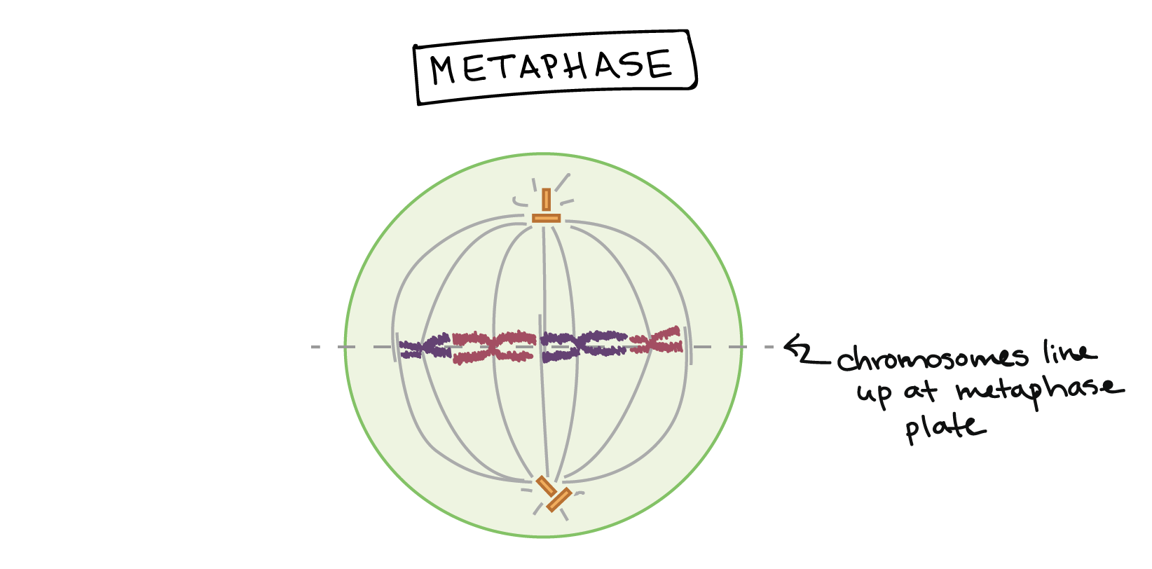

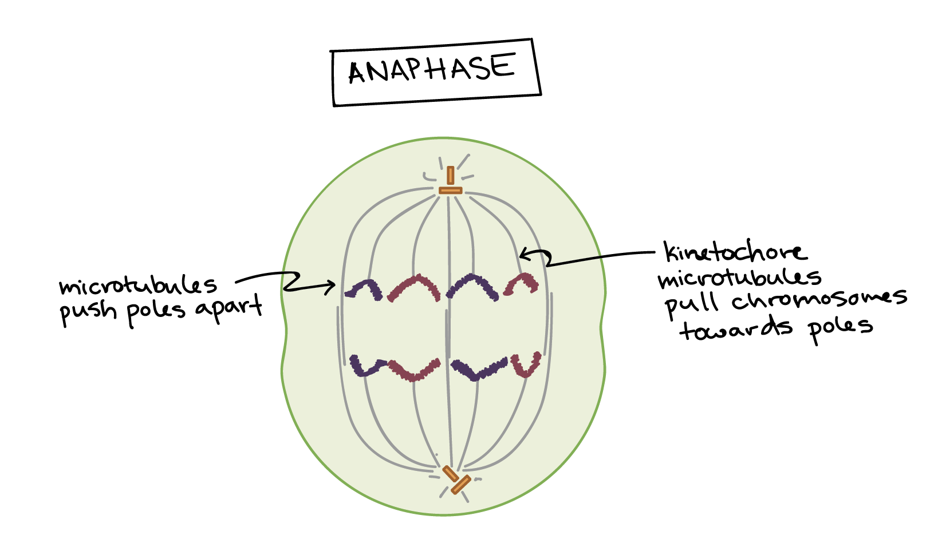

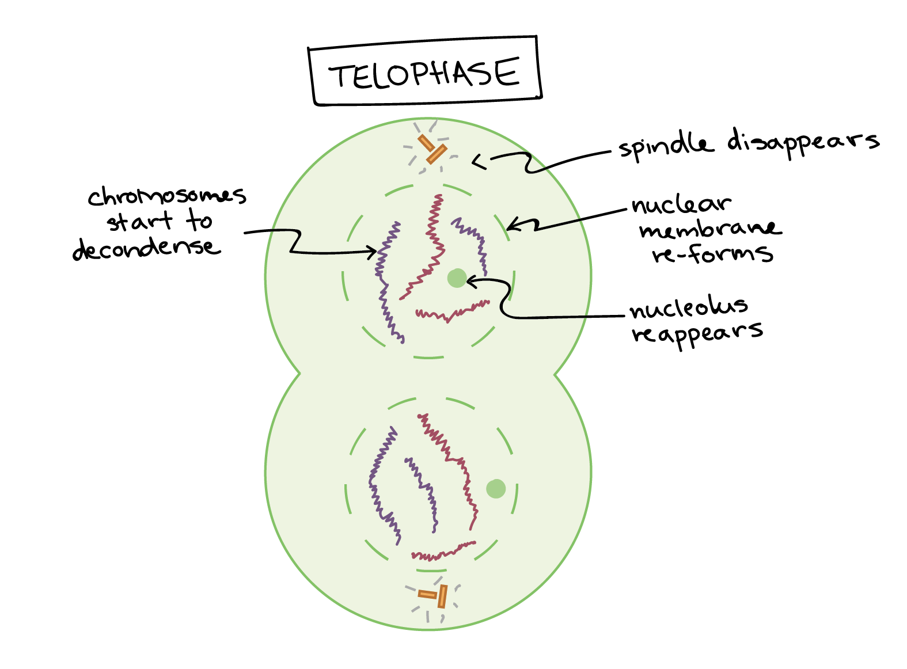

Cytokinesis in animal and plant cells.

Cytokinesis in an animal cell: an actin ring around the middle of the cell pinches inward, creating an indentation called the cleavage furrow.

Cytokinesis in a plant cell: the cell plate forms down the middle of the cell, creating a new wall that partitions it in two.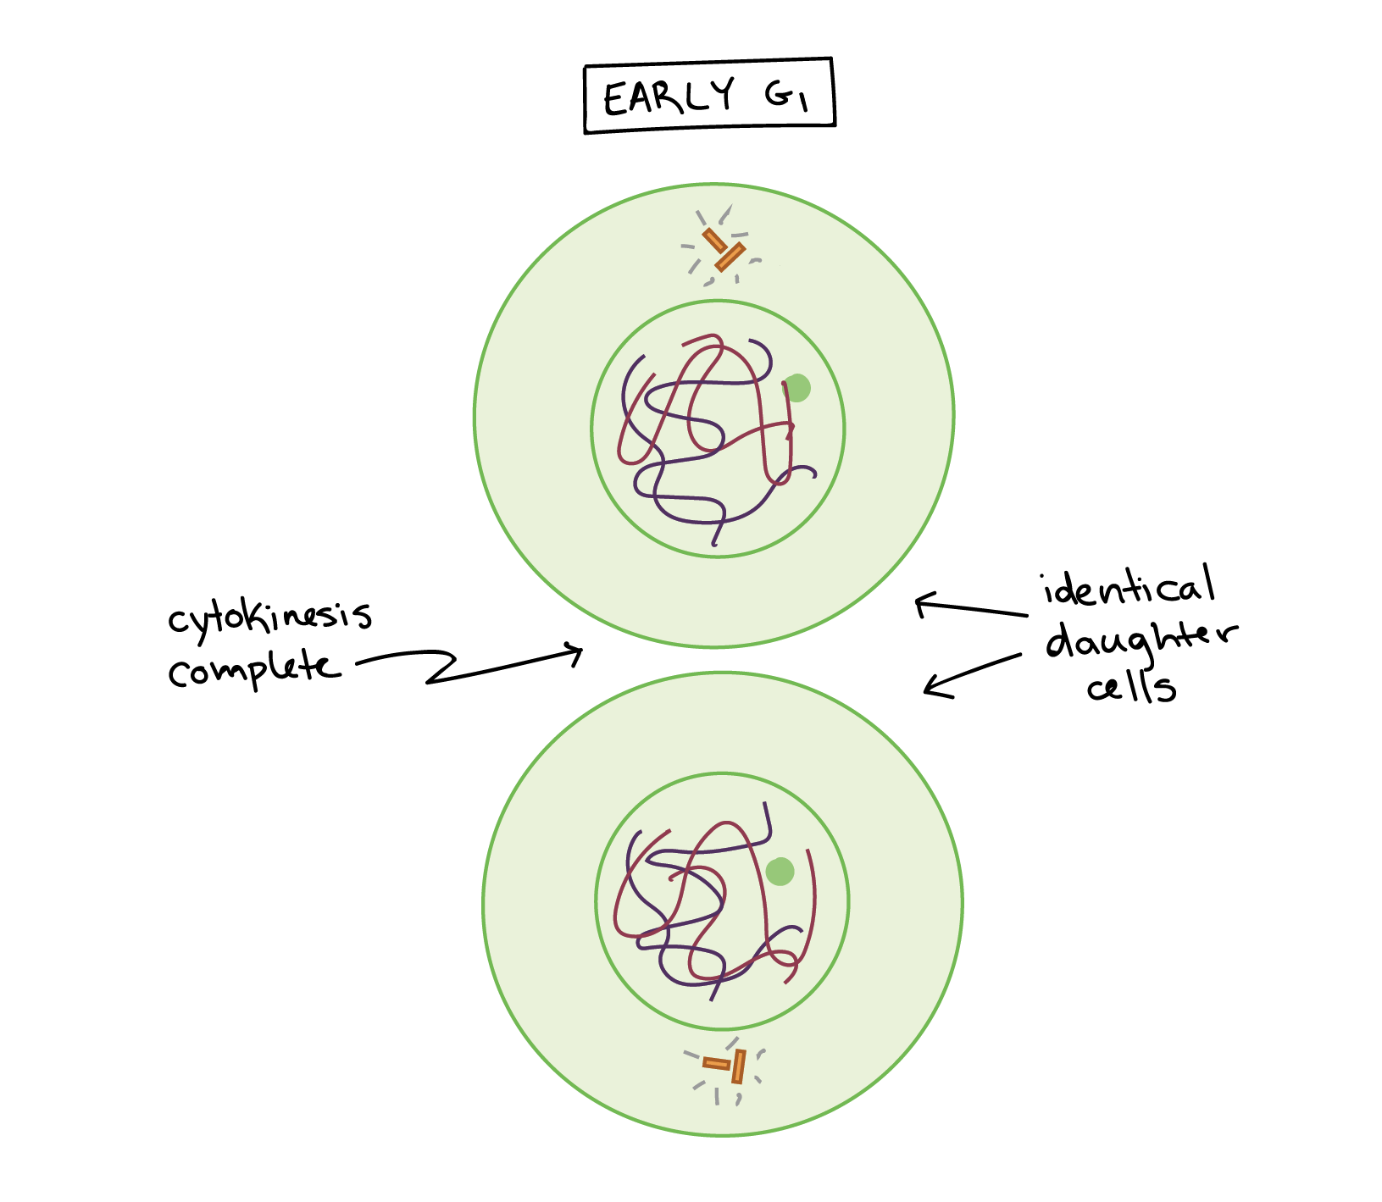

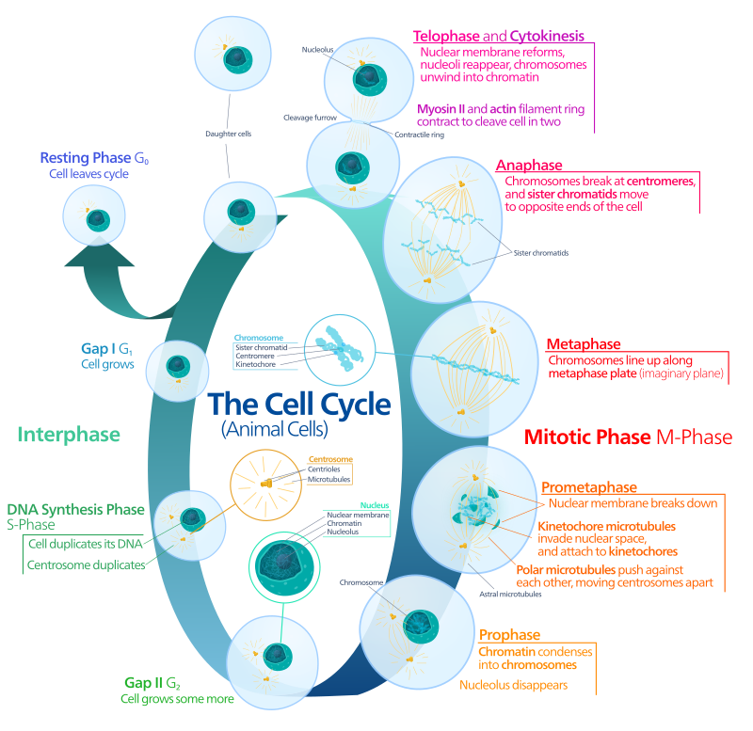

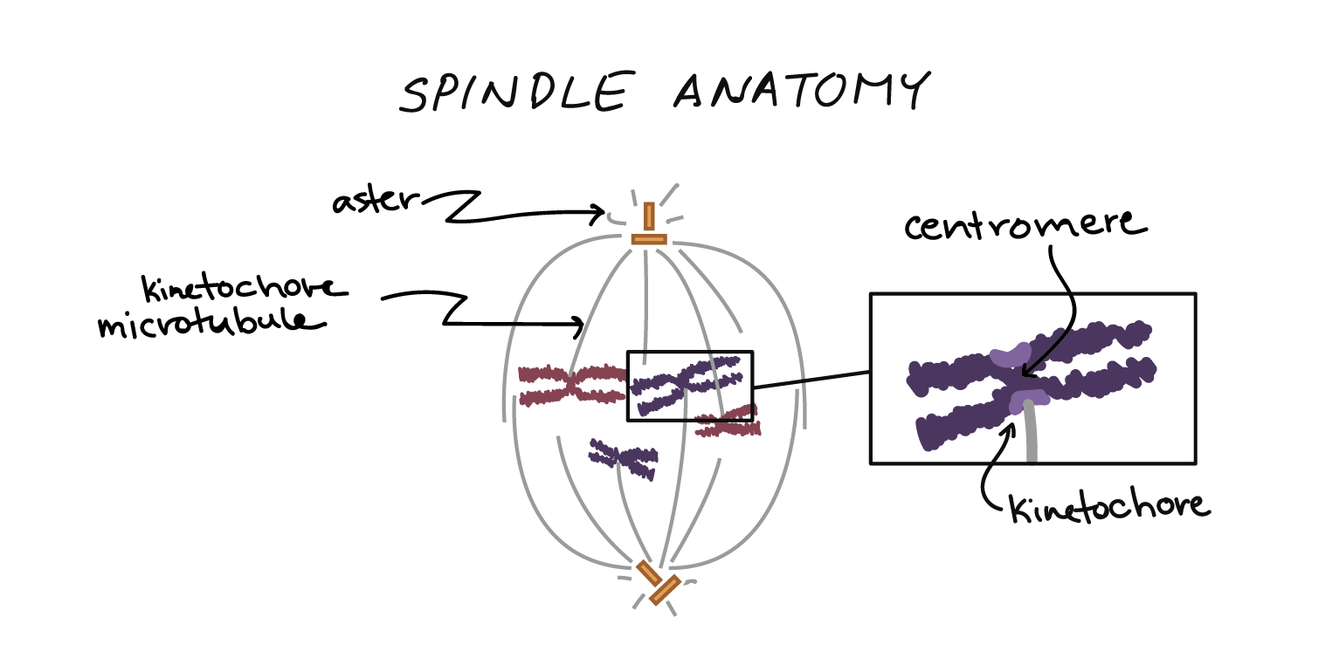

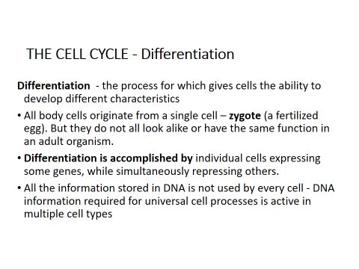

* Meiosis is a cell division in which four haploid cells are formed from a single diploid cell.
* It usually occurs in reproductive organs or gonads of the organisms.
* Meiosis is also known as reductional cell division because four daughter cells produced contain half the number of chromosomes than that of their parent cell
* A different process of cell division is necessary to produce **gametes (sperm and ova). This is because** gametes combine genetic information from two different cells during fertilization to form a zygote
* **Meiosis is a form of** nuclear division that occurs in the gonads, which reduces chromosome number of each daughter cell by half.
* meiosis consists of two successive divisions of the nucleus
* Results in the production of four daughter cells.

1. **Meiosis-I (Reductional division)**
2. **Meiosis-II (Equational division)**

Meiosis-I has four different phases or stages:

1. Prophase-I
2. Metaphase-I
3. Anaphase-I
4. Telophase-I

Meiosis-II is exactly similar to mitosis, so it is also known as meiotic mitosis

1. Prophase-II
2. Metaphase-II
3. Anaphase-II
4. Telophase-I

## Comparison Meiosis Vs mitosis

In order to understand meiosis, a comparison to mitosis is helpful. The table below shows the differences between meiosis and mitosis.

|  |  |  |
| --- | --- | --- |
|  | **Meiosis** | **Mitosis** |
| End result | Normally four cells, each with half the number of chromosomes as the parent | Two cells, having the same number of chromosomes as the parent |
| Function | Production of gametes (sex cells) in sexually reproducing eukaryotes with diplont life cycle | Cellular reproduction, growth, repair, asexual reproduction |
| Where does it happen? | Almost all eukaryotes (animals, plants, fungi, and [protists](https://en.wikipedia.org/wiki/Protist)) In gonads, before gametes (in diplontic life cycles);  After zygotes (in haplontic);  Before spores (in haplodiplontic) | All proliferating cells in all eukaryotes |
| Steps | Prophase I, Metaphase I, Anaphase I, Telophase I,  Prophase II, Metaphase II, Anaphase II, Telophase II | Prophase, Prometaphase, Metaphase, Anaphase, Telophase |
| Genetically same as parent? | No | Yes |
| Crossing over happens? | Yes, normally occurs between each pair of homologous chromosomes | Very rarely |
| Pairing of homologous chromosomes? | Yes | No |
| Cytokinesis | Occurs in Telophase I and Telophase II | Occurs in Telophase |

