## Lesson 8: Fat soluble vitamins

Outcomes **Learning outcomes**

Upon completion of this lesson, the learners will be able to

* + Define vitamin;
  + Classify vitamin;
  + Describe sources, functions and deficiency diseases of fat soluble vitamins.



### Vitamins

Vitamins regulate a wide range of biochemical reactions within the body. Most vitamins with known functions are coenzymes (helpers of enzyme). The name vitamin implies their importance. *Vita* in Latin means life.

Vitamins are a group of essential organic micronutrients that are needed for normal cell function, growth, and development, found in minute amounts in natural foodstuffs or sometimes produced synthetically: deficiencies of vitamins produce specific disorders.

Many people think that vitamins are sources of energy for our bodies. But the truth is that vitamins do not provide energy. Unlike carbohydrates, lipids, or proteins, vitamins do not provide energy or serve as the body’s building materials.

Of the thirteen vitamins recognized as essential, humans can synthesize only small amounts of vitamins D and K, so we must consume virtually all of the vitamins in our diets. Almost everyone who eats a varied and healthful diet can readily meet their vitamin needs from foods alone. The specific amounts and types of vitamins in foods vary.

### Classification of vitamins

Vitamins are classified depending on their solubility-

1. Fat soluble vitamins
2. Water soluble vitamins
3. Fat soluble vitamins: Those which are soluble in fats but not in water are called fat soluble vitamins, such as-
   1. Vitamin A or Retinol
   2. Vitamin D or Calciferol
   3. Vitamin E or Tocopherol
   4. Vitamin K or Phylloquinone

They are found in the fatty portions of foods (butterfat, cod liver oil, corn oil, and so on) and are absorbed along with dietary fat. Fat-containing meats, dairy products, nuts, seeds, vegetable oils, and avocados are all sources of one or more fat-soluble vitamins.

In general, the fat-soluble vitamins are readily stored in the body’s adipose tissue; thus, we don’t need to consume them every single day. Of the four fat-soluble vitamins, vitamins A and D are the most toxic; **megadosing** with ten or more times the recommended intake of either can result in irreversible organ damage and even death.

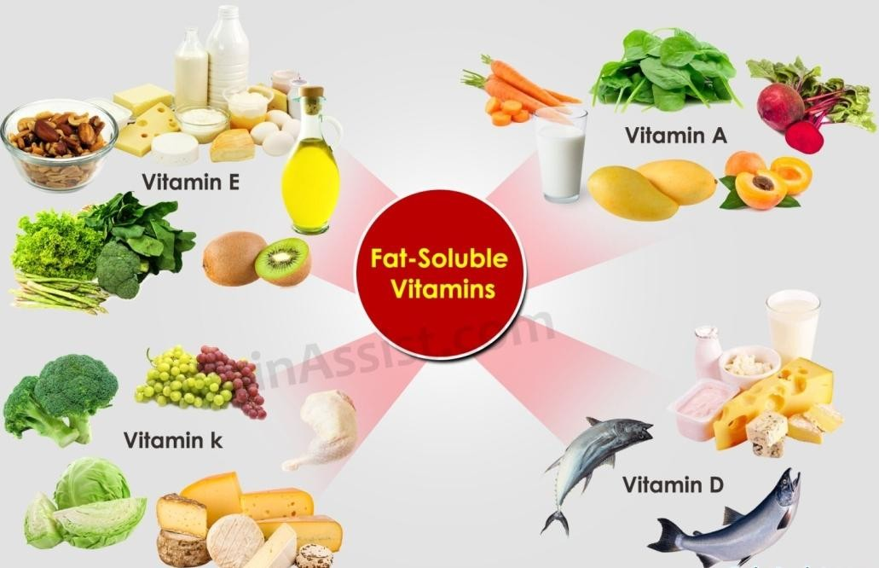

**Figure 7.1.** Sources of fat soluble vitamins

Sources, functions and deficiency diseases of fat soluble vitamins are given below-

### Vitamin A

Vitamin A consists of two basic dietary forms: preformed vitamin A, also called **retinol,** which is the active form of vitamin A; and ***β*-carotene** (yellow-orange pigments) (also called provitamin A/precursor of vitamin A) the inactive form of vitamin A which can be converted into vitamin A in our body and are found in plants. Body can convert 10% of plant origin provitamin A to vitamin A.

### Major sources

|  |  |  |  |  |  |
| --- | --- | --- | --- | --- | --- |
| Animal: |  |  |  |  |  |
| Liver | Butter | Whole milk | Egg yolk | Cod liver oil | Small fish |

|  |  |  |  |  |  |
| --- | --- | --- | --- | --- | --- |
| Plants (Precursors): Green and orange fruits and vegetables, such as | | | | | |
| Carrots | Sweet potatoes | Broccoli | Pumpkin | Mango | Fortified oil |

* + 1. 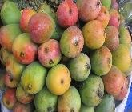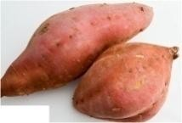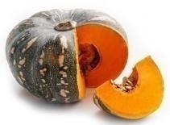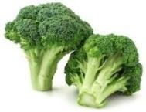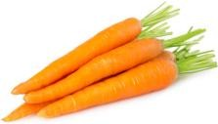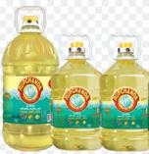**Functions of vitamin A**
       1. Plays an important role in vision in dim light/low light conditions, bone growth and development, reproduction, and cell division;
       2. Assists in maintaining the linings and coverings of tissues; Helps in regulating the immune system, which fights infections;
       3. Helps in maintaining healthy skin;
       4. Acts as an antioxidant.

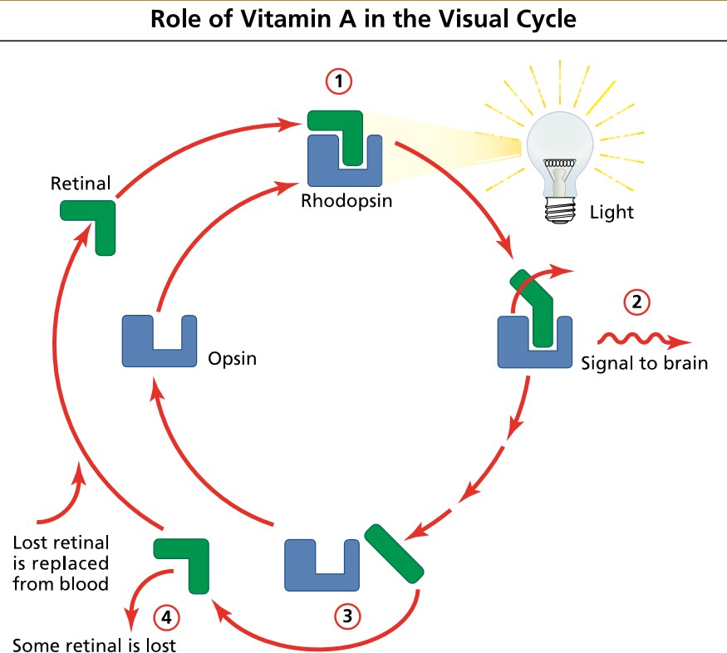

**Figure 7.1.** Vitamin A is an important part of the visual cycle. In the eye, retinal combines with opsin to form rhodopsin (1). When low light strikes rhodopsin, retinal changes shape, causing a

nerve signal to be sent to the brain (2) and retinal to separate from opsin (3). Some of this retinol is lost and must be replaced from retinoids in the blood (4).

### Deficiency symptoms of vitamin A

1. Xerophthalmia (dye eye)

Vitamin A deficiency can lead to the dysfunction of the linings and coverings of the eye, causing dryness of the eyes, a condition called xerophthalmia. This condition can progress, causing ulceration of the cornea and eventually blindness. The successive ocular signs and symptoms that appear depending on the severity of vitamin A deficiency are given below-

* 1. Night blindness (inability to see in dim light/low light) (earliest clinical signs)
  2. Conjunctival xerosis (dryness)
  3. Bitot’s spots (foamy/cheesy appearance on white area)
  4. Corneal xerosis (cornea becomes dry and hazy)-Up to corneal xerosis stage, vision can be restored fully through supplementation of high-dose vitamin A capsule).
  5. Corneal ulceration/keratomalacia
  6. Corneal scaring (grey-white appearance of cornea)

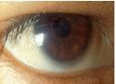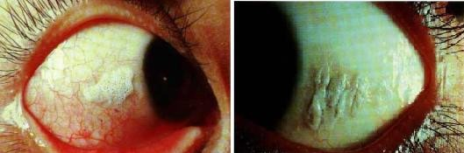

|  |  |  |
| --- | --- | --- |
| Conjunctival xerosis | Foamy | Cheesy |
|  | Bitot’s spot | |

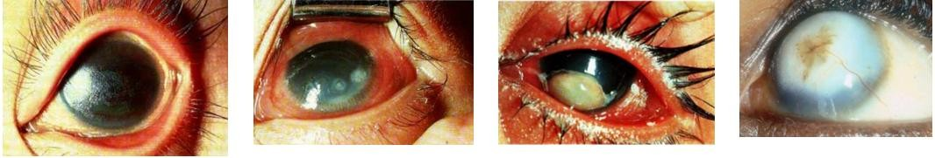

|  |  |  |  |
| --- | --- | --- | --- |
| Corneal xerosis | Corneal ulceration  with infection | Keratomalacia  (1/3 of cornea) | Corneal scaring |

**Figure 7.2.** Ocular signs and symptoms of vitamin A deficiency [Source: WHO, 1995]

Other deficiency symptoms

1. Dry, rough skin; slow and faulty development of bones and teeth.
2. Increased incidence of ear, sinus, respiratory, urinary, and digestive system infections.
3. Stunted growth, delayed wound healing and follicular hyperkeratosis especially in the knees and elbows.

### Risk groups of vitamin A deficiency

Those groups of people having high demand of vitamin A are at the highest risk of developing vitamin A deficiency such as children, adolescents and pregnant and lactating mother. Infants suffering from diarrhoeal diseases and infections are also at risk of vitamin A deficiency.

### Toxicities

Hypervitaminosis A, or vitamin A toxicity, typically results from taking high-dose supplements over a long period of time. Fatigue; bone and joint pain; spontaneous abortion and birth defects of fetuses in pregnant women; dry skin, nausea, diarrhea and headache; liver damage; nervous system damage; blurred vision; hair loss; skin disorders, etc.

### Vitamin D

Vitamin D is known as the sunshine vitamin. It is made in our skin from its precursor, cholesterol, when skin is exposed to sunlight. 90% of our daily vitamin D requirements can be met just exposing 20 minutes of our body (40%; face, arms, legs or back) to sunlight (ultraviolet B radiation) between 10 am to 3 pm two to three times every week. Vitamin D is only essential in the diet when exposure to sunlight is limited or when the body’s ability to make it is reduced.

Vitamin D is heat-stable and not easily oxidized, so it is not harmed by storage, food processing, or cooking.

### Major food sources:

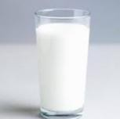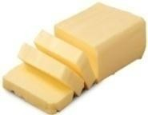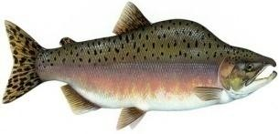The best food sources of vitamin D are-

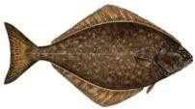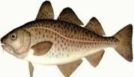

|  |  |  |  |  |
| --- | --- | --- | --- | --- |
| Milk | Fish liver oils | Egg yolk | Butter | Fatty fish |

### Functions

* + - 1. The primary function of vitamin D is to help in absorption of calcium and phosphorus from the small intestine.
      2. Vitamin D is also necessary for the normal calcification of bone.
      3. Vitamin D is also now believed to play a role in preventing cells from transforming into cancer cells.

### Deficiency diseases of vitamin D

Vitamin D helps in absorption of calcium from intestine as well as deposition of calcium and phosphorus in the bone. Deficiency of either vitamin D or calcium or both may lead to inadequate mineralization or demineralization of the skeleton resulting the following signs and symptoms/diseases-

### General signs and symptoms

|  |  |  |
| --- | --- | --- |
| * Hypotonia (low muscle tone) * Irritability, fits * Profuse sweating while asleep, * Delayed in walking, delayed dentition * Leg pain | * Retarded growth * Poor teeth and bone formation * Tetany-insufficient calcium in the blood can cause a condition characterized by involuntary muscle   movement | * Protruding abdomen (due to low abdominal and intestinal muscle tone and descending displacement of the liver and spleen) |

1. 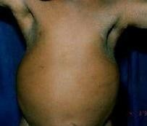**Severe deficiency diseases/signs and symptoms**

Severe deficiency of vitamin D may lead to the deformities of the skeleton which includes

### Rickets

A deficiency of vitamin D in children causes the bone disease called nutritional rickets. Rickets is very common among children (6 months-2 years) in developing countries and is characterized by soft, weak, deformed bones that are exceptionally susceptible to fracture. The signs and symptoms of rickets include

### In upper extremities

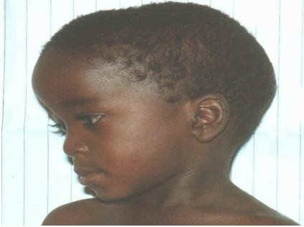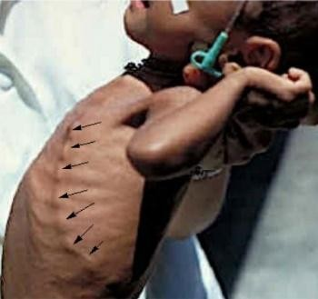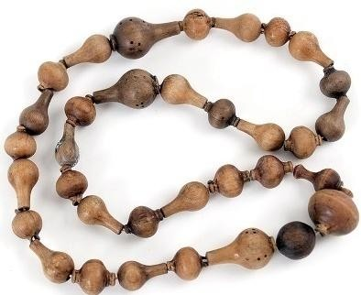Larger head (frontal and parietal bossing), rachitic rosary/beading of the ribs (prominent knobs of bone at the costochondral junctions), pigeon chest deformity (chest bones grow outwardly and usually happen during adolescent growth spurt), scoliosis (sideways curvature of the spine) and so on.

|  |  |
| --- | --- |
| **Frontal bossing** | **Rachitic rosary** |

|  |  |
| --- | --- |
|  | Curvature of spine bone |
| **Pigeon chest deformity** | **Scoliosis** |

### In lower extremities



Bowed legs (varus), knocked knees (valrus), enlargement of wrist and ankle joints, windswept deformity (combination of valgus deformity of one leg with varus deformity of the other leg), bending of leg, etc.

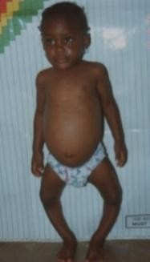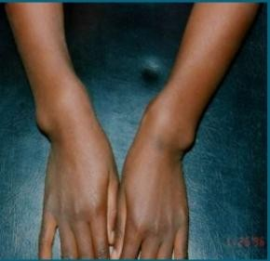

|  |  |  |
| --- | --- | --- |
| **Bowed legs** | **Knocked knees** | **Enlargement of wrist joints** |
| **Enlargement ankle joints** | **Windswept deformity** | **Bending of leg** |

* 1. 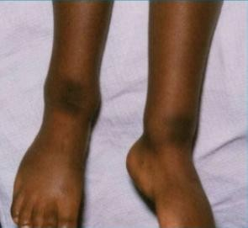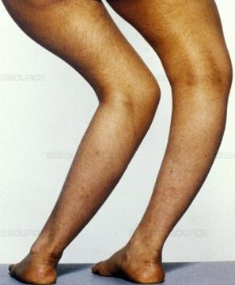In adults, vitamin D deficiency causes a similar disease called **osteomalacia** (*osteo* means bone and *malacia* means softening) which is characterized by low bone mineral density.
  2. **Osteoporosis** (*osteo* means bone and *porosis* means porous) is condition where the bones become very porous (less dense), weak, and are more likely to fracture just like brittle glass or soft clay can easily break apart. Other factors contributing to osteoporosis include deficiency of vitamin D and sex hormones. Osteoporosis primarily affects middle-aged and elderly people, 80% of them are women.

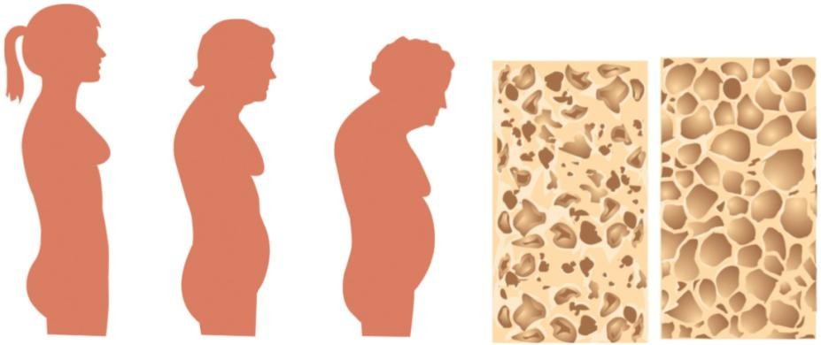

**Figure 7.3.** Osteoporosis is characterized by a gradual weakening of the bones, which leads to poor skeletal formation.

### Risk groups of vitamin D deficiency:

* People living in cool countries where sunlight either absent in day time or too low level to synthesize vitamin D in the body (e.g., Eastern Europe) or people wearing heavy clothing so that sunlight cannot reach to the skin;
* Lack of exposure to the sunlight in combination with diets low in vitamin D and high in phytic acid (found in bread);
* People staying inside house;
* Elderly (due to skin pigmentation) and dark-skinned populations.
  + 1. **Toxicities of vitamin D:** Hypervitaminosis D can cause calcification of soft tissues and kidney stones (hypercalcemia), hypertension.

### Vitamin E

Vitamin E consists of two groups of chemical compounds. They are the tocopherols and the tocotrienols. There are four types of tocopherols: alpha, beta, delta, and gamma. The most biologically active of these is alpha-tocopherol.

### Major sources

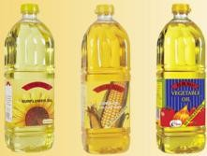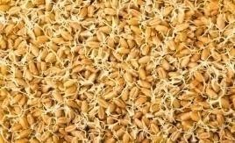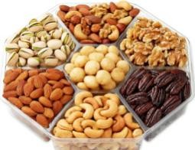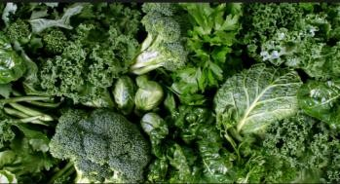

|  |  |  |  |
| --- | --- | --- | --- |
| Vegetable oils | Wheat germ | Nuts | Green leafy vegetables |

* + 1. **Functions**
       1. Acts as a powerful antioxidant to protects cell membranes, polyunsaturated fatty acids, and vitamin A from oxidation;
       2. Protects white blood cells;
       3. Enhances immune function;
       4. Improves absorption of vitamin A;
       5. Lower risk of heart disease and cancer.

### Deficiency diseases of vitamin E

Vitamin E deficiency is rare because it is plentiful in the food supply and is stored in many of the body’s tissues.

### Risk population

People suffering from fat malabsorption (because vitamin E is absorbed with fat) are at risk of vitamin E deficiency.

### Vitamin K

There are several forms of vitamin K, one synthesized by plants, one synthesized by animals (including humans) and a large range of types synthesized by bacteria in the small intestine of humans. Vitamin K deficiency is fairly uncommon in healthy adults, because bacteria in the intestines synthesize the vitamin.

Breast milk is a poor source of vitamin K and newborns have no bacteria in their gut to synthesize it. To ensure normal blood clotting, infants are typically given a vitamin K injection within six hours of birth.

### Major sources:

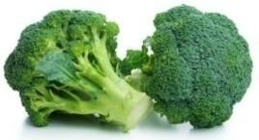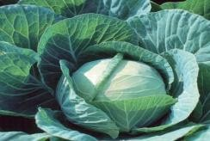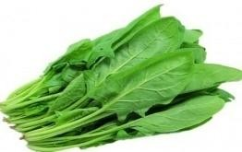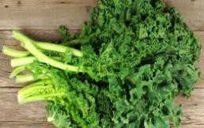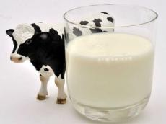

|  |  |  |  |  |
| --- | --- | --- | --- | --- |
| Broccoli | Cabbage | Spinach | Kale | Cow’s milk |

* + 1. **Functions**
       1. Helps in blood clotting by acting as a coenzyme.
       2. Helps in bone metabolism

### Deficiency symptoms

* Increases clotting time and prone to hemorrhage;
* Bone mineral density is reduced, and the risk of fractures increases.

### Risk population of vitamin K deficiency

Those people are at risk of vitamin K deficiency who are suffering from fat malabsorption, use antibiotic for long time (as antibiotics kill intestinal bacteria), consuming diet containing inadequate vitamin K, or using anticoagulants.

**Table 7.1:** Recommended dietary allowances of fat-soluble vitamins per day

|  |  |  |  |  |  |
| --- | --- | --- | --- | --- | --- |
| **Types** | **Age (years)** | **Vit. A** | **Vit. D** | **Vit. E** | **Vit. K** |
| **(mg RE)** | **(g)** | **(mgTE)** | **(g)** |
| New born | 0 to 0.5  0.5 to 1 | 375  375 | 7.5  10 | 3  4 | 5  10 |
|  | 1 to 3 | 400 | 400 | 6 | 15 |
| Children | 4 to 6 | 500 | 500 | 7 | 20 |
|  | 7 to 10 | 700 | 700 | 7 | 30 |
|  | 11 to 14 | 1000 | 5 | 10 | 45 |
|  | 15 to 18 | 1000 | 5 | 10 | 65 |
| Man | 19 to 24 | 1000 | 5 | 10 | 70 |
|  | 25 to 50 | 1000 | 5 | 10 | 80 |
|  | 51+ | 1000 | 5 | 10 | 80 |
|  | 11 to 14 | 800 | 10 | 8 | 45 |
|  | 15 to 18 | 800 | 10 | 8 | 55 |
| Woman | 19 to 24 | 800 | 10 | 8 | 60 |
|  | 25 to 50 | 800 | 10 | 8 | 65 |
|  | 51+ | 800 | 5 | 10 | 65 |
| Pregnant |  | 800 | 10 | 10 | 65 |
| Lactating | 1 to 6 months | 1300 | 10 | 12 | 65 |
| Mother | 2 to 6 months | 1200 | 10 | 11 | 65 |
| RE=Retinol equivalent, TR=Tocopherol, mg=milligram,g=microgram [ 1g=1000 mg; 1 mg= 1000g] | | | | | |

### Study skills Evaluation at the end of the lesson:

**Short Questions:**

* + - 1. Define vitamin.
      2. Classify vitamin.
      3. Describe sources, functions and deficiency diseases of vitamin A.
      4. Describe sources, functions and deficiency diseases of vitamin D.
      5. Describe sources, functions and deficiency diseases of vitamins E and K.

## Lesson 9 Water soluble vitamins

Outcomes **Learning outcomes**

Upon completion of this lesson, the learners will be able to

* + - * + Define water-soluble vitamins;
        + Describe sources, functions and deficiency diseases of water soluble vitamins.



### Water-soluble vitamins

Water-soluble vitamins are those vitamins which are soluble in water. They are not stored in the body (as oppose to fat-soluble vitamins) except vitamin B12; after absorption, excess vitamins are excreted in the urine. As they are not stored, so a continuous supply is needed daily through the foods, supplements or a combination of both.

Unlike fat-soluble vitamins, they can be destroyed by heat or by being exposed to the air. Boiling and poaching will cause a great loss of water-soluble vitamins, such as folate, vitamin B1 and C; so steaming and microwave cooking as good methods to minimize the loss of vitamins.

Water soluble vitamins include

* + 1. Vitamin C or Ascorbic acid
    2. Vitamin B complex-Vitamin B complex is composed of several compounds such as-
       1. Vitamin B1 or Thiamine
       2. Vitamin B2 or Riboflavin
       3. Vitamin B3 or Niacin
       4. Vitamin B5 or Pantothenic acid
       5. Vitamin B6 or Pyridoxine
       6. Vitamin B7 or Biotin
       7. Vitamin B9 or Folic acid or Folate
       8. Vitamin B12 or Cyanocobalamin

Earlier vitamins B4, B8, B10 and B11 were included in group B vitamins. Later, these vitamins were found not to be essential in our diet and were subsequently removed from the list. Group B vitamins exhibit similar function in our body, that’s why they are called vitamin B complex.

### Sources, functions, deficiency diseases and risk group of deficiency of water soluble vitamins-

* 1. **Vitamin C**
     1. **Major sources:**

No animal food contains vitamin C. Vitamin C is only found in plant foods and the best sources are-

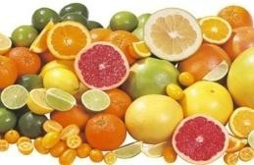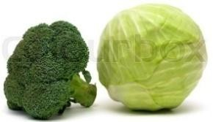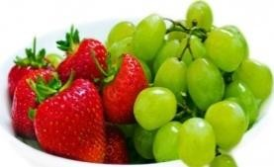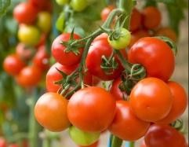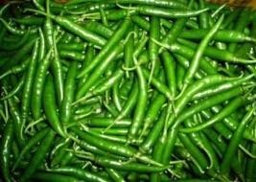

|  |  |  |  |  |
| --- | --- | --- | --- | --- |
| Citrus fruits | Broccoli, Cabbage | Berries, Gapes | Tomatoes | Green papers |

### Functions

* + - 1. Acts as antioxidant.
      2. Enhances iron absorption from nonheme sources (e.g., plant sources).
      3. Enhances immune function.
      4. Promotes wound healing.
      5. Promotes the formation of new blood vessels.
      6. Helps in excreting harmful chemical.

### Deficiency diseases

* + - 1. Deficiency of vitamin C leads to scurvy which is characterized by gingivitis (soft, bleeding, and swollen gums, loose teeth); flesh that is easily bruised; hemorrhages under the skin; delaying wound healing; sore joints and muscles; and weight loss.
      2. 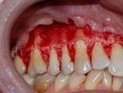Retardation in growth.
      3. Anemia, bone pain and fractures.

### Hypervitaminosis

Excessive doses can cause kidney stones and break down red blood cells

### Risk groups of vitamin C deficiency

Those populations do not eat fresh fruits and vegetables or

those rely entirely on inadequate ration are at risk of vitamin C deficiency.

Scurvy

* 1. **Vitamin B1**

**8.3.1 Sources**

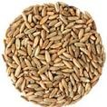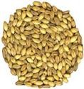**Plant sources**

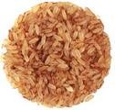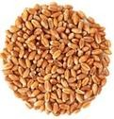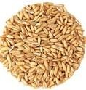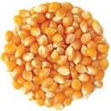

|  |  |  |  |  |  |
| --- | --- | --- | --- | --- | --- |
| Unpolished rice | Whole wheat | Oats | Corn | Rye | Barley |
| **8.3.2 Animal sources** | |  |  |  |  |

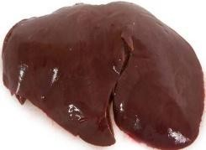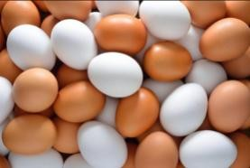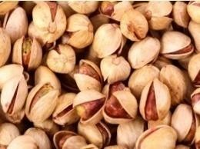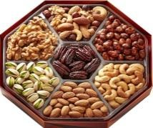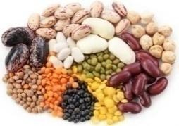

|  |  |  |  |  |
| --- | --- | --- | --- | --- |
| Liver | Eggs | Seeds | Nuts | Legumes |

### Functions

* + - 1. It is essential for the metabolism of carbohydrates and some amino acids.
      2. It is also essential for nerve and muscle function.

### Deficiency diseases

Deficiency symptoms include loss of appetite, fatigue, nervous irritability, and constipation. An extreme deficiency causes beriberi. There are three types of beriberi-

### Dry Beriberi -Peripheral neuropathy

* + Difficulty in walking.
  + Burning sensation in the feet.
  + Loss of feeling (sensation) in hands.
  + Paralysis of the lower legs.
  + Calf muscle tenderness.
  + Tingling, ataxia

### Wet Beriberi-Cardiopathy

* + Edema (swelling) of lower legs, trunk and face
  + Increase heart rate and enlargement of heart

|  |  |
| --- | --- |
| Dry beriberi | Wet beriberi |

* + Congestive heart failure (cause of death)

1. **Infantile beriberi-**Sudden onset of shock which is preceded by a hoarse, week cry; poor feeding; and vomiting.

### Risk groups of vitamin B1 deficiency:

* Consuming diets rich in anti-thiamine factors, such as sulphites (added in food processing), thiaminase (found in raw fish and shellfish) and phytic acid (found in betel nuts).
* Consuming polished rice as a staple food which has not been parboiled.
* Breastfed babies whose mothers are in deficiency of vitamin B1.

### Vitamin B2

* + 1. **Sources**

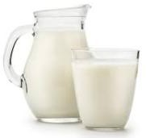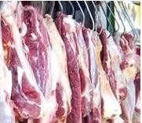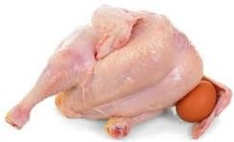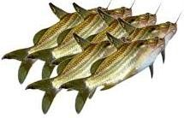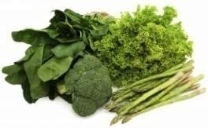Riboflavin is found in small amount in animal and plant foods. Some sources are-

|  |  |  |  |  |
| --- | --- | --- | --- | --- |
| Milk | Meat | Poultry | Fish | Green vegetables |

### Functions

* + - 1. Essential as co-enzymes for carbohydrates, proteins and fats metabolism
      2. Necessary for tissue maintenance, especially the skin around the mouth and for healthy eyes.

### Deficiency symptoms

A deficiency of riboflavin may lead to cheilosis, a condition characterized by

* sores on the lips
* cracks at the corners of the mouth
* glossitis (inflammation of the tongue),
* dermatitis, and
* eye strain in the form of itching, burning.

### Vitamin B3 or Niacin

* + 1. **Sources**

The best sources of niacin are meats, poultry, fish, peanuts and legumes. Milk and eggs provide good sources of its precursor, tryptophan (an amino acid). Vegetables and fruits contain little niacin.

### Functions

☞ Helps in energy metabolism by acting as coenzymes.

☞ Inhibits production of cholesterol.

☞ Assists in triglyceride breakdown.

### Deficiency diseases

Serious deficiency of niacin leads to pellagra (an Italian word meaning rough skin) commonly referred to as 4 Ds (dermatitis, diarrhea, dementia and death). Pellagra is also associated with deficiency of tryptophan and other B vitamins.

### Dermatitis-

* 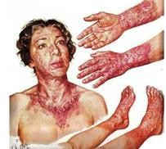Symmetrical distribution of skin lesions on the direct sunlight exposed parts. The lesions with erythema look like sunburn. There is a clear demarcation zone between the normal skin and pellagra dermatitis affected skin.

**Diarrhea**- Increased frequency and fluidity of the stools, often with blood and mucus.

**Dementia** (Neurological disorder) symptoms include

* + Anxiety (fear and worry)
  + Irritability (respond or reaction to stimulus)
  + Poor memory, Insomnia (sleeplessness).
  + Headaches
  + Restlessness

**Death**-If not treated.

### Risk groups of niacin deficiency

Fig. Symptoms of pellagra

* Those people eating maize as staple food without cooking with lime water or alkali.
* People solely rely on ration which contains inadequate niacin.

### Vitamin B5 or Pantothenic acid

* + 1. **Sources**

Pantothenic acid is mainly found in animal foods such as meats, poultry, fish, and eggs. It is also found in whole-grain and legumes. In addition, it is thought to be synthesized by the body.

### Functions

☞ Takes part in metabolism of carbohydrates, fats, and proteins.

☞ Helps synthesis of the neurotransmitter (acetylcholine) and steroid hormones.

☞ Improves human skin and hair

### Deficiency symptoms

Vitamin B5 deficiency is exceptionally rare. Signs and symptoms include fatigue, irritability, numbness, muscle pain, and cramps

### Vitamin B6 or Pyridoxine

* + 1. **Sources**

Some of the pyridoxine dense foods are-

|  |  |  |  |  |
| --- | --- | --- | --- | --- |
|  |  |  |  |  |
| Poultry | Fish | Liver | Kidney | Potatoes |
| Whole oats | Whole wheat | Bananas | Spinach |  |

### Functions

**** Helps in protein metabolism and absorption.

**** Aids in releasing glucose from glycogen.

**** Acts as a catalyst in converting tryptophan to niacin.

**** Helps in synthesis of hemoglobin and neurotransmitters such as serotonin and dopamine.

### Deficiency symptoms

* Muscle weakness, dermatitis, mouth sores, fatigue, and confusion;
* Anemia (RBCs size is normal or somewhat smaller but the hemoglobin content is lower).

### Vitamin B7 or Biotin

**8.8.1. Sources:** The best dietary sources of biotin are egg yolks, milk, poultry, fish, broccoli, spinach, and cauliflower.

### Functions

* + - * Helps in lipid metabolism.
      * Helps in the synthesis of glucose and some nonessential amino acids.

### Deficiency symptoms

Symptoms of biotin deficiency are similar to those of other B vitamins, but may also include hair loss when severe.

### Vitamin B9 or Folic acid/Folate

* + 1. 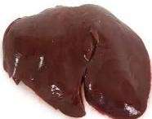**Sources**

|  |  |  |  |  |
| --- | --- | --- | --- | --- |
|  |  |  |  |  |
| Green leafy veg. | Legumes | Sunflower seeds | Citrus fruits | Liver |

* + 1. **Functions**

☞ Helps in synthesis of DNA and thus production of new cells, including red blood cells.

☞ Prevention of malformation of the neural tube (the tissue in a fetus, from which the brain and spinal cord develop)

☞ Synthesis of the amino acids

☞ Lower blood homocysteine levels by converting homocysteine to methionine.

☞ Regulate gene expression.

### Deficiency diseases

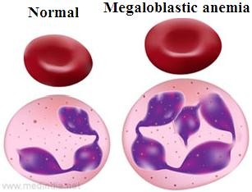

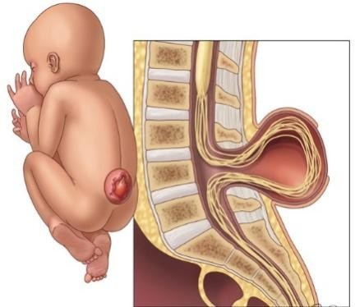

Fig. Spina bifida

* Causes megaloblastic anemia where immature and large RBCs circulate in the bloodstream.
* Deficiency during the early weeks of pregnancy causes neural tube defects which leads to anencephaly (the brain fails to develop normally) and spina bifida (abnormal development of the lower spinal cord).
* Increases homocysteine levels in blood which causes atherosclerosis and thereby increased risk of heart attack

and stroke.

* May lead to silent gene expression; it may cause to develop cancer.

### 8.9.3 Risk groups of folate/folic deficiency

Those having high demand but consume less folate containing foods such as infants, adolescents, pregnant and lactating mothers.

### Vitamin B12 or Cyanocobalamin

* + 1. **Sources**

The best food sources of B12 are animal foods, especially

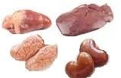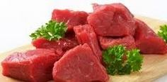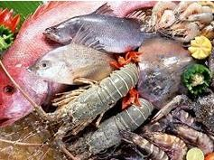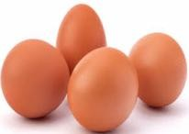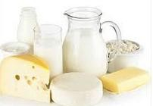

|  |  |  |  |  |
| --- | --- | --- | --- | --- |
| Organ meats | Lean meat | Seafood | Eggs | Dairy products |

### Functions

☞ Assists with formation of blood.

☞ Required for healthy nervous system function.

☞ Involved as enzyme cofactor in metabolism of homocysteine.

### Deficiency diseases

Megaloblastic anemia (an abnormally big of red blood cell) (megaloblast).

### Risk groups of vitamin B12 deficiency

Vitamin B12 is only found in animal foods. Those who are strictly vegan may have chance to develop deficiency.

**Table 8.1.** Recommended dietary allowances of water-soluble vitamins per day.

|  |  |  |  |  |  |  |  |  |
| --- | --- | --- | --- | --- | --- | --- | --- | --- |
| Types | Age  (years) | Vit. C | Vit. B1 | Vit. B2 | Niacin | Vit. B6 | Folate | Vit. B12 |
| (mg) | (mg) | (mg) | (mg) | (mg) | (µg) | (µg) |
| New born | 0 to 0.5  0.6 to 1 | 30  35 | 0.3  0.4 | 0.4  0.5 | 5  6 | 0.3  0.6 | 25  35 | 0.3  0.5 |
| Children | 1 to3  4 to 6  7 to10 | 40  45  45 | 0.7  0.9  1 | 0.8  1.1  1.2 | 9  12  13 | 1  1.1  1.4 | 50  75  100 | 0.7  1  1.4 |
| Man | 11 to 14  15 to 18  19 to 24  25 to 50  51+ | 50  60  60  60  60 | 1.3  1.5  1.5  1.5  1.2 | 1.5  1.8  1.7  1.7  1.4 | 17  20  19  19  15 | 1.7  2  2  2  2 | 150  200  200  200  150 | 2  2  2  2  2 |
| Woman | 11 to 14  15 to 18  19 to 24  25 to 50 | 50  60  60  60 | 1.1  1.1  1.1  1.1 | 1.3  1.3  1.3  1.3 | 15  15  15  15 | 1.4  1.5  1.6  1.6 | 180  180  180  180 | 2  2  2  2 |

|  |  |  |  |  |  |  |  |  |
| --- | --- | --- | --- | --- | --- | --- | --- | --- |
|  | 51+ | 60 | 1 | 1.2 | 13 | 1.6 | 180 | 2 |
| Pregnant |  | 70 | 1.5 | 1.6 | 17 | 2.2 | 400 | 2 |
| Lactating  Mother | 1-6 mon.  7-12 mon. | 95  90 | 1.6  1.6 | 1.8  1.7 | 20  20 | 2.1  2.1 | 280  260 | 2.6  2.6 |

### Study skillsEvaluation at the end of the lesson:

**Short Questions:**

* + - 1. Define vitamin.
      2. Classify vitamin.
      3. Describe sources, functions and deficiency diseases of vitamin C.
      4. Describe sources, functions and deficiency diseases of vitamin B1.
      5. Describe sources, functions and deficiency diseases of vitamins B2, B3 and B6.
      6. Describe sources, functions and deficiency diseases of folic acid.
      7. Describe sources, functions and deficiency diseases of vitamin B12.