BLOOD SYSTEM
# Blood
Blood is specialized fluid connective tissue in which there is liquid intracellular substance (plasma) and formed elements – (RBC, WBC and Platelets) suspended in the plasma. It is red, thick and slightly alkaline.
# Composition of blood
- Cellular substances: 45% (42-45%)
  - Erythrocytes(RBC)
  - Leucocytes (WBC)
iii) Platelets (thrombocytes)
- Liquid intracellular substances: Plasma 55% (55-58%)
  - Liquid: 91-92% water
  - ii) Solid: 8-9%
  - Inorganic substances (0.9%): Na, K, Ca, Mg, P, Fe, Cu
  - Organic constituents:
- Proteins- 7.5%: serum albumin, serum globulin, fibrinogen and prothrombin
ii. Non-protein nitrogenous substances: urea, uric acid, xanthine, hypoxanthine, creatine, ammonia, amino acids
  - Fats: Neutral fats, phospholipids, cholesterol.
  - Carbohydrates: Glucose, sucrose
  - Others: antibodies, enzymes
  - Coloring materials: bilirubin, carotene and xanthophyllin.
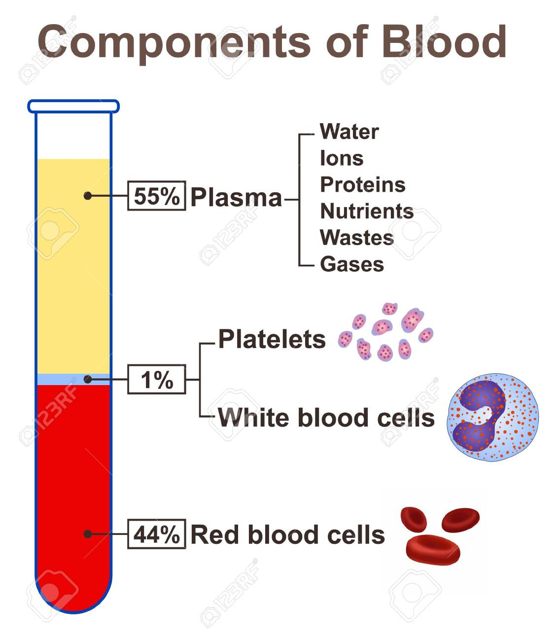
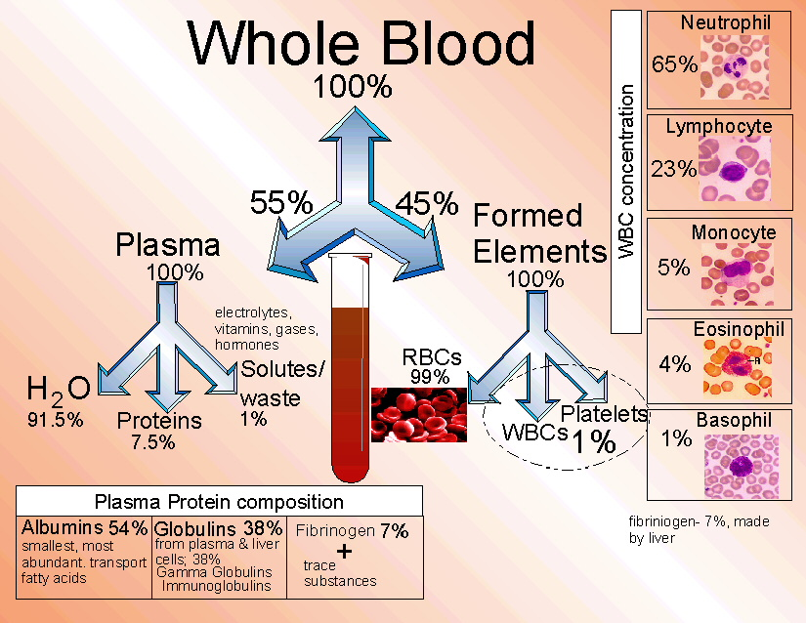
# Properties of blood
i) Blood volume: 5-6 liters ii) Normal reaction: slightly alkaline, pH 7.36-7.45 iii) Specific gravity: 1.052-1.060 iv) Viscosity: 4.5 times more viscous than water v) Temperature: 36-38⁰c vi) Osmotic pressure: 25 mm Hg vii) Taste: Salty viii) Color: Red, due to presence of Hemoglobin in RBC.
# Functions of blood
- Transport of respiratory gases
It carries O2 from alveoli of the lungs to the tissues and eliminates CO2 from the tissues to the alveoli of the lungs.
- Transports of nutrients
It carries digestive food materials absorbed by the intestine to the tissue cells.
- Acts as vehicles
Hormone, enzyme, vitamin and other chemical are brought to their places of activity through blood stream.
- Regulation of body temperature
It regulates the body temperature as it contains huge amount of water.
- Regulation of water and electrolytes balances it maintains the normal body water and electrolyte balance.
- Maintenance of acid base balance
By effective buffering power and with the help of kidney, skin and lungs blood maintain acid base regulation.
- Defensive function
WBC by its phagocytotic property, engulf bacteria and foreign particles.
- Excretory function
The metabolic end product and other waste products are carried out by blood to the organ.
- Regulation of blood pressure
By changing the volume and viscosity of blood, it regulates the blood pressure.
# Plasma
The fluid portion containing ions, inorganic and organic molecules are called plasma. The normal plasma volume is about 7 % of body weight or roughly 3500 mL in a 70 Kg man.
Plasma proteins with their percentage is indicated below;
  - Albumin (60%), Globulin (35%), Fibrinogen (4%), Regulatory proteins, lipoproteins and iron binding proteins (1%)

# Serum
After clotting, the remaining fluid potion of plasma except the clotting factor (fibrinogen, clotting factor 2, 4 and 8) is called serum. It contains high amount of serotonin.

# Plasma and serum
Serum | Plasma
Serum is the extracellular portion of blood after adequate coagulation is complete. | Plasma is a clear, straw-colored watery portion of the blood in which several types of blood cells are suspended.
Serum is part of blood which lack clotting factor. | Plasma is composed of serum and clotting factor.
Acquired after centrifuging of coagulated blood. | Acquired after centrifuging blood with anticoagulant.
Anticoagulant are not needed to separate the serum. | Anticoagulant are required to get plasma.
Less volume in comparison to plasma.
[Plasma – Fibrinogen (Clotting factor)=  Serum] | Consists 55% of total volume of blood.
Difficult to separate and is time consuming. | Comparatively easier and less time consuming than serum.
Lack fibrinogen. | Contain fibrinogen.
Consists 90% water with dissolved proteins, minerals, hormones and carbon dioxide. | Consists ~92% water with Proteins, Salts, Lipids, Glucose.
Density of serum is 1.024g/ml. | Density of plasma is 1.025g/ml.
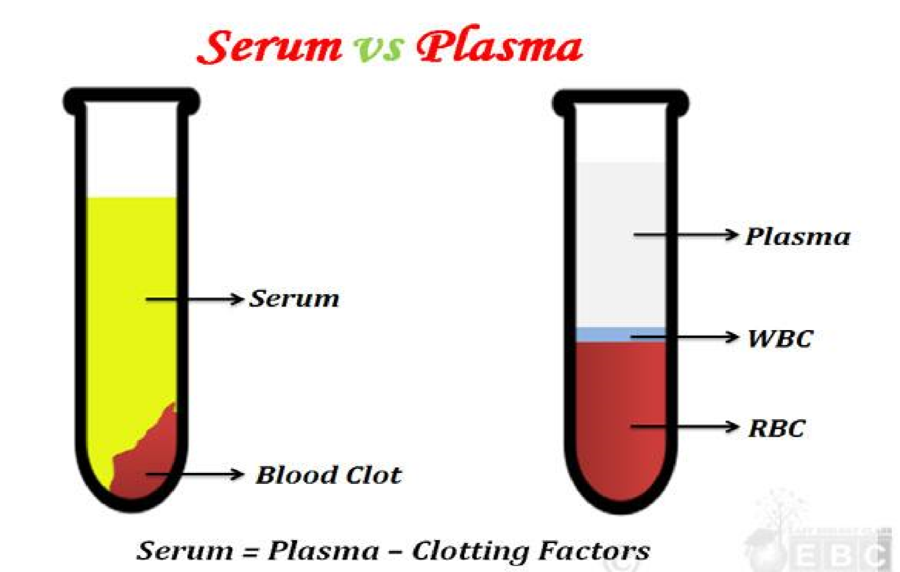
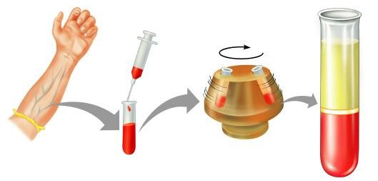
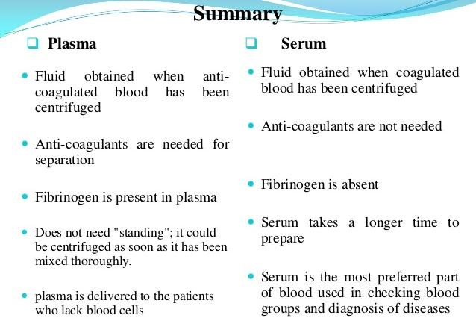
# Plasma protein
The protein which remain in plasma is known as plasma protein. Total normal serum values of plasma protein are 6-8 g/dL.
# Types of plasma protein
  - Albumin: 3.1-4.3 g/dl
  - Globulin: 2.6-4.1 g/dl
    - α1 Globulin
    - α2 Globulin
    - β Globulin
    - γ Globulin (Immunoglobulin) (IgG, IgA, IgM, IgD, IgE )
  - Fibrinogen: 200-450 mf/dl
  - Prothrombin
  - Others:
  - Angiotensinogen
  - Transferrin
  - Cerulo-plasmin
  - Thromboplastin

#Albumin
The albumins are a family of globular proteins, the most common of which are the serum albumins. All the proteins of the albumin family are water-soluble, moderately soluble in concentrated salt solutions. Albumins are commonly found in blood plasma.

Serum albumin is the most abundant blood plasma protein and is produced in the liver and forms a large proportion of all plasma protein. The human serum albumin normally constitutes about 50% of human plasma protein.
- Synthesis of albumin decrease: during starvation
- Synthesis of albumin increase: during nephrosis

Functions:
- Maintain colloidal osmotic pressure (75-80% of total blood)
- Act as carrier and binding protein
- Transport hormone, amino acids, lipids, bilirubin, vitamin and drugs
- Maintain viscosity of blood
- Act as acid base balance regulator
- Acts as protein reservoir.
# Globulin
The globulins are a family of globular proteins that have higher molecular weights than albumins and are insoluble in pure water but dissolve in dilute salt solutions. Some globulins are produced in the liver, while others are made by the immune system.
- Site of formation: Liver, plasma cell and lymphoid nodules
- Classification: α1 Globulin, α2 Globulin, β Globulin, γ Globulin (Immunoglobulin)
Functions:
- It maintains 20% of total colloidal osmotic pressure of blood.
- Helps to maintain viscosity of blood.
- α1 transport lipid and steroids
- α2 transport Cu as ceruloplasmin
- β transports Fe as transferrin and helps in blood clotting
- γ (gama) helps in formation of antibodies.
# Functions of plasma protein
- Role in coagulation of blood
Fibrinogen is essential for the coagulation of blood. During coagulation of blood, the fibrinogen is converted into fibrin.

- Role in defense mechanism of body
The gamma globulins play an important role in the defense mechanism of the body by acting as antibodies (immune substances).
- Role in transport mechanism
Plasma proteins are essential for the transport of various substances like hormone, enzymes and respiratory gases in the blood.
- Role in maintenance of pressure in blood
Because of their large size, the plasma proteins cannot pass through the capillary membrane easily and remain in the blood. In this way, the plasma proteins play an important role in the maintenance of osmotic pressure of blood.
- Role in regulation of acid base balance
Plasma proteins, particularly the albumin, play an important role in regulating the acid base balance in the blood. This is because of the virtue of their buffering action
- Role in viscosity of blood
The plasma proteins provide viscosity to the blood, which is important to maintain the blood pressure.
- Role in suspension stability of red blood cells
During circulation, the red blood cells remain suspended uniformly in the blood. Globulin and fibrinogen help in the suspension stability of the red blood cells.
- Role as reserve proteins
During the conditions like fasting, the plasma proteins are utilized by the body tissues. Because of this, the plasma proteins are called the reserve proteins.

# Haemopoiesis
Haematopoiesis or haemopoiesis is the formation of blood cellular components. All cellular blood components are derived from haematopoietic stem cells. In a healthy adult person, approximately 10¹¹–10¹² new blood cells are produced daily in order to maintain steady state levels in the circulation.
Types:
  - Medullary: Production of blood cells in the hematopoietic tissue of bone marrow.
  - Extra-medullary: Production of blood cells in organs (Liver, spleen and lymph nodes) other than bone marrow in certain disorder like hemorrhage.
Site of formation:
  - Intra-uterine life
    - 1st – 2nd month: yolk sac
ii) 3rd -7th month: liver and spleen
iii) 5th – birth: bone marrow, liver, spleen and lymph nodes.
  - Extra-uterine life:
    - RBC, granulocytes and platelets: Bone marrow ii) Lymphocytes: Lymph nodes and bone marrow iii) Monocytes: Bone marrow and spleen.

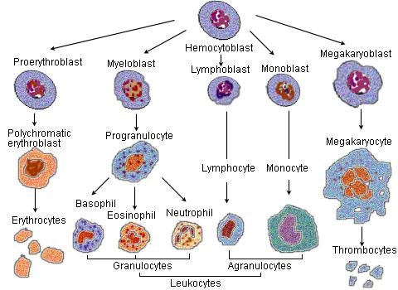

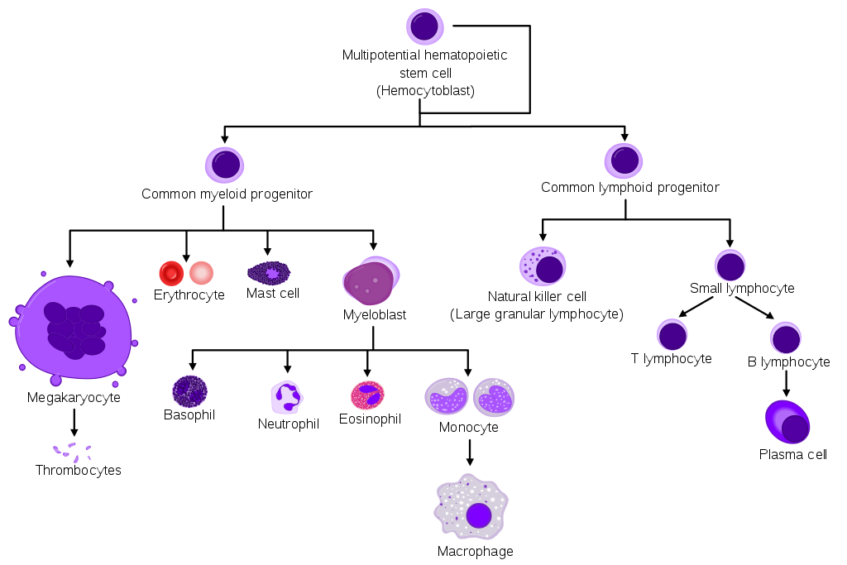
ERYTHROPOIESIS –STAGES
  - Haemocytoblast
  - Proerythroblast
  - Early erythroblast
  - Late erythroblast
  - Normoblast
  - Reticulocyte
  - Normal Erythrocyte
Erythropoiesis is a highly regulated, multistep process by which the body generates mature RBC.

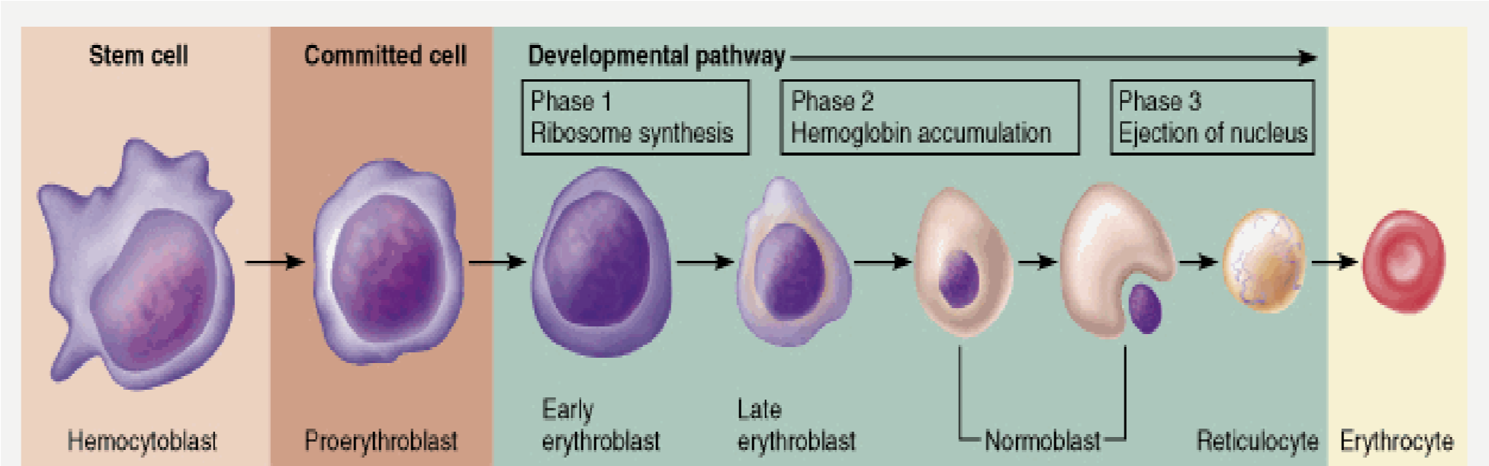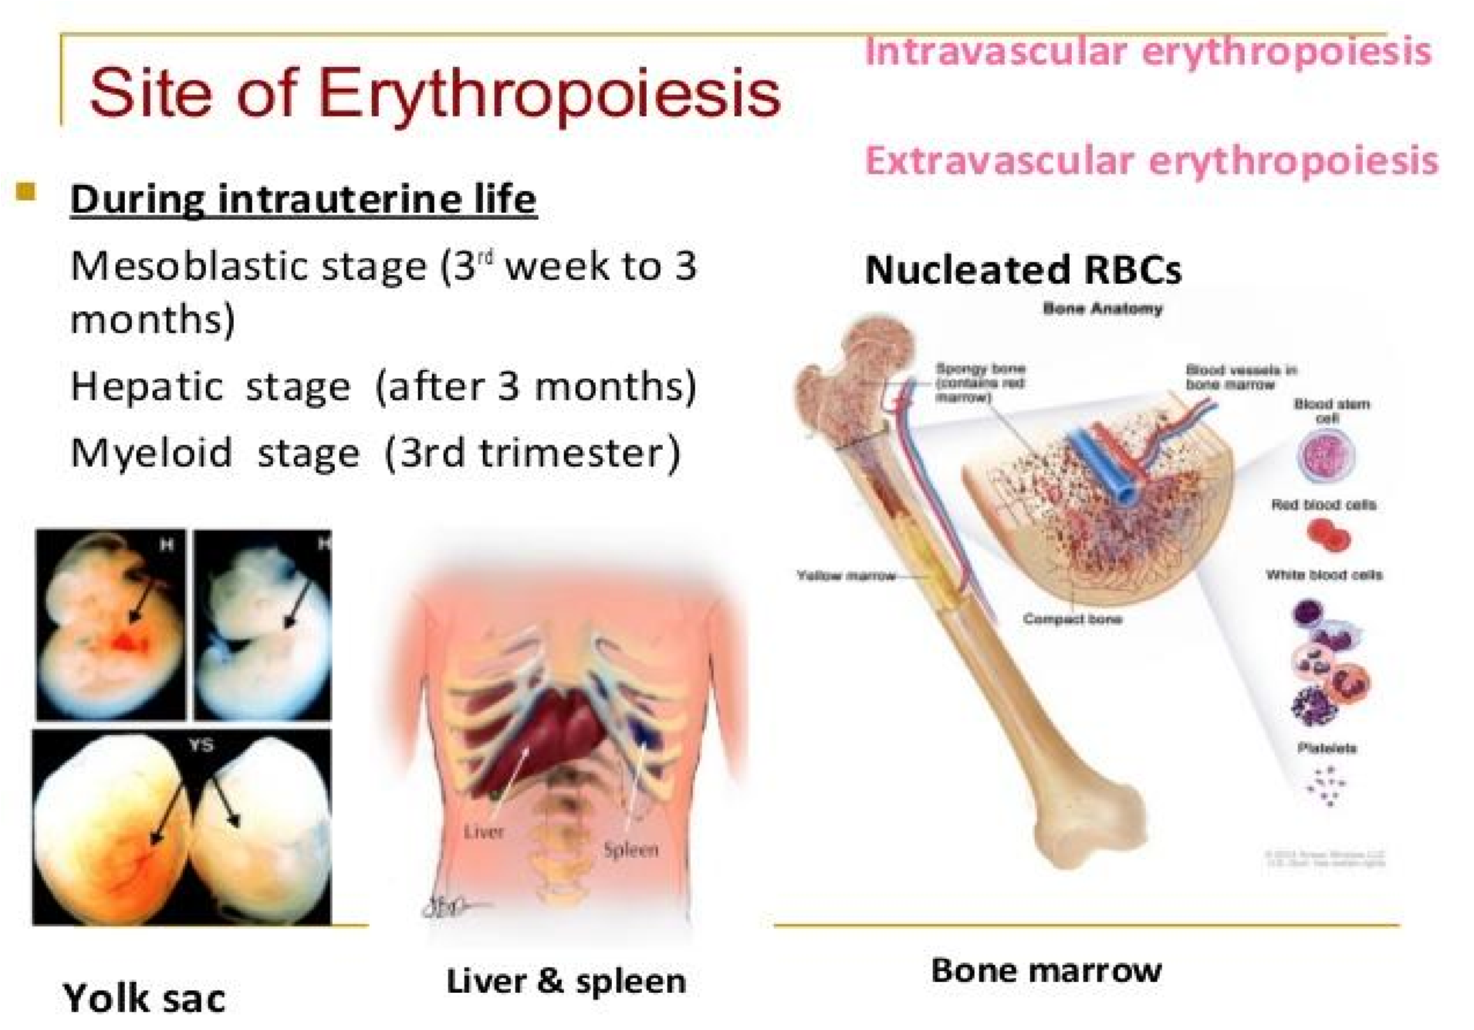
.

# Erythropoietin
Erythropoietin (EPO) is a hormone (glycoprotein) produced by the kidney that promotes the formation of red blood cells by the bone marrow. The kidney cells that make erythropoietin are sensitive to low oxygen levels in the blood. These cells make and release erythropoietin when the oxygen level is too low (anemia). These hormones then promote the bone marrow to produce more RBC in the blood.
# Functions
- Erythropoietin is an essential hormone for red blood cell production under the hypoxic conditions.
- Vasoconstriction-dependent hypertension
Stimulating angiogenesis (formation of new blood vessels
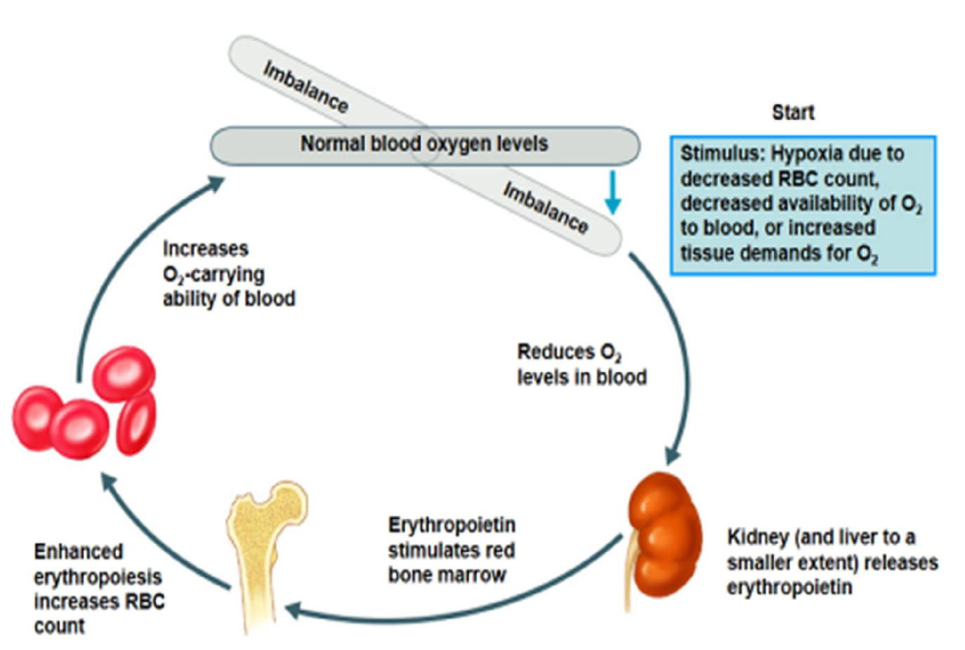
# Factors affecting erythropoiesis
- Decreased oxygen supply to tissue (hypoxia)
- High dietary factors (Protein) for RBC synthesis
- Metal ions
  - Iron
  - Copper
  - Cobalt
- Vitamin C, B12 and folic acid
- Hormones
- Androgens Glucocorticoids
- Pituitary Thyroid
# Red Blood Cell (Erythrocyte)
Red blood cells (RBCs), also called erythrocytes, are the most common type of blood cell and the vertebrate's principal means of delivering oxygen (O2) to the body tissues—via the circulatory system.
  - In humans, mature red blood cells are flexible and oval biconcave disks.
  - They lack a cell nucleus, in order to accommodate maximum space for hemoglobin.
  - Approximately 2.4 million new erythrocytes are produced per second in human adults.
  - The cells develop in the bone marrow.
  - Circulate for about 100–120 days in the body before their components are recycled by macrophages.
  - Each circulation takes about 60 seconds.
  - Nearly half of the blood's volume (40% to 45%) is red blood cells.
Composition of RBC
  - Water: 65%
  - Solid: 35%
      - Hemoglobin: 33%
      - Stromal mash: 2% (Protein, phospholipid, cholesterol. Ester and neutral fat)
Morphology of RBC
    - Shape and size: Bi-concave
    - Thickness: at center 1µm or less and at margin 2.5µm.
    - Diameter: 7.8 µm
    - Surface area: 120-140 sq.µ
    - Volume: 90-95 cubic µ VI. Life span: 120 days
Normal count of RBC
  - Adult male: 4.5-5.5 million/mcL of blood
  - Adult female: 4.0-5.0 million//mcL of blood
III. Infants: 6-7 million//mcL of blood Structure
  - Inner: Stroma, containing hemoglobin
  - Outer: cell membrane (Composed of two layer)
      - Stromatin layer by protein
      - Inulin layer by phospholipid, cholesterol and carbohydrate
Function
I. Respiratory functions
RBC contain Hb which carry O2 from lungs to the tissue and CO2 from the tissue to lungs.
II. Acid base regulation
Helps to maintain acid base balance, by buffering action of Hb.
III. Ion balance
By cell membrane, it helps to maintain intercellular ion balance.
IV. Maintenance of viscosity
Helps to maintain viscosity of blood.
V. Various pigment are derived from Hb after the disintegration of RBC, like bilirubin.
VI. It contains antigen.

# Hemoglobin
It is a conjugated protein or metaloporphyrin. Hemoglobin is the protein molecule in red blood cells that carries oxygen from the lungs to the body's tissues and returns carbon dioxide from the tissues back to the lungs.
Structure
  - Hemoglobin is made up of four protein molecules (globulin chains) that are connected together.
  - The normal adult hemoglobin molecule contains two alpha-globulin chains and two beta globulin chains.
  - In fetuses and infants, hemoglobin molecule is made up of two alpha chains and two gamma chains. As the infant grows, the gamma chains are gradually replaced by beta chains, forming the adult hemoglobin structure.
  - Each globulin chain contains an important iron-containing porphyrin compound termed heme.
  - Embedded within the heme compound is an iron atom that is vital in transporting oxygen and carbon dioxide in our blood.
  - The iron contained in hemoglobin is also responsible for the red color of blood.
  - Hemoglobin also plays an important role in maintaining the shape of the red blood cells.
  - The chromoprotein consist of two parts: Globulin 96% and Heam 4%.
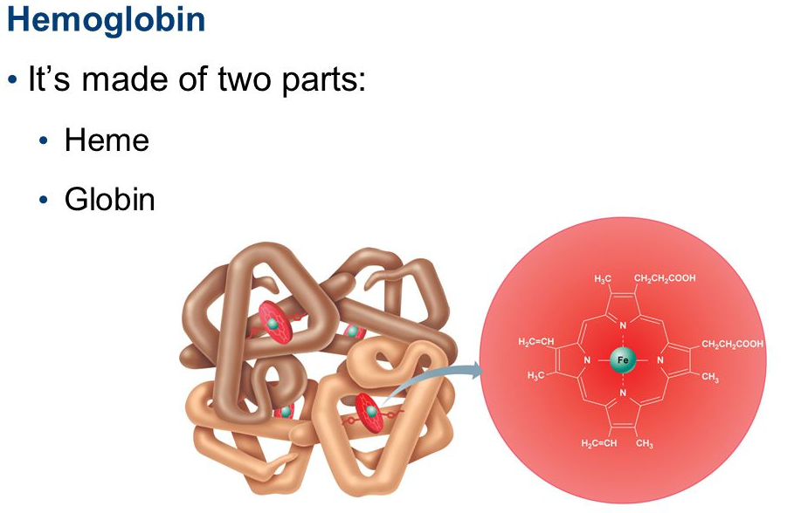
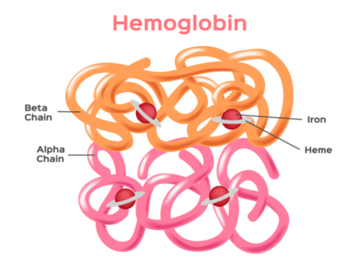
Normal count:
  - Male: 14-18 gm/100 ml of blood.
  - Female: 12-15.5 gm/100 ml of blood.
  - At birth: 23 gm/100 ml.

Functions
I. Respiratory functions
Hb carries O2 from lungs to the tissue and CO2 from the tissue to lungs.
II. Acid base regulation
Helps to maintain acid base balance with buffering action of Hb.
III. It reserve iron and protein
IV. Various pigment are derived from Hb like bile, stool and urine.

Synthesis
1. Heam portion
- During the krebs cycle, acetyl CoA is changed into succinyl Co-A through a series of reactions.
- Two molecule of succinyl Co-A is combined with two molecule of glycine and form a pyrole compound.
- In turn, four pyrrole compounds combine to form a protoporphyrin compound.
- One of the protoporphyrin compound, called protoporphyrin 1X, then combined with iron to form the heam molecule.

2. Globin portion
- It is composed of four large polypeptide chains, synthesized by the ribosome.
Finally, each heam molecule combines with a very long peptide chain (globin) forming a subunit of hemoglobin, called hemoglobin chain.

Types of hemoglobin
There are two types of variation in Hb, which is only in globin and heam portion is same.
- Physiological variation
  - Hemoglobin A (Hb A1)
It contains 2α and 2β chain of globin. More than 98% in normal adult.
  - Hemoglobin A2 (Hb A2)
It contains 2α and 2δ, where there is a difference between 10 amino acids. Only 2% found in normal adult.
  - Hemoglobin F (Hb F)
It contains 2α and 2δ, where there is a difference between 37 amino acids. Found in fetus.
- Pathological variation
  - Hb S or sickle cell hemoglobin.
  - Hb C or Hemoglobin C
  - Hb M or hemoglobin M.
#White blood corpuscle (Leukocyte)
WBC are the nucleated colorless cells of blood and are the mobile unit of the body’s protective system. It is also called leukocytes or leucocyte. All white blood cells are produced and derived from multipotent cells in the bone marrow known as hematopoietic stem cells. All white blood cells have nuclei, which distinguishes them from the other blood cells, like red blood cells (RBCs) and platelets. Morphology
    - Normal size: 10-20 µm
    - Normal counts: 4000-11000 µL/ of blood
    - Life span: Few hours to few days 4. Production: In bone marrow, spleen.
Functions
  - Phagocytosis
By this process, WBC engulf the bacteria and foreign particles.
  - Antibody formation
They produce antibody and play an important role in defensive mechanism.
  - Secretion of heparin
Basophil secrets heparin, that prevent the intravascular clotting.
  - Formation of fibroblasts
They converted into fibroblast at the affected area to accelerate the repair.
  - Anti-histamine functions
Eosinophil produce 5HT that has an anti-histamine property.
  - Chemotaxis
They have a chemotactic property to migrate out of the vessels.
  - Act as scavengers
By removing debris of dead tissues, they do the job of scavengers.

# Types of WBC
On the basis of granule presence or absent, WBC can be divided into two types:
  - Granulocytes
      - Neutrophils
      - Eosinophils
      - Basophils
  - Agranulocytes
      - Lymphocytes
      - Monocytes

# Neutrophils
Characteristic
  - Neutrophils are the most abundant type of granulocytes.
  - It is also the most abundant (40% to 75%) type of white blood cells in most mammals.
  - They are formed from stem cells in the bone marrow.
  - They are short-lived (average 6 hours) and highly mobile.
  - They are radish brown or violet in color.
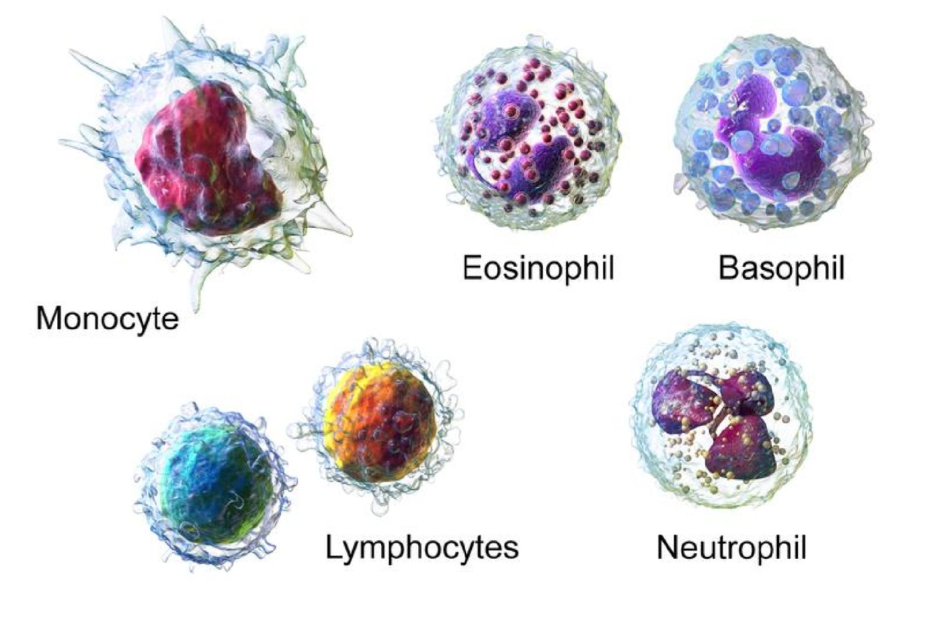
Functions
  - They engulf bacteria by phagocytic activity
  - They secrete proteolytic enzyme that degrade ingested particles protein
  - They have chemotactic properties
  - They act as first line defense mechanism against bacteria
# Eosinophil
Characteristic
  - Eosinophils, sometimes called eosinophiles or, less commonly, acidophils
  - They are granulocytes that develop during hematopoiesis in the bone marrow before migrating into blood.
  - These cells are acid-loving.
  - Normally transparent, but after staining with eosin, they appear brick-red.
  - It makes up about 1–6% of white blood cells
  - Eosinophils persist in the circulation for 8–12 hours.
Functions
  - Detoxify foreign particles
  - Collect at the sight of allergic reaction
  - Inhibit antigen-antibody reaction
  - Important for the dissolution of old clot

# Basophil
Characteristic
  - Basophils are a type of white blood cells.
  - They are the least common of the granulocytes, representing about 0.5 to 1% of circulating white blood cells.
  - They are the largest type of granulocyte.
Functions
  - They are responsible for inflammatory reactions during immune response.
  - They can perform phagocytosis (cell eating)
  - They produce histamine and serotonin that induce inflammation, and heparin prevents blood clotting also.
# Lymphocyte
Characteristics
  - A lymphocyte is one of the subtypes of white blood cell.
  - They are agranulocytes.
  - They are basically found in lymph.
  - In human adults’ lymphocytes make up roughly 20 to 40 percent of the total number of white blood cells.
  - There are three types of lymphocytes: natural killer cells (function in cell-mediated, cytotoxic innate immunity), T cells (for cell-mediated, cytotoxic adaptive immunity), and B cells (for humoral, antibody-driven adaptive immunity).

Functions
  - Carries antibody
  - They give rise to monocytes and plasma cell.
  - They take part in immune system
  - They can convert to fibroblast & repair tissue damage
# Monocytes
Characteristic
    - Monocytes are a type of white blood cell, or leukocyte.
    - They are the largest type of leukocyte.
    - Originally formed in the bone marrow and they are released into our blood and tissues.
    - When certain germs enter the body, they quickly rush to the site for attack.

Functions
  - Monocytes have the ability to change into another cell form called macrophages before facing the germs.
  - Monocytes help other white blood cells identify the type of germs that have invaded the body.
  - They remove dead cells from the sites of infection.

#Platelets (Thrombocytes)
Platelets, also called thrombocytes, are a component of blood whose function is to stop bleeding. Platelets have no cell nucleus. They are derived from the megakaryocytes of the bone marrow, and then enter the circulation. Their normal count is 1.5-3.0 lacs / cu mm of blood. The normal life span is about 8 to 12 days. Platelets are lens-shaped structures and 2–3 µm in diameter. Platelets are found only in mammals.

Functions:
  - Vasoconstriction through release of 5HT
  - Formation of platelet plug to prevent bleeding (Hemostasis)
  - Formation of prothrombin activator and help in coagulation
  - Initiate the blood clotting
  - Repair the damaged capillary endothelium
  - Helps in defensive mechanism.

# ESR (Erythrocytic sedimentation rate)
When the blood is mixed with a suitable anticoagulant and is made to stand vertically, red blood corpuscles settle down to the bottom. The rate, at which this sedimentation of RBC take place is known as ESR.
Normal count
1. Western Method:
        - Male: 0-6 mm in 1st Hour
        - Female: 0-12 mm in 1st hour 2. Wintrobe method:
        - Male: 0-12 mm in 1st hour
        - Female: 0-18 mm in 1st hour
Importance
  - To see the prognosis of diseases
  - To assay the condition of some chronic inflammatory diseases, like
      - Pulmonary tuberculosis
      - Pulmonary embolism
      - Myocardial infraction
      - Coronary thrombosis
      - Rheumatic arthritis
      - Carcinoma
  - To see the therapeutic effect of drugs.
ESR increases in: ESR decreases in:
      - During pregnancy 1. Dehydration
      - Tuberculosis 2. High red blood cell count (polycythemia)
      - Rheumatic arthritis 3. High white blood cell count (leukocytosis)
      - Chronic inflammation 4. Sickle cell anemia
      - Hemorrhage
      - Tissue necrosis
Hematological Disorders
# Anemia
Anemia is a condition that develops when blood lacks enough healthy red blood cells or hemoglobin. With too few or abnormal red blood cells or hemoglobin, the cells will not get enough oxygen.
Causes
  - Excessive blood loss due to acute or chronic hemorrhage
  - Destruction of bone marrow
  - Reduced production of RBC due to lack of factors necessary for RBC production. 4. Chronic gastrointestinal hemorrhage: ulcer, gastritis, cancer
  - Use of excessive amount of aspirin like NSAID drugs.
  - Menstruation and child birth
Types of anemia:
    - Iron deficiency anemia
    - Aplastic anemia
    - Megaloblastic anemia
    - Hemolytic anemia
    - Pernicious anemia
    - Sickle cell anemia
Symptoms
Headache | Shortness of breath
Weakness | Dizziness or lightheadedness
Fatigue | Chest pain
Irregular heartbeats | Cold hands and feet
Pale or yellowish skin

# Iron deficiency anemia
When the supply of iron to the bone marrow is insufficient for the requirements of Hb synthesis, iron deficiency anemia takes places. It is the most common type of anemia. When there isn’t enough iron in blood stream, the rest of body can’t get the amount of oxygen it needs.
Symptoms
Headache | Shortness of breath
Weakness | Dizziness or lightheadedness
Fatigue | Chest pain
Irregular heartbeats | Cold hands and feet
Pale or yellowish skin | Brittle nails

Causes:
  - Inadequate iron intake
  - Pregnancy or blood loss due to menstruation
  - Internal bleeding
  - Inability to absorb iron
Diagnosis
  - Complete blood count (CBC)
  - Iron level in blood
  - Total Iron binding capacity (TIBC)
  - Endoscopy for internal bleeding
Treatment
  - Iron tablets
  - Diet (Red meat, green vegetables, dried fruits, nuts)
# Aplastic anemia
Aplastic refers to inability of the stem cells to generate mature blood cells. This causes a deficiency of all three blood cell types (pancytopenia): red blood cells, white blood cells (leukopenia), and platelets (thrombocytopenia).
Aplastic anemia develops when damage occurs to your bone marrow, slowing or shutting down the production of new blood cells. Bone marrow is a red, spongy material inside our bones that produces stem cells, which give rise to other cells. Stem cells in the bone marrow produce blood cells — red cells, white cells and platelets. In aplastic anemia, the bone marrow is described in medical terms as aplastic or hypoplastic — meaning that it's empty (aplastic) or contains very few blood cells (hypoplastic).
Symptoms
Headache | Shortness of breath
Weakness | Dizziness or lightheadedness
Fatigue | Frequent or prolonged infections
Irregular heartbeats | Prolonged bleeding from cuts
Pale or yellowish skin | Brittle nails

Causes
  - Radiation and chemotherapy treatments
  - Exposure to toxic chemicals
  - Use of certain drugs
  - Autoimmune disorders
  - A viral infection
  - Pregnancy
Diagnosis
  - CBC
  - Bone marrow biopsy

Treatment
  - Blood transfusions (RBC and platelets) 2. Stem cell transplant
3. Immunosuppressant (Cyclosporine) 4. Bone marrow stimulants (sargramostim, epoetinalfa) 5. Antibiotics, antivirals

# Megaloblastic anemia
Megaloblastic anemia is caused when red blood cells aren’t produced properly. Because the cells are too large, they may not be able to exit the bone marrow to enter the bloodstream and deliver oxygen. It is a blood disorder in which the number of red blood cells is lower than normal. It is due to impaired DNA synthesis as a result of vitamin B₁₂ or folic acid deficiency.
Vitamin B-12 Deficiency:
Vitamin B-12 is a nutrient found in some foods like meat, fish, eggs, and milk. Some people can’t absorb enough vitamin B-12 from their food, leading to megaloblastic anemia.
Vitamin B-12 deficiency is most often caused by the lack of a protein in the stomach called “intrinsic factor.” Without intrinsic factor, vitamin B-12 can’t be absorbed, regardless of how much you eat. It’s also possible to develop pernicious anemia because there isn’t enough vitamin B-12 in your diet.
Found in fresh animal products (such as liver), vitamin B₁₂ attaches haptocorrin, (commonly known as the R-protein, or previously referred to as transcobalamin I, is a unique glycoprotein produced by the salivary glands of the oral cavity) which has a high affinity for its molecular structure. Coupled together vitamin B₁₂ and haptocorrin create a complex. This Haptocorrin-B₁₂ complex is impervious to the insult of the stomach acid, and passes on via the pylorus to the duodenum.
In the duodenum pancreatic proteases (a component of pancreatic juice) cleave haptocorrin, releasing vitamin B₁₂ in its free form. The same cells in the stomach that produce gastric hydrochloric acid, the parietal cells, also produce a molecule called the intrinsic factor (IF), which binds the B₁₂ after its release from haptocorrin. This complex then travels through the small bowel and reaches the terminal tertiary portion of the small intestine, called the ileum.

Folate Deficiency
Folate is another nutrient that’s important for the development of healthy red blood cells. Folate is found in foods like beef liver, spinach, and Brussels sprouts. Folate is often mixed up with folic acid — technically, folic acid is the artificial form of folate, found in supplements. You can also find folic acid in fortified cereals and foods.
Your diet is an important factor in making sure you have enough folate. Folate deficiency can also be caused by chronic alcohol abuse, since alcohol interferes with the body’s ability to absorb folic acid. Pregnant women are more likely to have folate deficiency, because of the high amounts of folate needed by the developing fetus.
Symptoms Causes
  - Shortness of breath 1. Vitamin B12 deficiency
  - Muscle weakness 2. Chronic pancreatitis
  - Abnormal paleness of the skin 3. Folate deficiency
  - Weight loss 4. Alcoholism
  - Diarrhea 5.Malabsorption
  - Nausea 6. Drugs (Anti-cancer)
7. Fast heartbeat

Diagnosis
- CBC
- Schilling test (blood test that evaluates the ability to absorb vitamin B-12)
Treatment
1. For Vitamin B₁₂ deficiency 2. For folate deficiency
        - Eggs a. Oranges
        - Chicken b. Leafy green vegetables
Fortified cereals c. Peanuts
        - Red meats (especially beef) d. Enriched grains

Pernicious anemia:
Megaloblastic anemia caused by vitamin B-12 deficiency is referred to as pernicious anemia.
Vitamin B₁₂ deficiency anemia/ pernicious anemia is a disease in which not enough red blood cells are produced due to a deficiency of vitamin B₁₂. The most common initial symptom is feeling tired. Other symptoms may include
Symptoms
Headache | Shortness of breath
Depression and confusion. | Dizziness or lightheadedness ,poor reflexes
Fatigue | numbness in the hands and feet,
Irregular heartbeats | poor balance, a smooth red tongue
Pale or yellowish skin | chest pain,

Hemolytic anemia. This type of anemia happens when red blood cells are destroyed by an abnormal process in your body before their lifespan is over. As a result, your body doesn't have enough red blood cells to function, and your bone marrow cannot make enough to keep up with demand.
Sickle cell anemia
This type of anemia is due to a problem with hemoglobin that causes red blood cells to have an abnormal crescent shape. The body destroys these cells quickly and new red blood cells cannot be made fast enough. Sickle cell anemia is a genetic disorder (i.e., it runs in the family).

In this inherited disease, the red blood cells are shaped like half-moons rather than the normal indented circles. This change in shape can make the cells "sticky" and unable to flow smoothly through blood vessels. This causes a blockage in blood flow. This blockage may cause acute or chronic pain and can also lead to infection or organ damage. Sickle cells die much more quickly than normal blood cells—in about 10 to 20 days instead of 120 days—causing a shortage of red blood cells.
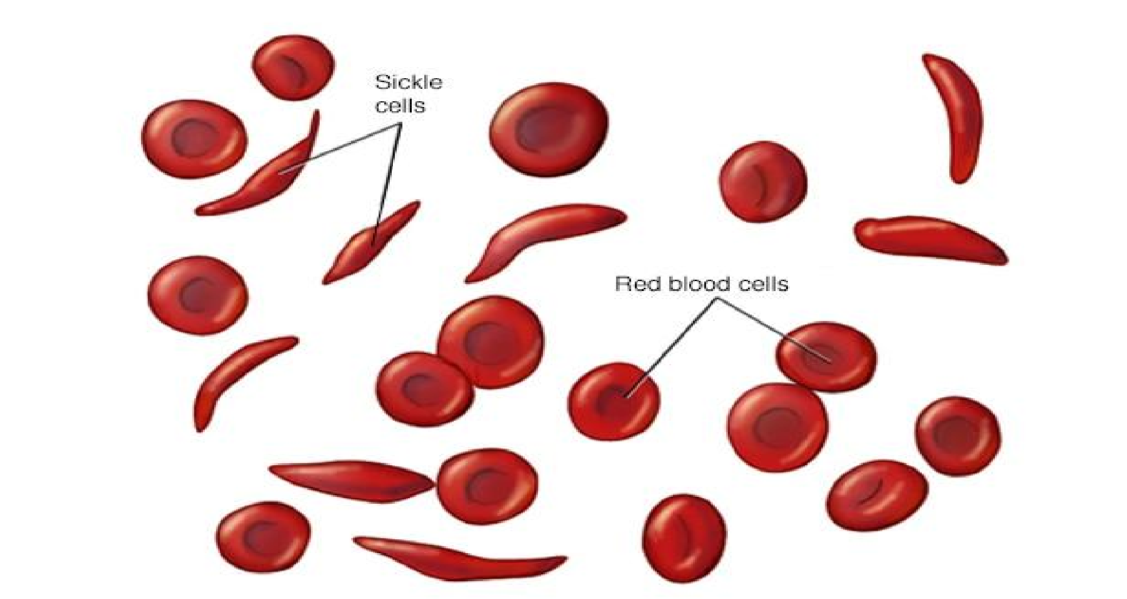
Symptoms:
Episodes of pain.
Painful swelling of hands and feet.
Frequent infections.
Delayed growth.
Vision problems.

# Thalassemia
Thalassemia is a blood disorder passed down through families (inherited) in which the body makes an abnormal form of hemoglobin. Hemoglobin is the protein in red blood cells that carries oxygen. The disorder results in large numbers of red blood cells being destroyed, which leads to anemia.
** There are two main forms of thalassemia that are more serious. In alpha thalassemia, at least one of the alpha globin genes has a mutation or abnormality. In beta thalassemia, the beta globin genes are affected.
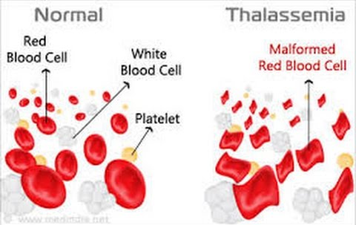
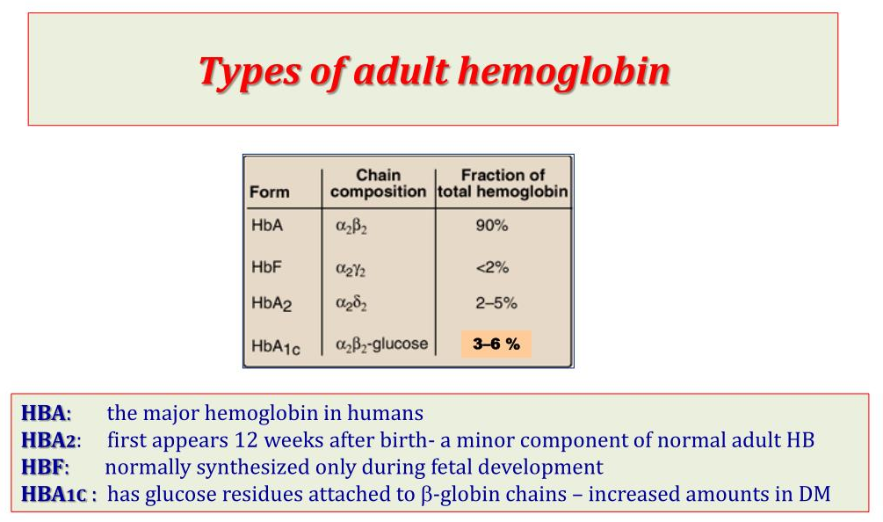
Symptoms
- Bone deformities, especially in the face
- Dark urine
- Delayed growth and development
- Excessive tiredness and fatigue
- Yellow or pale skin
Causes
Thalassemia occurs when there’s an abnormality or mutation in one of the genes involved in hemoglobin production.
If only one of the parents is a carrier for thalassemia, children develop a form of the disease known as thalassemia. Diagnosis
  - CBC
  - Physical examination of blood to identify the abnormal form of blood cell
  - Hemoglobin electrophoresis Treatment
- Blood transfusions
- Medications (Deferoxamine)
- Bone marrow transplant

# Jaundice
When free or conjugated bilirubin accumulates in the blood, skin and mucous membranes turn yellow. This yellowness is known as jaundice (icterus) and is usually detectable when the total plasma bilirubin is greater than 2 mg/dl.
** Bilirubin is a waste product, created when red blood cells break down. It's transported in the bloodstream to the liver, where it's combined with a digestive fluid called bile. This eventually passes out of the body in urine or stools. It's bilirubin that gives urine its light yellow colour and stools their dark brown colour.

Sign
- Yellowing of the skin, eyes and the lining of the inside of parts of the body, such as the mouth and nose.
- Pale-colored stools
- Dark-colored urine
Causes Diagnosis
- Malaria  - Sickle cell anemia  - Thalassemia  - Viral hepatitis  - Alcoholism  - Drug misuse (paracetamol)  - Liver cancer  - Pancreatic cancer | Urine test  Liver functions test  CT scan of liver and bile  MRI scan of liver  Liver biopsy

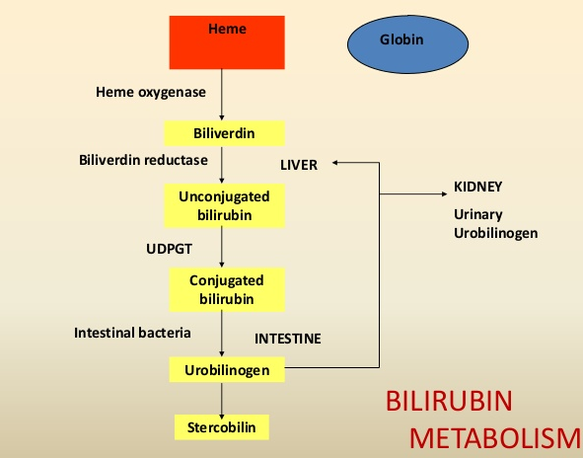
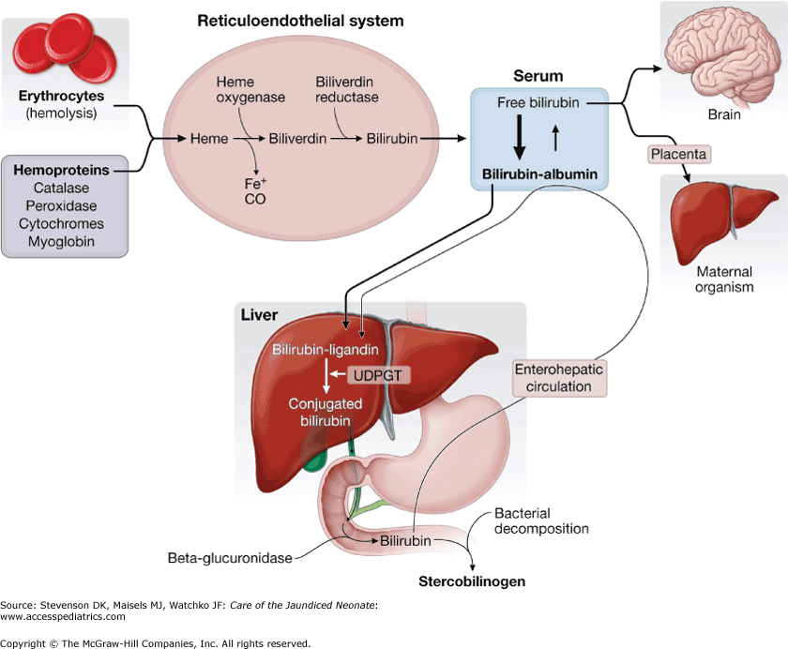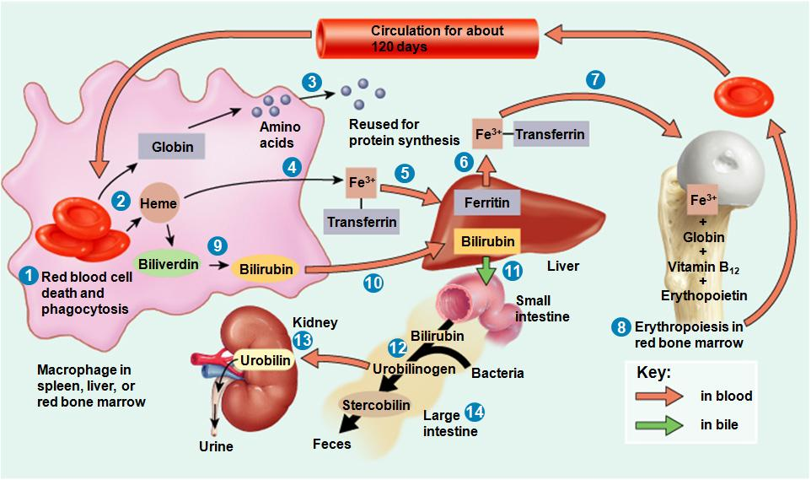
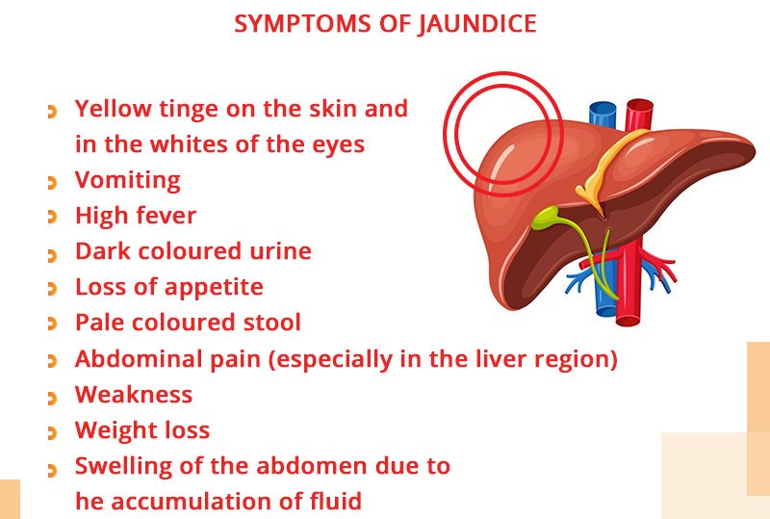
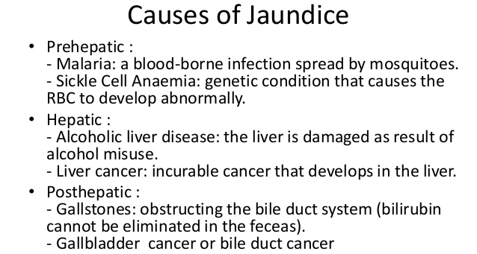
Treatment
1. Medication (in case of malaria)
      - RBC replacement (in case of sickle cell anemia or thalassemia)
      - Prohibition of alcohol
      - Gallbladder surgery
# Leukemia
Leukemia, is a group of cancers that usually begin in the bone marrow and result in high numbers of abnormal white blood cells. These white blood cells are not fully developed and are called blasts or leukemia cells.
Symptoms
  - Pain in the bones or joints,
  - Swollen lymph nodes that usually don't hurt
  - Fevers or night sweats
  - Feeling weak or tired
  - Bleeding
  - Frequent infections
  - Discomfort in the abdomen 8. Weight loss or loss of appetite.
Causes
  - Radiation
  - Genetic factors
  - Mutation in DNA
  - Viruses such as human T-lymphotropic virus
  - Chemicals, like benzene and alkylating chemotherapy agents
Diagnosis
  - CBC 2. Lymph node biopsy 3. MRI or CT scan

Treatment
  - Bone marrow transplant
  - Radiation therapy
  - Medication

# Antigen
An antigen is a substances, protein or polysaccharide which when introduced into the system in a considerable dose and appropriate route is capable of inducing an immune response leading to formation of antibody with which it reacts specifically.

# Antibody
Antibody is a type of globulin produced in response to an antigen with which it reacts specifically. There are five antibodies:
IgG, IgA, IgM, IgD, IgE

# Blood group
Human blood is divided into one of four main blood types (A, B, AB, and O) and are based on the presence or absence of specific markers on red blood cells. These markers (also called antigens) are proteins and sugars that our bodies use to identify the blood cells as belonging in our own system.

The four main blood groups are:
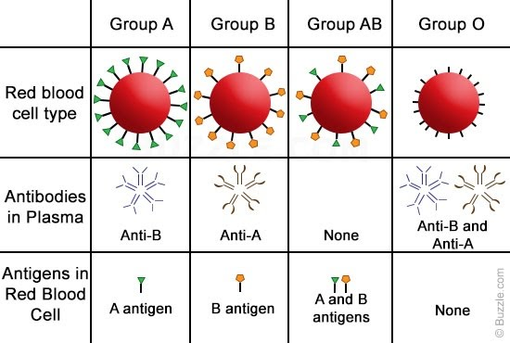
The presence or absence of A or B antigens gives us four main blood types:
Blood type A: your red blood cells have antigen A only.
Blood type B: your red blood cells have antigen B only.
Blood type AB: your red blood cells have both A and B antigens.
Blood type O: you have neither A nor B antigens on your red blood cells.
Antibodies are specialized immune proteins that are produced based on the antigens that are not present on your red blood cells. In your plasma you will have antibodies against whichever antigens you don’t have on your own red blood cells i.e. antigens that are foreign. These antibodies are present without you having contact with the “foreign” blood type.
For example, if you have A antigens, you will develop only anti-B antibodies. So
• A type blood has anti-B antibody in the plasma
• B type blood has anti-A antibody in the plasma
• AB has neither A or B antibody in the plasma
• O has both A and B antibody in the plasma.
Some people have an additional marker, called Rh factor (Rhesus factor), in their blood. Based on Rh factor, scientists further classify blood as either "positive" (meaning it has Rh factor) or "negative" (without Rh factor).
The ABO blood grouping system.

- A sample of your blood is tested separately against 2 laboratory solutions – one that contains antibodies against the A antigen (anti-A) and one that contains antibodies against the B antigen (anti-B).
- The way your blood reacts to the antibodies shows which antigens your blood contains. For example, if you have the A antigen on your red blood cells (you are blood group A), when the solution containing anti-A antibodies is added, your blood cells will react by clumping together (agglutinating). If you blood doesn't react to either of the solutions, it must be O type blood.
- if you have the B antigen on your red blood cells (you are blood group B), when the solution containing anti-B antibodies is added, your blood cells will react by clumping together (agglutinating).
******
Bleeding time: It is the measure of how rapidly blood can start to clot formation and become able to stop bleeding.
- In this test, a small puncture is made in the skin of the person. By performing this test, it can be easily determined the way in which the platelets work together to form clots.
- If there is prolonged bleeding in a person, it indicates that the person has an acquired defect of platelet function.
- The normal bleeding time is between 2-7 minutes.

Clotting time:
Clotting time means after injury it takes how much time to stop bleeding which occurs due to clot formation of blood. Clotting time is the time required for a sample of blood to coagulate in vitro. Normal value of clotting time is 8 to 15 minutes.

Prothrombin time
Prothrombin is another protein your liver produces. The prothrombin time (PT) test measures how well and how long it takes your blood to clot.
It normally takes about 25 to 30 seconds. It may take longer if you take blood thinners. Other reasons for abnormal results include hemophilia. It’s also useful in monitoring those who take medications that affect clotting, such as warfarin (Coumadin).

Hemostasis: ~is a process which causes bleeding to stop, meaning to keep blood within a damaged blood vessel (the opposite of hemostasis is hemorrhage). It is the first stage of wound healing.

Coagulation, also known as clotting, is the process by which blood changes from a liquid to a gel, forming a blood clot.
Hemostasis vs Coagulation
Hemostasis is the overall process of arresting bleeding following a vascular injury. |  |  |  | Coagulation is the final step of hemostasis in which a stable blood clot isformed by platelets and insoluble fibrin network.
Process
The ultimate result of the hemostasis is the stoppage of bleeding. |  |  |  | Soluble plasma fibrinogen polymerizes into insoluble fibrin during the coagulation and forms a plug toblock the hole made by the injury.
Types
 | Hemostasis can be categorized into two types named primary hemostasis  and secondary hemostasis. |  |  | Coagulation can be categorized into intrinsic pathway of blood clottingand extrinsic pathway of blood clotting.
 | Disorders
 | Hemostasis can show platelet disorders. | abnormalities due to |  | Coagulation can be impaired by disorders of the liver and inactive or abnormal fibrinogen production.

# Blood coagulation factors
By the action of thrombin, blood fibrinogen (soluble) is converted in fibrin (Insoluble) and makes the blood semisolid mass. This is called blood coagulation. There are several factors involved:
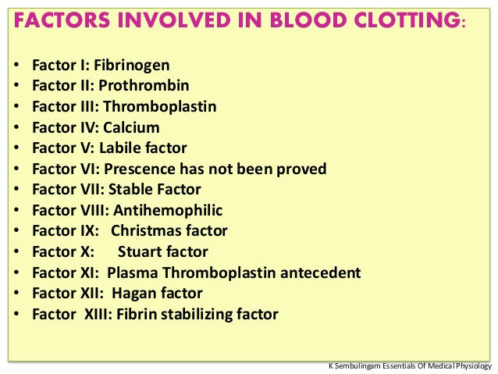
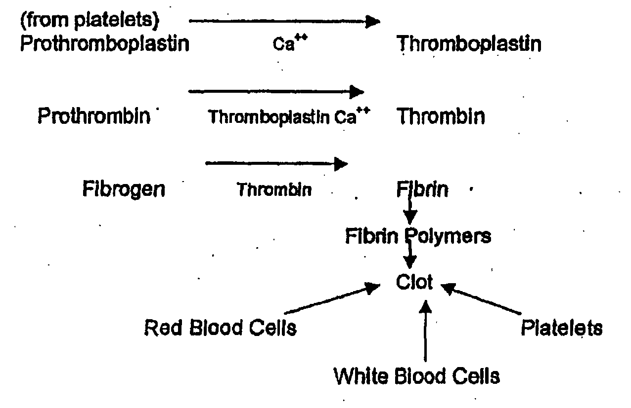

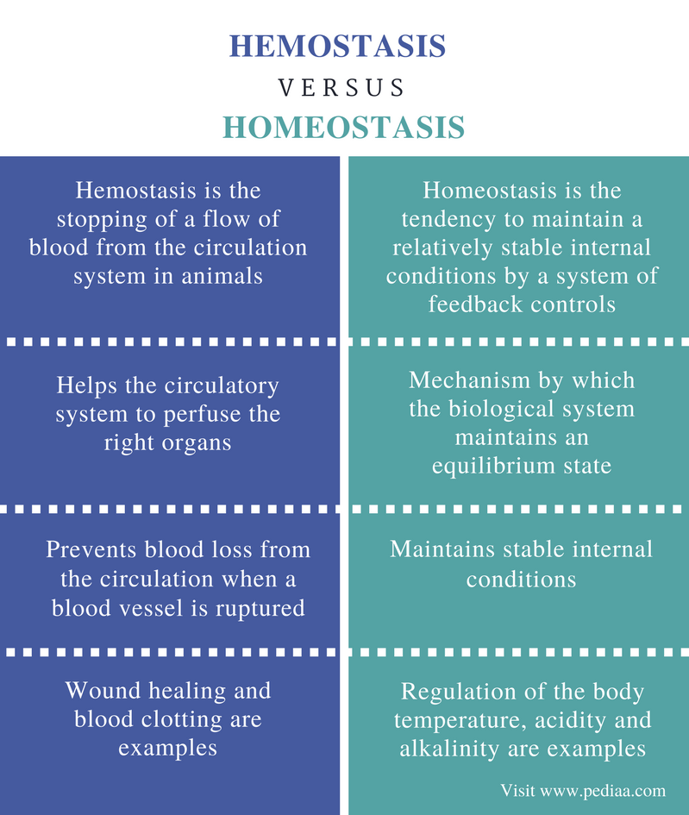

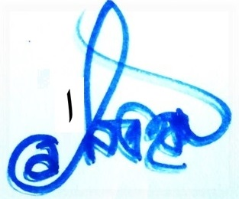

THE END

