**Electric potential**

**Electric potential of a point in an electric field is the amount of work done in bringing a unit charge (without acceleration) from infinity to that point.**  
  
So suppose a positive ***charge 'Q'*** is present and it creates an **electric field 'E'**. Inside the electric field there lies a point ***point 'P'***and distance between**charge 'Q'** and **point 'P'** is**'r'**  
Now in simpler terms due to this **charge 'Q'**, there will be some potential at a **point 'P'** which lies inside **electric field 'E'**

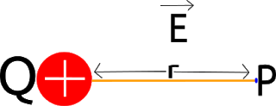

Symbol of electric potential is 'V' and the formula is:

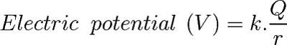

Here 'k' is the Columbus constant    
In the formula you can clearly see that potential is directly proportional to the *charge 'Q'* so *more is the charge more will be the potential at the point 'P'*

**Electric potential energy:**

Electric potential energy of *charge 'q'* at a point is the *work done by external forces in bringing charge 'q' from infinity to that point present.*  
  
*In electric potential energy, we talk about work done by external force in bringing charge 'q' from infinity to point*but when we are talking about the *electric potential we are dealing with the work done by external force in bringing a unit charge 'q' from infinity to a point.*  
  
*The unit of electric charge is coulomb* so when we say a unit charge we are generally referring to the 1 Coulomb charge.

**Equipotential surface:**

Equipotential surfaces are nothing different; these *are the surfaces where electric potential at every point is the same.*  
  
The formula of electric potential for a *single charge Q:*

[https://1.bp.blogspot.com/-erzqg_jyl58/XcLnWrcYq_I/AAAAAAAABzA/ApEE6hIDYAwjiy0RFGBbPkxX27dLq9WoACLcBGAsYHQ/s320/CodeCogsEqn.png](https://1.bp.blogspot.com/-erzqg_jyl58/XcLnWrcYq_I/AAAAAAAABzA/ApEE6hIDYAwjiy0RFGBbPkxX27dLq9WoACLcBGAsYHQ/s1600/CodeCogsEqn.png)

So electric potential 'V' will be constant and the same for all the points if the distance between the point and charge 'r' is constant.  
  
So *equipotential surfaces* of a single point charge present at the centre are *concentric spherical surfaces.*

**Dielectric :**

*Dielectrics are non-conducting substances*, in other words, you can also say that dielectric is just another name of the insulator. So this *dielectric has no or negligible charge carrier present inside* them, therefore, they can't conduct.  
  
In electrostatics of conductor one property which we have learned was whenever *conductors are introduced in an external electric field, the free charge career present inside arranging them in such a manner that electric field due to induced (created due to moved charge carrier arrangement) charge opposes the external field within the conductor.*  
  
Well, this arrangement only happens until a static situation in which *both external and induced electric fields cancel out each other* and the net electrostatic field inside a conductor is zero.

**Types of dielectric:**

Dielectric is of two types ***(i) Non-polar and (ii) Polar***  
  
**Non-polar molecules:** In this kind of molecules*, positive and negative charges are present at the centre* and they don't have distance between them, therefore, they don't have there own dipole.

**For example CO2, H2, and N2.**

[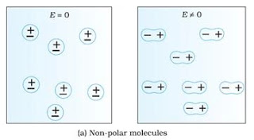](https://1.bp.blogspot.com/-S1XJ39kh8mY/XcQ_JC-_JII/AAAAAAAABzc/4A2dlAA8OdMCD98Q0PPvUrXdUkp85af0QCLcBGAsYHQ/s1600/1.webp)

**Polar molecules:** In this, *positive and negative charge are not present at the centre and have some distance,*therefore they have dipole of their own. **For example H2O.**

[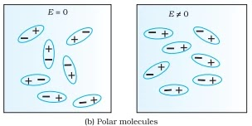](https://1.bp.blogspot.com/-D70fro_rpe8/XcQ_XxbQDFI/AAAAAAAABzg/fFOpdfGWVRUnvOPwqc7E4TSFq_RvLjfTwCLcBGAsYHQ/s1600/word-image-46.webp)

When *non-polar molecules are exposed to the external electric field they create a dipole moment but as soon as this external electric field is removed they get back to normal* whereas in case of polar molecules they have their own dipole moment but at molecular level net dipole moment in this dielectric is also 0 but due to different reason.  
  
In *polar molecules, different small permanent dipole are arranged randomly and therefore due to this they cancel out each other* but *when an external electric field is applied in polar molecules this small dipole arranges themselves according to an electric field*. Hence, a net dipole moment gets created in the direction of the electric field.

**Polarization:**

**this small-small dipole or molecules arrange themselves according to the electric field this is called polarisation.**

