Demand and Supply

**Demand:** Demand in economics is the consumer's **desire and ability** to purchase a goods or services. It's the underlying force that drives economic growth and expansion. Without demand, no business would ever bother producing anything.

Price is inversely proportionate to demand, If price increase, demand will be lower

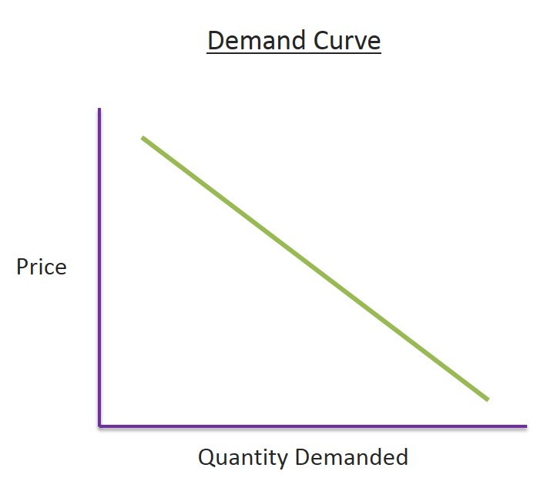

**Determinants of Household Demand**

* The ***price of the product***.
* The ***income*** available to the household.
* The household’s amount of ***accumulated wealth****.*
* The ***prices of substitute products*** available to the household.
* The household’s ***tastes and preferences***.
* The household’s ***expectations*** about future income, wealth, and prices.

**Supply**

* **Supply:** Supply means the quantities that a seller is **willing and able** to sell at different prices. It is obvious that if the price goes up, seller will offer more for sale.
* But if the price goes down, seller will be reluctant to sell and will offer less to sell.

**Demand supply curve:**

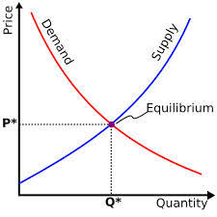

**The Law of Supply:**

The ***law of supply*** states that there is a positive relationship between price and quantity of a good supplied. Higher price ensures greater quantity of supply.

**Equilibrium**

In economics, **economic equilibrium** is a state where economic forces such as **supply and demand are balanced** and in the absence of external influences the (equilibrium) values of economic variables will not change.

For example, in the standard textbook model of perfect competition, **equilibrium occurs at the point at which quantity demanded and quantity supplied are equal**.

**Market Equilibrium:**

The operation of the market depends on the interaction between buyers and sellers.

An ***equilibrium*** is the condition that exists when quantity supplied and quantity demanded are equal.

At equilibrium, there is no tendency for the market price to change.

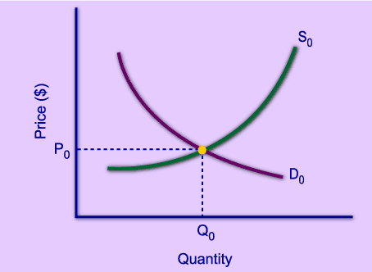

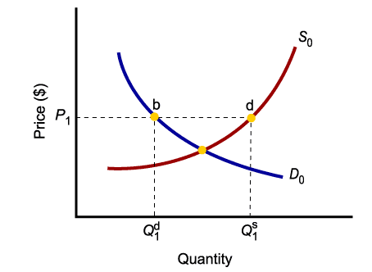

Only in equilibrium is quantity supplied equal to quantity demanded.

At any price level other than *P*0, the wishes of buyers and sellers do not coincide.