**Risk Analysis through Tree Analysis**

**in**

**Capital Budgeting**

* **Risk** exists because of the inability of the decision-maker to make perfect forecasts.
* The risk associated with an investment may be defined as the variability that is likely to occur in the future returns from the investment.
* Three broad categories of the events influencing the investment forecasts:
  + ***General economic conditions***
  + ***Industry factors***
  + ***Company factors***
* **Statistical Techniques for Risk Analysis**
  + Probability
  + Variance or Standard Deviation
  + Coefficient of Variation
* **Conventional Techniques of Risk Analysis**
  + Payback
  + Risk-adjusted discount rate
* **Risk Analysis in Practice:**

The following factors are considered to influence the riskiness of investment projects:

* + price of raw material and other inputs
  + price of product
  + product demand
  + government policies
  + technological changes
  + project life
  + inflation
* Four factors thought to be contributing most to the project riskiness are:
  + selling price
  + product demand
  + technical changes
  + government policies

**SENSITIVITY ANALYSIS:**

* Sensitivity analysis is a way of analysing change in the project’s NPV (or IRR) for a given change in one of the variables.
* The decision maker, while performing sensitivity analysis, computes the project’s NPV (or IRR) for each forecast under three assumptions:
  + pessimistic,
  + expected, and
  + optimistic.
* The following three steps are involved in the use of sensitivity analysis:
  1. Identification of all those variables, which have an influence on the project’s NPV (or IRR).
  2. Definition of the underlying (mathematical) relationship between the variables.
  3. Analysis of the impact of the change in each of the variables on the project’s NPV.

**What is a Decision Tree?**

A decision tree is the graphical depiction of all the possibilities or outcomes to solve a specific issue or avail a potential opportunity. It is a useful financial tool which visually facilitates the classification of all the probable results in a given situation.

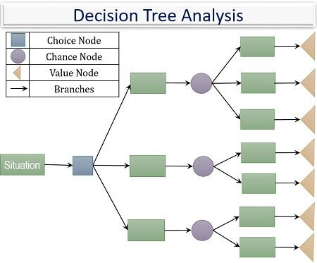

**Steps in Decision Tree Analysis**

Following steps simplify the interpretation process of a decision tree: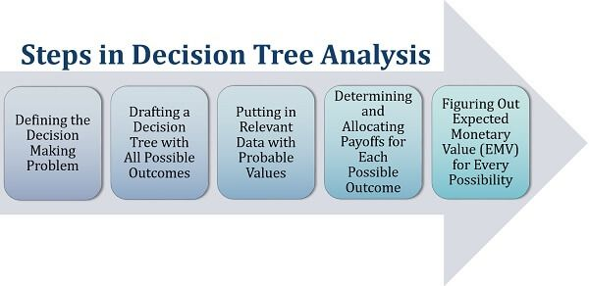

1. The *first step* is understanding and specifying the problem area for which decision making is required.
2. The *second step* is interpreting and chalking out all possible solutions to the particular issue as well as their consequences.
3. The *third step* is presenting the variables on a decision tree along with its respective probability values.
4. The *fourth step* is finding out the outcomes of all the variables and specifying it in the decision tree.
5. The *last step* is highly crucial and backs the overall analysis of this process. It involves calculating the EMV values for all the chance nodes or options, to figure out the solution which provides the highest expected value.

**Decision Tree Analysis**

ABC Ltd. is a company manufacturing skincare products. It was found that the business is at the maturity stage, demanding some change. After rigorous research, management came up with the following decision tree: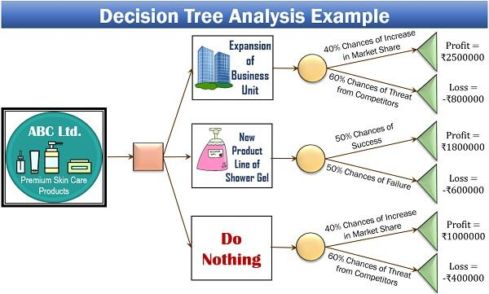

**Advantages of Decision Tree Analysis**

Business organizations need to consider various parameters during decision making. A decision tree analysis is one of the prominent ways of finding out the right solution to any problem.

Let us now understand its various benefits below: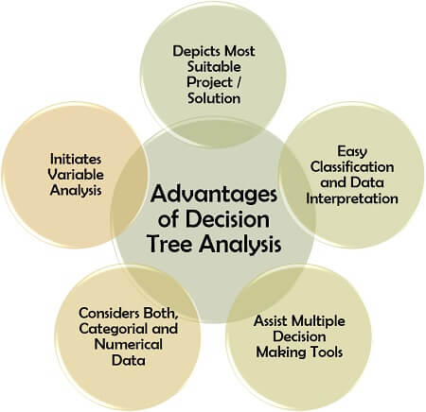

* **Depicts Most Suitable Project/Solution**: It is an effective means of picking out the most appropriate project or solution after examining all the possibilities.
* **Easy Data Interpretation and Classification**: Not being rocket science, decision tree eases out the process of segregation of the acquired data into different classes.
* **Assist Multiple Decision-Making Tools**: It also benefits the decision-maker by providing input for other analytical methods like nature’s tree.
* **Considers Both, Categorial and Numerical Data**: This technique takes into consideration the quantitative as well as the qualitative variables for better results.
* **Initiates Variable Analysis**: Its structured phenomena also facilitates the investigation and filtration of the relevant data.

**Disadvantages of Decision Tree Analysis**

Decision tree analysis has multidimensional applicability. However, its usage becomes limited due to its following shortcomings: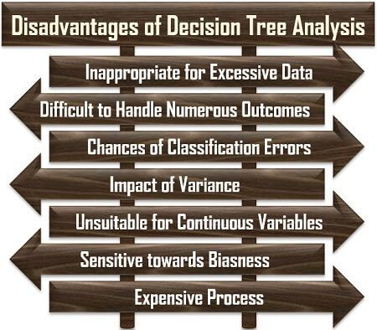

* **Inappropriate for Excessive Data**: Since it is a non-parametric technique, it is not suitable for the situations where the data for classification is vast.
* **Difficult to Handle Numerous Outcomes**: If there are multiple possible results of every decision, it becomes tedious to compile all these on a decision tree.
* **Chances of Classification Errors**: A less experienced decision tree maker usually makes a mistake while putting the variables into different classes.
* **Impact of Variance**: Making even a slightest of change becomes problematic since it results in a completely different decision tree.
* **Unsuitable for Continuous Variables**: Incorporating many open-ended numerical variables increases the possibility of errors.
* **Sensitive towards Biasness**: A decision tree maker may lay more emphasis on preferable variables which may divert the direction of analysis.
* **Expensive Process**: Collection of sufficient data, its classification and analysis demand high expense, being a resource-intensive process.