**Chapter- Cost-Volume-Profit Analysis**

**Learning Objectives**

After reading and studying Chapter 9, you should be able to answer the following questions:

1.      Why is variable costing more useful than absorption costing in determining the break-even-point and doing cost-volume-profit analysis?

2.      How is the break-even point determined using the formula approach, graph approach, and income statement approach?

3.      How do companies use cost-volume-profit (CVP) analysis information in decision making?

4.      How do break-even and CVP analysis differ for single-product and multiproduct firms?

5.      How are margin of safety and operating leverage concepts used in business?

6.      What are the underlying assumptions of CVP analysis?

**Terminology**

**Break-even chart:** a graph that depicts the relationships among revenue, volume, variable costs, fixed costs, and profits (or losses)

**Break-even point** **(BEP):** the level of activity, in units or dollars, at which total revenues equal total costs

**Contribution margin:** the difference between selling price and variable cost per unit or in total for the level of activity; it indicates the amount of each revenue dollar remaining after variable costs have been covered that is available to cover fixed costs and profits

**Contribution margin ratio:** the proportion of each revenue dollar remaining after variable costs have been covered; computed as contribution margin divided by revenue

**Cost-volume-profit** **(CVP)** **analysis:** a procedure that examines changes in costs and volume levels and the resulting effects on net income (profits)

**Degree of operating leverage:** a factor that indicates how a percentage change in sales, from the existing or current level, will affect company profits; it is calculated as contribution margin divided by net income or (1 ¡Â margin of safety percentage)

**Incremental analysis:** a process of evaluating alternatives that focuses only on the factors that differ from one course of action or decision to another

**Margin of safety:** the excess of the budgeted or actual sales of a company over its break-even point; it can be calculated in units or dollars or as a percentage; it is equal to (1 ¡Â degree of operating leverage)

**Operating leverage:** the proportionate relationship between a company¡¯s variable and fixed costs

**Profit-volume** **graph:** a visual representation of the amount of profit or loss associated with each level of sales

**Variable cost ratio:** the proportion of each revenue dollar needed to cover variable costs; computed as variable costs divided by sales or as (1 ¨C contribution margin ratio)

**¡¡**

**Lecture Outline**

**LO.1: Why is variable costing more useful than absorption costing in determining the break-even-point and doing cost-volume-profit analysis?**

A.    Break-Even Point

1.      This chapter focuses on understanding how costs, volumes, and profits interact. Understanding these relationships helps in predicting future conditions (planning) as well as explaining, evaluating, and acting on past results (controlling).

2.      Variable costing is commonly used for internal purposes because it makes cost behavior more transparent.

a.      The variable costing presentation of separating variable from fixed costs facilitates the use of break-even point, cost-volume-­profit, margin of safety, and degree of operating leverage models.

b.      The traditional approach to product costing is called absorption (or full) costing and is the one primarily used for external reporting.

c.       A variable costing income statement for Baldwin Corporation is presented in text **Exhibit 9¨C1**. This example is used for illustration purposes in the text narrative.

3.      The **break-even point (BEP)** is the level of activity, in units or dollars, at which total revenues equal total costs.

a.      Knowing the BEP, managers are better able to set sales goals that should result in profits from operations rather than losses.

4.      Several simplifying assumptions must be made concerning revenue and cost functions (These are discussed in more detail at the end of the chapter):

a.      *Relevant range:* The company is assumed to be operating within the relevant range of activity specified in determining the revenue and cost information used in the BEP model;

b.      *Revenue:* Total revenue fluctuates in direct proportion to the level of activity or volume while revenue per unit is assumed to remain constant, and fluctuations in per unit revenue for factors such as quantity discounts are ignored;

c.       *Variable costs:* Total variable costs fluctuate in direct proportion to the level of activity or volume. Variable costs per unit are assumed to remain constant within the relevant range. Variable production costs include direct material, direct labor, and variable overhead; variable selling costs include charges for items such as commissions and shipping; and variable administrative costs may exist in areas such as purchasing;

d.     *Fixed costs:* Total fixed costs are assumed to remain constant within the relevant range. Fixed cost per unit decreases as volume increases, and it increases as volume decreases. Fixed costs include both fixed factory overhead and fixed selling and administrative expenses; and

e.      *Mixed costs:* Mixed costs must be separated into their variable and fixed elements before they can be used in CVP analysis. Any method (such as regression analysis) that validly separates these costs in relation to one or more predictors may be used.

5.      **Contribution margin** **(CM)** is defined as the difference between selling price and variable cost per unit or in total for a specific level of activity

a.      CM indicates the amount of revenue that remains after all variable costs have been covered and goes toward the coverage of fixed costs and the generation of profits.

**LO.2: How is the break-even point determined using the formula approach, graph approach, and income statement approach?**

B.     Formula Approach to Breakeven

1.      The formula approach uses an algebraic equation to calculate the exact break-even point.

2.      Sales activity, rather than production, is the focus for the relevant range.

3.      Algebraic break-even computations use an equation that represents the variable costing income statement and shows the relationships among revenue, fixed cost, variable cost, volume, and profit as follows:

                        R(X) ¨C VC(X) ¨C FC = P

                        where   R         =  revenue (selling price) per unit

                                      X         =  number of units sold or to be sold

                                      R(X)    =  total revenue

                                      FC       =  total fixed cost

                                      VC      =  variable cost per unit

                                      VC(X) =  total variable cost

                                      P          =  profit

a.      The equation represents an income statement, so P can be set equal to zero for the formula to indicate a break-even situation.

b.      The break-even point in units can be found by solving the equation for X:

                                    X = FC ¡Â (R ¨C VC)

c.       *Break-even point volume* is equal to total fixed cost divided by the unit contribution margin (revenue per unit minus the variable cost per unit):

                                    X = FC ¡Â CM

                                    where CM = contribution margin per unit

4.      The break-even point can be expressed in either units or dollars of revenue.

a.      The break-even point in sales dollars can be found by multiplying the break-even point in units by the selling price per unit.

5.      The break-even point in sales dollars can also be computed.

a.      **Contribution margin (CM) ratio** is the proportion of each revenue dollar remaining after variable costs have been covered; it is computed as contribution margin divided by sales on a total or per unit basis.

b.      The **variable cost (VC) ratio** represents the variable cost proportion of each revenue dollar and is computed as variable costs divided by sales or as (1 ¨C contribution margin ratio).

c.       The BEP in dollars is found by dividing total fixed cost by the contribution margin ratio.

                                    Sales = FC ¡Â (1 ¨C VC%)

                                    or

                                    Sales = FC ¡Â CM%

                                    where   VC%   =  the percentage relationship of variable cost to sales

                                                  CM%  = the percentage relationship of contribution margin to sales

6.      The *break-even point* provides a starting point for planning future operations.

a.      Managers want to earn profits, not just cover costs, so the break-even point formula can be used by substituting an amount other than zero for the profit (P) term.

b.      This substitution converts break-even analysis to *cost-volume-profit analysis.*

**C.     CVP Analysis**

1.      General

a.      **Cost-volume-profit analysis** is a procedure that examines changes in costs and volume levels and the resulting effects on net income (profits).

i.        CVP analysis can be used to calculate the sales volume necessary to achieve a desired target profit on a before or after-tax basis.

b.      Managers can use CVP to plan and control more effectively since the technique allows them to concentrate on the relationships between revenues, costs, volume changes, taxes, and profits.

i.        The CVP model can be expressed through a formula or as a graph.

ii.     All costs¡ªregardless of whether they are product, period, variable, or fixed¡ªare considered in the CVP model.

iii.   The same basic CVP model and calculations can be applied to a single- or multiproduct business.

**2.      Using Cost-Volume-Profit Analysis**

a.      CVP analysis requires the substitution of known amounts in the formula to determine an unknown amount.  In the typical CVP model profits are used to refer to operating profits before extraordinary and other non-operating, nonrecurring items.

b.      A significant application of CVP analysis is the setting of a desired target profit and focusing on the relationships between it and specified income statement amounts to find an unknown.

i.        Volume is a common unknown in such applications since managers want to achieve a particular amount of profit and need to know what quantity of sales must be generated to accomplish this objective.

ii.     Selling price is not as common an unknown as volume since the selling price is usually market-related rather than being set solely by company management.

c.       Profits may be stated as either fixed or variable amount and on either a before-tax or after-tax basis.

**3.      Fixed Amount of Profit**

a.      Each dollar of contribution margin is a dollar of profit after the break-even point is reached. (See text **Exhibits 9-2** and **9-3**.)

i.        The formula to compute target profit before tax is as follows:

                                    R(X) ¨C VC(X) ¨C FC = PBT

                                    or

                                    R(X) ¨C VC(X) = FC + PBT

                                    or

                                    CM(X) = FC + PBT

                                    or

                        X = (FC + PBT) ¡Â CM

                                    where PBT = fixed amount of profit before taxes

ii.     The formula to compute target profit after taxes is as follows:

                                    PBT ¨C [(TR) (PBT)] = PAT

                                    and

                                    R(X) ¨C VC(X) ¨C FC ¨C [(TR) (PBT)] = PAT

                                    where             PBT = fixed amount of profit before tax

                                                            PAT = fixed amount of profit after tax

                                                            TR = tax rate

                                    PBT is further defined as:

                                                PBT ¨C (1 ¨C TR) = PAT

                                    or

PBT = PAT ¡Â             (1 ¨C TR)

substituting into the formula

                                                R(X) ¨C VC(X) ¨C FC = PBT

                                    or

                                                R(X) ¨C VC(X) = FC + PBT

                                    or

                                                (R ¨C VC)(X) = FC + [PAT ¡Â (1 ¨C TR)]

                                    or

                                                CM(X) = FC + [PAT ¡Â (1 ¨C TR)]

**4.      Set Amount of Profit Per Unit**

a.      Managers may desire a specific amount of profit per unit.

i.        In this case, profit must be treated similarly to a variable cost.

ii.     A set amount of profit can be stated on either a before tax or after tax basis or as either a percentage of revenues or a per unit amount.

b.      Text **Exhibit 9-4** provides analysis of a set amount of profit per unit before tax

i.        The adjusted CVP formula for computing the necessary unit sales volume to earn a specified amount of profit before tax per unit is as follows:

                                    R(X) - VC(X) - FC = PuBT(X)

or

                                    R(X) - VC(X) - PuBT(X) = FC

or

                                    CM(X) - PuBT(X) = FC

                                    or

                                    X = FC ¡Â (CM ¨C PuBT)

c.       Text **Exhibit 9-5** provides analysis of a set amount of profit per unit after tax

i.        The adjusted CVP formula for computing the necessary unit sales volume to earn a specified amount of profit after tax per unit is as follows:

                                    R(X) - VC(X) - FC ¨C {(TR) [PuBT(X)]} =  PuAT(X)

                                    where PuAT = amount of profit per unit after tax

or

                                    X = FC ¡Â (CM ¨C PuBT)

                                    where PuBT = variable amount profit per unit before taxes

**D.    Graph Approach to Breakeven**

1.      General

a.      A **break-even chart** is a graph that depicts the relationships among revenues, volume, and costs.

b.      The BEP is located at the point where the total cost and total revenue lines intersect.

c.       Text **Exhibit 9-6** provides a graphical presentation of income statement items.

2.      Traditional Approach

a.      The *traditional approach* to graphical break-even analysis is a break-even chart that does not show contribution margin and is prepared as illustrated in text **Exhibit 9-7**:

i.        Step 1: Label each axis and graph the total cost and fixed cost lines.

ii.     Step 2: Chart the revenue line, beginning at $0. The BEP is located at the intersection of the revenue line and the total cost line.

b.      The vertical distance to the right of the BEP and between the revenue and total cost lines represents profit; the distance between the revenue and total cost lines to the left of the BEP represents loss.

i.        Text **Exhibit 9-8** presents a traditional breakeven graph.

3.      Profit-Volume Graph

a.      The **profit-volume graph** is a visual representation of the amount of profit or loss associated with each level of sales. (See text **Exhibit 9-9**.)

b.      The horizontal axis on the PV graph represents unit sales volume and the vertical axis represents dollars.

c.       Amounts shown above the horizontal axis are positive and represent profits, while amounts below the horizontal axis are negative and represent losses.

E.     The Income Statement Approach (See text **Exhibit 9-10**.)

1.      The income statement approach to CVP analysis allows the preparation of pro forma (budgeted) statements from available information.

2.      Income statements can be used to prove the accuracy of computations made with the CVP formula, or the statements can be prepared simply to determine the impact of various sales levels on profit after taxes (net income).

**LO.3: How do companies use cost-volume-profit (CVP) analysis information in decision making?**

F.      Incremental Analysis for Short-Run Changes

1.      The following quote from the text indicates the pervasive usefulness of the CVP model:

Cost Volume Profit analysis (CVP) is one of the most hallowed, and yet one of the simplest, analytical tools in management accounting. [CVP] allows managers to examine the possible impacts of a wide range of strategic decisions [in] such crucial areas as pricing policies, product mixes, market expansions or contractions, outsourcing contracts, idle plant usage, discretionary expense planning, and a variety of other important considerations in the planning process. Given the broad range of contexts in which CVP can be used, the basic simplicity of CVP is quite remarkable. Armed with just three inputs of data¡ªsales price, variable cost per unit, and fixed costs¡ªa managerial analyst can evaluate the effects of decisions that potentially alter the basic nature of a firm.

2.      CVP analysis allows managers to set a desired target profit and focus on the relationships between it and other known income statement amounts to find an unknown.

3.      CVP analysis is very useful for performing short-term incemental analysis.

a.      **Incremental analysis** is a process of evaluating changes that focuses only on the factors that differ from one course of action or decision to another.

b.      The break-even point may increase or decrease, depending on the particular changes that occur in the revenue and cost factors.

c.       The break-even point will increase if there is an increase in total fixed cost or a decrease in unit (or percentage) contribution margin.

d.     A decrease in contribution margin could arise due to a reduction in selling price, an increase in variable unit cost, or a combination of the two.

e.      The break-even point will decrease if there is a decrease in total fixed cost or an increase in unit (or percentage) contribution margin.

f.        Any factor that causes a change in the break-even point will also cause a shift in total profits or losses at any activity level.

4.      The text presents four examples (cases) of changes that could occur in a company and the incremental computations that can be used to determine the effects of those changes on the BEP or on profit.

a.      In most situations, incremental analysis is sufficient to determine the feasibility of contemplated changes, and a complete income statement need not be prepared.

**LO.4: How do break-even and CVP analysis differ for single-product and multiproduct firms?**

G.    CVP Analysis in a Multiproduct Environment (See text **Exhibits 9-11 and 9-12**.)

1.      A constant product sales mix or, alternatively, an average contribution margin ratio must be assumed in order to perform CVP analysis in a multiproduct company.

2.      The constant sales mix assumption can be referred to as the ¡°bag¡± (or ¡°basket¡±) assumption, with sales mix representing a bag of products that are sold together.

3.      The computation of a weighted average contribution margin ratio for the bag of products being sold is necessary under the constant sales mix assumption.

4.      Any shift in the sales mix proportion of products will change the weighted average contribution margin and the break-even point.

**LO.5: How are margin of safety and operating leverage concepts used in business?**

H.    Margin of Safety

1.      The **margin of safety** is the excess of the budgeted or actual sales of a company over its break-even sales; it can be calculated in units or dollars or as a percentage; it is equal to (1 ¡Â degree of operating leverage).

2.      The margin of safety (See text **Exhibit 9-13**) is the amount that sales can drop before reaching the break-even point and, thus, provides a certain amount of ¡°cushion¡± from losses.

3.      The following formulas are applicable:

a.      Margin of safety in units = Actual units ¨C Break-even units

b.      Margin of safety in $ = Actual sales $ ¨C Break-even sales in $

c.       Margin of safety % = Margin of safety in units ¡Â Actual unit sales

d.     Margin of safety % = Margin of safety in $ ¡Â Actual sales $

4.      The margin of safety calculation allows management to determine how close to a danger level the company is operating, and thus provides an indication of risk.

I.        Operating Leverage (See text **Exhibits 9-14** and **9-15**.)

1.      **Operating leverage** is the proportionate relationship between a company¡¯s variable and fixed costs.

2.      Low operating leverage and a relatively low break-even point are found in companies that are highly labor-intensive, experience high variable costs, and have low fixed costs.

a.      Companies with low operating leverage can experience wide swings in volume levels and still show a profit.

i.        An exception is a sports team, which is highly labor-intensive, but whose labor costs are fixed.

3.      High operating leverage and a relatively high break-even point are found in companies that have low variable costs and high fixed costs.

a.      Companies will face this type of cost structure and become more dependent on volume to add profits as they become more automated.

b.      A company¡¯s **cost structure**, or the relative composition of its fixed and variable costs, strongly influences the degree to which its profits respond to changes in volume.

c.       Companies with high operating leverage also have high contribution margin ratios.

4.      The **degree of operating leverage** is a factor that indicates how a *percentage* change in sales, from the existing or current level, will affect company profits; it is calculated as contribution margin divided by net income; it is equal to (1 ¡Â margin of safety percentage). The calculation providing the degree of operating leverage factor is:

                  Degree of operating leverage = Contribution margin ¡Â Profit before tax

a.      The calculation assumes that fixed costs do not increase when sales increase.

b.      The degree of operating leverage *decreases* the farther a company moves from its break-even point; when the margin of safety is small, the degree of operating leverage is large.

**LO.6: What are the underlying assumptions of CVP analysis?**

J.        Underlying Assumptions of CVP Analysis

1.      CVP analysis is a short-run model that focuses on relationships among selling price, variable costs, fixed costs, volume, and profits.

2.      CVP is useful as a planning tool that can provide information about the impact on profits when changes are made in the cost structure or in sales levels.

a.      The CVP model, like other human-made models, is an abstraction of reality and, as such, does not reveal all the forces at work. It reflects reality but does not duplicate it.

b.      CVP is a tool that focuses on the short run partially because of the assumptions that underlie the calculations.

c.       The assumptions are necessary, but they limit the accuracy of the results.

3.      The underlying assumptions are:

a.      The revenue and cost behavior patterns are constant per unit and linear within the relevant range.

b.      Total contribution margin is linear within the relevant range and increases proportionally with output.

c.       Total fixed cost is a constant amount within the relevant range.

d.     Mixed costs can be *accurately* separated into their fixed and variable elements.

e.      Sales and production are equal; thus, there is no material fluctuation in inventory levels. This assumption is necessary because of the allocation of fixed costs to inventory at potentially different rates each year.

f.        In a multiproduct firm, the sales mix will remain constant. If this assumption were not made, no useful weighted average contribution margin could be calculated for the company.

g.      Labor productivity, production technology, and market conditions will not change. Any such changes would change costs correspondingly, and possibly selling prices would change, invalidating the first three assumptions.

4.      Accountants have generally assumed that cost behavior, once classified, remains constant as long as operations remain within the relevant range.

a.      It is more appropriate, however, to regard fixed costs as long-term variable costs.

i.        Part of the traditional ¡°misclassification¡± of fixed costs has been caused by improperly specifying drivers of costs.

ii.     As production and sales volumes are less often viewed as cost drivers, companies will begin to recognize that a ¡°fixed cost¡± exists only in a short-term perspective and therefore cost drivers for long-term variable costs must be specified in break-even and CVP analyses.

iii.   The CVP model will need to be expanded to include these additional drivers, and more information and a longer time frame will be needed to make the calculations. These adjustments will force managers to take a long-run, rather than a short-run, view of product opportunities.

¡¡

**Definition**

What is the Break Even Point?

The Break Even Point (BEP) is the quantity at which total costs and total revenues are equal thereby profit is zero.

Break-even analysis is a managerial accounting technique that helps to estimate the relationship between sales volume and production costs. It helps to determine how the change in sales will affect the operating profit of a business. The key performance indicator is a break-even point (BEP) that represents such production and sales volume in which revenues of a business are equal to the sum of total variable cost and total fixed cost. At that point, the total contribution margin is also equal to total fixed costs, and the operating profit of a business equals zero.

**Assumptions**

Break-even analysis implies the following assumptions:

1. The selling price of a unit, the variable cost per unit, and the fixed cost do not change within a relevant time period.
2. All costs can be classified into two categories: fixed and variable.
3. All units produced within a relevant time period are sold, which means that inventories at the beginning of the period are equal to inventories at the end of the period.

## BREAK-EVEN SALES

Break-even sales analysis is a simple business decision-making tool that deals intelligently with areas of uncertainty, such as demand rates. This assessment methodology can indicate whether or not a more intensive/expensive analysis is required. The variables used to determine the break-even point are discussed in the following sections.

### Fixed Costs

*Fixed costs* are those that remain the same regardless of sales levels. Depending on the type of business, some typical examples include

* Salary of permanent full-time workers
* Plant and equipment expenses
* Business licenses
* Interest on debt
* Insurance
* Rent

### Variable Costs

*Variable costs* are those that increase directly in proportion to the level of sales in dollars or units sold. Depending on the type of business, some examples include

* Wages of part-time or temporary employees
* Costs of direct materials or supplies
* Sales or production bonuses
* Cost of goods sold
* Sales commissions
* Shipping charges
* Delivery charges

**Break-Even Point Calculation**

1. BEP can be calculated both “in units” and “in dollars”:

|  |  |
| --- | --- |
| BE in units = | FC |
| P – VC |

1. where FC represents fixed costs, P is the selling price of a unit, and VC is the variable cost per unit

|  |  |  |
| --- | --- | --- |
| BE in dollars = | FC | × S |
| S - TVC |

**Example 1: Single Product**

Company A sells 12,000 units of a single product at $100 per unit, the variable cost is $70 per unit, and the total fixed cost is $270,000. Substituting these values into the formula of “BE in units,” we get 9,000 units:

|  |  |  |
| --- | --- | --- |
| BE in units = | $270,000 | = 9,000 units |
| $100 - $70 |

In turn, “BE in dollars” is $900,000:

|  |  |  |
| --- | --- | --- |
| BE in dollars = | $270,000 | × [12,000 × $100] = $900,000 |
| [12,000 × $100] - [12,000 × $70] |

**Example 2: Sales mix**

Company B sells three products: X, Y, and Z. Detailed information about the sales mix is presented in the table below.

|  |  |  |  |
| --- | --- | --- | --- |
|  | Product X | Product Y | Product Z |
| Proportion in sales mix | 50% | 30% | 20% |
| Price per unit, P | $25 | $17 | $19 |
| Variable cost per unit, VC | $21 | $12 | $13 |
| Total fixed cost, FC | $150,000 | | |

The break-even point “in units” of Product X will be 18,750 units, Product Y 9,000 units, and Product Z 5,000 units:

|  |  |  |
| --- | --- | --- |
| BE X = | $150,000 × 0.5 | = 18,750 units |
| $25 - $21 |

|  |  |  |
| --- | --- | --- |
| BE Y = | $150,000 × 0.3 | = 9,000 units |
| $17 - $12 |

|  |  |  |
| --- | --- | --- |
| BE Z = | $150,000 × 0.2 | = 5,000 units |
| $19 - $13 |

The break-even point “in dollars” of Product X will be $468,750 (18,750 × $25), Product Y $153,000 (9,000 × $17), and Product Z $95,000 (5,000 × $19).

**Example 3: Break-Even Analysis**

Let’s assume that Company XYZ produces only one product and sells it at $25 per unit, the variable cost per unit is $15, and the total fixed costs are $50,000. So, the break-even point will be 5,000 units:

|  |  |  |
| --- | --- | --- |
| BE in units = | $50,000 | = 5,000 units |
| $25 - $15 |

Break-even analysis is based on two alternative scenarios. Under Scenario A, the selling price rises to $28 per unit, and Scenario B assumes that the selling price drops to $22 per unit:

|  |  |  |
| --- | --- | --- |
| BE Scenario A = | $50,000 | = 3,846 units |
| $28 - $15 |

|  |  |  |
| --- | --- | --- |
| BE Scenario B = | $50,000 | = 7,143 units |
| $22 - $15 |

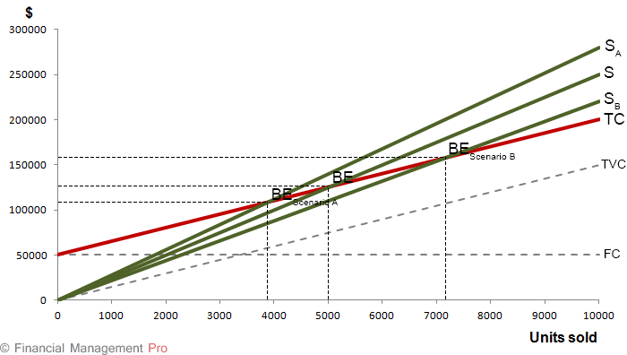

Q. Zoltrixound company manufactures high quality speakers for desktop and laptop computers. Last month Zoltrixound suffered a loss of $18,000. The [income statement](https://www.accountingformanagement.org/income-statement/) for the last month is as follows:

[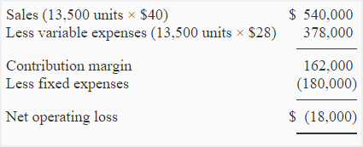](http://www.accountingformanagement.org/wp-content/uploads/2012/08/problem-1-cvapr-img1.png)

**Required:**

1. Compute the break-even point and [contribution margin](https://www.accountingformanagement.org/contribution-margin/) ratio (CM ratio) of Zoltrixound company?
2. Sales department feels that if monthly advertising budget is increased by $16,000, the sales will be increased by 3,500 units. Show the effect of these changes assuming the selling price remains unchanged.
3. If sales price is reduced by 20% and monthly advertising expenses are increased by $70,000, the unit sales are expected to increase by 100%. Show the effect of this change by preparing a new [income statement](https://www.accountingformanagement.org/income-statement/) of Zoltrixound company.
4. The Zoltrixound wants to make the packing of  its product more attractive. The new packing would increase cost by $1.20 per unit. Assuming no other changes, compute the number of units to be sold to earn a net operating income of $9,000.
5. The company is planning to purchase a new machine. The installation of  new machine will increase fixed cost by $236,000 and decrease unit variable expenses by 50%.  
   (a). Compute the CM ratio and break-even point if the new machine is installed.  
   (b). Company expects a sale of 20,000 units for the next month. Prepare two income statement, one assuming that the machine is not installed and one assuming that it is installed.  
   (c) Should the company install new machine. Give your recommendations.

## Solution:

### (1) Computation of CM ratio and break-even point:

**a.** [Contribution margin](https://www.accountingformanagement.org/contribution-margin/) ratio = Contribution margin/Net sales

= $162,000/$540,000

= 0.30 or 30%

**b.** Break-even point in units = Fixed expenses/Contribution margin per unit

= $180,000/$12*

= 15,000 units

*$162,000/13,500 units

Break-even point in dollars = Break-even point in units × Sale price

=  15,000 units × $40

= $600,000

### (2) Effect of increase in advertising budget by $16,000 and sales by $140,000:

[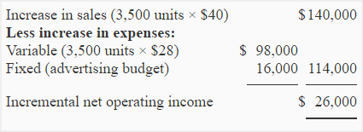](http://www.accountingformanagement.org/wp-content/uploads/2012/08/problem-1-cvapr-img2.png)

If monthly advertising budget is increased by $16,000 and sales revenues is increased by $140,000, the company will earn a profit of $8,000 ($26,000 – $18,000) rather than suffering a loss.

### (3) Effect of reduction in sales price by 20%, increase in monthly advertising budget by $70,000 and increase in unit sales by 100%:

[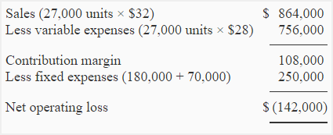](http://www.accountingformanagement.org/wp-content/uploads/2012/08/problem-1-cvapr-img3.png)

### (4) Computation of the number of units to be sold to earn $9,000:

Unit sale for target profit = (Fixed expenses + Target profit)/Contribution margin per unit

= ($180,000 + $9,000) / $10.80*

= 17,500 Units

*The new packing will increase variable expenses from $28 per unit to $29.20 per unit and reduce the contribution margin from $12 per unit to $10.80 per unit.

[$40 – ($28 + $1.20)] = $10.80

### (5). Installation of new machine:

**a.** [**Contribution margin ratio**](https://www.accountingformanagement.org/contribution-margin-ratio/) **and break-even point if new machine is installed:**

**i.** [Contribution margin ratio](https://www.accountingformanagement.org/contribution-margin-ratio/) = Contribution margin/Net sales

= $351,000/$540,000

= 0.65 or 65%

**ii.** Break-even point in units = Fixed expenses/Contribution margin per unit

= $416,000/$26*

= 16,000 units

*Variable expenses have decreased from $28 to $14 (50% reduction) therefore the contribution margin would increase from $12 per unit to $26 per unit ($40 – $14).

Break-even point in dollars = Break-even point in units × Sale price

= 16,000 units × $40

= $640,000

**(b). Income statement with and without installing new machine:**

If new machine is not installed:

[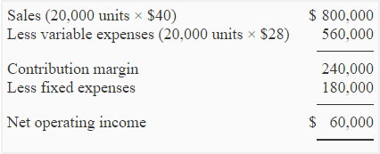](http://www.accountingformanagement.org/wp-content/uploads/2012/08/problem-1-cvapr-img4.png)

If new machine is installed:

[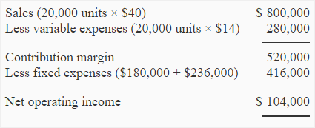](http://www.accountingformanagement.org/wp-content/uploads/2012/08/problem-1-cvapr-img5.png)

**c. Decision about installing new machine:**

If only the monthly net operating income is considered, Zoltrixound should purchase and install the new machine because it will generate more net operating income. At 20,000 units per month, variable expenses will decrease by $280,000 (20,000 units × $14) and monthly fixed expenses will increase by only $236,000. The saving in variable expenses is therefore greater than the increase in fixed expenses

Q.1

Beta company sells blouses in Washington, USA. Blouses are imported from Pakistan and are sold to customers in Washington at a profit. Salespersons are paid basic salary plus a decent commission of $14 on each sale made by them. Selling price and expense data is given below:

[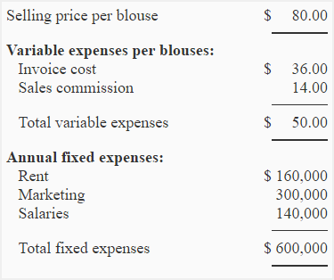](http://www.accountingformanagement.org/wp-content/uploads/2012/08/problem-2-cvapr-img1.png)

**Required:**

1. Compute the break-even point in units and in dollars using the information given above.
2. Prepare a CVP graph (break-even chart) and show the break-even point on the graph.
3. What would be net operating income or loss if company sells 18,500 blouses in a year?
4. If the manage is paid a commission of $6 blouse (in addition to the salesperson’s commission), what will be the effect on company’s break-even point?
5. As an alternative to (3) above, company is thinking to pay $6 commission to manager on each blouse sold in excess of break-even point. What will be the effect of these changes on the net operating income or loss of the Beta company if 23,500 blouses are sold in a year?
6. Refer to the original data. What will be the break-even point of the company if commission is entirely eliminated and salaries are increased by $214,000?

## Solution:01

### (1) Calculation of break-even point:

**a. Equation method:**

SpQ = VeQ + Fe

$80Q = $50Q + $600,000

$80Q – $50Q = $600,000

$30Q = $600,000

Q = $600,000/$30

Q = 20,000 blouses

20,000 blouses × $80.00 per blouse = $1,600,000

**b.** [**Contribution margin**](https://www.accountingformanagement.org/contribution-margin/) **method:**

Break-even point = Fixed expenses/[Contribution margin](https://www.accountingformanagement.org/contribution-margin/) per unit

= $600,000/$30*

= 20,000 blouses

20,000 blouses × $80.00 per blouse = $1,600,000

*$80 – $50 = $30

**Alternatively;**

Break-even point = Fixed expenses/CM ratio

= $600,000/0.375*

= $1,600,000

*$30/$80 = 0.375

### (2) CVP graph or break-even chart:

[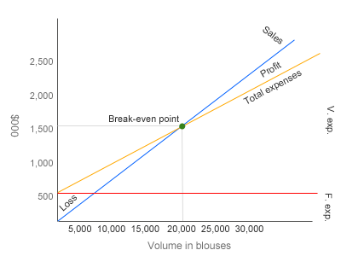](http://www.accountingformanagement.org/wp-content/uploads/2012/08/cvp-graph-breakeven-chart1.png)

### (3). Net operating income or loss if 18,500 blouses are sold in a year

[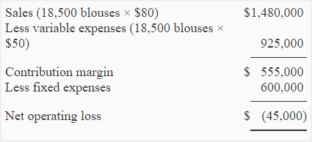](http://www.accountingformanagement.org/wp-content/uploads/2012/08/problem-2-cvapr-img2.png)

An alternative and more simple approach is given below:

[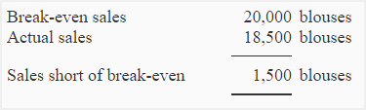](http://www.accountingformanagement.org/wp-content/uploads/2012/08/problem-2-cvapr-img3.png)

Net operating loss = Sales short of break-even × Contribution margin per unit

= 1,500 blouses × $30

= $45,000

### (4) Break-even point if manager is also paid a commission of $6 per blouse sold:

The payment of a commission of $6 to manager will increase variable expenses and decrease contribution margin. Now the variable expenses will be $56 ($50 + $6) per unit and contribution margin will be $24 ($80 – $56) per unit.

**a. Equation method:**

SpQ = VeQ + Fe

$80Q = $56Q + $600,000

$80Q – $56Q = $600,000

$24Q = $600,000

Q = $600,000/$24

Q = 25,000 blouses

25,000 blouses × $80.00 per blouse = $2,000,000

**b. Contribution margin method:**

Break-even point in units = Fixed expenses/Contribution margin per unit

$600,000/$24*

25,000 blouses

25,000 blouses × $80.00 per blouse = $2,000,000

*$80 – $56 = $24

**Alternatively;**

Break-even point = Fixed expenses/CM ratio

= $600,000/0.30*

= $2,000,000

*$24/$80 = 0.30

### (4) Effect on net operating income or loss if manager is paid a commission of $6 on each blouse sold after break-even point:

[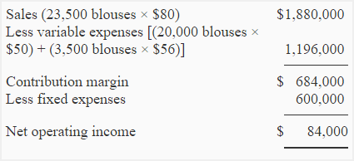](http://www.accountingformanagement.org/wp-content/uploads/2012/08/problem-2-cvapr-img4.png)

**Alternatively the net operating income of $84,000 may also be computed by using the following simple approach:**

[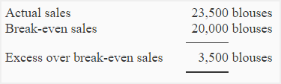](http://www.accountingformanagement.org/wp-content/uploads/2012/08/problem-2-cvapr-img5.png)

3,500 shirts × $24 per shirt* = $84,000 profit

*[$80 – ($50 + $6)] = $24

### (5) Break-even point after elimination of commission and increase in salaries:

The new variable expenses are $36 (invoice cost, no commission) and new fixed expenses are $814,000 ($600,000 + $214,000).

**a. Equation method:**

SpQ = VeQ + Fe

$80Q = $36Q + $814,000

$80Q – $36Q = $814,000

$44Q = $814,000

Q = $814,000/$44

Q = 18,500 blouses

18,500 blouses × $80.00 per blouse = $1,480,000

**b. Contribution margin method:**

= $814,000/$44*

= 18,500 blouses

18,500 blouses × $80 = $1,480,000

*$80 – $36 = $44

***Alternatively;***

Break-even point = Fixed expenses/CM ratio

= $814,000/0.55*

= $1,480,000

*$44/$80 = 0.55