Urinary system
# 1. Urinary system
The urinary system, also known as the renal system, produces, stores and eliminates urine, the fluid waste excreted by the kidneys. The kidneys make urine by filtering wastes and extra water from blood.
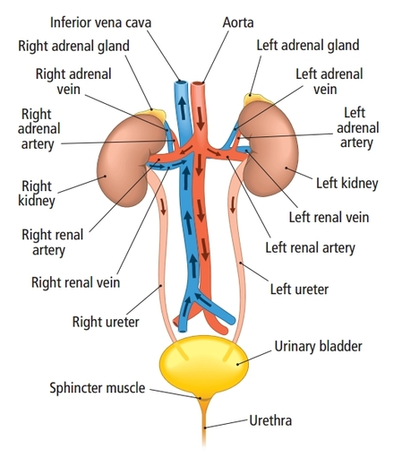
#2. Kidney
The kidneys are a pair of organs located in the back of the abdomen. Each kidney is about 4 or 5 inches long -- about the size of a fist.
# 3. Structure of kidney
- The kidneys are a pair of bean-shaped structures that are located just below and posterior to the liver in the peritoneal cavity.
- Adrenal glands, also called suprarenal glands, sit on top of each kidney.
- All the blood in the human body is filtered many times a day by the kidneys.
- Externally, the kidneys are surrounded by three layers.
- The outermost layer is the renal fascia, is a tough connective tissue layer.
- The second layer is the perirenal fat capsule, and the third and innermost layer is the renal capsule.
- Internally, the kidney has three regions.
- An outer cortex, a medulla in the middle, and the renal pelvis.
- Kidney nephrons is the functional units where the kidney's main functions are performed. There are about a million nephrons in each kidney.
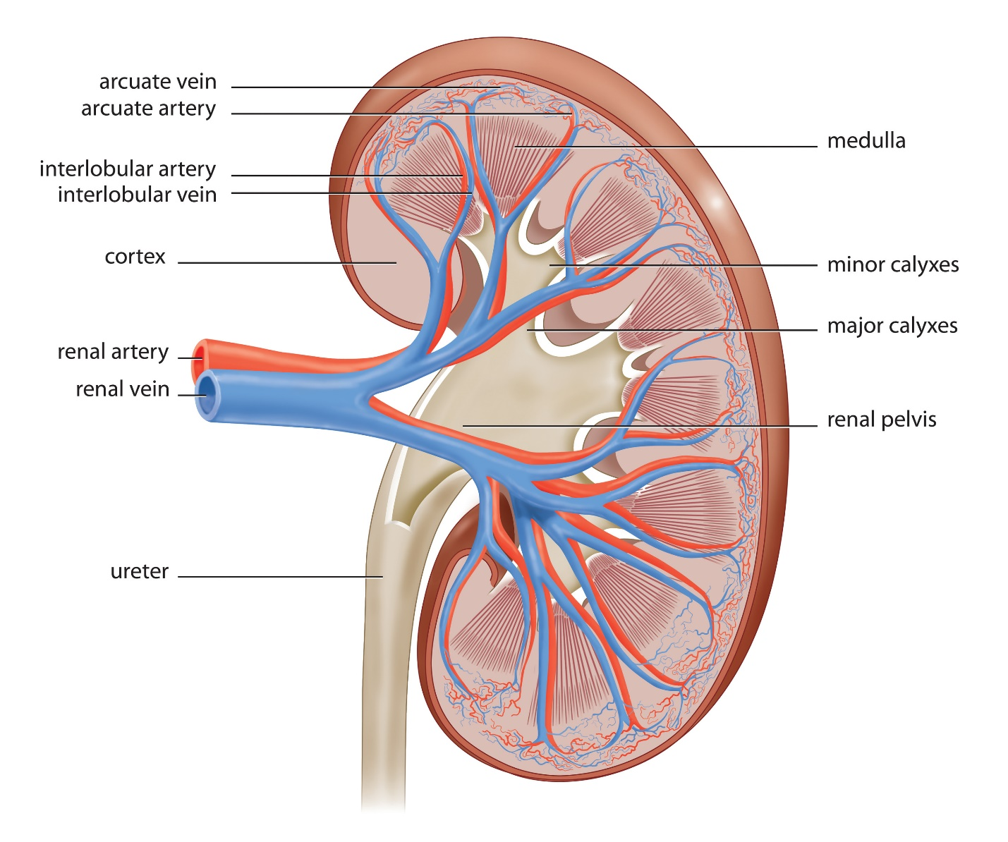
#4. Functions of kidney
- Waste excretion: The kidneys filter out toxins, excess salts, and urea. Urea is synthesized in the liver and transported through the blood to the kidneys for removal.
- Water level balancing: It maintains body’s water level throughout the day when water intake decreases.
- Blood pressure regulation: As the kidneys need constant pressure to filter the blood, so when blood pressure falls, the kidneys increase the pressure.
- Red blood cell regulation: The kidneys produce erythropoietin, a hormone that stimulates bone marrow to produce more red blood cells when the body does not get enough oxygen.
- Acid regulation: As cells metabolize, they produce acids. Kidneys do the acid regulation within our body.
#5. Nephron: The functional unit of kidney
- The nephron is responsible for removing waste from the body.
- Each kidney is composed of over one million nephrons.
- 85% of nephrons are cortical nephrons, deep in the renal cortex; the remaining 15% are juxta-medullary nephrons, which lie in the renal cortex close to the renal medulla.
- A nephron consists of three parts: a renal corpuscle, a renal tubule, and the associated capillary network.
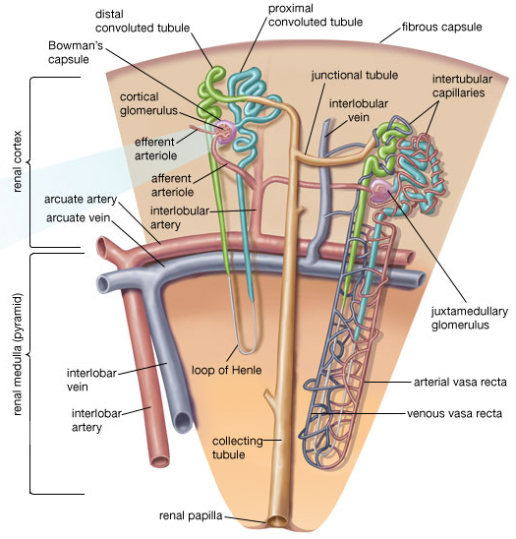
- The renal corpuscle, located in the renal cortex, is composed of a network of capillaries known as the glomerulus, as well as a cup-shaped chamber that surrounds it, called the glomerular or Bowman's capsule.
- The renal tubule is a long, convoluted structure that emerges from the glomerulus.
- It is divided into three parts based on function.
- The first part is called the proximal convoluted tubule (PCT), due to its proximity to the glomerulus.
- The second part is called the loop of Henle, because it forms a loop.
- The third part is called the distal convoluted tubule (DCT).
#6. Functions of nephron
The basic function of the nephron is to filter blood and remove waste substances while retaining essential substances for various biochemical processes. In the process, the nephron can also influence the pH (acid-base balance) of the blood, regulate blood pressure, maintain the blood volume and control the level of electrolytes in the body fluids.
The functions of the nephron can be discussed with regards to each part:
- Bowman’s capsule
  - Collects the incoming fluid from the glomerular capillaries.
- Proximal tubule
  - Sodium, chloride, water, glucose and amino acids are reabsorbed.
  - Organic acids and bases like bile salts, oxalate and urate are secreted into the proximal tubule.
- Loop of Henle
  - Water is reabsorbed mainly in the descending limb and thin segment of the ascending limb.
  - Sodium, calcium, chloride, magnesium and potassium are actively reabsorbed in the thick segment of the ascending limb.
- Distal tubule
  - Controls the blood flow through the glomerular capillaries and glomerular filtration of the nephron.
  - Sodium, potassium and chloride reabsorption.
- Collecting tubule
  - Sodium, potassium and chloride reabsorption.
  - Hydrogen ion secretion.
#7. Urine

Urine is a liquid by-product of the body secreted by the kidneys through a process called urination and excreted through the urethra.
Urine is an aqueous solution of greater than 95% water. Other constituents include urea, chloride, sodium, potassium, creatinine and other dissolved ions, and inorganic and organic compounds. Urea is a non-toxic molecule made of toxic ammonia and carbon dioxide. Any abnormal constituents found in urine are an indication of disease.

# 8. Composition of urine
Chemical | Concentration in g/100 ml urine
water | 95
urea | 2
sodium | 0.6
chloride | 0.6
sulfate | 0.18
potassium | 0.15
phosphate | 0.12
creatinine | 0.1
ammonia | 0.05
uric acid | 0.03
calcium | 0.015
magnesium | 0.01
protein | --
glucose | --

#9. Properties of urine
Urine is a sterile waste product composed of water soluble nitrogen products.
- Color: Typically yellow-amber, but varies according to recent diet and the concentration of the urine.
- Smell: Generally fresh urine has a mild smell but aged urine has a stronger odor similar to that of ammonia.
- The pH of normal urine is generally in the range 4.6 – 8.
- Density: The density of normal urine ranges from 0.001 to 0.035.
- Turbidity: The turbidity of the urine sample is reported as clear, slightly cloudy, cloudy, opaque or flocculent.
#10. Urinary bladder
The urinary bladder is a hollow elastic organ that functions as the body’s urine storage tank. Urine produced by the kidneys flows through the ureters to the urinary bladder, where is it stored before passing into the urethra and exiting the body.
Urine is made in the kidneys, and travels down two tubes called ureters to the bladder. The bladder stores urine, allowing urination to be infrequent and voluntary. The normal capacity of the bladder is 400 to 600 mL.
