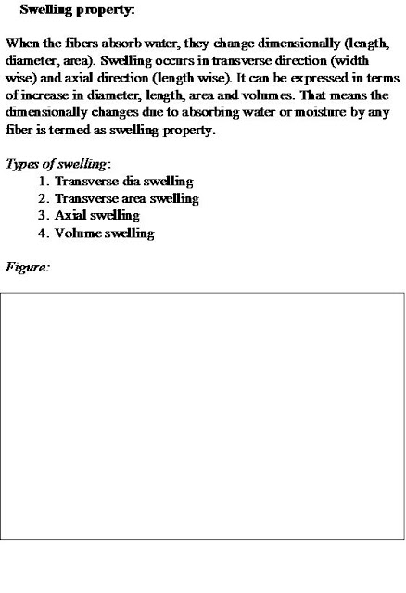
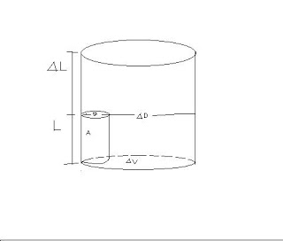

11. Transverse dial swelling: Fractional increase in diameter of a fiber after swelling is called transverse dia swelling.

Mathematically,
Transverse dia swelling, S_{D} = ∆D / D
Where, D = original diameter of fiber,
∆D =increased diameter of swollen fiber.

2. Transverse area swelling: Fractional increase in area of a fiber after swelling is called transverse area swelling.

Mathematically,
Transverse area swelling, S_{A} = ∆A / A
Where, A = original area of fiber,
∆A =increased area of swollen fiber.

3. Axial swelling: Fractional increase in length of a fiber after swelling is called axial swelling.

Mathematically, Axial swelling, S_{L} = ∆L / L
Where, A = original length of fiber,
∆L =increased length of swollen fiber.

4. Volume swelling: Fractional increase in volume of a fiber after swelling is called volume swelling.

Mathematically,
Volume swelling, S_{V} = ∆V / V
Where, V = original Volume of fiber,
∆V =increased volume of swollen fiber.

Relation between S_{A} & S_{D}:
We know that,
Transverse area swelling, S_{A} = ∆A / A
Transverse dia swelling, S_{D} = ∆D / D
For a circular fiber, area A = (π/4)D²
For a swollen fiber, we get, A+∆A = (π/4)(D+∆D)
= (π/4)(D² + 2D. ∆D + ∆D²)
Now,
S_{A} = ∆A / A
= (A+∆A-A) / A
= {(π/4) (D² + 2D. ∆D + ∆D²) - (π/4) D2}/ (π/4) D2
= (π/4) (D² + 2D. ∆D + ∆D² - D²⁾ / (π/4) D2
= (2D. ∆D + ∆D²) / D²
= (2D. ∆D / D²) + (∆D²/ D²)
= 2(∆D / D) + (∆D²/ D²)
= 2 S_{D} + S_{D}²

So, S_{A} = 2 S_{D} + S_{D}².

Relation among S_{A} ,S_{V} & S_{L}:

We know that,
Transverse area swelling, S_{A} = ∆A / A
Volume swelling, S_{V} = ∆V / V
Axial swelling, S_{L} = ∆L / L
For a circular fiber, volume, V=AL
For a swollen fiber, we get, V +∆V = (A +∆A )(L +∆L)
= AL + A∆L + ∆AL + ∆A ∆L
Now, S_{V} = ∆V / V
=(V+ ∆V - V) / V
=( AL + A∆L + ∆AL + ∆A ∆L - AL)/AL
= ∆L / L+ ∆A/ A + ∆A/ A. ∆L / L
= S_{L} + S_{A} + S_{L.} S_{A}
So, S_{V} = S_{L} + S_{A} + S_{L.} S_{A.}

