Endocrine system
#1. Hormone
Hormones are chemical messengers that are secreted directly into the blood, which carries them to organs and tissues of the body to exert their functions. There are many types of hormones that act on different aspects of bodily functions and processes. Some of these include:
- Development and growth
- Metabolism of food items
- Sexual function and reproductive growth and health
- Cognitive function and mood
- Maintenance of body temperature and thirst
#2. Endocrine system
The endocrine system includes all of the glands of the body and the hormones produced by those glands. The glands are controlled directly by stimulation from the nervous system. By regulating the functions of organs in the body, these glands help to maintain the body’s homeostasis like: cellular metabolism, reproduction, sexual development, heart rate, and digestion.

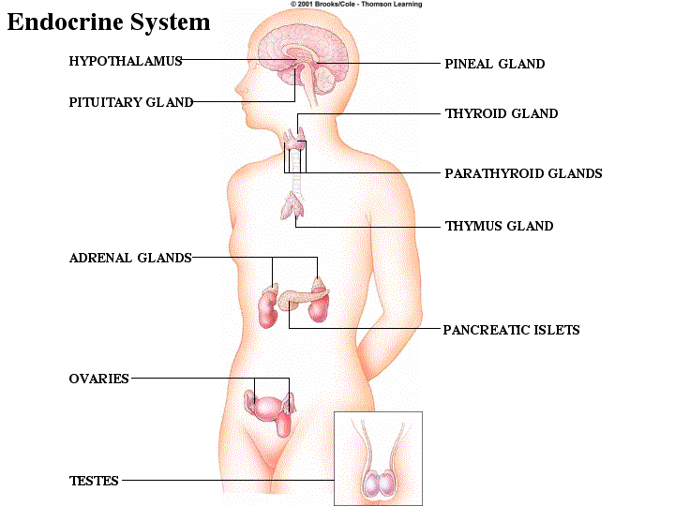

# 3. Glands of endocrine system
The glands of the endocrine system are:
- Hypothalamus
- Pineal Gland
- Pituitary Gland
- Thyroid
- Parathyroid
- Thymus
- Adrenal
- Pancreas
- Ovaries
- Testes
# 4. Glands and their functions
- Hypothalamus: It is responsible for body temperature, hunger, moods and the release of hormones from other glands; and also controls thirst, sleep and sex drive.
- Thymus: function the adaptive immune system and and produces T-cells.
- Pancreas: This gland produces the insulin that helps control blood sugar levels.
- Thyroid: The thyroid produces hormones associated with calorie burning and heart rate.
- Parathyroid: This gland controls the amount of calcium in the body.
- Adrenal: Adrenal glands produce the hormones that control sex drive and cortisol, the stress hormone.
- Pituitary: Considered the "master control gland," the pituitary gland controls other glands and makes the hormones that trigger growth.
- Pineal: this gland produces serotonin derivatives of melatonin, which affects sleep.
- Ovaries: Only in women, the ovaries secrete estrogen, testosterone and progesterone, the female sex hormones.
- Testes: Only in men, the testes produce the male sex hormone, testosterone, and produce sperm.
#5. Hypothalamus
The hypothalamus is a part of the brain located superior and anterior to the brain stem and inferior to the thalamus. It is responsible for the direct control of the endocrine system through the pituitary gland. The secreted hormones are:
- Thyrotropin-releasing hormone (TRH): stimulates the anterior pituitary gland to release thyroid-stimulating hormone
- Growth hormone-releasing hormone (GHRH): stimulates growth hormone release
- Growth hormone-inhibiting hormone (GHIH): inhibit growth hormone release
- Gonadotropin-releasing hormone (GnRH): stimulates the release of follicle stimulating hormone and luteinizing hormone
- Corticotropin-releasing hormone (CRH): stimulates the release of adrenocorticotropic hormone
- Oxytocin
- Antidiuretic hormone (ADH)
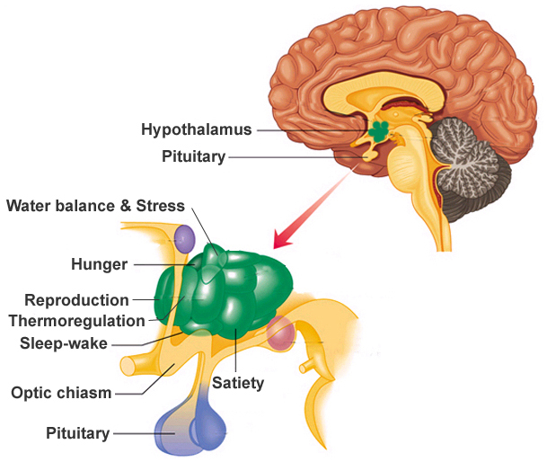
# 6. Pituitary gland
The pituitary gland, also known as the hypophysis, is a small pea-sized lump of tissue connected to the inferior portion of the hypothalamus. Many blood vessels surround the pituitary gland to carry the hormones it releases throughout the body. The pituitary gland is actually made of 2 completely separate structures: the posterior and anterior pituitary glands.
Posterior Pituitary: 2 hormones in the hypothalamus that are stored and released by the posterior pituitary:
- Oxytocin: triggers uterine contractions during childbirth and the release of milk during breastfeeding.
- Antidiuretic hormone (ADH): prevents water loss in the body by increasing the re-uptake of water in the kidneys.
Anterior Pituitary: The anterior pituitary produces 6 important hormones:
- Thyroid stimulating hormone (TSH): stimulates the thyroid gland.
- Adrenocorticotropic hormone (ACTH): stimulates the adrenal cortex and the adrenal gland, to produce its hormones.
- Follicle stimulating hormone (FSH): stimulates the follicle cells of the gonads to produce gametes—ova in females and sperm in males.
- Luteinizing hormone (LH): stimulates the gonads to produce the sex hormones—estrogens in females and testosterone in males.
- Human growth hormone (HGH): stimulate growth, repair, and reproduction.
- Prolactin (PRL): stimulates the mammary glands of the breast to produce milk.
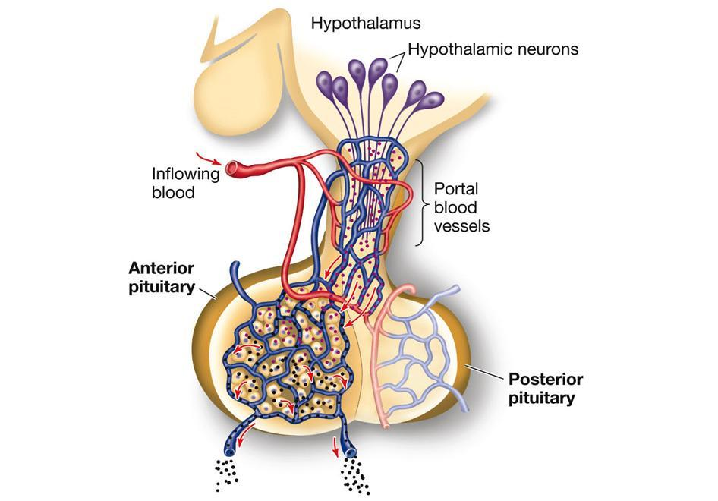
# 7. Thyroid gland
The thyroid gland is a butterfly-shaped gland located at the base of the neck and wrapped around the lateral sides of the trachea. The thyroid gland produces 3 major hormones:
- Calcitonin: Reduce the concentration of calcium ions in the blood by aiding the absorption of calcium into the matrix of bones.
- Triiodothyronine (T3)
- Thyroxine (T4)
The hormones T3 and T4 work together to regulate the body’s metabolic rate. Increased levels of T3 and T4 lead to increased cellular activity and energy usage in the body.
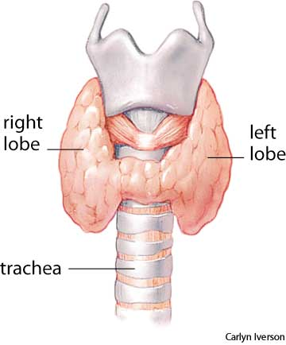
# 8. Parathyroid glands
- The parathyroid glands are 4 small masses of glandular tissue found on the thyroid gland.
- The parathyroid glands produce the hormone parathyroid hormone (PTH).
- When calcium ion levels in the blood drop below a set point, PTH is released.
- PTH stimulates the osteoclasts to break down the calcium containing bone matrix to release free calcium ions into the bloodstream.
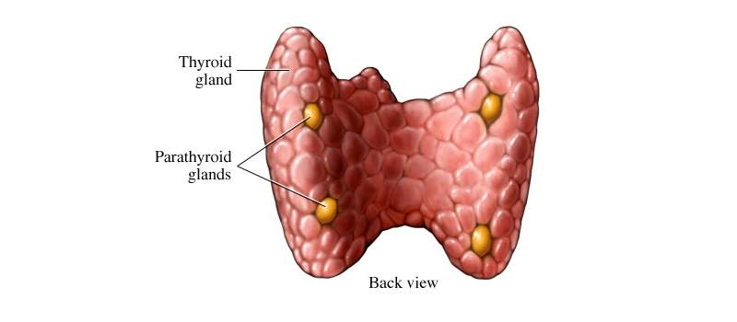
#9. Adrenal Glands
The adrenal glands are a pair of triangular glands found superior to the kidneys. The adrenal glands are each made of 2 distinct layers: the outer adrenal cortex and inner adrenal medulla.
Adrenal cortex: It produces cortical hormones in 3 classes: glucocorticoids, mineralocorticoids, and androgens.
- Glucocorticoid: breakdown the proteins and lipids to produce glucose.
- Mineralocorticoids: regulate the concentration of mineral ions in the body.
- Androgens: produced at low levels in the adrenal cortex to regulate the growth and activity of cells that are receptive to male hormones (testosterone).
Adrenal medulla:
- The adrenal medulla produces the hormones epinephrine and norepinephrine.
- These hormones work to increase heart rate, breathing rate, and blood pressure.

