Lesson 3: Dietary fibers (Non-digestible carbohydrates)
Learning outcomes
Upon completion of this lesson, the learners will be able to
    - Define dietary fibers;
    - Classify dietary fibers;
    - Describe health benefits and deficiency diseases of dietary fibers.

Dietary fibers
Dietary fiber (complex carbohydrates/polysaccharide), also called roughage, is the non-digestible parts of plants that form the support structures of leaves, stems, and seeds. They are polysaccharides (except lignins), highly branched, cross-linked and have β-1,4-glycosidic linkage among glucose units. Dietary fibers are considered as the plant’s “skeleton’’. They are non- digestible because human do not have enzyme to break down β-1,4-glycosidic linkage into absorbable form glucose. So, dietary fibers do not contribute energy to our diet as they pass through digestive tract without being absorbed.

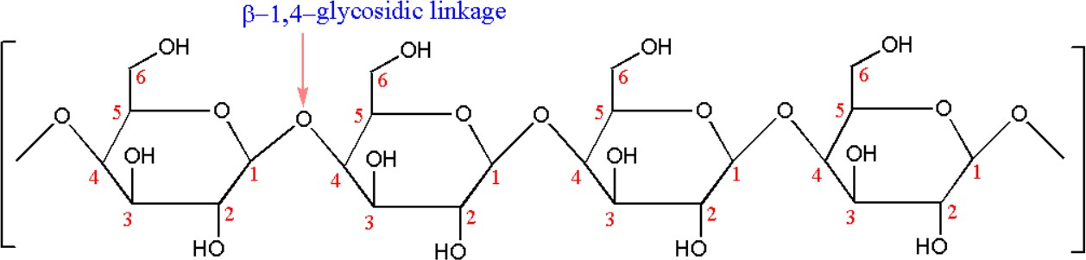

Cellulose

  - Classification of dietary fibers
Dietary fibers can be classified based on physical properties-
    - Soluble fibers: They are soluble in water and become viscous, forming gel when wetted by water adding bulk to stools which serves to slow the rate at which stool passes through the small intestine. Examples of soluble fibers: pectins, gums and mucilages.

    - Insouble fibers: This type of fibers are not soluble in water; they are usually nonviscous, increases stool bulk and promotes to pass stool quickly through the intestine. Examples of insoluble fibers: cellulose, hemicelluloses and lignins
Table 3.1: Sources of dietary fibers

Dietary fibers | Members | Sources
Water insoluble/ less fermentable | Cellulose | Component of plant cell walls abundant in whole  grains, legumes, the skin of fruits and vegetables
 | Hemicelluloses | Often associated with cellulose
 | Lignins  (Noncarbohydrate) | Found in woody parts (seeds of fruits, bran, husk of  grains), carrots and pears
Water soluble/viscous More fermentable | Gums | Seeds
 | Pectins | Pears, apples, guavas, plums, gooseberries, and oranges and other citrus fruits contain large amounts  of pectin,
 | Mucilages | Psyllium husk (isabgul), seaweeds, oats, barley,  legumes, eggplants

There is another type of fiber called functional fiber which is either extracted from plants or manufactured in laboratory. Functional fiber is added to food or supplied as supplement to prevent constipation or lowering blood glucose levels/cholesterol after meals. But they lack of nutrients and necessary phytochemicals that come with the fiber found in whole foods. For example, polydextrose psyllium β-glucans, cellulose, guar gum, inulin, resistant maltodextrin.
Most foods of plant origin contain mixtures of soluble and insoluble fibers. List of some high dietary fibers containing foods are given below (Table 3.2).

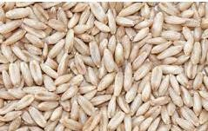
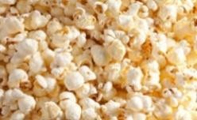
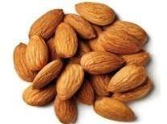
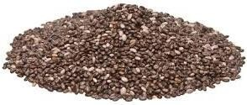
Table 3.2: Dietary fiber content of different foods (g/100 g edible portion)
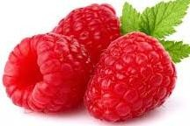
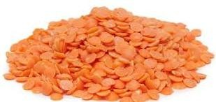
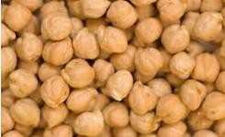
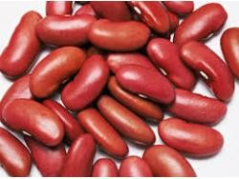
Raspberries (6.5 g) | Lentils (7.9%) | Chickpeas (7.6%) | Kidney Beans (6.4%)
Oats (10.6%) | Popcorn (14.5%) | Almonds (12.5%) | Chia seeds (34.4%)

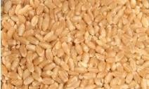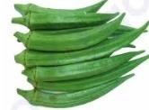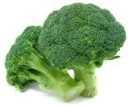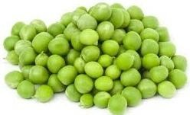

Whole wheat (13%) | Ladies finger (4.2%) | Broccoli (2.6%) | Green peas (6%)

Table 3.3: Typical serving size and fiber content of some foods

Fruits | Serving size | Total fiber (grams)*
Raspberries | 1 cup | 8.0
Pear | 1 medium | 5.5
Apple, with skin | 1 medium | 4.5
Banana | 1 medium | 3.0
Orange | 1 medium | 3.0
Strawberries | 1 cup | 3.0

Vegetables | Serving size | Total fiber (grams)*
Green peas, boiled | 1 cup | 9.0
Broccoli, boiled | 1 cup chopped | 5.0
Turnip greens, boiled | 1 cup | 5.0
Brussels sprouts, boiled | 1 cup | 4.0
Potato, with skin, baked | 1 medium | 4.0
Sweet corn, boiled | 1 cup | 3.5
Cauliflower, raw | 1 cup chopped | 2.0
Carrot, raw | 1 medium | 1.5
Tomato, raw sliced | 1 cup (180 g) | 2.5
Raw, chopped cabbage | 1 cup (89g) | 2.5
Raw okra/ladies finger | 1 cup (100 g) | 3.5

Grains | Serving size | Total fiber (grams)*
Spaghetti, whole-wheat, cooked | 1 cup | 6.0
Barley, pearled, cooked | 1 cup | 6.0
Bran flakes | 3/4 cup | 5.5
Quinoa, cooked | 1 cup | 5.0
Oat bran muffin | 1 medium | 5.0
Oatmeal, instant, cooked | 1 cup | 5.0
Popcorn, air-popped | 3 cups | 3.5
Brown rice, cooked | 1 cup | 3.5
Bread, whole-wheat | 1 slice | 2.0
Bread, rye | 1 slice | 2.0

Legumes, nuts and seeds | Serving size | Total fiber (grams)*
Split peas, boiled | 1 cup | 16.0
Lentils, boiled | 1 cup | 15.5
Black beans, boiled | 1 cup | 15.0

Baked beans, canned | 1 cup | 10.0
Chia seeds | 28 g | 10.0
Almonds | 28 (23 nuts) | 3.5
Pistachios | 28 (49 nuts) | 3.0
Sunflower kernels | 28 g | 3.0
*Rounded to nearest 0.5 gram.

Fate of dietary fibers
Soluble and insoluble fibers behave somewhat differently in the gastrointestinal tract. Soluble fiber absorbs water and form viscous solutions that slow the rate at which nutrients are absorbed from the small intestine. Because neither soluble nor insoluble fiber can be digested in the small intestine and so they travel into the large intestine. Bacteria in the colon digest some soluble fiber to produce gas and fatty acids (propionic acid & butyric acids); fatty acids can be absorbed into the body and used as an energy source. Some soluble fiber-and most insoluble fiber-is excreted in the feces.

Health benefits of dietary fibers
A diet high in fiber has numerous health benefits related with gastrointestinal tract and chronic diseases; some of which are given below-

Prevents hemorrhoids and constipation
Consuming high fiber containing diet produces soft and large volume stool which reduces pressure for defecation. This reduces the incidence of constipation (dry and hard stool which difficult to pass) and prevents hemorrhoids (swellings of the veins in the rectal or anal area).
Adds bulk to the stool, which is easier to pass, hence decreases the chance of constipation.

Prevention of diarrhea
Soluble fiber can absorb excess fluid in the bowel. In case of loose watery stools, soluble dietary fiber can solidify loose stool because it absorbs water and adds bulk to stool.

Increase muscle strength of colon
Dietary fibers increase the amount and volume of stool. The presence of larger and softer stool in the colon stimulates peristalsis (rhythmic muscle contraction) that pushes the stool onwards and makes it easier to eliminate. The continuous pushing action of colon (gut) muscles makes it stronger.

Reduce the risk of heart disease
Soluble fibers due to its gel forming capacities increase the viscosity of the content of the small intestine. Absorption of fats (cholesterol, fatty acids and lecithin) comes from either foods or bile secretion is either blocked or slowed absorption into the bloodstream due to increase viscosity of the gastrointestinal content by soluble fibers and promotes fecal excretion and thereby reduces the

risk of heart disease. Study shows that every additional 10 grams of fiber in the diet reduced the incidence of heart disease by 17%.

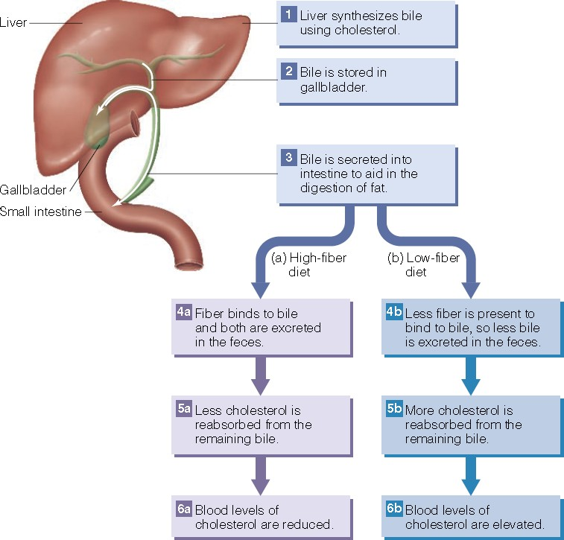
Figure 3.1: Mechanism of reduction of blood cholesterol by dietary fibers.

Prevent and manage diabetes
High-fiber diet slows the absorption of glucose from carbohydrate-containing meal by increasing viscosity of gastric and intestinal contents. Therefore, blood glucose levels will rise more slowly and less amount of insulin needed to keep glucose level in the normal range. This beneficial effect manages blood glucose level in individuals with diabetes and over the long term may reduce the risk of developing type 2 diabetes.

Enhance weight loss
Fibers slows gastric emptying rate which keeps you full for a longer time. This helps to prevent overeating. High fiber diet is low in calories and fats. Fibers also inhibit fats absorption. These combined effects of fibers enhance weight loss.

Prevent colon cancer
Fiber dilutes the intestinal contents and speeds up evacuation. These effects decrease exposure time of the potentially cancer-causing substances present in the intestinal contents to the lining cells of the colon. This role of fiber may reduce the incidence of colon cancer. The bulk and water of the feces may dilute the carcinogens to a nontoxic level.

Favour growth of beneficial bacteria
Favour the selection of beneficial gut bacteria such as Bifidobacteria, Lactobacilli and Streptococci. These bacteria detoxify harmful bacteria and synthesize beneficial compounds (e.g., vitamins) for us.

Deficiency diseases of dietary fibers
☞ Increase constipation and hemorrhoids.
☞ Increase risk of type 2 diabetes.
☞ Increase risk of heart disease due to increase cholesterol level.
☞ Increase body weight.
☞ Lack of fibrous foods increases the hardness of the stool. To eliminate the hard stool, large intestine needs to generate a great deal of pressure which weakens intestinal walls. The weakened intestinal wall then develops small outpouchings and form pockets (diverticula) (Figure 3.2) in which fecal material becomes trapped, infected and inflamed.
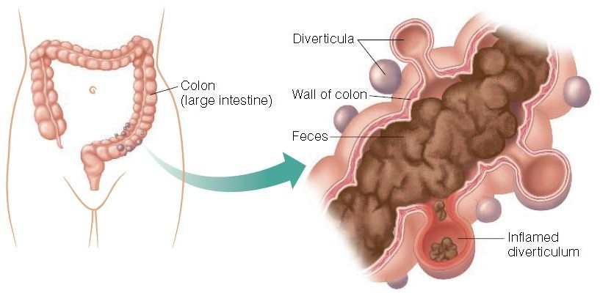

Figure 3.2: Diverticulosis occurs when bulging pockets form in the wall of the colon.

Problems with High-Fiber Diets
Consuming high fiber diet without drinking enough fluid/water can cause constipation (the stool becomes hard and difficult to eliminate). A sudden increase in fiber intake with plenty of fluid can cause abdominal discomfort, gas, and diarrhea due to the bacterial breakdown of fiber.
Too much fiber may decrease absorption of micronutrients (vitamins and minerals- zinc, calcium, magnesium, and iron) either by binding to them or by simply speeding the passage through the

intestinal tract and before being absorbed which may lead to deficiencies. Children need high amount of nutrients but their stomach is small. Children consuming very high fiber containing foods may feel full before consuming enough food to meet their energy and nutrient needs.

Recommended amount of fiber intake
Dietary reference intakes (DRIs) recommend a daily intake of 25 grams for young adult women and 38 grams for young adult men. This recommendation refers to total fiber, which includes dietary fiber and functional fiber.

Life stage | Age | Males (g/day) | Females (g/day)
Infants | 0-6 months | Not determined | Not determined
Infants | 7-12 months | Not determined | Not determined
Children | 1-3 yrs | 19 | 19
Children | 4-8 yrs | 25 | 25
Children | 9-13 yrs | 31 | 26
Adolescents | 14-18 yrs | 38 | 26
Adults | 19-50 yrs | 38 | 25
Adults | 51 yrs and older | 30 | 21
Pregnancy | All ages |  | 28
Breast feeding | All ages |  | 29

Evaluation at the end of the lesson:
Short Answer Questions:

    - Define dietary fibers;
    - Classify dietary fibers;
    - Write down the sources of dietary fibers
    - Describe health benefits and deficiency diseases of dietary fibers.

