Familiarization of various Solar (PV) system equipment

- Photovoltaic Module
A PV module consists of many PV cells wired in parallel to increase current and in series to produce a higher voltage. 36 cell modules are the industry standard for large power production.
The module is encapsulated with tempered glass (or some other transparent material) on the front surface, and with a protective and waterproof material on the back surface. The edges are sealed for weatherproofing, and there is often an aluminum frame holding everything together in a mountable unit. In the back of the module there is a junction box, or wire leads, providing electrical connections.
There are currently four commercial production technologies for PV Modules:
- Single Crystalline
This is the oldest and more expensive production technique, but it's also the most efficient sunlight conversion technology available. Module efficiency averages about 14% to 17%.
- Polycrystalline or Multicrystalline
This has a slightly lower conversion efficiency compared to single crystalline but manufacturing costs are also lower. Module efficiency averages about 13% to 15%.
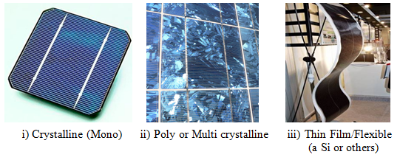
- Amorphous or Thin Film
Silicon material is vaporized and deposited on glass or stainless steel. The cost is lower than any other method. Module efficiency averages 5% to 7%.

Photovoltaic Array
A PV Array consists of a number of individual PV modules or panels that have been wired together in a series and/or parallel to deliver the voltage and amperage a particular system requires. An array can be as small as a single pair of modules, or large enough to cover acres.
12 volt module is the industry standard for battery charging. Systems processing up to about 2000 watt-hours should be fine at 12 volts. Systems processing 2000 - 7000 watt-hours will function better at 24 volt. Systems running more than 7000 watt-hours should probably be running at 48 volts.
2. Battery: Batteries accumulate excess energy created by PV system and store it to be used at night or when there is no other energy input. Batteries can discharge rapidly and yield more current that the charging source can produce by itself, so pumps or motors can be run intermittently. The battery's capacity for holding energy is rated in amp-hours: 1 amp delivered for 1 hour = 1-amp hour

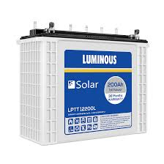
Figure: Battery

3. Charge Controller: Solar charge controller is charge controller that is used in the solar application and also called solar battery charger. Its function is to regulate the voltage and current from the solar arrays to the battery in order to prevent overcharging and also over discharging. There are many technologies have been included into the design of solar charge controller. For example, MPPT charge controller included maximum power point tracking algorithm to optimize the production of PV cell or module
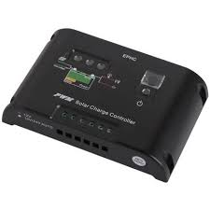
Figure: Charge Controller
4. Inverter: A solar inverter is one of the most important elements of the solar electric power system. It converts the variable direct current (DC) output of a photovoltaic (PV) solar panel into alternating 240V current (AC). This AC electricity then can be fed to the consumers.
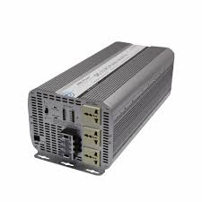
Figure: Solar Inverter

Working principle of Solar Cell:
The solar cells are based on the principles of photovoltaic effect. The generation of voltage across the PN junction in a semiconductor due to the absorption of light radiation is called photovoltaic effect. The Devices based on this effect is called photovoltaic device.
Solar cell (crystalline Silicon) consists of a n-type semiconductor (emitter) layer and p-type semiconductor layer (base). The two layers are sandwiched and hence there is formation of p-n junction. The surface is coated with antireflection coating to avoid the loss of incident light energy due to reflection.
When a solar panel exposed to sunlight, the light energies are absorbed by a semi conduction materials. Due to this absorbed energy, the electrons are liberated and produce the external DC current. Thus when this p and n layers are connected to external circuit, electrons flow from n-layer to p-layer. The electrons that leave the solar cell as current give up their energy to whatever is connected to the solar cell, and then re-enter the solar cell.

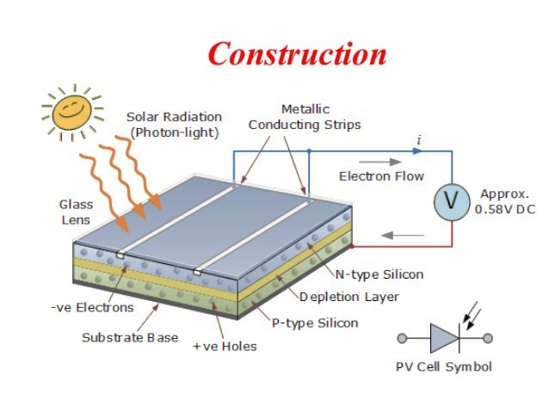

Schematic Arrangements Solar PV System:

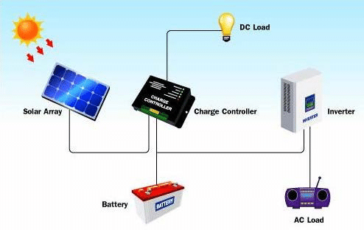

Types of PV Systems
Photovoltaic-based systems are generally classified according to their functional and operational requirements, their component configuration, and how the equipment is connected to the other power sources and electrical loads (appliances).
The two principle classifications are
- Grid-Connected and
- Stand Alone Systems.

- Grid Connected: Grid-connected or utility-intertie PV systems are designed to operate in
parallel with and interconnected with the electric utility grid. The primary component is the inverter, or power conditioning unit (PCU). The inverter converts the DC power produced by the PV array into AC power consistent with the voltage and power quality required by the utility grid. The inverter automatically stops supplying power to the grid when the utility grid is not energized. A bi-directional interface is made between the PV system AC output circuits and the electric utility network, typically at an on-site distribution panel or service entrance. This allows the power produced by the PV system to either supply on-site electrical loads, or to back feed the grid when the PV system output is greater than the on-site load demand. During periods when the electrical demand is greater than the PV system output (night-time), the balance of power required is received from the electric utility. This safety feature is required in all grid-connected PV systems, it also ensures that the PV system will not continue to operate and feed back onto the utility grid when the grid is down for service or repair.

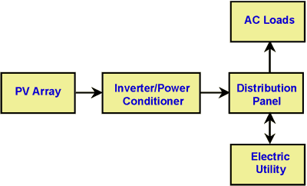

Figure 1. Diagram of grid-connected photovoltaic system.
- Stand Alone System: Stand-alone PV systems are designed to operate independent of the electric utility grid, and are generally designed and sized to supply certain DC and/or AC electrical loads. Stand-alone systems may be powered by a PV array only, or may use wind, an engine-generator or utility power as a backup power source in what is called a PV-hybrid system. The simplest type of stand-alone PV system is a direct-coupled system, where the DC output of a PV module or array is directly connected to a DC load.

Figure 2. Direct-coupled PV system.
Since there is no electrical energy storage (batteries) in direct-coupled systems, the load only operates during sunlight hours, making these designs suitable for common applications such as ventilation fans, water pumps, and small circulation pumps for solar thermal water heating systems. Matching the impedance of the electrical load to the maximum power output of the PV array is a critical part of designing well-performing direct-coupled system. For certain loads such as positive-displacement water pumps, a type of electronic DC-DC converter, called a maximum power point tracker (MPPT) is used between the array and load to help better utilize the available array maximum power output.
In many stand-alone PV systems, batteries are used for energy storage. Below is a diagram of a typical stand-alone PV system with battery storage powering DC and AC loads.
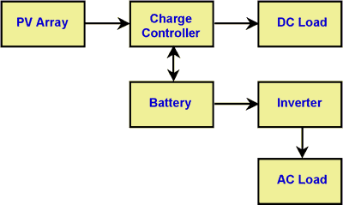

Figure 3. Diagram of stand-alone PV system with battery storage powering DC and AC loads.
Below is a diagram of a Photovoltaic Hybrid System with battery storage powering DC and AC loads and using a using a backup power source (wind, engine-generator or utility power)
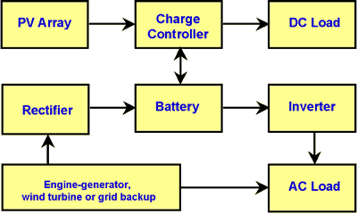

Figure 4. Diagram of photovoltaic hybrid system.

Advantages of PV System:
- It is clean and non-polluting.
- It is a renewable energy.
- Solar cells do not produce noise and they are totally silent.
- They require very little maintenance.
- They are long lasting sources of energy which can be used almost anywhere.
- They have long life time.
- There are no fuel costs or fuel supply problems.

Disadvantages of PV System:
- Solar power can`t be obtained in night time.
- Solar cells (or) solar panels are very expensive.
- They need large area of land to produce more efficient power supply

