Daffodil International University (DIU)
Department of Electrical and Electronic Engineering

EEE 324: Microprocessors and Interfacing Laboratory

Experiment No: 10

Name of the Experiment:
Writing a C language program to turn ON/OFF 8x8 Matrix LED present in microprocessor 8086 kit and load it to memory using Wincom software.

Dot Matrix LED Display:
KMD D1288C is 8x8 dotmatrix display. Both orange and green LEDs are present in each point. In the same column 8 orange and 8 green leds’ anodes(+ terminals) are all connected to a bit of port C of an 8255A(named U30, see board). In the same row 8 orange leds’ cathodes (- terminals) are all connected to a bit of port A. In the same row 8 green leds’ cathodes (- terminals) are all connected to a bit of port B.
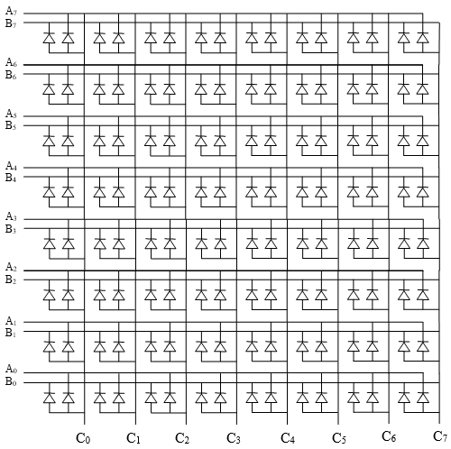
Figure: C. A. arrangement of 8x8 bi-color LED

Some syntax rules in C language:

            - In C, hexadecimal numbers are written in form of 0x(Num)
            - Whatever is written after // is considered as comment
            - Whatever is written between /* and */ also is considered as comment
            - #include “mde8086.h” adds a file mde8086.h from current/header file directory during compile time
            - Outportb(address,data) sends one byte data to output port located at particular address.
            - C-8086 is a batch file………….

Procedure:

- Create a source file using editor program: Open: C:\mda\8086\8086c>edit ↵
- We use the built-in program.
- From File menu Open Matrix file. Or write the code

void main(void)

{

outportb( 0x1e, 0x80 ); //0x1e is address of control register of 8255

outportb( 0x18, 0xff ); //0x18 is address of port A of 8255

outportb( 0x1a, 0x55 ); //0x1a is address of port B of 8255

outportb( 0x1c, 0xff ); //0x1c is address of port C of 8255

}
- Save the file as matrix.c

Creating .abs file and .obj file from .c file
- Make sure that folder containing your file also have TCC.EXE , MEXE2ABS.EXE, LINK.EXE, CS.LIB, RAMSTART.OBJ, TASM.EXE
- In command prompt browse to your folder.
- Write command c-8086 matrix↵
- C:\mda\8086\8086c>c-8086 matrix ↵

- You will see
C:\mda\my>c-8086 matrix
Turbo C Version 2.0 Copyright (c) 1987, 1988 Borland International
matrix.c:
Turbo Assembler Version 1.0 Copyright (c) 1988 by Borland International

Assembling file: MATRIX.ASM
Error messages: None
Warning messages: None
Remaining memory: 302k

Available memory 439410

C:\mda\my>link ramstart+matrix, matrix, matrix, cs.lib

Microsoft (R) Overlay Linker Version 3.60
Copyright (C) Microsoft Corp 1983-1987. All rights reserved.

LINK : warning L4021: no stack segment
Press any key to continue . . .

Then

Press Enter
Press Enter
Press Enter

>>Change Execution file name (*.exe): matrix.exe↵<<

Program of Segment: 0000

Program of Offset: 1000

Are you want to set up a jump instruction address of FFFF0H (Y/N)? N ↵

It is all done making HEX (*.ABS)!

Press any key to return DOS......

- Then see there is matrix.abs filein that folder.
- Start Wincomm software and reset the MDE-8086(which must be in serial monitor mode).
- Give L command “8086> L ↵” you will see “Down load start!!”
- Press F3 key and open the Matrix.ABS file.

8086 >L

Down load start !!

:061000000B155B030FEC145

:00

OK Completed !!

8086>

- Run the program By G command
- 8086>G
- To terminate program press MON in 8086 kit.

APPENDIX

Exp 1: Flag bits

Flag Register
The 8086 contains a 16-bit flag register that indicates the salient states and status of the processor after execution of an instruction. The flag register is also called Status Register (SR) or Program Status Word (PSW). Each bit of the flag register is called a flag and can take a value of 1 or 0. There are altogether nine flags in 8086. The bit assignment of the flag register is shown in Table 0.1.
Table 0.1 Flag register in 8086.
15 | 14 | 13 | 12 | 11 | 10 | 9 | 8 | 7 | 6 | 5 | 4 | 3 | 2 | 1 | 0
 |  |  |  | OF | DF | IF | TF | SF | ZF |  | AF |  | PF |  | CF

Carry Flag (CF) - this flag is set to 1 when there is an unsigned overflow. For example when you add bytes 255 + 1 (result is not in range 0...255). When there is no overflow this flag is set to 0.
Zero Flag (ZF) - set to 1 when result is zero. For none zero result this flag is set to 0.
Sign Flag (SF) - set to 1 when result is negative. When result is positive it is set to 0. Actually this flag take the value of the most significant bit.
Overflow Flag (OF) - set to 1 when there is a signed overflow. For example, when you add bytes 100 + 50 (result is not in range -128...127).
Parity Flag (PF) - this flag is set to 1 when there is even number of one bits in the result, and to 0 when there is odd number of one bits. Even if result is a word (16-bit wide) only 8 low bits are analyzed.
Auxiliary Flag (AF) - set to 1 when there is an unsigned overflow for low nibble (4 bits).
Interrupt enable Flag (IF) - when this flag is set to 1, the processor reacts to interrupts from external devices.

Direction Flag (DF) - this flag is used by string instructions to process data chains, when this flag is set to 0 - the processing is done forward, when this flag is set to 1 the processing is done backward.

Exp 5 : make bangladesh flag example

CODE SEGMENT

ASSUME CS:CODE

ORG 1000H

MOV AL, 10000000B

OUT 1EH, AL

START:

MOV AL, 00011000B

OUT 1CH, AL

MOV AL, 10111101B

OUT 18H, AL

MOV AL, 11000011B

OUT 1AH, AL

CALL DELAY

MOV AL, 11000011B

OUT 1CH, AL

MOV AL, 10000001B

OUT 18H, AL

MOV AL, 11111111B

OUT 1AH, AL

CALL DELAY

MOV AL, 00100100B

OUT 1CH, AL

MOV AL, 11100111B

OUT 1AH, AL

MOV AL, 10011001B

OUT 18H, AL

CALL DELAY

JMP START

DELAY: MOV CX, 1000;

L1: NOP

NOP

LOOP L1

RET

CODE ENDS

END

