Lesson 9: Minerals

Learning outcomes
Upon completion of this lesson, the learners will be able to
        - Define minerals;
        - Classify minerals;
        - Describe sources, functions and deficiency diseases of water soluble vitamins.

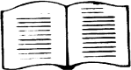
Minerals are inorganic elements (non-carbon containing) that occur naturally in the earth’s crust. They are the simplest form of chemicals and are not digested or broken down prior to absorption. Body can only use ions of minerals (water soluble form) which are also called electrolytes because they carry electrical charges. Minerals cannot be synthesized in the laboratory or by any plant or animal, including humans. However, humans can obtain minerals from water or plant foods or animal foods those eating plants.

9.1. Classification of minerals

- Major minerals: Major minerals are those that require at least 100 mg per day. Major minerals with known functions in the body include calcium (Ca), phosphorus (P), magnesium (Mg), sulfur (S), sodium (Na), potassium (K), and chloride (Cl). Special attention will be given in supplying calcium and phosphorus.
- Trace minerals: Trace minerals are those that require less than 100 mg per day. Currently, eight trace minerals are recognized as essential for human health: iron (Fe), iodine (I), copper (Cu), selenium (Se), zinc (Zn), fluoride (F), manganese (Mn) and chromium (Cr). Some attention must be paid eating foods that provide enough iron and iodine.

Sources, functions, deficiency diseases and risk of deficiency of major minerals

  - Calcium (Ca)

    - Sources
Most abundant mineral in body is calcium appears in combination with phosphates. About 99% stored in bone and teeth.

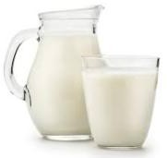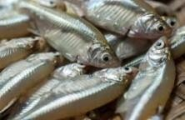

Milk | Egg yolk | Shellfish | Leafy vegetables | Small fish

Functions
☞ Develop bones and teeth in combination with phosphorus.
☞ Helps in transmission of nerve impulses.
☞ Helps in blood clotting.
☞ Helps in normal heart action
☞ Maintain normal muscle activity.
☞ Helps in cell division, glycogen metabolism, release of neurotransmitters and hormones.

Deficiency diseases
Similar signs and symptoms are observed due to the deficiency of calcium as vitamin D deficiency.

Risk groups of calcium deficiency
☞ Those having high demand of calcium such as children, adolescents, pregnant and lactating mother.
☞ Decrease sex hormone production and skin pigmentation (skin pigmentation prevents sunlight penetration into the skin), middle-aged and elderly people are at risk of calcium deficiency.

Phosphorus (P)

    - Sources
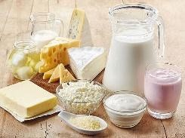
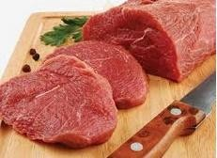
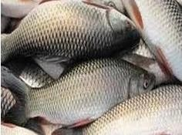
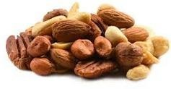
Dairy products | Meat | Fish | Poultry | Nuts

    - Functions
☞ Helps in formation of bones and teeth.
☞ Maintains blood pH.
☞ Plays role in muscle contraction and nerve activity.
☞ Component of many enzymes.

☞ Involved in energy transfer (ATP).
☞ Component of DNA and RNA.

Deficiency diseases:
      - Bone demineralization(loss of minerals),
      - Fatigue, and anorexia, muscle weakness, dizziness

Sodium (Na)

9.4.1. Sources: Table salt, fast foods, processed foods, meats, eggs, milk, cheese, etc.

Functions
☞ Maintain fluid balance.
☞ Transmission of impulses across nerve and muscle fibers.
☞ Acid-base balance.
☞ Muscle contraction.

Deficiency or Excess
Excessive loss of sodium due to severe vomiting, diarrhea, or heavy sweating can upset the acid- base balance in the body. Alkalosis may develop due to excessive sodium loss which cause tetany. An excess of sodium cause edema which can cause hypertension and congestive heart failure.

Potassium (K)

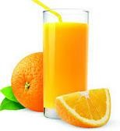
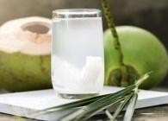
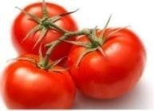
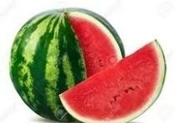
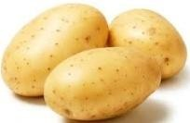
    - Sources: Some important sources are-
Banana | Orange juice | Coconut water | Tomatoes | Water melon | Potatoes

Functions:
☞ Needs for generation and conduction of impulse in neurons and muscle fibers.
☞ Maintains fluid and electrolytes balance.
☞ Participates many biochemical reactions in the body.
☞ Regulates heart rate.

Deficiency or Excess
Deficiency (hypokalemia) can be caused by diarrhea, vomiting, diabetic acidosis, severe malnutrition, or excessive use of laxatives or diuretics. Nausea, anorexia, fatigue, muscle weakness, and heart abnormalities (tachycardia) are symptoms of its deficiency. Hyperkalemia can be caused by dehydration, renal failure, or excessive intake. Cardiac failure can result.

Chloride (Cl)
    - Sources: Sufficient amount is found table salt (sodium chloride) and sea foods.

Functions
☞ Maintains fluid and electrolytes balance.
☞ Maintains acid-base balance.
☞ Transmits nerve impulse.
☞ Forms gastric hydrochloric acid (HCl).

Deficiency
Normally deficiency is rare but may occur due to vomiting, diarrhea, or excessive use of diuretics; also can occur in patients who follow long term sodium-restricted diets.

Magnesium

    - Sources
Green leafy vegetables (Mg part of the green pigment, chlorophyll, which is vital for photosynthesis), whole grains, fish, meats, avocados, nuts, milk, legumes, etc.

Functions
      - Required for normal functioning of muscle and nervous tissue.
      - Helps in bone maintenance.
      - Magnesium is required for functioning cellular energy molecule, ATP.
      - Plays a role in the synthesis of DNA and RNA, carbohydrates, and lipids.
      - Activate more than 300 enzymes and coenzymes.

Deficiency
Due to the wide availability, magnesium deficiency is rare on normal diets.

Sulfur
    - Sources
Amino acids cysteine and methionine containing protein foods such as fish, meat, milk, broccoli, etc.

Functions
☞ Component of amino acids cysteine and methionine;
☞ Part of vitamins biotin & thiamine as well as insulin hormone;
☞ Helps in detoxification of harmful chemicals in the liver.

Requirements or Deficiency
Neither the amount of sulfur required by the human body nor its deficiency is known.

Iron
    - Sources: Meat, poultry, fish, whole-grains, vegetables, fruit and eggs

Functions
☞ Iron is present in hemoglobin of RBC which helps to carry oxygen to all parts of the body.
☞ Iron is also present in myoglobin (a muscle protein) which helps to supply and store oxygen in muscles.
☞ Plays an important role in immune function.
☞ Participates in energy production (component of coenzymes in electron transport).
☞ Helps in oxidative degradation of drugs and toxic chemicals.

Deficiency diseases
WHO considers iron deficiency to be the number one nutritional disorder in the world. Deficiency of iron causes anemia (small and pale RBCs). Symptoms include fatigue, weakness, irritability, and shortness of breath. Clinical signs include pale skin and spoon-shaped fingernails.

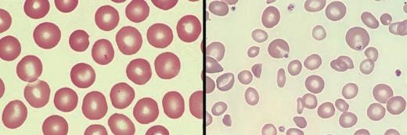
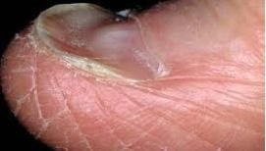
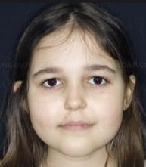
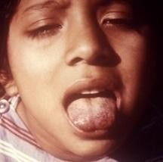

RBCs: Healthy (left) and  anemic (small and pale) (right) | Spoon-shaped  fingernail | Pale face and tongue

Risk groups of iron deficiency
      - Women of child-bearing age (because of blood loss through menstruation);
      - Pregnant and breastfeeding women (because of increased iron requirements);
      - Babies greater than six months who are exclusively breastfed;
      - Babies less than six months in particular-who are fed on animal milk;
      - Complementary foods that are often low in iron;
      - People living in regions where malaria and intestinal parasitic infestation are prevalent are also at risk;
      - Insufficient intake, malabsorption, lack of sufficient stomach acid, excessive blood loss, frequently donate blood, or take excessive antacids.
    - Toxicity: Nausea, vomiting, and diarrhea; dizziness, confusion; rapid heartbeat, organ damage, death.

Iodine
    - Sources: Sea foods, iodized salt, vegetables grown in iodine-rich soils.

Functions
Iodine is necessary for the synthesis of the thyroid hormones, thyroxine and triiodothyronine. Thyroid hormones are responsible for a number of important functions in the
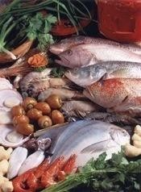
body such as-
☞ Regulates metabolic rate;
☞ Regulate body temperature;
☞ Necessary for protein synthesis;
☞ Intestinal absorption of glucose and galactose, as well as lipolysis;
☞ Promote nitrogen retention;

☞ Uptake of glucose by adipocytes;
☞ Growth and development in particular brain development;
☞ Prevent certain types of cancer.

Deficiency diseases
      - Maternal deficiency- stillbirths, spontaneous abortions
Different sea foods containing iodine

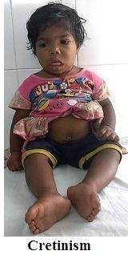
      - Infants born from iodine deficient mothers-endemic cretinism characterized by severe physical and mental retardation, low birth weight outcome.
      - Goiter or enlargement of thyroid gland is the first symptoms of iodine deficiency.
      - Intense feeling of fatigue, depression, slow down metabolism leads to weight gain.

M. A. Mojid Mondol

      - Reduce cognitive abilities like memory and overall thought process.
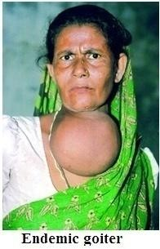
      - Increase risk of infection as white blood cells cannot work against infection without iodine.

Risk groups of iodine deficiency
      - People living in northern region (e.g., Kurigram, Dinajpur) of Bangladesh because soil of this region contains very low-level iodine and thereby crops.
      - People consuming salt lack of iodine and not sea foods are also at risk of deficiency.
      - Women of reproductive age, pregnant women, infants, adolescents.

WHO estimates iodine deficiency affects over two billion people worldwide and it is the number- one cause of preventable brain damage worldwide.

Zinc
    - Sources: Dietary sources of zinc are red meat (3-5 mg/100 g), whole grains and legumes (2-3 mg/100 g) and oysters (70 mg/100 g).

Functions
Zinc is necessary for
☞ maintain immune function;
☞ DNA synthesis, cell division, protein synthesis and digestion;
☞ cell growth and repair;
☞ normal sperm counts in males;
☞ cell repair and wound healing;
☞ decrease stool volume and frequency.

Deficiency diseases
      - Growth retardation, dwarfism, delayed sexual maturation;
      - Hypogonadism (subnormal development of male sex organs);
      - Eye and skin lesions, hair loss, diarrhea;
      - Increased incidence of illness and infection;
      - Poor wound healing, anemia and acnelike rash;
      - Decreased appetite and taste acuity.

Copper (Cu)

    - Sources: Organ meats, shellfish, legumes, nuts, cocoa, whole grains

Functions
☞ An essential component of several enzymes.
☞ Helps in the formation of hemoglobin
☞ Aids in the transport of iron to bone marrow (soft tissue in bone center) for the formation of red blood cells.
☞ Participates in energy production (component of coenzymes in electron transport).
☞ Plays important role in oxidation-reduction (redox) reactions and in scavenging free radicals.

Deficiency or Toxicities
Anemia, reduced levels of white blood cells, osteoporosis, in infants and growing children. Excess copper can be highly toxic-Nausea, vomiting, and diarrhea, liver damage.

Fluoride (F)
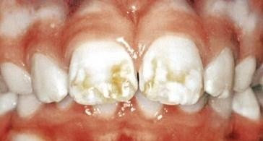
    - Sources: Fish, seafood, legumes, whole grains, drinking water
    - Functions: Development and maintenance of healthy teeth and bones.
    - Deficiency: Dental caries, low bone density
    - Toxicity: Fluorosis (hypomineralization of tooth enamel) of teeth and bones.

Evaluation at the end of the lesson:
Short Questions:
      - Define minerals.
      - Classify minerals.
      - Describe sources, functions and deficiency diseases of calcium.
      - Describe sources, functions and deficiency diseases of iron.
      - Describe sources, functions and deficiency diseases of iodine.
      - Describe sources, functions and deficiency diseases of folic acid.
      - Describe sources, functions and deficiency diseases of zinc.

[Note: It is an impossible task to consume optimum level of micronutrients through correctly balance food choices; rather the best approach is to eat a variety of healthful foods every day.]

Table 9.1. The amount of daily requirements of different major and trace minerals

Life stage | Ca (mg/d) | P  (mg/d) | Na (g/d) | Cl (g/d) | K  (g/d) | Mg (mg/d) | Fe (mg/d) | I  (μg/d) | Zn (mg/d) | F  (mg/d) | Cu (μg/d)
Infants
0–6 mo | 210* | 100* | 0.12* | 0.18* | 0.4* | 30* | 0.27* | 110* | 2* | 0.01* | 200*
7-12 mo | 270* | 275* | 0.37* | 0.57 * | 0.7* | 75* | 11 | 130* | 3 | 0.5* | 220*
Children
1–3 y | 500* | 460 | 1.0* | 1.5* | 3.0* | 80 | 7 | 90 | 3 | 0.7* | 340
4–8 y | 800* | 500 | 1.2* | 1.9* | 3.8* | 130 | 10 | 90 | 5 | 1* | 440
Male
9–13 y | 1300* | 1250 | 1.5* | 2.3 | 4.5* * | 240 | 8 | 120 | 8 | 2* | 700
14–18 y | 1300* | 1250 | 1.5* | 2.3* | 4.7* | 410 | 11 | 150 | 11 | 3* | 890
19–30 y | 1000* | 700 | 1.5* | 2.3* | 4.7* | 400 | 8 | 150 | 11 | 4* | 900
31–50 y | 1000* | 700 | 1.5* | 2.3* | 4.7* | 420 | 8 | 150 | 11 | 4* | 900
51–70 y | 1200* | 700 | 1.3* | 2.0* | 4.7* | 420 | 8 | 150 | 11 | 4* | 900
>70 y | 1200* | 700 | 1.2* | 1.8* | 4.7* | 420 | 8 | 150 | 11 | 4* | 900
Female
9–13 y | 1300* | 1250 | 1.5* | 2.3* | 4.5* | 240 | 8 | 120 | 8 | 2* | 700
14–18 y | 1300* | 1250 | 1.5* | 2.3* | 4.7* | 360 | 15 | 150 | 9 | 3* | 890
19–30 y | 1000* | 700 | 1.5* | 2.3* | 4.7* | 310 | 18 | 150 | 8 | 3* | 900
31–50 y | 1000* | 700 | 1.5* | 2.3* | 4.7* | 320 | 18 | 150 | 8 | 3* | 900
51–70 y | 1200* | 700 | 1.3* | 2.0* | 4.7* | 320 | 8 | 150 | 8 | 3* | 900
>70 y | 1200* | 700 | 1.2* | 1.8* | 4.7* | 320 | 8 | 150 | 8 | 3* | 900
Pregnancy
14–18 y | 1300* | 1250 | 1.5* | 2.3* | 4.7* | 400 | 27 | 220 | 12 | 3* | 1000
19–30 y | 1000* | 700 | 1.5* | 2.3* | 4.7* | 350 | 27 | 220 | 11 | 3* | 1000
31–50 y | 1000* | 700 | 1.5* | 2.3* | 4.7* | 360 | 27 | 220 | 11 | 3* | 1000
Lactation
14–18 y | 1300* | 1250 | 1.5* | 2.3* | 5.1* | 360 | 10 | 290 | 13 | 3* | 1300
19–30 y | 1000* | 700 | 1.5* | 2.3* | 5.1* | 310 | 9 | 290 | 12 | 3* | 1300
31–50 y | 1000* | 700 | 1.5* | 2.3* | 5.1* | 320 | 9 | 290 | 12 | 3* | 1300

[Note: Recommended Dietary Allowances (RDAs) (bold type) and Adequate Intakes (AIs) followed by an asterisk (*).]

Lesson 6: Water

Learning outcomes
Upon completion of this lesson, the learners will be able to
- Define water;
- Discuss about distribution of fluid (water) in our body;
- Explain fluid and electrolyte balance;
- Discuss the functions of water;
- Discuss the consequences of deficiency diseases or excess of water.

Water is a neutral molecule (chemical formula H₂O) and has a pH of 7.0, meaning it is neither acidic nor basic. Maintaining the right level of water in our body is crucial for proper functioning of the body. 50 to 60% of the body weight of
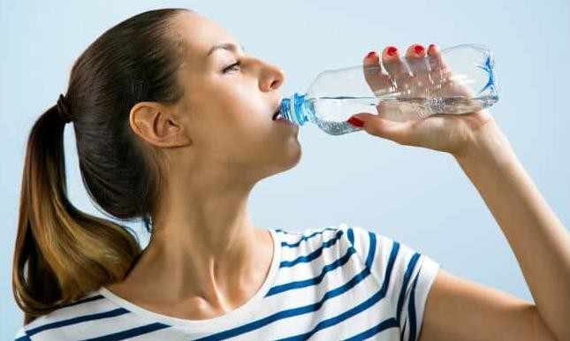
normal adults is composed of water.

Humans can live about 30 to 45 days without food but only 10 to 14 days without water. Thirst/dry mouth indicates low water level in our body, or blood electrolyte concentrations too high and sends signals to the brain stimulating the feeling to drink. Water lost during either exercise or heavy work is not replaced can be a life-threatening situation.

Distribution of fluid (water) in our body
Body water is divided into two basic compartments: intracellular and extracellular. The intracellular fluid (ICF) compartment is the system that includes all fluid within cells enclosed by their plasma membranes and accounts for about 64% of total body fluid. Extracellular fluid (ECF) surrounds all cells in the body.

Extracellular fluid has two primary constituents: the fluid component of the blood (called plasma) and the interstitial fluid (IF) that surrounds all cells not in the blood. The body has other water- based ECF. These include the cerebrospinal fluid that bathes the brain and spinal cord, lymph, the synovial fluid in joints, the pleural fluid in the pleural cavities, the pericardial fluid in the cardiac

sac, the peritoneal fluid in the peritoneal cavity, the aqueous humor of the eye, in GI cavity and glandular secretions.
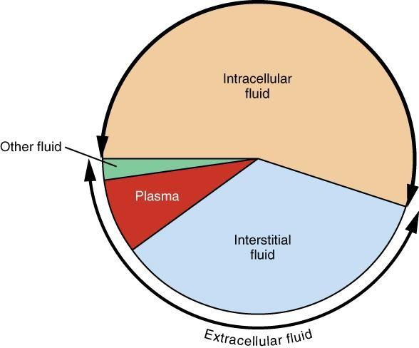
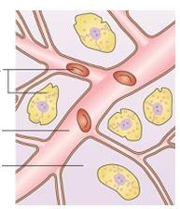
Intracellular fluids
Plasma fluid
Interstitial fluid

Figure 6.1. Body compartments and percentage of their water content.

Fluid and Electrolyte Balance
Water in our body is not pure but rather a mixture of cells, proteins, glucose, lipoproteins, electrolytes, and other dissolved substances. Electrolytes are minerals that have either positive (also called cations) (e.g., Ca²⁺, Na⁺) or negative charge (also called anions) (e.g., Cl⁻). K⁺ and Na⁺ are the principal electrolyte in intracellular fluid (ICF) and extracellular fluid (ECF), respectively.

Sensible (through urine) and insensible (through feces, perspiration and respiration) water lost must be replaced in terms of both volume and electrolyte content. Body maintains the fluid and solutes (dissolved substances) balance in different compartments through homeostatic mechanism.

Water can move freely across cell membranes by osmosis from an area of low to an area of high solutes concentration. The purpose of movement of water across the cell membranes is to maintain the same osmolality (the total number of dissolved particles) inside and outside of the cells.

For example, if the concentration of sodium in ECF is reduced, water flows from the ECF into the cells, causing cellular edema. This triggers the kidneys to reabsorb sodium. When the missing sodium is replaced in the ECF, the excess water from the cells moves back to the ECF, and the edema is disappeared. Cells indirectly control water movement across the cells by controlling movement of electrolytes and other solutes

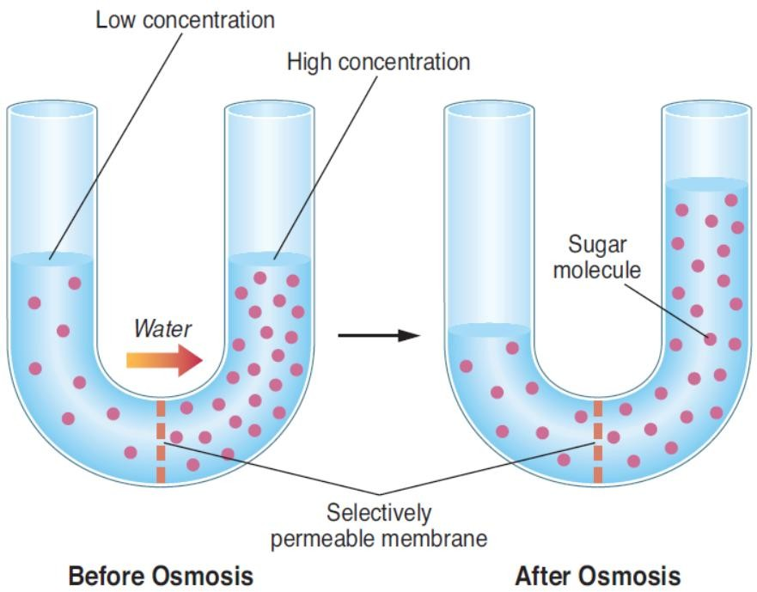
Figure 6.2. In osmosis, water passes through the selectively permeable cell membrane from an area of low-solute concentration to an area of high-solute concentration.

A role of thumb, 1 mL water is needed for every calorie consumed from food. For example, if person consumes 1,800 kcal through food, he/she needs to drink 7.5 glasses of fluid. Fever, diarrhea, unusual perspiration, and hyperthyroidism increase water requirement.

Tonicity, Osmosis and Size of the cells
The ability of an extracellular fluid/solution to make water move into or out of a cell by osmosis is known as its tonicity. A fluid's tonicity is related to its osmolarity. When solutions of different osmolarities are separated by a membrane only permeable to water, but not to solute, water will move from the lower osmolarity side to the higher osmolarity side.

Three terms (isotonic, hypotonic and hypertonic) are used to compare the osmolarity of a cell to the osmolarity of the extracellular fluid around it.

Isotonic solution
An extracellular solution is said to be isotonic (iso means the same) when it has the same osmolarity as inside of the cell. When a cell is placed in isotonic solution, there will be no net movement of water into or out of the cell.

Hypotonic solution
If the extracellular fluid has lower osmolarity than the fluid inside the cell, it’s said to be hypotonic (hypo means less than) to the cell. When a cell is placed in hypotonic solution, there will be net movement of water into the cell. In such a case, the cells keep their water volume constant by pumping electrolytes outside the cells in an effort to balance the concentrations of

dissolved particles on either side of the membranes. The cells without wall will swell up and may burst (lyse). Lysis of cells is a reversible process.

Hypertonic solution
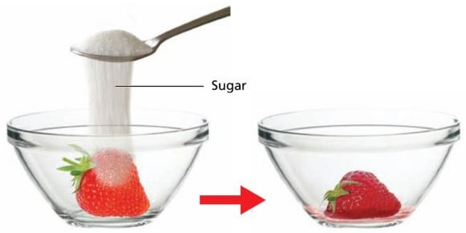
If the extracellular fluid has a higher osmolarity than the cell’s cytoplasm, it’s said to be hypertonic (hyper means greater than) to the cell. If a cell is placed in a hypertonic solution, water moves from inside the cell to the outside and the cell will shrink. Cells keep their water volume constant by pumping electrolytes inside the cells in an effort to balance the concentrations of
dissolved particles on either side of the membranes. For example, when sugar is sprinkled on the surface of the strawberries, water will move out of the strawberries to dilute the sugar. The strawberries will be shrinked. It is a reversible process.
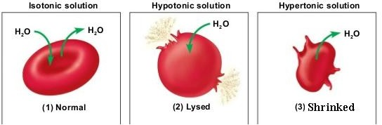

Functions of water
Of all the nutrients, water is considered as the most critical for our body as its absence produces lethal effect within a few days. Water performs the following four basic functions:

Transports Substances
Water is called the “universal solvent” because more substances are dissolved in it than any other solvent. The water molecule has different electrical charges-one end is positive and another end is negative. This property allows water to surround other charged molecules and disperse them.

Water serves as a transport medium to deliver substances to cells and remove wastes. For example, blood (which contains 90% water) transports oxygen, nutrients, hormones, drugs, and other substances to cells and removes metabolic waste products such as CO₂, urea, ketones etc from the cells and transports to the lungs or kidneys for excretion.

Serves as a medium for chemical reactions
Water acts as a medium for all biochemical reactions in the body. Among the roles it plays is as a medium in which all of the body’s metabolic reactions occur. Water also participates directly in a number of chemical reactions, many of which are involved in energy production. The addition of water to a large molecule can break it into two smaller ones.

Regulates body temperature
Water plays an important role in fixing body temperature at around set point 98.6°F (37°C). The water in blood helps to regulate body temperature at around set point by increasing or decreasing the amount of heat lost at the body surface. Body can operate properly in narrow range of temperature around set point. Too low or too high of a temperature causes enzymes to stop functioning and metabolism is halted which can be life threatening.

When body temperature starts to raise, the blood vessels in the skin dilate (meaning the opening becomes wider), which increases blood flow to the skin and allows more heat to be released into the environment. The most obvious way that water helps to regulate body temperature is through the evaporation of sweat. When body temperature increases, the brain triggers the sweat glands in the skin to produce sweat, which is mostly water. As the sweat evaporates from the skin, heat is lost, cooling the body.

Acts as lubricant/shock absorber
Water protects the body by acting as a cushion. For example, fluids inside the eyeballs and spinal cord cushion against shock; the fluid between joints cushions, lubricates and eases the movement of articulated bones.

Regulation of daily water balance Daily water input
Total water output per day is about 2.5 L. This must be balanced through water input. Our body tissues can produce around 300 mL of water per day through metabolic processes. The remaining water output must be balanced by drinking fluids and eating solid foods. The average fluid consumption approximately per day is 1.5 L through beverages and 700 mL through solid foods.

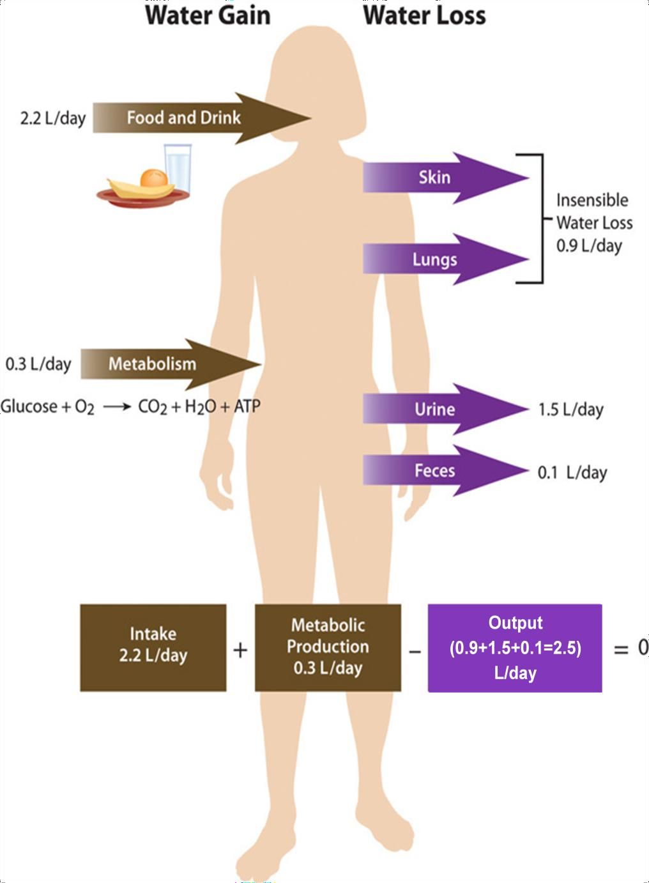

Daily water output
Body loses water in two ways: insensible way and sensible way. In insensible way, body loses 400 mL through exhalation and 500 mL through skin. In sensible way, body loses about 1.5 L through urine and roughly 100 mL through feces. Kidneys can increase or decrease urine output depending on the situation; in short kidneys regulate urine output.

Recommended water intake daily
The recommendation for total water intake is about 2.7 L (11 cups; 1 cup is equivalent to 250 mL) per day for women and 3.7 L (15 cups) per day for men. It is important to note that recommended water intake includes water from all sources such as drinking pure water, milk, juice and other beverages. Water and other beverages account for about 80% of adult fluid intake. The other 20% comes from water in foods.

The demand for water intake is increased in certain incidences which increase water loss such as drinking caffeine containing beverages (e.g., coffee, tea) (caffeine is a diuretic that increases water loss in the urine), sweating in exercise, in dry environment (water is evaporated quickly from the skin and lungs), low-calorie diets (extra urine is produced in order to excrete ketone bodies produced by fat breakdown), high-protein and high-salt diets (extra urine is produced in order to eliminate the urea from protein breakdown and the extra salt, respectively), high-fiber diets (fiber increases water lost in the feces). Water loss can be estimated by weighing before and after exercise. To restore fluid balance, 2 to 3 cups of fluid should be consumed for every ½ kg of weight lost.

Water needs are also higher for pregnant women to allow for the increase in maternal blood volume, the production of amniotic fluid, and the needs of the fetus. During lactation, fluid needs are increased because the fluid secreted in milk, about 3 cups per day, must be restored by the mother’s fluid intake.

Water content of different foods

90–99 | Nonfat milk, strawberries, blueberries, watermelon, lettuce, cabbage, celery, spinach,  squash, pumpkin, watermelon, bottle gourd, tomato, broccoli, cucumber, carrots
80–89 | Fruit juice, yogurt, apples, grapes, oranges, carrots, broccoli, pears, pineapple, milk,  pears
70–79 | Bananas, potato, chicken
60–69 | Pasta, legumes, salmon, meat
50–59 | Ground beef, hot dogs, steak, feta cheese
40–49 | Pizza
30–39 | Cheddar cheese, bread
20–29 | Pepperoni, cake, biscuits, honey
10–19 | Butter, margarine, raisins, wheat flour, rice
1–9 | Walnuts, dry-roasted peanuts, crackers, cereals, pretzels, peanut butter
0 | Oils, sugars

  - Consequences of deficiency or excess
Excess water: Water Intoxication/Hyponatremia
Water intoxication can occur due to either too much water or too little sodium (called hyponatremia) in the body. This can occur due to improper administration of intravenous fluids, or drinking too much plain water during excessive sweating. For example, hyponatremia can occur in an athlete if he/she drinks plain water to replenish water and sodium lost in sweating. Water intoxication may cause edema. Water intoxication is extremely rare, primarily because healthy kidneys are capable of excreting up to one liter of excess water per hour.

Water deficiency: Dehydration
Dehydration (inadequate water in the body) can occur due to inadequate intake or abnormal loss such as severe diarrhea, vomiting, hemorrhage, burns, diabetes mellitus, excessive perspiration, excessive urination, or the use of certain medications such as diuretics. Symptoms of dehydration include low blood pressure, thirst, dry skin, fever, and mental disorientation.

A loss of 10% of body water can cause serious problems. Blood volume and nutrient absorption are reduced, and kidney function is upset. A loss of 20% of body water can cause circulatory failure and death. Infants are at high risk of dehydration during vomiting and diarrhea. Electrolytes are always lost with water; so intravenous (IV) fluids may be required to replace water loss. The thirst sensation often lags behind the body’s need for water, especially in the elderly, children, athletes, and the ill.

Evaluation at the end of the lesson:
Short Questions:
- Define water.
- Discuss about distribution of fluid (water) in our body.
- Explain fluid and electrolyte balance.
- Discuss the functions of water.
- Discuss the consequences of deficiency diseases or excess of water

