Basic Nutrition
(FSN11301T)

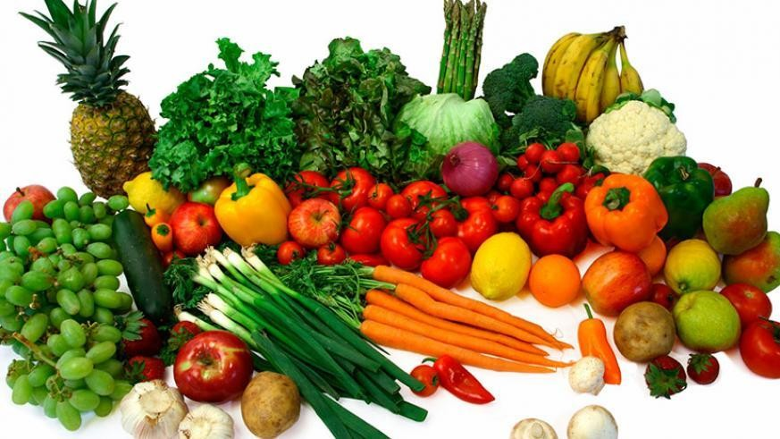

Dr. Md. Abdul Mojid Mondol
Associate Professor School of Science and Technology
Bangladesh Open University

Introduction to this Module

Among the modules of B.Sc (Hons) in Food Science and Nutrition program, Basic Nutrition (FSN11301T) is one of them. This module covers: the definition of food and nutrition, the food sources of basic nutrients (carbohydrates, proteins, fats, vitamins and minerals), the functions of nutrients in our body and deficiency diseases. Basic Nutrition (FSN11301T) module is different from traditional books used in the class. The learners can understand this module just studying at home without attending in class. Please read carefully the instructions to understand the lessons clearly.

Arrangement of Module
There are 24 lessons in this module. The lessons of this module have been arranged in such a way that a learner can understand about the content just after reading the heading of the lesson. Every lesson has been started with objectives followed by content. To understand the content, some pictures have been added. At the end of each lesson, the learners have been subjected to evaluate their merit.

How to read this module?
Before reading the main text, first read objectives with care. A learner how much understood the objectives of the lesson, will be evaluated at the end of the lesson. If necessary, a learner has to read again and again main test to under the objectives clearly. When a learner will understand objectives clearly, then he/she will write the answer of the exercise.

Audio-video program and tutorial service
Learners may easily understand some lessons of this module just after reading but some may not. Those hard lessons will be made easily understandable through audio-video programs and tutorial services. Audio-video programs will be broadcasted through Bangladesh Betar and BTV at specified date and time. Before broadcasting audio-video programs, learners are advised to sit in front of Betar or TV with book, note book and pen so that necessary notes can be written down. Learners will get chance to solve any part of any lesson and audio-video programs which are hard and not easily understandable from tutor in tutorial class. Keep in mind, tutorial class is not like traditional class where tutor will only help learners to understand those hard portions of this module. So, learners are advised to mark hard portions of the lessons according to the tutorial class schedule before coming to the class so that it can be discussed with tutor to solve. After all, tutor as well as Bangladesh Open University respective teachers will help the learners to complete this module successfully.

Lesson 1: Food, nutrition, nutrients and calorie

Learning outcomes
Upon completion of this lesson, the learners will be able to
- Define food and nutrition;
- Classify foods and nutrients;
- Describe functions of food and nutrients;
- Calculate the energy of foods.

Food
Food has been a basic part of our existence. The term ‘food’ refers to anything that we eat and which nourishes our body. In short, food is the raw material from which our bodies are made. It includes solids, semi-solids and liquids. Intake of the right kinds and amounts of food can ensure good nutrition and health, which may be evident in our appearance, efficiency and emotional well- being. Thus, two important features for any item to be called food are:
    - It should be worth eating, that is, it should be ‘edible’.
    - It must nourish the body.

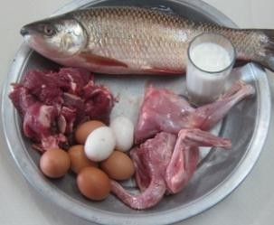
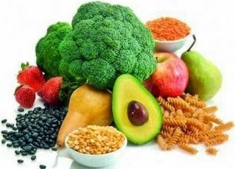
Classification of foods
Foods can be classified based on-

Origin: such as
        - Animal foods: milk, meat, eggs, fish, shrimps, snails, crabs, etc.
        - Plant foods: vegetables, whole grains, nuts, seeds, legumes, fruits, oils, etc.
Animal Foods | Plant Foods

      - Predominant functions: such as
- Body building foods: This group of foods allows us to grow and repair tissues such as meat, milk, poultry, fish, eggs, pulses, etc.
- Energy giving foods: This group of foods gives energy to our body such as cereals, sugars, fats, oils etc.
- Protective foods: This group of foods protects our body from diseases such as vegetables, fruits, milk, etc.

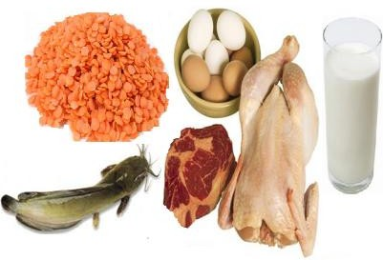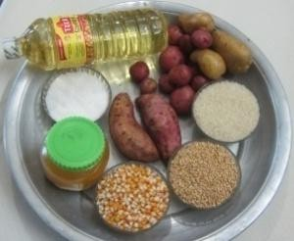

Bodybuilding foods | Energy giving foods | Protective foods

Functions of Food
- Social and religious function
Foods function as an integral part in different social occasions (e.g., naming, birthday, putting rice to a child's mouth for the first time, marriage ceremony, get-togethers, meeting etc) and religious functions (e.g., circumcision, Eid, Christmas, Pooja, etc).

Physiological function
There are three physiological functions performed by food. These are (i) providing energy, (ii) building body, (iii) regulating body processes and providing protection against diseases and germs.

Psychological function
Our metal satisfaction or dissatisfaction is sometimes related with the serving foods irrespective of nutritional value; even you may not satisfy with a nutritionally balanced meal if the foods included are unfamiliar or distasteful.

Different types of foods
- Whole foods
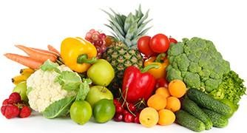
Whole foods are those foods which directly obtain from nature. Examples include milk, eggs, meats, poultry, fish, fruits, vegetables, dried beans and peas, and grains. Many whole foods are also considered fresh foods. Fresh foods are raw foods that have not been processed (such as canned or frozen) or heated. Fresh foods also do not contain any preservatives.

Organic foods
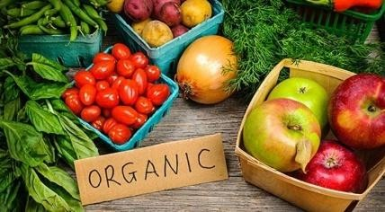
Organic foods are foods that have been grown without most conventional pesticides, fertilizers, herbicides, antibiotics, or hormones and without genetic engineering or irradiation. Organic farmers use, for example, animal and plant manures to increase soil fertility and crop rotation to decrease pest problems.

Enriched foods
A food is considered enriched when nutrients are added to it to replace the same nutrients that are lost in processing. For example, when whole wheat is milled to produce white flour, nutrients are lost. By law, white flour must be enriched with several vitamins and iron to make up for some of these lost nutrients.

Fortified foods
A food is considered fortified when nutrients are added that were not present originally or nutrients are added that increase the amount already present. For example, orange juice does not contain calcium, and so when calcium is added to orange juice, the product is called calcium- fortified orange juice. Similarly, salt is fortified with iodine, milk is fortified with calcium, cooking oil is fortified with vitamin A etc.

Processed foods
Processed foods are prepared using a certain procedure such cooking, freezing (frozen dinners), canning (canned vegetables), dehydrating (dried fruits), milling (white flour), culturing with bacteria (yogurt), or adding vitamins and minerals (enriched foods). In some cases, processing removes and/or adds nutrients.

Whole grains vs. Refined/Processed grains
Whole grain products, such as whole wheat bread, brown rice, and oatmeal, contain the entire kernel of the grain, including the bran, germ, and endosperm. Refined grain products, such as white bread and white rice, are made by removing the bran and the germ to produce a more uniform product. Removing the bran and germ, however, also removes most of the fiber and reduces the amounts of many of the vitamins and minerals. So, whole grain products are more nutritious than refined grain products.

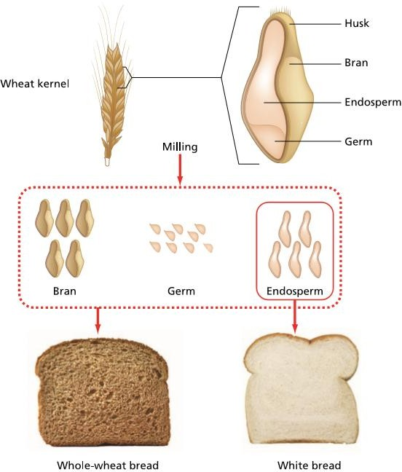

Figure 1.1: Parts of a whole wheat grain
The nutrient compositions of a whole grain (e.g., wheat) are given in the following table-

Parts | Nutrient content
Bran | Fatty acids (omega-3 and omega-6 fatty acid), vitamins (B₁, B₂, B₆, niacin, folate,  B₅, E, K), minerals (Mg, Mn, P, Fe, Cu, Zn, Ca), proteins, carbs, dietary fibers
Endosperm | Carbs (starch), some proteins
Germ | B vitamins (folate, niacin), minerals (Mg, P, Mn, K, Se, Na, Zn, Fe), proteins,  carbs, fibers, omega-3/6 fatty acid
Outer husk | Inedible part of a grain

Nutrient-Dense foods and empty-calorie foods
Nutrient-dense foods are those that contain a high amount of healthy nutrients but a low amount of energy, or calories per weight. Nutrient-dense foods are rich in vitamins, minerals, fiber, lean protein and healthy fats. Examples of nutrient-dense foods include fruits and vegetables, whole

grains, low-fat or fat-free milk products, seafood, organ meats, lean meats, eggs, peas, beans, lentils and nuts.

Empty-calorie foods (opposite to nutrient-dense foods) are those that contain a high amount of calories but fewer amounts of healthy nutrients per weight. Examples of empty-calorie foods include soft drinks, baked goods, processed foods, ice cream, cookies, cake, chips, pizza, beer etc. Small amount of empty-calorie foods add a lot of calories in our diet opposite to nutrient-dense foods.

For example, if one compares the protein content of isocaloric portions of dal, bread and milk, one can see that dal has the highest nutrient density for protein, milk next and bread the least.

Food | Calories | Protein (g)
Dal | 85 | 5.5
Milk | 85 | 4.0
Bread | 85 | 2.4
Thus nutrient density is an important aspect to be considered in selection of foods, especially for diet of children, pregnant women, nursing mothers and in therapeutic diets for patients.

Nutrition
All of us eat food. Food provides nourishment to the body and enables it to stay fit and healthy. The food that we eat undergoes many processes, like, first the food is digested, then it is absorbed into blood and transported to various parts of the body where it is utilized. The waste products and undigested food are excreted from the body
NUTRITION = Eating → Digestion →Absorption →Transportation →Utilization
Nutrition is the process which includes consumption and digestion of foods, absorption of nutrients and finally utilization of absorbed nutrients for growth, development, and maintenance of a healthy life.

Optimum nutrition or Adequate nutrition
When all the essential nutrients (that body cannot synthesize) (details given below) are present in right proportion and in sufficient amount as required by our body is called optimum nutrition or adequate nutrition. Optimum nutrition is required to maintain good health. When almost all essential nutrients are present in the body below the required level, the condition is known as under-nourished. An under-nourished person manifests symptoms of deficiency diseases and feels unwell.

Nutrients
We enjoy eating foods because of its taste, smell, pleasure and filling hunger. But we do not think usually what chemicals foods actually contain. Foods contain different types of chemical substances; some of which are not important but others are critical to the body. Nutrients are chemical substances present in food that are needed for the cells of body for growth, maintenance, and repair. The six groups of nutrients found in foods are:
- Carbohydrates
- Lipids (including fats and oils)
- Proteins
- Vitamins
- Minerals
- Water

Classification of nutrients
Nutrients can be classified in several ways such as-
- Based on functions
- Based on chemical nature
- Based on importance
- Based on the amount required daily

Based on functions

Nutrients | Major function
Carbohydrates, Fats | Produce energy
Proteins | Build and repair body tissues
Vitamins, Mineral, Water | Regulate biochemical reactions of the body

- Based on chemical nature
- Organic nutrients
The nutrients that contain carbon in their structural makeup are referred to as organic nutrients.
They originate from living organisms. Examples-carbohydrates, lipids, proteins and vitamins.

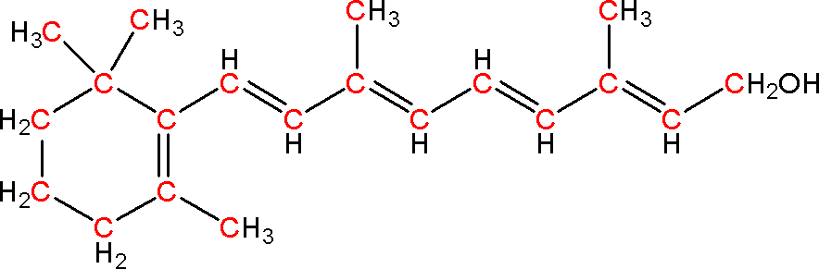
Vitamin A

Inorganic nutrients
Atom or molecule that does not contain carbon. Minerals (e.g., sodium, potassium, calcium, magnesium, iron) and water are the inorganic nutrients because they do not contain carbon and exist in simplest forms; so, they do not break down before absorption.

Based on importance
  - Essential nutrients
Those nutrients that cannot be synthesized by the body at all or can be synthesized insufficient quantities that cannot meet the body’s requirement. Therefore, they must be supplied to our body through the diet. They are-
    - 9 amino acids
    - 2 fatty acids
    - 13 vitamins
    - 15 minerals
  - Nonessential nutrient
Those nutrients that can be synthesized by the body in sufficient quantities when necessary are called nonessential nutrients. We may also get these nutrients from foods. Non-essential nutrients are as important as essential nutrients for normal body process. Simply unlike essential nutrients, they do not need to be present necessarily in the food. They are
    - Certain amino acids
    - Cholesterol
    - Phospholipids etc

Based on the amount required daily
  - Macronutrients
Those nutrients that are needed in larger quantities every day are called macronutrients. They normally include carbohydrates, fats, proteins and water. Macronutrients (except water) are also called energy-providing nutrients. Carbohydrates, proteins, and fats are interchangeable as sources of energy. Water is the macronutrient needed in the largest amount-about 2-3 liters per day.

Micronutrients
Those nutrients that are needed in smaller quantities every day are called micronutrients (e.g., minerals and vitamins). Unlike macronutrients, these are required in very minute amounts. Although, micronutrients are required in minute amount very day but their deficiency may lead to serious health consequences. In fact, most of nutrient related illnesses are due to the deficiency of micronutrients.
.

Nutrient (chemical) composition of human body
The approximate chemical compositions of adult human body are given in the following table.
Table 1.1: Chemical constituents of human body

Chemical constituent | % of Body weight
Water | 60%
Proteins | 17%
Fats | 15%
Minerals | 5%
Nucleic Acids | 2%
Carbohydrates | only 1%
Infants and children have more water in their body as compare to adult. The second major nutrient (chemical compound) that makes up our body is protein. There are tens of thousands of different types of proteins in our body; most of them are enzymes. The third major nutrient after protein is lipids (fats). All 60 trillion cells of our body are made from lipids. Women have more lipids in their body as compare to men counterparts. We eat more carbohydrates containing foods than others. Surprisingly, our body contains very little carbohydrates, as carbohydrates turn to lipids/fats.

Food calories
The amount of energy in the form of heat required to raise 1°C temperature of 1 g of water is called one calorie. As calorie is relatively small unit, so to express energy content of foods kilocalorie (kcal) is often used. One kilocalorie (Kcal) is equal to 1000 calories (C). Thus, when we say that a food contains 400 Calories, we are actually referring to kilocalories.
In our body, energy (calorie) is produced from the break down (catabolism) of carbohydrates, proteins, and fats. The energy content of carbohydrates, proteins and fats is summarized in the following table 1.2.
Table 1.2: Energy content of different macronutrients.

Nutrient | Energy content
Carbohydrate | 4 kcal/g
Protein | 4 kcal/g
Fat | 9 kcal/g

When catabolic reactions occur, energy is released. About 40% of this energy is used for performing biological work. The remaining 60% is converted to heat; some of which is used to maintain normal body temperature and excess is lost to the environment.

Calculation of energy (Calories) in food
For example, suppose a chicken burger contains 50 g of carbohydrates, 25 g of fats and 15 g of proteins. Calculate the total number of kcal of the chicken burger.
Calculation:

Nutrient | Amount in burger | Energy content | Energy from burger
Carbohydrates | 50 g | 4 kcal/g | 50g×4 kcal/g = 200 kcal
Fats | 25 g | 9 kcal/g | 25g×9 kcal/g = 225 kcal
Proteins | 15 g | 4 kcal/g | 15g×4 kcal/g = 60 kcal
Total energy from the chicken burger: |  |  | 485 kcal
% of carbohydrates in the burger |  |  | 200×100/485=41.2%
% of fats in the burger |  |  | 225×100/485=46.4
% of proteins in the burger |  |  | 60×100/485=12.3%

Evaluation at the end of the lesson Short answer questions:
- Define foods.
- Classify foods
- Describe different types of foods.
- What is nutrient dense and nutrient empty food?
- Define nutrition and nutrient.
- What is micro and macronutrient?
- What is essential and nonessential nutrient?
- Define organic and inorganic nutrients.
- What is calorie? How can you calculate calorie of food.

Activities:

- A pizza contains 70 g of carbohydrates, 20 g of fats and 10 g of proteins. Calculate the total number of kcal of the pizza.
- A bowl of pasta contain 65 g of carbohydrates, 23 g of fats and 15 g of proteins. Calculate the total number of kcal of the pasta.
- What is nutrient dense and nutrient empty food?

