Daffodil International University (DIU)
Department of Electrical and Electronic Engineering

EEE 324: Microprocessors and Interfacing Laboratory

Experiment No: 12

Name of the Experiment:
WRITE A PROGRAM TO DISPLAY THE DIGITS IN DECIMAL, FROM 0-7 INTO 7 SEGMENT DISPLAY

Objective:
- Program the 8255 to show digits on a 7-segment LED.
- Program both the 8255 and 8279 in order to accept keypad inputs from 0 to F and display it on a 7-segment LED.

Part 1: Displaying a 7-Semgent LED from keypad inputs
The 7-segment LED display can be found in many displays such as microwave or fancy toaster ovens and occasionally in non-cooking devices. It is composed of 7 LEDs that are fabricated in one case to make a convenient device for displaying numbers and some letters. Figure L10.1 shows a typical 7-segment LED display with its pin layout.
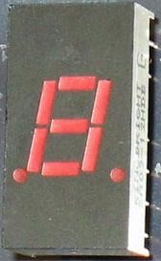
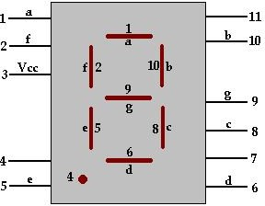
The 7-segment LED shown in Figure L10.1 is a common anode LED display. This means that the positive leg of each LED is connected to a common point which is pin 3 in this case. Each LED has a negative leg that is connected to one of the pins of the device. To make it work, you need to connect pin 3 to +5 volts. Then to make each segment light up, connect the ground pin to ground. A resistor is required to limit the current. Rather than using a resistor from each LED to ground, you can just use one resistor from Vcc to pin 3 to limit the current.

Figure L10.1 A 7-segment LED display and its pin layout.

Table L10.1 provides the information that is needed to display digits from 0 to 9 and the letters A, b, C, d, E, and F. '0' means that pin is connected to ground and '1' means that pin is connected to V_{cc}.

Table L10.1 Logic states of 7-segment LED to display different digits or letters.

 | a (Pin 1) | b (Pin 10) | c (Pin 8) | d (Pin 6) | e (Pin 5) | f (Pin 2) | g (Pin 9)
0 | 0 | 0 | 0 | 0 | 0 | 0 | 1
1 | 1 | 0 | 0 | 1 | 1 | 1 | 1
2 | 0 | 0 | 1 | 0 | 0 | 1 | 0
3 | 0 | 0 | 0 | 0 | 1 | 1 | 0
4 | 1 | 0 | 0 | 1 | 1 | 0 | 0
5 | 0 | 1 | 0 | 0 | 1 | 0 | 0
6 | 0 | 1 | 0 | 0 | 0 | 0 | 0
7 | 0 | 0 | 0 | 1 | 1 | 1 | 1
8 | 0 | 0 | 0 | 0 | 0 | 0 | 0
9 | 0 | 0 | 0 | 1 | 1 | 0 | 0
A | 0 | 0 | 0 | 1 | 0 | 0 | 0
b | 1 | 1 | 0 | 0 | 0 | 0 | 0
C | 0 | 1 | 1 | 0 | 0 | 0 | 1
d | 1 | 0 | 0 | 0 | 0 | 1 | 0
E | 0 | 1 | 1 | 0 | 0 | 0 | 0
F | 0 | 1 | 1 | 1 | 0 | 0 | 0

Figure L10.2 shows the 7-segment LED decoder circuit. With this information we can design assembly instructions to display different digits or letters on the 7-segment LED. For example, the instruction to display ‘1’ on the 7-segment LED is:
OUT 3FF0, F9

To avoid showing the consecutive digits from 0 to F too quickly, we need to insert time delay before outputting the next digit on the 7-segment LED. This can be accomplished by writing a time delay loop as follows:
MOV CX, 0A000H LOOP $

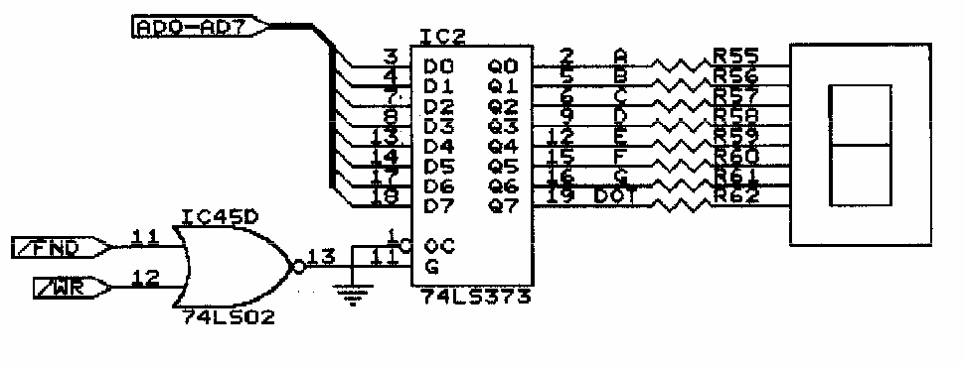
Figure L10.2 The 7-segment LED decoder circuit

Here we will begin our practice of displaying digits or letters on a 7-segment LED with a simple program. We will analyze, run, and modify the program. Check off each step as it is completed.

Part 2: Code
DATA SEGMENT
PORTA EQU 120H
PORTB EQU 121H
PORTC EQU 122H
CWRD EQU 123H
TABLE DB 8CH, 0C7H, 86H, 89H
DATA ENDS
CODE SEGMENT
ASSUME CS:CODE, DS: DATA
START: MOV AX, DATA ;intialise data segment
MOV DS, AX
MOV AL, 80H ;initialise 8255 portb and portc as o/p
MOV DX, CWRD
OUT DX, AL
MOV BH, 04 ; BH = no of digitsto be displayed
LEA SI, TABLE ; SI = starting address of lookup table
NEXTDIGIT: MOV CL,08 ; CL = no of segments = 08
MOV AL, [SI]
NEXTBIT: ROL AL, 01
MOV CH, AL ;save al
MOV DX, PORTB ;one bit is sent out on portb
OUT DX, AL
MOV AL, 01
MOV DX, PORTC ;one clock pulse sent on pc0
OUT DX, AL
DEC AL
MOV DX, PORTC
OUT DX, AL
MOV AL, CH ; get the sevensegment code back in al
DEC CL ;send all 8 bits,thus one digit is displayed
JNZ NEXTBIT
DEC BH
INC SI ;display all the four digits
JNZ NEXTDIGIT
MOV AH, 4CH ;exit to dos
INT 21H
CODE ENDS
END START

