Lesson 6: Proteins-Sources, Functions and Deficiency Diseases

Learning outcomes
Upon completion of this lesson, the learners will be able to
- Define amino acids and proteins;
- Classify essential and nonessential amino acids;
- Explain mutual supplementation for complete protein source;
- Discuss functions and deficiency diseases of proteins.

Protein constitutes about 20 percent of the human body and is present in every single cell. Proteins are considered as the workhorses of life as they do a vast array of functions. An adequate supply of proteins in the daily diet is essential for normal growth and development and for the maintenance of health.

Amino acids
    - Definition of amino acids
Amino acids are the building blocks of proteins consist of a central carbon atom connected to a side chain, a hydrogen, a nitrogen containing amino group, a carboxylic acid group-hence the name “amino acid.” There are 20 different amino acids; they all have different side chains.
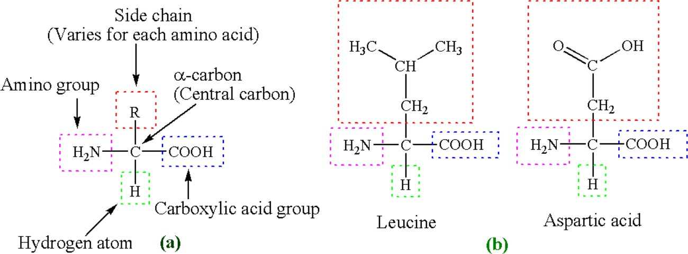

Figure 5.1. Basic structure of amino acids (a) and representative amino acids (b)

Classification of amino acids
Based on the nutritional aspects, amino acids are classified in the following ways-

Essential amino acids
Essential amino acids are those that the body cannot produce either at all or sufficient quantities to meet the physiological needs. Thus, essential amino acids must be consumed from food. Without sufficient essential amino acids, our bodies cannot make the proteins and other nitrogen- containing compounds that we need. Of the 20 amino acids, nine are classified as essential.
For example, synthesis of hemoglobin protein essential amino acid, histidine, is necessary. No amino acid can be substituted for histidine in synthesis of hemoglobin protein. If we do not consume enough histidine containing food, the production of hemoglobin is hampered and loses its ability to transport oxygen to cells.

Nonessential amino acids
Those amino acids that the body can synthesize sufficient amount from essential amino acids are called nonessential amino acids. They are just as important as essential amino acids, but we do not need to consume necessarily them through diet. Of the 20 amino acids, eleven are classified as nonessential.

Conditionally essential amino acid
Under certain conditions (during infancy, growth and in diseased states), a nonessential amino acid can become an essential amino acid. These types of amino acids are called conditionally essential amino acids. For example, the amino acid tyrosine can be synthesized in the body from the essential amino acid phenylalanine. However, if phenylalanine is deficient, tyrosine must be consumed in the diet.
Table 5.1: List of essential and nonessential amino acids

Essential amino acids |  | Nonessential amino acids
Name | 3 letter code | Name | 3 letter code
Histidine | His | Alanine | Ala
Isoleucine | Ile | *Arginine | Arg
Leucine | Leu | Asparagine | Asn
Lysine | Lys | Aspartic acid | Asp
Methionine | Met | *Cysteine | Cys
Phenylalanine | Phe | Glutamic acid | Glu
Threonine | Thr | *Glutamine | Gln
Tryptophan | Trp | Glycine | Gly
Valine | Val | Proline | Pro
 |  | Serine | Ser
 |  | *Tyrosine | Tyr
*Conditionally essential amino acids

Proteins
Simply, proteins are macromolecules composed of amino acids. Amino acids are commonly called protein’s building blocks joined by peptide bonds. Besides carbon, hydrogen and oxygen atoms like carbohydrates and lipids, proteins also contain additional element nitrogen and in some cases sulphur atoms. Unlike carbohydrates and lipids, proteins are made according to instructions provided by our genetic material, DNA.

Our body can synthesize proteins (50,000-100,000 unique proteins from combinations of just 20 amino acids) by selecting the needed amino acids from the “pool” of all amino acids available in the bloodstream at any given time. The situation is just like the endless number and variety of words that can be made with only 26 letters.

Muscles, ligaments, organs, tendons, tissues, glands, nails, hair-almost every part of our body are made from proteins. All enzymes of our body are protein in nature. Protein is appropriately named as the word “protein” is derived from Greek word “proteios” which means “outmost importance’’.

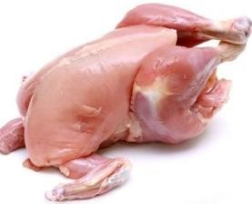
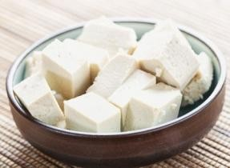
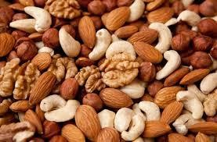
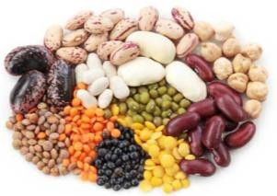
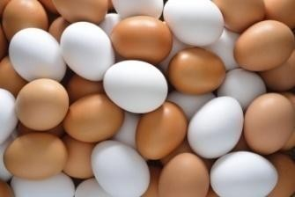
Sources of proteins
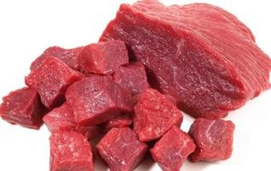
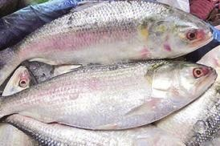
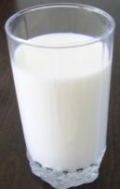
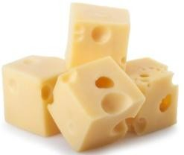

Lean meat | Poultry | Fish | Milk | Cheese
Tofu | Seeds and nuts | Legumes | Eggs

    - Classification of proteins
Proteins can be classified in the following ways-

Based on peptide bonds
When two amino acids join together, the amine group of one binds to the acid group of another in a unique type of chemical bond called a peptide bond. In the process, a molecule of water is released as a by-product.

  - Dipeptide: A molecule containing two amino acids joined by a peptide bond.

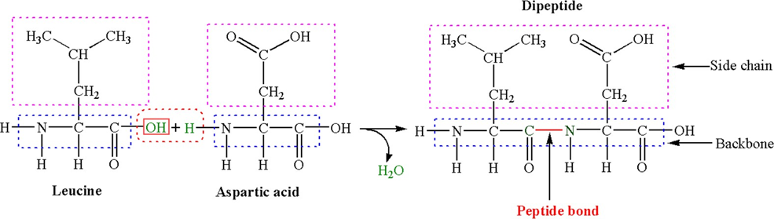

Figure 5.2 Amino acid bonding. Two amino acids join together to form a dipeptide. By combining multiple amino acids, proteins are made.

- Tripeptide: A molecule containing three amino acids joined by peptide bonds.
- Oligopeptide: In oligopeptide, 4-9 amino acids are joined together by peptide bonds.
- Polypeptide: In polypeptide, 10 or more amino acids are bonded together.

According to the composition
  - Simple proteins: composed only of amino acids, e.g. albumin, globulins, insulin etc.
  - Complex (conjugated) proteins: proteins that have a non-protein part, for example
    - Lipoproteins: Conjugated with lipids, e.g., LDL, HDL
    - Glycoprotein: Conjugated with sugar (carbohydrate), e.g.
      - Some hormones such as erythropoeitin, LH, FSH
      - present in cell membrane structure
      - blood groups that are present on the surface of RBCs ( A, B, O)
    - Nucleoproteins: Basic proteins histones conjugated with nucleic acid (DNA or RNA).e.g. chromosomes, ribosomes
    - Metalloproteins: Conjugated with metals (Fe, Cu, Zn etc), e.g.,
- Fe containing proteins, e.g., hemoglobin, myoglobin, ferritin, transferring
- Cu containing proteins, e.g., ceruloplasmin
- Mg containing proteins, e.g., kinases and phosphatases.
    - Phosphoproteins: Conjugated with phosphate group, e.g., casein, ovo-vitellin

According to the shape of the proteins
- Fibrous proteins: Structural proteins usually play a protective or supportive role, e.g. collagen, keratin and elastin.
- Globular proteins: polypeptide chains tightly folded into compact spherical or globular shape, e.g., albumin, globulins, enzymes.

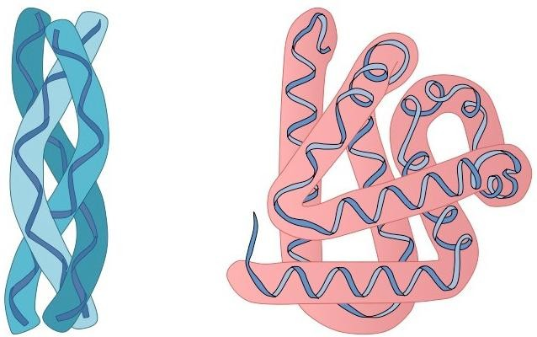

Fibrous protein Globular protein

According to the functions

Classification | Functions | Example
a. Catalytic proteins
- Enzymes | Catalyze chemical reactions | Lactate dehydrogenase (LDH),  amylase, pyruvate dehydrogenase
b. Noncatalytic proteins  - Carrier proteins | Carry molecules or ions through the  bloodstream | Hemoglobin, albumin
- Receptor proteins | Bind hormones and neurotrans-  mitters to cell membranes | The insulin receptor
- Membrane transport proteins | Carry molecules across cell membranes | Na⁺/K⁺-ATPase, which transports  K⁺ ions into cells and pumps Na⁺ ions out of cells
- Structural proteins | Form extracellular structures such  as hair and nails | Collagen, keratin
- Contractile proteins | Extend or contract muscles cells or  subcellular parts | Actin, myosin, tubulin
- Storage proteins | Store nutrients | Casein, ferritin

- Based on protein quality/nutritional aspects
Based quality, proteins can be classified as

Complete proteins or High quality proteins
Proteins which contain all nine of the essential amino acids in sufficient quantities required by the body to promote growth and health are called complete or high-quality proteins. Animal foods such as milk, cheese, egg white, fish, poultry and meat are complete protein sources.

Incomplete proteins or Low quality proteins
Proteins that do not contain all of the essential amino acids in sufficient quantities to support growth and health are called incomplete (or low-quality) protein. Consequently, incomplete proteins need helping from other proteins to build tissue.

Proteins found in plant foods (e.g., corn, grains, nuts, sunflower seeds, sesame seeds and legumes such as soybeans, navy beans, pinto beans, split peas, chickpeas, and peanuts) are incomplete proteins. Gelatin is the only incomplete protein found in the animal sources.
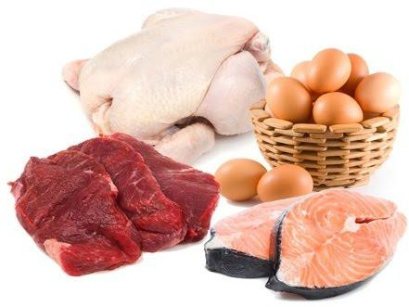
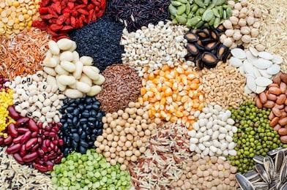
Figure 5.3. Complete protein sources | Figure 5.4. Incomplete protein sources

Differing proteins from each other
Our body have thousands of different proteins. They differ from each other in four different ways-
- Number of amino acids in the polypeptide chain
Some proteins might be 50 or 60 amino acids long and other proteins might be 500 or 600 amino acids long.
- Types of amino acids in the polypeptide chain;
Some proteins may contain all 20 types of amino acids and others may contain 10 out of 20 amino acids.
- Ordering of amino acids in the polypeptide chain;
Two different proteins may contain same number and types of amino acids but they differ from each other in ordering of these amino acids in the polypeptide chains.
- Coiling of the polypeptide chain.
Proteins differ in their three dimensional structures how they are coiled. Every single protein has different molecular conformation/shape.

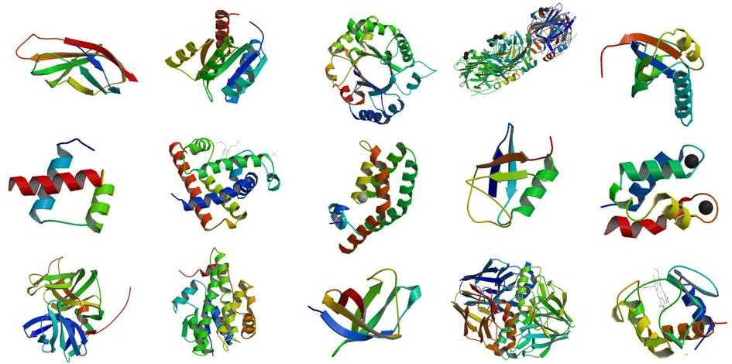

Figure 5.5. Different shape of proteins

  - Principle of mutual supplementation for complete protein source
If a diet is inadequate in any essential amino acid, protein synthesis cannot proceed beyond the rate at which that amino acid (AA) is available. This amino acid is called a limiting amino acid (LAA).
Mutual supplementation is the process of combining two or more incomplete protein sources to make a complete protein, and the foods involved are called complementary foods. Suppose food A has limiting essential amino acids Met and Leu but rich in Lys and Thr, and another food B has the opposite strength and weakness that means has limiting amino acids Lys and Thr and but rich in Met and Leu. Another way of making complementary food is that food, for example, food A besides containing sufficient other essential amino acids it has limiting amino acid Met and other the contrary food B has sufficient Met in addition to other essential amino acids. If we combine food A with food, we can make complete protein source. This concept has been summarized in the following table.
Table 5.2. Tricks of complementary food combination

Food | No. of EEA |  |  | Total EAAs | Target AA sequence in protein | Limiting AA | No. of target protein from food | Protein Value
 | Met | Leu | Phe |  | Met Leu Phe |  | Met Leu Phe
1 | 10 | 10 | 10 | 30 |  | None | 10 | 10
2 | 2 | 18 | 10 | 30 |  | Met | 2 | 2
3 | 18 | 2 | 10 | 30 |  | Leu | 2 | 2
(2+3)  2 | 10 | 10 | 10 | 30 |  | None | 10 | 10

Examples of complementary food combination:
Consider a meal of beans and rice. Beans are low in the amino acids methionine and cysteine but have adequate amounts of isoleucine and lysine. Rice is low in isoleucine and lysine but contains sufficient methionine and cysteine. By combining beans and rice, a complete protein source is created.

Food 1 | LAA | RAA | Food 2 | LAA | RAA | ECFC (Food 1+2)
Legumes | Met   Cys | Ile  Lys | Grains | Ile  Lys | Met  Cys | Rice+ Lentil
 |  |  | Nuts  seeds | Ile  Lys | Met  Cys | Rice+ hazelnut | 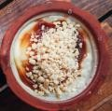
Vegetables | Lys, Met   Cys |  | Grains |  | Met  Cys | Rice+spinach  +chickpea | 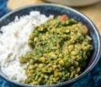
 |  |  | Legumes |  | Lys | Tofu+broccoli  +almond | 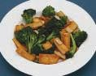
 |  |  | Nuts  seeds |  | Met  Cys
LAA: Limiting, RAA: Rich in amino acids, ECFC: Example of complementary food combination
When we eat one potentially complementary protein, its amino acids join those in the amino acid pool. Body uses these free amino acids for synthesizing complete proteins. However, it is wise to eat complementary-protein foods during the same day, as partially synthesized proteins cannot be stored for later time to be complete. Mutual supplementation is important for vegetarian who do not consume animal foods and poor people who are unable to buy animal foods.

Maintaining acid-base balance
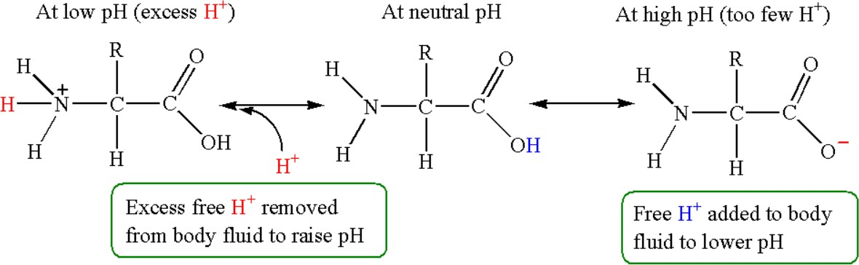
The body’s metabolic processes result in the constant formation of acids and bases. These substances are transported in the blood to be excreted through the kidneys and the lungs. The human body maintains pH, or the acid–base balance of the blood very tightly. The body goes into a state called acidosis when the blood becomes too acidic. Alkalosis results if the blood becomes too basic. Acidosis and alkalosis can cause coma and death by denaturing body proteins.

Figure 5.3. Buffering action of proteins

Proteins are excellent buffers, meaning they can maintain proper acid–base balance. Acids contain hydrogen ions, which are positively charged. The side chains of proteins have negative charges that attract the hydrogen ions and neutralize their detrimental effects on the body. Proteins can release the hydrogen ions when the blood becomes too basic. In this way, proteins maintain acid- base balance and blood pH.

Functions of Proteins
Proteins do numerous functions in our body. Note that proteins function most effectively when we consume adequate amounts of the other energy nutrients, carbohydrates and fat. When there is no enough energy available, the body uses proteins as an energy source, limiting their availability for the functions.
- The primary function of proteins is to build and repair body tissues.
- Most of the hormones and all enzymes are proteins in nature. Hormones and enzymes are essential for the regulation of metabolism and digestion.
- Antibodies are proteins that defend against invading microbes and allergens.
- Proteins help in maintaining fluid and electrolyte balances in the body and thus prevent edema (abnormal retention of body fluids).
- Help in muscle contraction and relaxation.
- Proteins act as a buffer in maintain proper acid-base balance.
- Proteins assist in transporting and storage of nutrients
- Provide energy when carbohydrate and fat intake are inadequate.

Daily protein requirements
The DRIs recommend 0.8 grams of protein per kilogram of body weight per day for everyone 19 years of age or older. Protein requirements are higher for children, teens, pregnant and lactating women due to their growing demands. Extreme stresses on the body, such as infections, fevers, burns, and surgery, increase protein losses and therefore, increase dietary needs.

Age (yrs) | Recommendation (g/kg/day)
0–0.5 | 1.52
0.5–1 | 1.50
1–3 | 1.10
4–13 | 0.95
14–18 | 0.85
19 and older | 0.80

Deficiency of proteins
- Hamper tissue building and repair;
- Loss appetite, and weight;
- Delay in wounds healing;

- Fatigue, muscle weakness;
- Acidosis or alkalosis
- Thin hair, weak nails and decrease libido
- A general deficiency of calories (proteins, carbs and fats) known as marasmus characterized by severe muscle wasting, arms and legs become very thin;
- Kwashiorkor due to sudden or recent lack of protein-containing food (such as during a famine) characterized by edema, painful skin lesions, and changes in the pigmentation of skin and hair. The mortality rate for kwashiorkor patients is high.

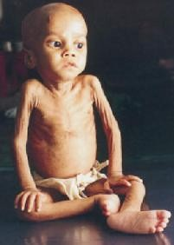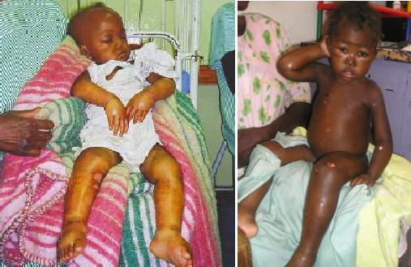

Marasmus | Kwashiorkor

Problems associated with excess intake of proteins
If a person consumes more protein than his/her body’s needs, the extra amino acids will be broken down and transformed into fat. Another concern associated with consumption of high-protein from animal foods, which are high in saturated fat and cholesterol. Therefore, consuming high-protein may increase the risk of heart disease.

Long-term consumption of high-protein diets may cause colon cancer and increase calcium excretion which depletes the calcium of bones and may contribute to osteoporosis. Excess proteins put extra burden on the liver to convert amino acids to urea and the kidneys to excrete excess urea than they are prepared to handle.

Evaluation at the end of the lesson:
Short Questions:

    - Define proteins.
    - What are essential and nonessential amino acids?
    - What is limiting amino acids?
    - What are the functions and deficiency diseases of proteins?
    - Discuss about the importance of complementary food combination.

