

**Learning in Two Stages:**

1. **Before starting your job**
2. **Academic, ii Non-academic**

**b. After starting your job (On job training)**

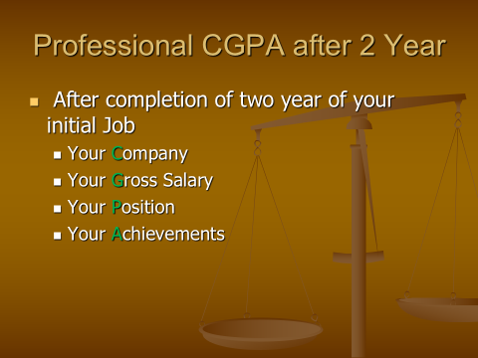

ID: -23- Name: CGPA:

|  |  |  |  |  |  |  |  |
| --- | --- | --- | --- | --- | --- | --- | --- |
| **Area** | **Area** | | **Present Condition** | **Target** | **Complete by** | **Remark** | **OK** |
| Computer Skills | MS PowerPoint | | 25 | Professional level - 100 | August -2020 | Youtube | √ |
| MS Word | |  | Professional level |  |  |  |
| MS Excel | |  | Professional level |  |  |  |
| Basic Hardware | |  | Workable |  |  |  |
| Download, Setup windows, E-mail | |  | Workable |  |  |  |
| Type without looking – English + Bengali | |  | Workable |  |  |  |
| Typing Speed | English |  | Targeted WPM: 35 |  |  |  |
| Bangla |  | Targeted WPM: 20 |  |  |  |
| Graphics Design | |  | Workable |  |  |  |
| Video Editing | |  | Workable |  |  |  |
|  |  | |  |  |  |  |  |
| English | Basic Grammar | |  | Noticeable improvement |  |  |  |
| Listening | |  | IELTS Score: 5.5/6 |  |  |  |
| Speaking | |  | IELTS Score: 5.5/6 |  |  |  |
| Writing | |  | IELTS Score: 5/6 |  |  |  |
| Reading | |  | IELTS Score: 5/5.5 |  |  |  |
|  |  | |  |  |  |  |  |
| Co-Curricular Activities | 1. | |  | Develop / Improve Communication Skill |  |  |  |
| 2. | |  |  |  |  |
| 3. | |  |  |  |  |
| Social Work | Will contribute in | |  | Betterment of society + communication skill |  |  |  |
|  | |  |  |  |  |
| Professional  Net working | Professionals of Textiles/Apparel, preferably working where you want to develop career | |  | At least 10 professionals who are in work + Close knitting with friends |  |  |  |
| Others | Reading Newspaper – daily  (Preferably English) | |  |  |  |  |  |
|  | Continuous Learning | |  |  |  |  |  |