**ASSIGNMENT CASE STUDY-2**

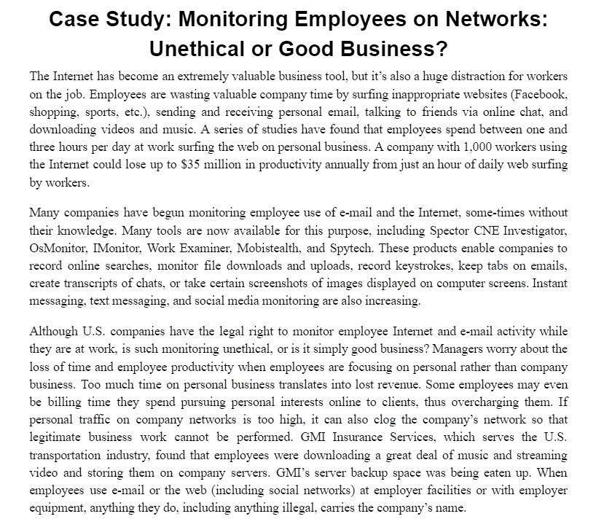

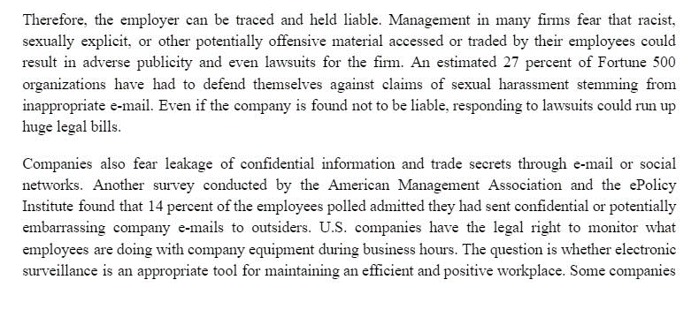

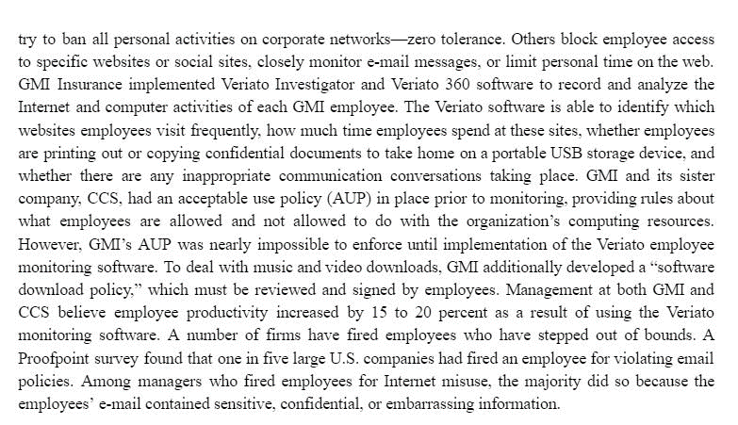

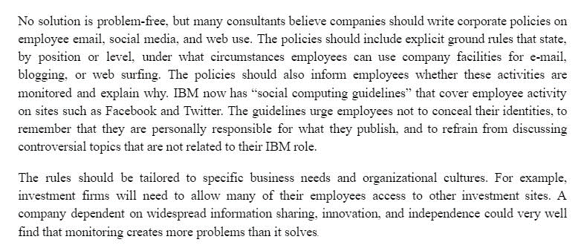

**QUESTIONS**

1. Should manager monitor employee email and internet usage? Why or why not? In your opinion, what could be an effective email and web use policy for a company? 1**.5 marks**
2. Should managers inform employees that their web behaviour is being monitored? Or should managers monitor secretly? Provide rationale for your stance. **1 mark**