**Lecture 1 & 2: Understanding Fabric Design and Analysis**

**Introduction**

**Types of Fabric:**

1. Woven Fabric. (Interlacement)
2. Knitted. (Inter looping)
3. Non woven. (Fibre sheet, interlining)
4. Braid.

**Woven Fabric:**

* Weaving is the intersection of two sets of straight yarns, warp and weft, which cross and interlace at right angles to each other. The lengthwise yarns are known as warp yarns and widthwise yarns are known as weft or filling yarns and the fabric produced is known as woven fabric.
* **Example:** Plain, Twill, Satin/Sateen
* **Application:** Poplin, Gavardin, Denim etc.

**Knitted fabric:**

* Knitting is a process of manufacturing a fabric by the intermeshing of loops of yarns and the fabric produced by this is known as knitted fabric.
* Example: Single Jersey, Double Jersey
* Application: T-Shirt, Polo Shirt, Stockings Etc.

**Non woven:**

* Non wovens are a sheet, web or bat of natural and manmade fibres or filaments, excluding paper, that have been covered into yarns and that are bonded to each other by any of several means – web formation, web bonding.
* Example: Fusible (interlining), Coated fabrics, Film fabrics.
* Application: Diapers, sanitary napkin, industrial musk, bandages etc.

**Braid:**

* Braid is one kind of narrow fabric. This kind of fabric is formed on braiding m/c by interlacing three or more strands of yarn. The process of interlacing three or more threads in such a way that they cross one another is laid together in diagonal formation.
* Example: Fire brigade water pipe, shoe lace, cloth lines, electric wire, ropes etc.

**Woven Fabric**

**Classification of Woven Fabric:**

* Considering the woven structure, the woven fabric may be conveniently divided into **two** principle categories:
* Simple Structure
* Compound Structure

1. **Simple Structure:**

* The ends and the picks intersect one another at right angles and in the cloth are respectively parallel with each other.
* There is only one series of ends and one series of picks.
* All the constituent threads are equally responsible for the utility or performance in a fabric and the aspect of aesthetic appeal.
* Example: Plain, Twill fabric.

1. **Compound Structure:**

* More than one series of ends and picks are used in this structure.
* Some of threads may be responsible for the body of the fabric whilst some may be employed entirely for ornamental purposes.
* In the clothes, some threads may be found not to be in parallel formation one to another in either plane.
* Example: Pile, Towel fabric.

**Methods of Fabric Representation:**

The unit of woven fabric is the point of intersection of a warp end and a weft pick. The interlacing is of two possible kinds-

1. Warp over weft interlacing.
2. Warp under weft interlacing.

 

1. In this interlacing, the warp thread is raised to produce interlacing.
2. In this interlacing, the warp yarn is lowered to produce interlacing.



**Feature of design:**

* The vertical lines/ space is to represented a warp end
* The Horizontal space is to represent to a weft pick.
* Each square indicates an intersection of an end and a pick.
* 🡒 Represents warp up over weft. And 🡒 represents weft up over warp.
* There are two and only two possibilities of each crossing, either the end passes over the pick or the pick passes over the end.
* Only one repeat should be shown on design paper.
* Symbols indicate repeat unit.
* # Represents starting point.

**Lecture 3: Understanding Fabric Design and Analysis**

**Important terms and definitions**

**Some Important Terms or Factors:**

|  |
| --- |
|  |
| x |
|  |
| x |
|  |
|  |
| x |
|  |
| x |

**Formula Number:** Formula number is notation diagram which represent the warp and weft interlacing point. The system of expressing the fabric representation is called Formula number.  
The warp floats coming up are put above the fraction line and the weft floats going down are put above the fraction line and the weft floats going down are put under the fraction line.  
 Formula no of weft = 

Formula no of warp = 

**Repeat Number or Repeat Size:** It indicates the number of warp and weft yarns in the repeat.

**Contact field:** These are the contact point’s betn warp and weft crossing at right angle. The number of contact field always equals the product of the number of warp and weft threads.   
 Contact field = RNwa X RNwe  
Here, R🡒 Repeat number.  
 Nwa 🡒warp.  
 New 🡒 weft.

**Interlacing Field:** These are the points where a yarn of one system of threads changes its position in relation to the other system.

Interlacing field may be of **two** types:

* Single Interlacing Field
* Double Interlacing Field

**Single Interlacing Field:** Here the yarn bends from the top of the fabric to the bottom and covers two or more yarn. It is found in *Twill* weave. After interlacing with one warp (or weft), the yarn does not interlace with adjacent warp (or weft).

**Double Interlacing Field:** Here the yarn bends and covers a yarn, bends again and reappears at the same fabric side. It is found in *Plain* weave. After interlacing the warp (or weft), the yarn interlaces with adjacent warp (or weft).

**Open Field:** These are the zones where neither warp nor weft thread is present. The number of open field is important for air and water permeability. Exa- Parachute.

**Free field:** These are the zones where the warp and weft yarns do not touch and do not change fabric side. Because of the free field, floats are formed and the yarns in the weave may shift.

**Interlacing Ratio:** The interlacing ratio of a fabric is the ratio between the actual number of interlacing fields and the maximum number of interlacing fields.

Interlacing Ratio = 

**Degree of Interlacing:** Degreeof Interlacing is the Interlacing Ratio expressed in percentage.

Degree of Interlacing = Interlacing Ratio × 100%

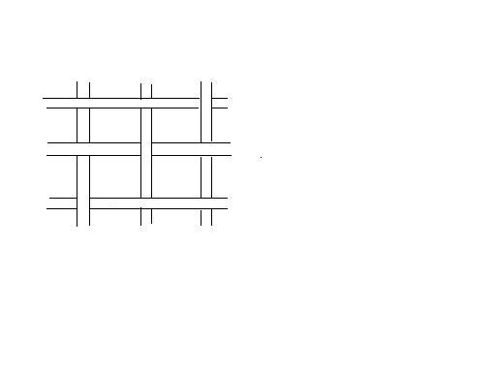

Warp

Weft

Open Field

Contact Field

Double Interlacing Field