**Lecture 3: Understanding Fabric Design and Analysis**

**Important terms and definitions**

**Some Important Terms or Factors:**

|  |
| --- |
|  |
| x |
|  |
| x |
|  |
|  |
| x |
|  |
| x |

**Formula Number:** Formula number is notation diagram which represent the warp and weft interlacing point. The system of expressing the fabric representation is called Formula number.  
The warp floats coming up are put above the fraction line and the weft floats going down are put above the fraction line and the weft floats going down are put under the fraction line.  
 Formula no of weft = 

Formula no of warp = 

**Repeat Number or Repeat Size:** It indicates the number of warp and weft yarns in the repeat.

**Contact field:** These are the contact point’s betn warp and weft crossing at right angle. The number of contact field always equals the product of the number of warp and weft threads.   
 Contact field = RNwa X RNwe  
Here, R🡒 Repeat number.  
 Nwa 🡒warp.  
 New 🡒 weft.

**Interlacing Field:** These are the points where a yarn of one system of threads changes its position in relation to the other system.

Interlacing field may be of **two** types:

* Single Interlacing Field
* Double Interlacing Field

**Single Interlacing Field:** Here the yarn bends from the top of the fabric to the bottom and covers two or more yarn. It is found in *Twill* weave. After interlacing with one warp (or weft), the yarn does not interlace with adjacent warp (or weft).

**Double Interlacing Field:** Here the yarn bends and covers a yarn, bends again and reappears at the same fabric side. It is found in *Plain* weave. After interlacing the warp (or weft), the yarn interlaces with adjacent warp (or weft).

**Open Field:** These are the zones where neither warp nor weft thread is present. The number of open field is important for air and water permeability. Exa- Parachute.

**Free field:** These are the zones where the warp and weft yarns do not touch and do not change fabric side. Because of the free field, floats are formed and the yarns in the weave may shift.

**Interlacing Ratio:** The interlacing ratio of a fabric is the ratio between the actual number of interlacing fields and the maximum number of interlacing fields.

Interlacing Ratio = 

**Degree of Interlacing:** Degreeof Interlacing is the Interlacing Ratio expressed in percentage.

Degree of Interlacing = Interlacing Ratio × 100%

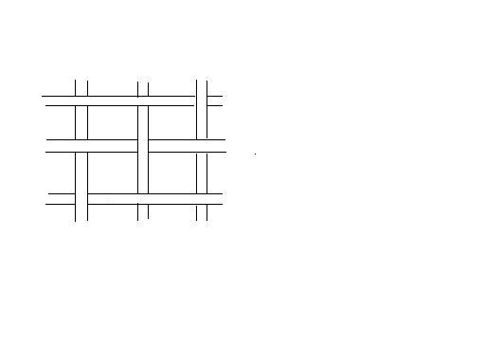

Warp

Weft

Open Field

Contact Field

Double Interlacing Field

**Classification of a Complete Design for a Woven Fabric:**

A complete design for a woven fabric consists of the following **three** major parts:

* Weave Plan
* Drafting Plan
* Lifting Plan

**Weave Plan:** It illustrates the interlacing of ends and picks in the fabric under consideration. It indicates *“ups”* and *“downs”* of each yarn in the fabric.

**Drafting Plan:** This plan indicates the number of *Heald shafts* used to produce a given design and the order in which the warp ends are threaded through *Heald eye* of the *Heald shafts.*

**Lifting Plan:** Lifting plan defines the selections of Heald shafts to be raised or lowered on each successive insertion of pick. Lifting plan is also known as *“Peg Plan”.*

There are also some other factors for designing a woven fabric. These are as follows:

* Denting Plan
* Structure
* Texture
* Handle

**Denting Plan:** The process of inserting warp yarn through reed is called *Denting.* The plan of denting according to an order is called *Denting Plan.*

**Structure:** In the manufacture of fabric by weaving on a loom, the technique how the two series of threads are interlaced at right angles to each other is called *Structure.*

**Texture:** The quality or properties which we get from fabric by interlacing of warp and weft yarn; such as handle properties, shinning properties, draping properties.  
Texture of woven fabric depend on-  
🡒Yarn (warp, weft) count  
🡒EPI, PPI  
🡒Yarn twist.  
🡒Characteristics of fibre.  
🡒Interlacement.

**Handle:** This is a term used to express the *Harshness* or *Smoothness* of fabric.