**Subject: Apparel Manufacturing I Lab**

**Experiment no. 11**

**Experiment name: Study on Round knife cutting machine.**

**Student Name:**

**Student ID with level & term:**

**Semester:**

**Introduction:** Fabric cutting means to cut out the garment pieces from the lays of fabric with the help of cutting template or marker. In other word, cutting is the process of separating garment parts from the fabric lay in precise size and shape.

**Round Knife Cutting Machine:** This machine is called round knife cutting machine because its cutter is round but slightly octagonal in shape. It is also called rotary knife cutting machine. This machine is small in size, flexible and used for small production. It is also a popular cutting machine. Round blade cutting machines are used to cut large and medium-size components of simple shape from low-fabric spreads or to cut single articles from one or two material plies. The machine is moved along the cut contours, while the fabric spread remains in a fixed position. Round-knife machines are the most effective for cutting slippery materials as the rotary movement of the knife ensures the continuous compression of the fabric plies. Round-knife cutters are lighter (between 3 and 11 kg) than [**straight knife cutting machines**](https://textilelearner.net/straight-knife-cutting-machine/)and are therefore easier to move.

**Features of Round Knife Cutting Machine:**

1. It contains a round but slightly octagonal type knife with sharp edge.
2. The other main parts of this machine are base plate, electric motor, handle and knife guard.
3. Knife diameter varies from 6-20 cm.
4. Manual grinder is used.
5. Motor r.p.m. is 800-1600.It depends on machine.
6. A handle for the cutter to direct the knife.
7. Easy to handle and movement due to low weight.
8. Knife is lubricating manually.
9. Three types of knife edge can be used for cutting different objects. Such as, waved edge, toothed edge and circular edge.
10. A round knife rotating so that the leading edge cuts downwards into the fabric.
11. Flexible movement helps to cut nonlinear shape.
12. Base plate gives support for fabric.

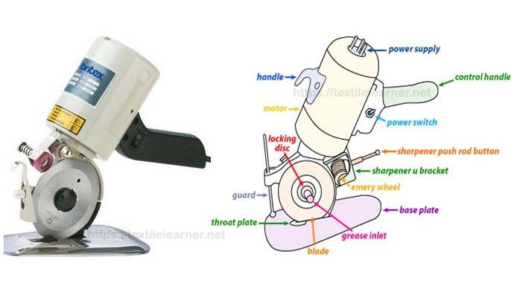

*Figure-2: Parts of round knife cutting machine*

**Draw the figure of round knife cutting machine:**

**Cutting knife blade**The cutting device is a circular knife with a blade sharpened along one side. The knife rotates and cuts the fabric only in the downward direction. The diameter of the knife can vary from 80 to 200 mm. The larger the knife diameter, the larger, heavier, and more powerful is the machine and is therefore less maneuverable. The most widely used machines are those with 100 and 110 mm knives. Blades of different shapes are used for cutting different materials. Round blades are used to cut light fabrics, but polygonal blades with 4, 6, 8, and 10 sides are used to cut thicker and harder materials. The knives may have one or two rotation speeds. Because of large overcut, rotary knives cannot be used to process detailed shapes and sharp corners.

Cutting knives come into two different grades for round knife cutting machine.

1. Carbon steel – commonly used for the cutting of all materials.
2. High speed steel – used for the heavy materials like canvas, which will quickly dull the carbon steel kind of knife. The round knife also available in different shapes other than the round shape as shown in Figure-3.

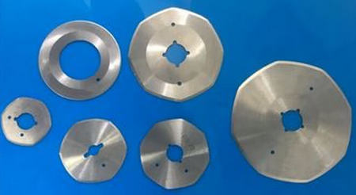

*Figure-3: Different knife shapes for round knife cutting machine*

**Knife sharpener**The machine has a built-in blade-sharpening system that uses replaceable emery stones. It is necessary to stop the [cutting process](https://textilelearner.net/process-sequence-of-cutting-section/) during the sharpening. The frequency of sharpening depends on the material being cut and on the knife blade.

There are two types of sharpening devices available for the round knife machine as in Figure-4.

1. Gliding grinder – most commonly used method, where the grinding stones are set perpendicular to the knife. It sharpens the cutting edge faster.
2. Normal grinder – uses slightly large stones which are almost parallel to the knife. This gives smoother cutting edges for cutting sheer fabrics, synthetics and plastics.

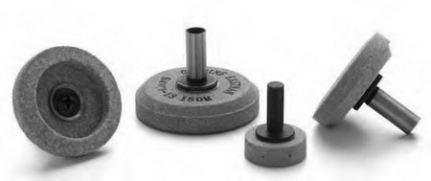

*Figure-4: Grinding rollers for round knife cutting machine*

**Base plate and its rollers**The lowest possible base plate profile is necessary to ensure the stability of the machine. It supports the foundation to balance the cutting. The base plate facilitates the manoeuvrability of the machine and minimizes the risk of deforming the material plies during the work process. Independently moving rollers are fixed under the base plate to ensure easy movement of the machine. It can vary in shape, sizes depending upon the size and weight of the knife. Edge of the plate is sloped.

**Handle**  
To grip, guide and propel the knife through the spread.

**Electric cable**  
An electrical cable supplies the motor with electricity. During the [fabric cutting](https://www.textileblog.com/garments-fabric-cutting-definition-requirements-and-methods/) process, it must be secured away from the surface of the cutting table to avoid the possibility of electric shock.

**Power system**  
Power controls the motor and provides potential cutting speed. The amount of power needed to cut a spread depends on the height of the spread and the density of the fabric to be cut. Horsepower determines the amount of thrust. Higher speed means knife moving faster. Greater horsepower increases machine power and weight also.

**Safety devices**  
The machine has a front safety shield to protect the operator’s hands from the knife blade. It may also be equipped with an auto stop trigger that switches off the power when the operator’s hand is removed from the lever. A separate on/off switch is situated on the top of the machine. During the cutting process, the operator must wear special protective gloves

**Advantages of Round Knife Cutting Machine:**

1. Suitable for cutting single ply as well as multilayer (say 20-30layers).
2. Easy to handle and operate.
3. Suitable for small scale cutting.
4. Suitable for gentle curve line cutting.
5. To cut the larger part of the garments.
6. With a same r.p.m. its efficiency is 10 times greater than the straight knife.

**Disadvantages of Round Knife Cutting Machine:**

1. Very low r.p.m. and knife height.
2. Manual grinder is used.
3. Low productivity since few number of lay can be cut.
4. Difficult to cut small components and high curve line.
5. Not suitable for large production.
6. Lubrication is manually done.

**Uses/Applications of Round Knife Cutting Machine:**It’s useful for gentle curve line cutting, big parts cutting, cutting out fabric block from lay and small scale cutting. It’s normally use for small production.

**Small round knife cutting machine (rotary shears):**Special small-sized round knife cutting machines are available for cutting single or multiple plies of material (for spreads up to 10 mm). These differ in shape, have a small diameter knife (typically 50 mm), and are light in weight. The machines may be electric or battery powered. Left-handed cutters are also available.

**Precaution:**

**Conclusion:**