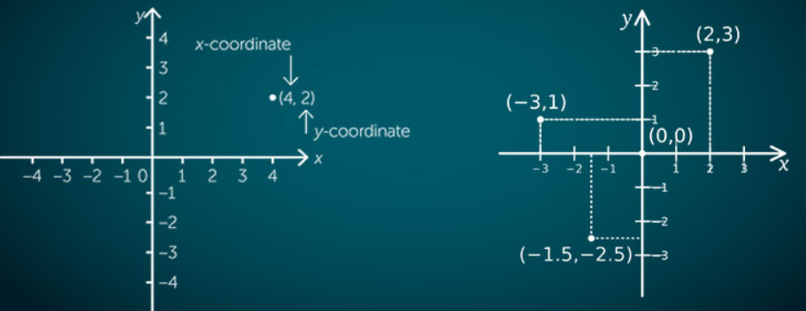

**Chapter 05**

**Introduction of Coordinate Geometry**

***Chapter Contents:*** *In this section learners are able to learn the followings*

* *El*

***Chapter Outcome:***After reading this chapter, you should be able to know:

1. About

**Introduction:**

Coordinate geometry is the branch of mathematics in which geometry is studied with the help of algebra. The great France mathematician and philosopher ***Rene Descartes*** (1596-1650) first applied algebraic formulae in geometry. A system of geometry where the position of [points](http://www.mathopenref.com/point.html) on the [plane](http://www.mathopenref.com/plane.html) is described using two numbers called an ordered pair of numbers or coordinates. The first element of the ordered pair represents the distance of that point on x-axis called abscissa and second element on y-axis called ordinate. This abscissa and ordinate make coordinates of that point.

The method of describing the location of points in this way was proposed by the French mathematician René Descartes (1596 - 1650). (Pronounced "day CART"). He proposed further that curves and lines could be described by equations using this technique, thus being the first to link algebra and geometry. In honor of his work, the coordinates of a point are often referred to as its Cartesian coordinates and the coordinate plane as the Cartesian Coordinate Plane and coordinate geometry sometimes called Cartesian geometry.

**Cartesian/Rectangular Coordinates System:**

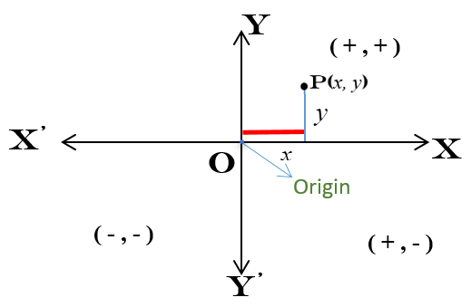Every plane is two dimensional so to locate the position of a point in a plane there is needed two coordinates. The Mathematician *Rene Descartes* first considered two perpendicular intersecting fixed straight lines in a plane as axes of coordinates. These two straight lines are named as rectangular axes and intersecting point as the origin denotes by the symbol O and the symbol Ocomes from the first letter of the word origin. The Cartesian coordinate system is named after the inventor name Rene Descartes. The Cartesian coordinate system is also known as Rectangular coordinates system as the axes are in right angle (Rec means right).In Cartesian coordinate system position of a point measured by the distance on both axes. First one is on x-axis called abscissa or x-coordinate denoted by the symbol ***x*** and the second one is on y-axis called ordinate or y-coordinate denoted by the symbol *y.* We express the coordinate of a point P in the Cartesian plane by the ordered pair *P(x, y) or P(abscissa, ordinate).*

The horizontal line XOX’ is called x-axis and the vertical line YOY’ is called y-axis. Both axes divide the whole plane into four parts called Quadrants .Four Quadrants XOY, X’OY, X’OY’ and XOY’ are called anti-clock-wisely 1st, 2nd, 3rd and 4th quadrant respectively. The coordinate of the origin is O(0,0) because all distances measured considering origin as starting point.

**Polar Coordinates System:**

In a similar manner of a Cartesian system for fixing or locating the point P in a plane, we take a fixed point Ocalled the pole and a fixed straight lineOX called the initial line. Joining the line of the points P and O is called radius vector and length of the radius vector

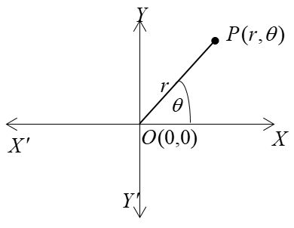OP= r and the positive angle is called the vectorial angle. It is sometimes convenient to locate the position of a point P in terms of its distances from a fixed point and its direction from a fixed-line through this point. So the coordinates of locating points in this system are called the Polar coordinates system. The coordinates of a point in this system are called Polar coordinates. The polar coordinates of the point P are expressed as  .

In expressing the polar coordinates of the point P the radius vector is always written as the first coordinate. It is considered positive if measured from the pole along the line bounding the vectorial angle otherwise negative. In a polar system the same point has an infinite number of representations and it is the demerits of polar coordinate system to Cartesian system.

**Example:** The point P has the coordinates

 etc.

**Relation Between Cartesian and Polar Coordinate System:**

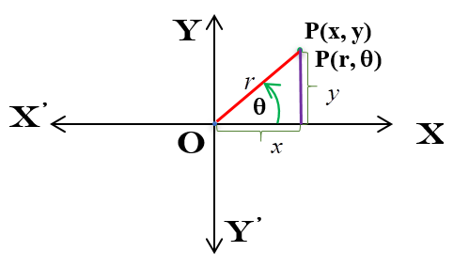Suppose that the coordinates of the point P in the Cartesian system is and in Polar system is . Our target here to establish the relation between two coordinates systems. From the triangle, with the help of trigonometry, we can find the relation between the Cartesian system & the polar system.

From the pictorial triangle, we get,



And, 

Again, applying Pythagorean Theorem from geometry we have a relation,



And, , so  {Principal Argument}

Therefore the relations are,

* If Polar coordinate  given then Cartesian/rectangular coordinate is,  and .
* If Cartesian/rectangular  given then Polar coordinate is, and .

**Example:** Determine the polar coordinates of the point.

**Solution:** We have given.Therefore  and 

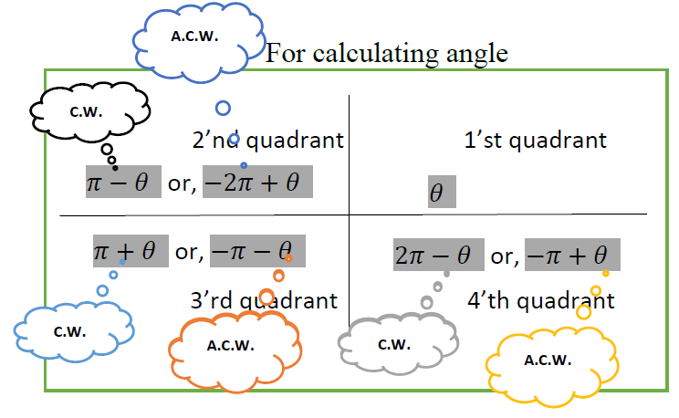We know that, 





And, 







Therefore the polar form of the given point is  or .

**Example:** Determine the Cartesian coordinates of the point.

**Solution:** We have given .Therefore  and 

We know that, 

And, 

Therefore the Cartesian form of the given point is .

**Example:** Transform the equation  to the Cartesian equation.

**Solution:** Given that the Polar equation is .

We know the relation between Polar and Cartesian form is,

,and  --------------------- (1)

Now we express the given equation is as,



 [Multiplying both sides by ]

 [We get from equation (1)]



Which is our required converted Polar equation from the given Cartesian equation.

**Example:** Express , in Polar form.

**Solution:** Given the Cartesian Equation is.

We know that  and 

Putting  and  the above relation is transformed into the following form









Which is our required converted Polar form of given Cartesian equation.

**Distance Between Two Points:**

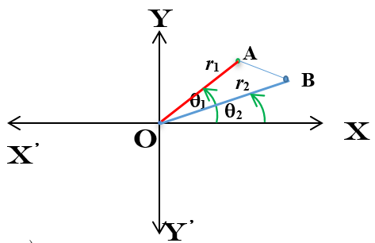If the coordinates of two points in the Cartesian system are  and , then the distance between two points is.

Again, if the coordinates of two points in Cartesian system are  and  then the distance between two points is,



**Area of a Triangle:**

If the coordinates of the vertices of the triangle in the Cartesian system are respectively, and , then the area of the triangle is

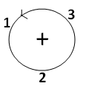  Square Units



The area by Sarrus Diagram Method:



An alternative representation of Sarrus diagram Method:



Note:

* In the determinant, the point must be chosen in the anti-clockwise direction.
* In the Sarrus Diagram method, the first point is repeated.
* Applying Sarrus Diagram Method we find the area of a polygon.

Again, If the coordinates of the vertices of the triangle in the Cartesian system are respectively, and , then the area of the triangle is

 Square Units



**Example:** Find the distance between the points  and (-2, 5).

**Solution:** Let the given points be  and .

.

**Example:** Find the distance between the points  and **.**

**Solution:** Let the given points be  and ****.

We know that the distance between two points is,



  



**Example:** Show that the three points A(1, 2), B(3, 4) and C(6, 7) lie on the same straight line.

**Solution:** Let the points be A(1, 2), B(3, 4) and C(6, 7).

Now, 



And 

Since . So  lie on the same straight line.

**Example:** Find the area which bounded by the region of the point A(1, 2), B(-3, 4) and C(-6, -7).

**Solution:** Let the points be A(1, 2), B(-3, 4) and C(-6, -7).





**Gradient or Slope of a Line:**

In the figure, the straight line  makes an angle  to the positive direction of axis. Trigonometrically, if any line makes an angle with the positive direction to axis is called the slope or tangent of the line and is denoted by. The slope of the line  is 

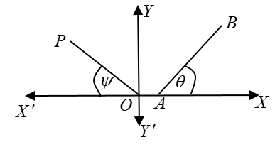In the figure, the line OP makes an angle  with the negative direction of axis. So the line OP makes an angle  with the positive direction of axis. Therefore the slope of OP is 

As for example if any line makes an angle  to the positive direction of axis, then the slope will be 

**Remarks:** The slope of the line parallel to the axis is not defined, for  is not defined. If  be the angle, then the slope will be negative. Clearly, the slope of the axis is zero.

**Some Formula For Finding the Slop of the Line:**

* The slope of the line joining the two points  and  is, .
* 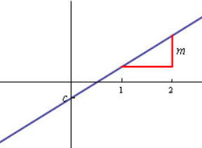The general formula of a straight line is here  is the slope of the line and  is the interception point on the axis. Compare with the general formula of the straight line we can find the slope of the line also possible to find the interception point on the axis.
* Two straight lines to be perpendicular if , here  and  are the slope of the two straight lines.
* Two straight lines to be parallel if , here  and  are the slope of the two straight lines.

**Example:** If a straight line passing through the points  and  then find the slope of the line.

**Solution:** Let the given points be,  and .

So the slope of the line 

**Example:** Find the slope and the intercept point on the axis of the straight line 

**Solution:** The given equation can be written as, 

Compare this with  we get the slope of the straight line is  and intercept point on the axis is 

**Example:** If the two straight lines are  and  then find is it perpendicular or parallel to each other.

**Solution:** Given that the lines are and 

Now, the line  can be written as,  Compare this with  we get the slope of this straight line is 

Again, the line  can be written as,  Compare this with  we get the slope of this straight line is 

So, . So given two lines are perpendicular to each other.

**Intercept or Point of Interception:**

Let the equation of two straight lines be

 ------------------------ (i)

 ------------------------ (ii)

The intersecting point of the two straight lines is a common point of them and the co-ordinates of this point will satisfy the equations.

Now solving the equations (i) and (ii) by cross multiplication we get,

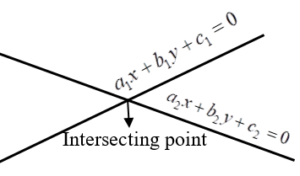



So the coordinate of the intersecting point is 

**Example:** Find the intersecting point of  and .

**Solution:** Given that the equation,  -------------- (i) and  ------------ (ii)

Now solving the equations (i) and (ii) by cross multiplication we get,











**Example:** Calculate the coordinates the point of intersection of the line  and the Curve 

**Solution:** Given that the equation, -------------- (i) and  ------------ (ii)

From (i) we get, 

 -------------- (iii)

Put the value of (iii) in (ii) then we get, 











Put the value of y in equation (iii) then we get,

If  then  and  then .

Hence the intersecting points are, .

**Exercise**

**Theoretical Questions:**

1. Write down the definition of the following terms:-

Cartesian/Rectangular Coordinates System, Polar Coordinates System, Gradient or Slope of a Line

**Mathematical Problems (Broad Questions):**

**1.** Convert the following points to the polar form:

i)  ii)  iii)  iv)  v) 

**2.** Convert the following points to the Cartesian form:

i)  ii)  iii)  iv)  v) 

**3.** Convert the following equations in polar form:

i)  ii)  (iii) 

**4.** Convert the following equations in Cartesian form:

i)  ii)  iii) 

**5.** Find the distance between the pair of points:

i)  and  ii)  and  iii)  and 

**6.** Show that the four points  and  are the vertices of the rhombus.

**7.** Find the area which bounded by the points .

**8.** Find the slope of the line if the straight line passing through the following points,

(a)  and  (b)  and  (c)  and 

**9.** Find the slope and the intercept point on the axis of the following straight lines,

(a)  (b)  (c) 

**10.** Find the following equations are perpendicular or parallel to each other,

(a)  and  (b)  and 

**11.** Find the intersecting point of the following equations,

(a)  and  (b)  and 

**12.** Calculate the coordinates the point of intersection of the line  and the Curve .