**Experiment No: 03**

**Experiment Name: Identification of microbes by Selective Media**

**Principle:**

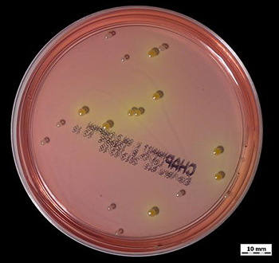Selective media are used for the growth of only selected microorganisms. Selective growth media are also used in cell culture to ensure the survival or proliferation of cells with certain properties, such as antibiotic resistance or the ability to synthesize a certain metabolite. Normally, the presence of a specific gene or an allele of a gene confers upon the cell the ability to grow in the selective medium. In such cases, the gene is termed a marker.

**Examples of selective media include:**

* MRS Agar
* SS Agar
* Potato Dextrose Agar
* Eosin methylene blue
* YM (yeast extract, malt extract agar)
* MacConkey agar
* Hektoen enteric agar
* Mannitol salt agar etc.

**Apparatus and Materials:**

1. Media

2. Petri-dish

3. Beaker

4. Measuring Cylinder

5. Conical Flask

6. Spatula

7. Aluminum Foil

8. Autoclave

9. Incubator

10. Hot Plate

11. Micro-pipette

12. Laboratory Films

13. Electronic Balance

**Reagent:**

1. Sodium Hydroxide (NaOH)

2. Conc. HCL

**Procedure:**

1. Measure your selective media into a conical flask and dissolve it by 200ml distil water

2. After dissolving properly mixed it by hot plate.

3. After mixing check the pH level and adjust it (If needed)

4. Autoclave it for 30 to 45 min at 121oC with 15 psi (Careful for some media, because those are do not need autoclave. Exp. SS Agar)

5. After autoclave, all apparatus and media keep into laminar air flow for preventing the air contaminates (do the next procedures into the laminar air flow).

6. Pure the media into the Petri-dish and wait some time for solid it.

7. After the solid form then pure the 0.5ml of your sample into the media.

8. Rapped it by laboratory films.

9. Keep it into Incubator for 16h to 24h at 35oC to 37oC

**Calculation:**

**Results**