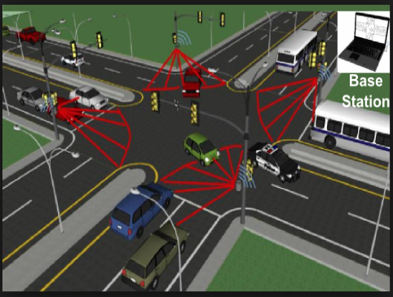

**Chapter 06**

**Change of Axis**

**Transformation of Coordinates:**

The process of changing the coordinates of a point or the equation of the curves is called the transformation of coordinates. Transformation of coordinates is of three types such as,

1. Translation of Axes
2. Rotation of Axes
3. Translation-Rotation of Axis

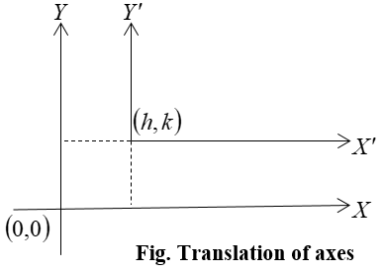**(1) Translation of Axes:**

In this process, the position of the origin is changed but the direction of coordinate axes is being parallel to the old system. When origin  shifted to the new point  and keeping the direction of coordinate axes fixed then the pair of equations  represents the relation between the new system and old system and is called the translation of axes.

**Theorem:** When origin shifted to the new point  and keeping the direction of coordinate axes fixed then the pair of equations  represents the relation between the new system and old system.

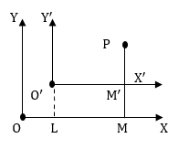**Proof:** Let,  be the original axes of co-ordinates and  be the origin. Let,  be the new axes of co-ordinates parallel to original axes of co-ordinates and  be the new origin.

Let *P* be any point whose co-ordinates referred to the old axes are  and referred to the new axes. Then,

 and 

Therefore, **

**

Similarly, **

**

The transformed coordinates are,  and 

Therefore we get,  and .

**Note:** When the origin is transferred to any arbitrarily chosen point and keeping the direction of axes fixed then it is observed that the coefficient of highest degree term remain unchanged but constant will be changed that means changes to .

**Example:** Determine the equation of the curve when the origin is transferred to the point.

**Solution:** Given equation of the curve is,

Origin is transferred to the point  so as the transformed relations are  and.

Using the above transformation given equation becomes













Removing suffices from the above equation we get the transformed equation of the given curve.



This is the required equation that represents an ellipse.

**Example:** What does the equation  becomes when the origin is transferred to the point  and the direction of axes remain unaltered.

**Solution:** Given the equation of the curve is,

Origin is transferred to the point  so as the transformed relations are  and.

Using the above transformation given equation  reduces to











Removing suffices from the above equation we get the transformed equation of the given curve.



This is the required equations that represent a circle.

**(2) Rotation of Axes :**

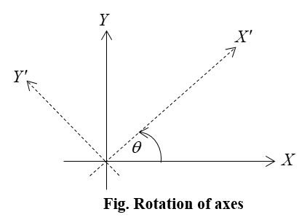In this process, the position of the origin is not changed but the direction of coordinate axes is being changed through a fixed angle with the x-axis. When the position of the origin is not changed and the direction of coordinate axes is being changed through a fixed angle  with the X-axis then this is called rotation of axes and the relation between the new  system and the old system  are given below.



Its matrix forms are as follows:



**Note:** In a rotation of axes the constant term of an equation remain same.

**Theorem:** When the position of the origin is not changed and the direction of coordinate axes is being changed through a fixed angle  with the x-axis then this is called rotation of axes and the relation between the new system and old system are and **.**

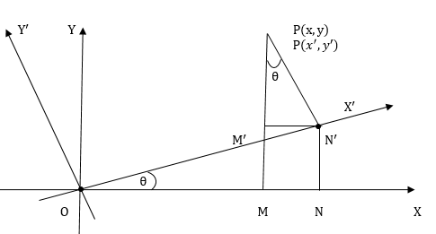**Proof:** Let, be original axes of co-ordinate and  be new axes of co-ordinates through the same origin and *θ* be the angle through which they have been turned in the same sense.

Let, *P* be any point whose co-ordinates referred to the original axes be  and referred to the new axes be  Draw PM perpendicular to , and  parallel to.

Then, 

**

Similarly, 



Hence the formula for the rotation of the axes through an angle *θ* is,

and **.**

**Example:** Transform equation  to axes turned through.

**Solution:** Given that, 

Since the axes rotated are an angle  and origin is unchanged.

So,

And, 

Using this value in the equation  we get,











Now removing suffixes, we can write,  This is the required equation.

**Example:** If the axes are turned through an angle, what does the equation  become?

**Solution:** Given equation of the curve is,



The coordinate axes turned through an angle  that implies .



Now,  and 



Considering the new coordinate of the point is and rotating the axes through an angle  and origin be unchanged as the transformed equations are as follows





and, 



Putting the value of x and y the above equation  becomes



















Removing suffices from the above equation we get the transformed equation of the given curve.



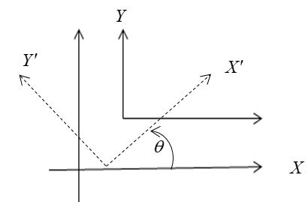

**(3) Translation-Rotation of Axis:**

In this process, the position of the origin is changed and the direction of coordinate axes is being changed through a fixed angle with the x-axis. The relation between the new system and old system are given below.

 and 

Here origin shifted to the new point and then turned the coordinate axes through an angle with x-axis.

**Example:** Determine the transform equation of  when the origin is transferred to the point  and the axes turned through an angle.

**Solution:** Given Equation is, …………………. (i)

Origin is transferred to the point  so as the transformed relations are  and 

Using the above transformation given equation  becomes







Now removing suffixes, we can write,  ……………… (ii)

Again the axes rotated are an angle 

So, and 





Using this value in equation we get,

**

**

**

**

Now removing suffixes, we can write, . This is the required transform equation.

**Example:** Find transform equation of  when the origin is transferred to the point  and the axes turned through an angle .

**Solution:** Given equation is,

Origin is transferred to the point  so as the transformed relations are  and.

Using the above transformation given equation  reduces to

 

Removing suffixes, 

The coordinate axes turned through an angle  that implies .



Now,  and 



Considering the new coordinate of the point is and rotating the axes through an angle and origin be changed at  as the transformed equations are as follows





and 



Putting the value of x and y the above equation  becomes















Removing suffixes we get the desired result  .

**Exercise**

**Mathematical Problems (Broad Questions):**

1. Determine the equation of the curve  when the origin is transferred to the point.
2. What does the equation becomes when the origin is transferred to the point and the direction of axes remain unaltered.
3. Transform the equation  to axes turned through  .
4. If the axes are turned through an angle, what does the equation  become?
5. Find transform equation of  when the origin is transferred to the point  and the axes turned through an angle.
6. Determine the transform equation of  when the origin is transferred to the point  and the axes turned through an angle.