Neonatal growth and anatomy
# Embryo
An embryo is an early stage of development of a diploid eukaryotic organism. In general, an embryo develops from a zygote, the single cell resulting from the fertilization of the female egg cell by the male sperm cell. The zygote possesses half the DNA of each of its two parents. This zygote will begin to divide by mitosis to produce a multicellular organism. The result of this process is an embryo.
Age range: From fertilization, Day 1 to 8th weeks.
# Fetus
A fetus is a prenatal human between the embryonic state and birth. The fetal stage of development tends to be taken at beginning at the nine weeks after fertilization to birth. The fetus generally implies an embryo that has developed to the point of being recognizable as a human. A fetus is also characterized by the presence of all the major body organs.
Age range: From 9th week to birth.
# Neonates/newborn
Newborn or neonate refers to an infant in the first 28 days after birth. It is basically the first 4 weeks of life.
Age range: From birth to 28 days of life.
# Infants
An infant or baby is the very young offspring of a human or other animal. The term "infant" is typically applied to young children between one month and one year of age.
Age range: From second month to 1 year of life.
# Toddler
A toddler is a child 12 to 36 months old. The toddler years are a time of great cognitive, emotional and social development.
Age range: From 12th to 36th month of life.

BLOOD CIRCULATION
# Fetal Circulation
During pregnancy, the unborn baby (fetus) depends on its mother for nourishment and oxygen. All the necessary nutrition, oxygen, and life support from the mother’s blood goes through the placenta and to the baby through blood vessels in the umbilical cord. Waste products and carbon dioxide from the baby are sent back through the umbilical cord blood vessels and placenta to the mother's circulation to be eliminated.
Oxygen rich blood in the unborn baby follows this pathway:
- The enriched blood flows from placenta through the umbilical cord (basically called umbilical vein) to the liver and splits into two branches.
- Majority of the blood then reaches the inferior vena cava, a major vein connected to the heart through ductus venosus.
- A small amount of this blood goes directly to the liver to give it the oxygen and nutrients it needs.
- In the heart, blood enters into the right atrium, the chamber on the upper right side of the heart.
- When the blood enters the right atrium, most of it flows through the foramen ovale into the left atrium.
- Blood then passes into the left ventricle (lower chamber of the heart) and then to the aorta.
- Blood is then sent to the heart muscle (myocardium), brain and lower body part, well as whole circulatory system.
Oxygen poor blood in the unborn baby follows this pathway:
- After circulating, the blood returns to the right atrium of the heart through the superior vena cava.
- About two thirds of the blood passes through the foramen ovale from right atrium to left atrium, but the remaining one third is passes into the right ventricle, toward the lungs.
- Most of this blood is bypassed away from the lungs through the ductus arteriosus to the aorta.
- This blood (containing carbon dioxide and waste products) is then enters the umbilical arteries and flows into the placenta for purification and coming back to fetus again.

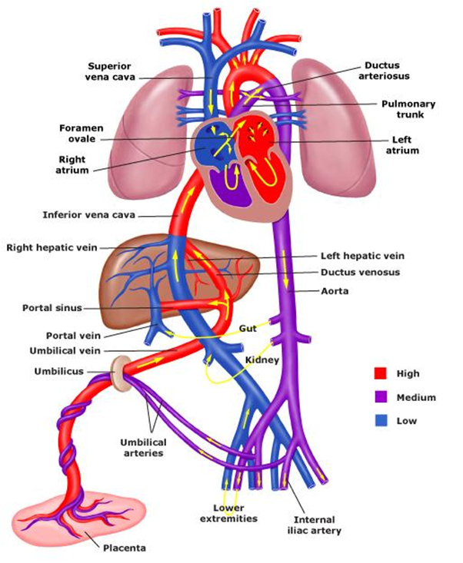
Fig: Fetal circulation
#Adult Circulation
The human circulatory system has two-part systems (systemic and pulmonary) whose purpose is to bring oxygen-bearing blood to all the tissues of the body. In the systemic loop, the blood circulates into the body’s systems, bringing oxygen and collecting carbon dioxide waste. In the pulmonary loop, the blood circulates to and from the lungs, to release the carbon dioxide and pick up new oxygen.
The Pulmonary loop (Controlled by right side of heart)
- From the right atrium (10) the oxygen poor blood reaches into the right ventricle (1) through the tricuspid valve.
- During ventricle contraction, the blood is pushed into the pulmonary artery (2) that divided into two main parts: one to the left lung (3) and one to the right lung (3).
- Here, in lungs carbon dioxide rich blood is converted into oxygen rich blood.
- The fresh, oxygen-rich blood returns to the left atrium (5) of the heart through the pulmonary veins (4).
The systemic loop (Controlled by left side of heart)
- The oxygen-rich blood coming from the lungs (3) enters the left atrium (5) of heart through pulmonary vein (4).
- As the chamber fills, it presses open the mitral valve and the blood flows down into the left ventricle (6).
- During the ventricle contraction, the blood on the left side is forced into the aorta (7).
- The blood leaving the aorta brings oxygen to all the body’s cells through the network of arteries and capillaries (8).
- The used blood from the body returns to the heart through veins.
- All of the blood from the body is eventually collected into the two largest veins: the superior vena cava (9), which receives blood from the upper body, and the inferior vena cava, which receives blood from the lower body region.
- Both veins, reach the blood into the right atrium (10) of the heart.
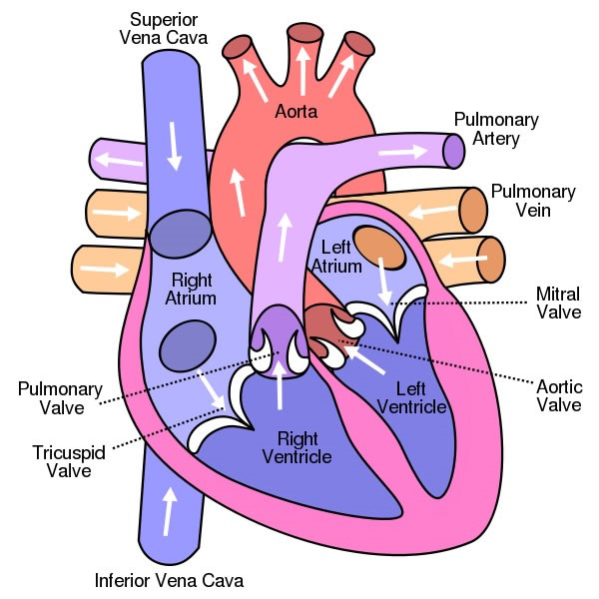
Fig: Circulation into the heart
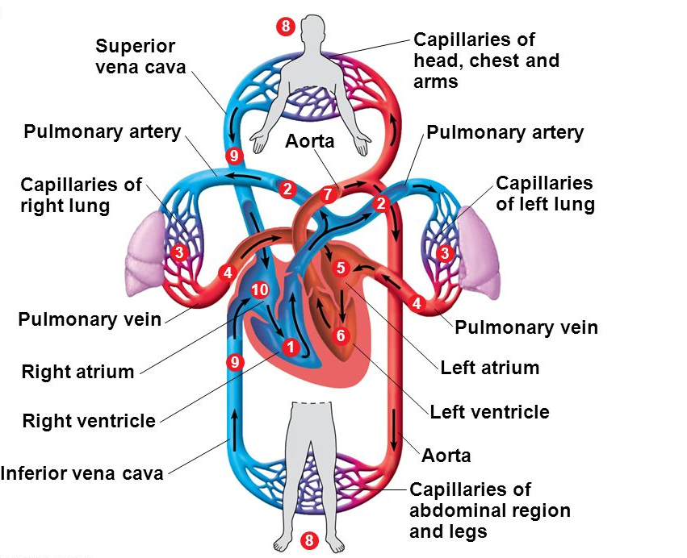
Fig: Systemic and pulmonary circulation

Gastrointestinal development
# Fetal development
The gastrointestinal tract (GIT) arises initially during the process of gastrulation from the endoderm of the tri-laminar embryo (week 3). During the 4th week three distinct regions (fore-, mid- and hind-gut) extend the length of the embryo and will contribute different components of the GIT. The gut tube is formed from endoderm, the lining of yolk sac which is enveloped by the developing coelom.
Germ layer contributions:
- Endoderm: mucosal epithelium, mucosal glands, and submucosal glands of the GI tract.
- Mesoderm: mucosae, submucosal connective tissue and blood vessels, muscularis externa.
- Neural crest: neurons and nerves of the submucosal
The oral cavity (mouth) is formed by breakdown of the oropharyngeal membrane and contributed to mainly by the pharynx lying within the pharyngeal arches.
Subdivision of GUT tube
- Foregut
From the oral cavity the next portion of the foregut is initially a single gastrointestinal (oesophagus) and respiratory (trachea) common tube, the pharynx which lies behind the heart.
- Midgut
From beneath the stomach the initial portion of the small intestine, the duodenum, and the associated pancreas.
- Hindgut
The distal transverse colon, descending colon, sigmoid colon, rectum.
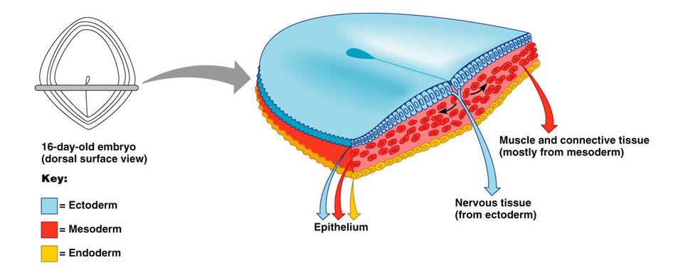
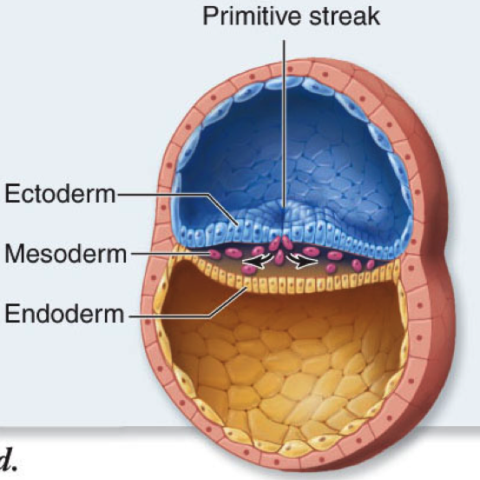

# Neonatal Development
In fetal development, meconium is formed from gut and associated organ secretions as well as cells and debris from the swallowed amniotic fluid. Meconium accumulates during the fetal period in the large intestine (bowel). It can be described as being a generally dark color (green black), sticky and odorless.
Passage of meconium within the 1st 24 hours is transitional stools (greenish soft stools) and in the next 4 days’ is milk stools (normal pasty consistency and yellow color).
Contribution of gut in neonatal development:
FOREGUT | MIDGUT | HINDGUT
Trachea & respiratory tract | Lower duodenum | Distal 1/3 of transverse colon
Lungs | Jejunum | Descending colon
Esophagus | Ileum | Sigmoid colon
Stomach | Cecum | Rectum
Liver | Appendix | Upper anal canal
Gallbladder & bile ducts | Ascending colon | Urogenital sinus
Pancreas (dorsal & ventral) | Proximal 2/3 of transverse colon

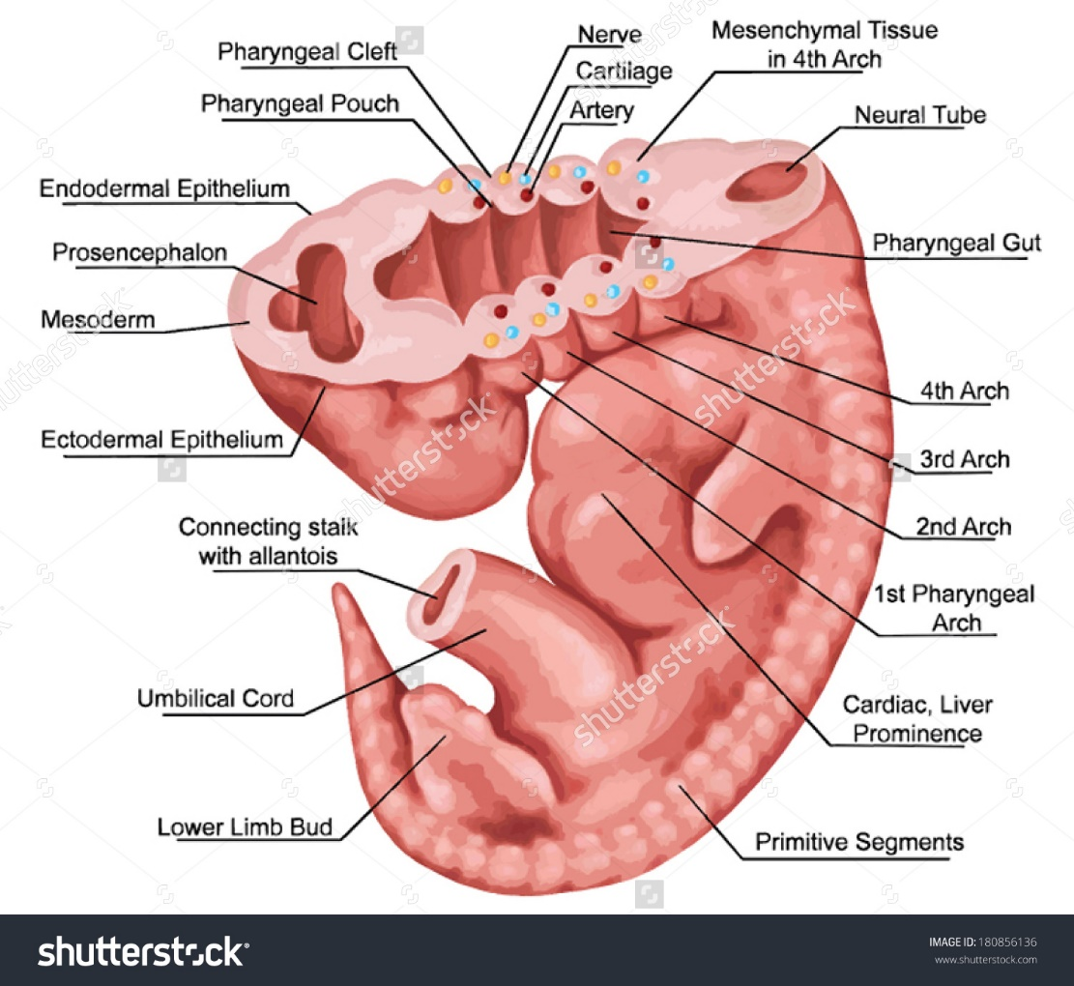

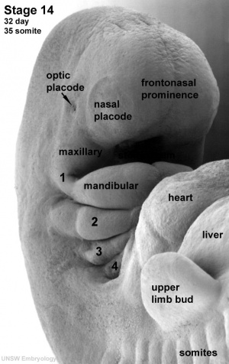
RENAL SYSTEM
# Fetal system
The paired adult kidneys consist of a functional unit called the "nephron", that filters blood, excretes waste and reabsorbs water. Each adult human kidney typically contains about 750,000 nephrons.
- In the embryo, nephron development, nephrogenesis, occurs through several stages.
- Nephrogenesis continues into the late fetal period (week 34–35)
- Production of urine as early as 4th month.
- Glomerular filtration begins at about 9 weeks
- Renal function (GFR & RPF) not reach adult levels till 2nd year of life
- The urinary system is developmentally and anatomically associated with genital development, often described as the "urogenital system
HEMATOPOIETIC SYSTEM
# Fetal System
- Erythropoietin: hormone produced in the kidney responsible for the production of RBC
- Due to relative hypoxia of the fetus at the bone marrow, the fetal hemoglobin is as high as 20g/dl
- Blood formation as early as 3rd week after conception
- Mesodermal tissue in the 1st month
- Liver in the 2nd month
# Neonatal System
- At birth - high hgb.
- Starts to drop on the 3rd day of life until a minimum of 10-12g/dl on the 2nd-3rd month of life.
- It happens as a result of decrease in bone marrow activity and increase in rate of hemolysis
- Hemo-dilution due to rapid expansion of blood volume
- Normal blood volume ranging from 80-90ml/kg
- WBC ranging from 10,000-30,000/mm3

