**Subject: Apparel Manufacturing I Lab**

**Experiment no. 04**

**Experiment name: Study on Principle of pattern making for shirt (Body section)**

**Student Name:**

**Student ID with level & term:**

**Semester:**

**Principle of Pattern Making for a Shirt**

According to the Standard Measurement, 40cm Neck and 100cm Chest for a body the principle pattern making of a shirt is given below:

To make the pattern the necessary measurements are given below:

**Neck Size : 40cm**

**Chest : 100cm**

**Scye Depth : 24.4cm**

**Natural Waist Length : 44.6cm**

**Half Back : 20cm**

**Sleeve Length : 80cm**

**Cuff Size : 23cm**

**Cuff Depth : 7cm**

**Shirt Length : 81cm**

**Body Section:**

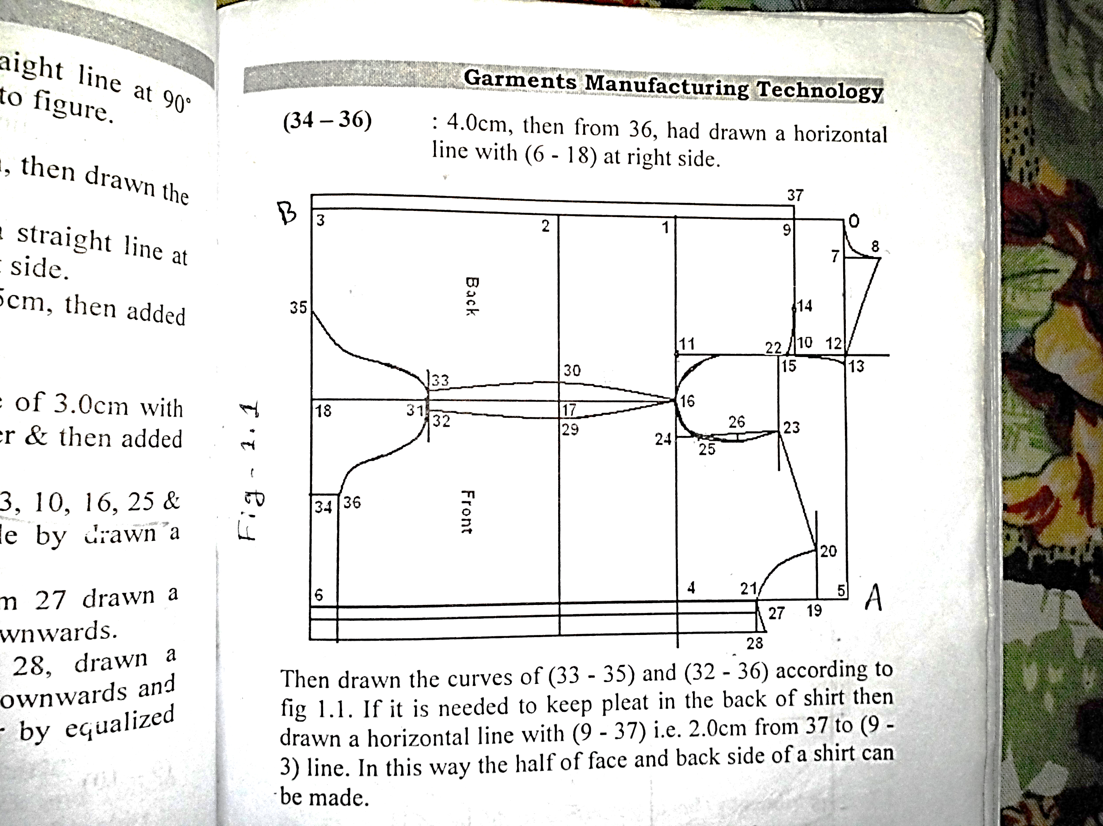

## Figure 1: Body Section

At first indicating “0” point at a corner of the graph paper, then from “0”, the line is extended (0-A) and from ‘0’ drawn a straight line (0-B) at a right angle with (0-A). Then:

(0-1) : Scye Depth + 4cm. Then from 1 drawn a straight line in right angle with (0-1) line at right side.

(0-2) : Natural Waist + 3cm. Then from 2 drawn a straight line in right angle with (0-2) line at right side.

(0-3) : Shirt Length + 8cm. Then from 3 drawn a straight line in right angle with (0-3) line at right side.

(1-4) : Half Chest + 12cm. Then extended 4 to 5 in the lineup and 6 in down at right angles with (1-4).

(0-7) : One fifth of neck size–0.5cm. Then from 7drawn a straight line in the up right angle.

(7-8) : 4.5cm. Then drawn the neck curve according to figure.

(0-9) : One fifth of (0-1) + 2cm. Then from 9drawn a straight line in right angle with (0-9) line at right side.

(9-10) : Half Back + 4cm. Then from 10 drawn a straight line in right angle with (9-10) line at upper and lower side and indicates 12 & 11 respectively.

(12-13): 0.75cm. then added 8 to 13 by slightly curved.

(10-14): 10cm.

(10-15): 0.75cm. Then added 14 to 15 by slightly curved.

(1-16) : Half measurement of (1-4) + 0.5cm. Then from 16 drawn a straight line in right angle with (1-16) so that got 17 & 18 points.

(5-19) : 4.5cm. Then from 19drawn a straight line in right angle with (5-19 line according to figure.

(19-20) : One fifth of neck size – 1cm.

(19-21): One fifth of neck size – 2.5cm. Then drawn a neck curve.

(10-22): 1.5cm. Then from 22drawn a straight line in right angle with (22-11) line at right side.

(20-23) : Measurement of (8-13) + 0.5cm. Then added (20-23) by slightly curved.

(1-24) : One third of chest + 4.5cm.

(24-25): From 24drawn a vertical line of 3cm with (1-24) at right angle in the upper and then added 23 to 25.

(23-26): Half of (23-25). Then added 13, 10, 16, 25 & 23 and from 26, made armhole by drawn a curve in the inside of 1.0cm.

(21-27) : 1.5cm button stand. Then from 27 drawn a horizontal line with (27-6) in downwards.

(27-28) : 3.5cm for facing. Then from 28drawn a horizontal line with (21-6) in downwards and made a curve from 28 at upper by equalized with neck curve.

(17-29) : 2.0cm.

(17-30) : 2.0cm.

(18-31) : 20cm. Then from 31 drawn two straight line at negative direction to each other in right angle with (18-31) line.

(31-32) : 1cm.

(31-33) : 1cm, then drawn two curves of 16, 30, 33, and 16, 29, 32 and made side seam lines.

34 : Drawn a midpoint of (6-18) and made a vertical line from 34 with (6-18)

35 : Drawn a midpoint of (3-18)

(34-36): 4cm. Then from 36 drawn a horizontal line in right angle with (6-18) line at right side.

Then drawn the curves of (33-35) and (32-36) according to fig. 1.1. If it is needed to keep pleat in the back of shirt then drawn a horizontal line with (9-37) i.e. 2cm from 37 to (9-3) line. In this way the half of face and back side of a shirt can be made.

**Calculation:**

**Calculation:**