**Subject: Apparel Manufacturing I Lab**

**Experiment no. 06**

**Experiment name: Study on Principle of pattern making for trousers Student Name:**

**Student ID with level & term:**

**Semester:**

**Principle of Pattern Making for Trouser**

**Principle of Pattern Making for Trouser**

**Pattern:** Patterns are paper templates for all the components of a garment, such as cloths, lining, interlining which have to be cut for a garment. These patterns are used to draw sketch on cloth or marker paper.

According to the standard measurement, pattern making of a trouser is given below for 102cm seat measurement:

To make the pattern the necessary measurements are given below:

**Seat : 102cm**

**Waist : 82cm**

**Body Size : 28cm**

**Inside Leg Measurement : 81cm**

**Trouser Bottom Width : 25cm**

**Waist Band Depth : 4cm**

**Top Side Section:**

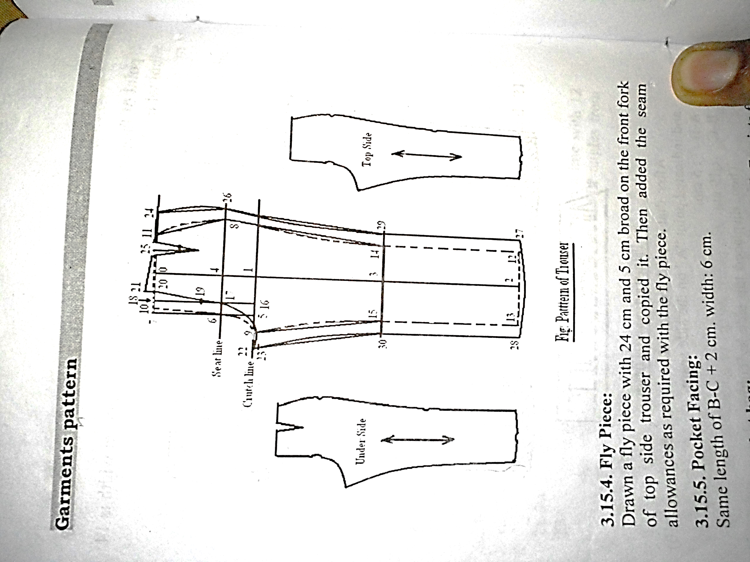

*Figure 1: Top & Under Side of Pant*

At first indicate‘0’ point from the left side of pattern paper at 24cm, then from “0”, drawn three straight lines at right angle in downside, left and right side. Then:

(0-1) : Body Rise + 1cm – Waist Band Depth. Then from 0drawn a perpendicular line in right angle with (0-1) line at right side and extended on both sides.

(1-2) : Inside Leg Measurement. Then from 2 drawn a perpendicular line in right angle with (1-2) line at right side and extended on both sides.

(2-3) : Half Measurement of (1-2) + 5cm. Then from 3 drawn a perpendicular line in right angle with (1-2) line at right side and extended on both sides.

(1-4) : One fourth measurement of Body Rise. Then from 4drawn a perpendicular line in right angle with (0-1) line at right side and extended on both sides.

(1-5) : One twelfth measurement of Seat + 1.5cm. Then from 5drawn a perpendicular line in right angle with (1-5) line at right side, which indicates the point 6 and 7.

(6-8) : One fourth of Seat Measurement + 2cm.

(5-9) : One sixteenth of Seat Measurement + 0.5cm.

(7-10) : 1cm.

Then drawn a front curve by adding 6, 9 and 10 according to figure.

(10-11) : One Fourth of Waist Measurement + 2.5cm.

(2-12) : Half of Bottom Width.

(2-13) : Half of Bottom Width.

(0-1) : Body Rise + 1cm – Waist Band Depth. Then from 0 drawn a perpendicular line in right angle with (0-1) line at right side and extended on both sides.

Then added by straight lines from 12-14 and 13-15. Then drawn curve from 11-8 and extended 0.5cm outside the curve. Again drawn a curve from 8-14 and extended 0.5cm inside the curve.

Now, the line caused by the points 11, 8, 14, 12 indicates the side seam.

After that, drawn a curve from 9-15 and squeezed 1cm inside the curve. Now, the line caused by 9, 15, 13 points indicates the inside leg.

**Calculation:**