**Experiment No. 01**

**Determination of pH of Water**

**Objective:**

The objective of this experiment is to measure the level of pH of the given samples and thereby determine its acid or alkaline condition by comparing with guideline value.

**pH:**

pHis a term used universally to express the intensity of the acidity or alkalinity of an aqueous solution. More exactly, it is a way of expressing positive hydrogen ion concentration. The term may be represented as

pH = -log10 [H+ ]

The hydrogen ion concentration is an important parameter in determining the quality of water and wastewater. Hence, pH level controls the suitability of water for different uses and determines probable need for and response to purification.

The pH scale is used to express the concentration of hydrogen ions in a liquid. The pH scale ranges from 0 to 14; i.e., most acid to most alkaline with pH=7 representing absolute neutrality.

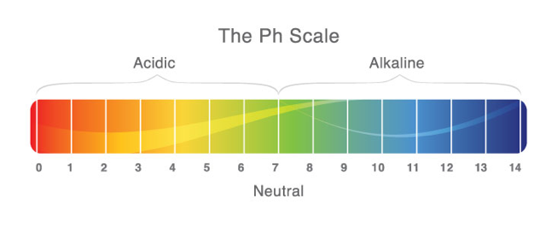

*According to the Bangladesh Environment Conservation Rules (1997), drinking water standard for pH is 6.5~8.5.*

**Principle:**

Certain compounds in solution ionize, i.e., split up into electrically charged ions. The hydrogen electrode is found to be a very suitable device for measuring hydrogen ion concentration. With its use, it was found that pure water dissociates to yield a concentration of hydrogen ions equal to 1O-7 gm/l.

H2O = H+ + OH- **... ...** (A)

Since water dissociates to produce one hydroxyl ion for each hydrogen ion, it is obvious that 10-7 gm of hydroxyl ion is produced simultaneously.

For pure water at about 25 °C

[H+] [OH-] = 10-7 * 10-7 = 10-14 **... ...** (B)

This is known as the ion product or ionization constant of water and expressed as Kw.

When an acid is added to water, it ionizes in the water and the hydrogen ion concentration increases; consequently the hydroxyl ion concentration must decrease in conformity with the ionization constant. For example, if acid is added to increase the H+ to 10-1, the OH- must decrease to 10-13.

10-1 * 10-13 = 10-14

Likewise, if a base is added to water to increase the OH- to 10-3,the H+ decreases to 10-11.

It is important to remember that the OH- or the H+ can never be reduced to zero, no matter how acidic or basic the solution may be.

**Apparatus:** pH meter

The pH of the water/wastewater sample is measured by pH meter. A pH meter consists of a measuring probe connected to electronic meter that measures and displays the pH reading.

**Procedure:**

1. Rinse the pH probe with distilled water. Calibrate the pH meter using reference solution.
2. Rinse the probe with sample, then dip the pH measuring probe in sample and read the value of pH on the screen of the pH meter.
3. Rinse the probe with distilled/deionized water between samples.
4. Thoroughly rinse the probe in distilled water after measurement, keep it in distilled water when not in use.

**Observation and Calculation:**

Model No of pH meter:

|  |  |  |  |
| --- | --- | --- | --- |
| Sample No | Type of sample | pH | H+ (mol/l) |
| 1 |  |  |  |
| 2 |  |  |  |
| 3 |  |  |  |

**Result:**

pH of the samples are

**Comments on Result:**

Example:

pH = 7.8

We know,

pH = -log[H+]

=>7.8= -log10[H+]

=> -7.8 = log10 [H+]

=> antilog10 (-7.8) = [H+] {in calculator shift+log}

=> [H+] = 1.585 * 10-8 gm equivalent per mole