**Communication Tools and Platforms**



|  |  |  |
| --- | --- | --- |
| **Tools/types of Communication** | **Products/materials** | **Measurement** |
| Interpersonal and Group Communication | Court yard meeting, meeting, seminar, workshop, discussion meet, meet the press, counselling and motivation etc. | Programme template, documentation minute, photographs etc. |
| Print media | Newspaper coverage(report, features, articles, editorial, post-editorial, pix), fact sheets, map, chart, etc. | Clippings of the Press coverage, recorded content list, etc. |
| Broadcast media | Radio/TV reports, interviews and other items | Storage of the audio-video clips, recorded content list, etc. |
| Online/Social media: website, facebook, youtube, twitter, whatsapp etc. | Updated contents on website, queries of people on website, Facebook viral, Facebook posting, comments, number of share and like, etc. | Screen shot, recorded content etc. |
| Smartphone/cell phones | SMS | Screen shot, content of SMS |
| Online media/portals | Reports , features, editorial and post-editorial write-ups on the thematic activities around a project | Screen shot, recorded content, storage of link |
| Website | Number of visits | Recording the number of visits, queries, comments |
| Folk/indigenous media/content | Folk songs, jaree, saree, vatiali, gombhira song etc. | No. of events |
| Audi-visual media | Audio-visual contents like PPT, LED board, sine-board, YouTube contents |  |
| Others- |  |  |

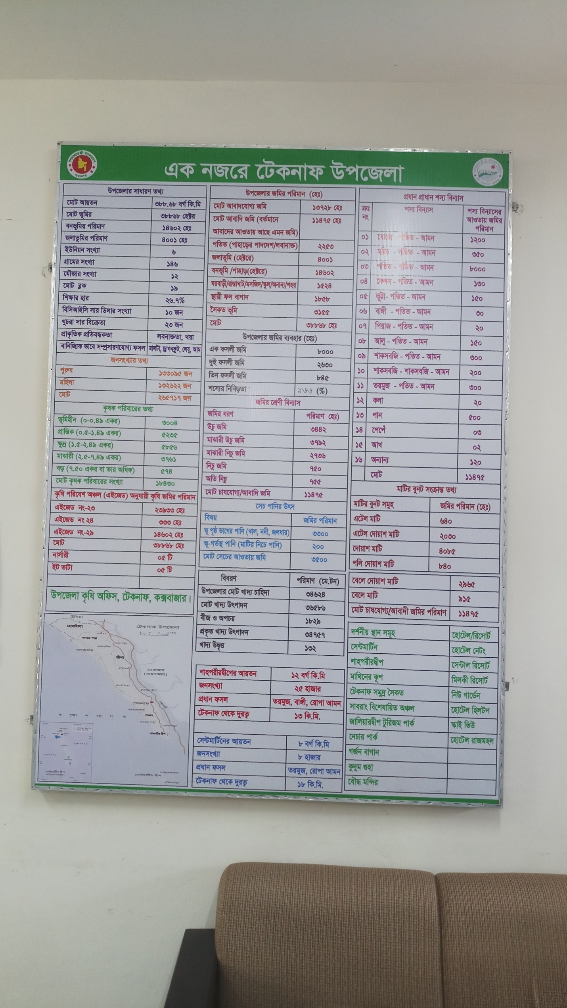**Sample: Fact Sheet**

**Sample: Seminar Working Sheet**

