What is a Trade Barrier:
Trade barriers are measures that governments or public authorities introduce to make imported goods or services less competitive than locally produced goods and services. Not everything that prevents or restricts trade can be characterized as a trade barrier.

Barriers to international trade
- Cultural and social barriers: A nation’s cultural and social forces can restrict international business. Culture consists of a country’s general concept and values and tangible items such as food, clothing, building etc. Social forces include family, education, religion and custom. Selling products from one country to another country is sometimes difficult when the culture of two countries differ significantly.
- Political barriers: The political climate of a country plays a major impact on international trade. Political violence may change the attitudes towards the foreign firms at any time. And this impact can create an unfavorable atmosphere for international business.
- Tariffs and trade restrictions: Tariffs and trade restrictions are also the barriers to international trade. They are discussed below:
  - Tariffs: A duty or tax, levied on goods brought into a country. Tariffs can be used to discourage foreign competitors from entering a digestive market. Import tariffs are two types-protective tariffs and revenue Tariffs.
  - Quotas: A limit on the amount of a product that can leave or enter a country.
  - Embargoes: A total ban on certain imports or exports.
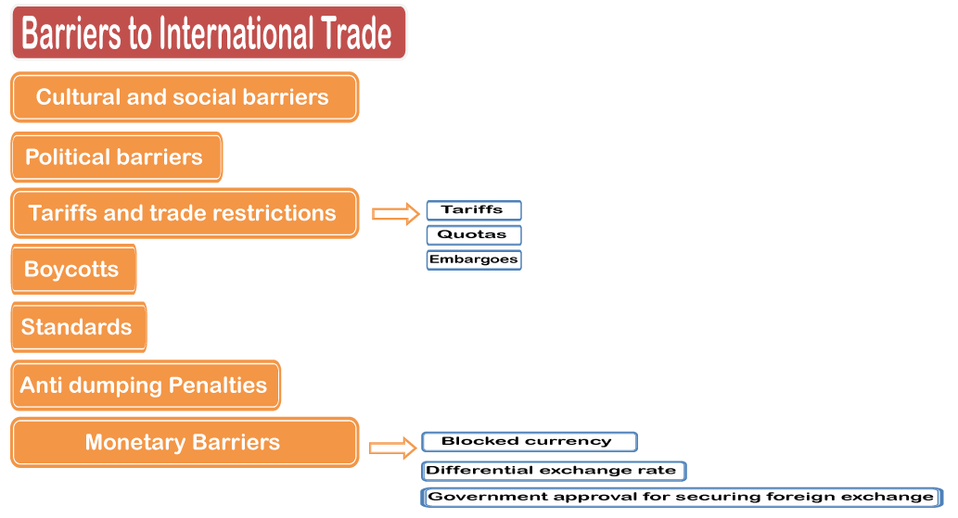
Barriers to international trade
- Boycotts: A government boycott is an absolute prohibition on the purchase and importation of certain goods from other countries. For example, Nestle products were boycotted y a certain group that considered the way nestle promoted baby milk formula to be misleading to mothers and harmful to their babies in fewer development countries.
- Standards: Non-tariff barriers of this category include standards to protect health, safety and product quality. The standards are sometimes used in an unduly stringent or discriminating way to restrict trade.
- Anti-dumping Penalties: It is one kind of practice whereby a producer intentionally sells its products for less than the cost of the product in order to undermine the competition and take control of the market.
- Monetary Barriers: There are three such barriers to consider:
  - Blocked currency: Blocked currency is used as a political weapon is response to difficult balance payments situation. The blockage is accomplished by refusing to allow importers to exchange their national currency for the seller’s currency.
  - Differential exchange rate: The differential exchange rate is a particularly ingenious method of controlling imports. It encourages the importance of goods the government deems desirable and discourage importation of goods the government does not want. The essential mechanism requires the importer to pay the varying amount of domestic currency for foreign currency with which to purchase products in different categories. Such as desirable and less desirable products.
- Government approval for securing foreign exchange: Countries experiencing severe shortages of foreign exchange often use it. At one time or another, most Latin American and East European countries have required all foreign exchange transactions to be approved by the central bank. Thus importers who want to buy foreign goods must apply of ran exchange permit that is permission to
  - exchange an amount of local currency for foreign currency.

Non-tariff barriers to trade (NTBs) or sometimes called "Non-Tariff Measures (NTMs)" are trade barriers that restrict imports or exports of goods or services through mechanisms other than the simple imposition of tariffs. The SADC says, "a Non-Tariff Barrier is any obstacle to international trade that is not an import or export duty. They may take the form of import quotas, subsidies, customs delays, technical barriers, or other systems preventing or impeding trade."^{[1]} According to the World Trade Organisation, non-tariff barriers to trade include import licensing, rules for valuation of goods at customs, pre-shipment inspections, rules of origin ('made in'), and trad Licenses
The most common instruments of direct regulation of imports (and sometimes export) are licenses and quotas. Almost all industrialized countries apply these non-tariff methods. The license system requires that a state (through specially authorized office) issues permits for foreign trade transactions of import and export commodities included in the lists of licensed merchandises. Product licensing can take many forms and procedures. The main types of licenses are general license that permits unrestricted importation or exportation of goods included in the lists for a certain period of time; and one-time license for a certain product importer (exporter) to import (or export). One-time license indicates a quantity of goods, its cost, its country of origin (or destination), and in some cases also customs point through which import (or export) of goods should be carried out. The use of licensing systems as an instrument for foreign trade regulation is based on a number of international level standards agreements. In particular, these agreements include some provisions of the General Agreement on Tariffs and Trade (GATT) / World Trade Organization (WTO) such as the Agreement on Import Licensing Procedures.

Quotas
Licensing of foreign trade is closely related to quantitative restrictions – quotas - on imports and exports of certain goods. A quota is a limitation in value or in physical terms, imposed on import and export of certain goods for a certain period of time. This category includes global quotas in respect to specific countries, seasonal quotas, and so-called "voluntary" export restraints. Quantitative controls on foreign trade transactions carried out through one-time license.
Quantitative restriction on imports and exports is a direct administrative form of government regulation of foreign trade. Licenses and quotas limit the independence of enterprises with a regard to entering foreign markets, narrowing the range of countries, which may be entered into transaction for certain commodities, regulate the number and range of goods permitted for import and export. However, the system of licensing and quota imports and exports, establishing firm control over foreign trade in certain goods, in many cases turns out to be more flexible and effective than economic instruments of foreign trade regulation. This can be explained by the fact, that licensing and quota systems are an important instrument of trade regulation of the vast majority of the world.
The consequence of this trade barrier is normally reflected in the consumers’ loss because of higher prices and limited selection of goods as well as in the companies that employ the imported materials in the production process, increasing their costs. An import quota can be unilateral, levied by the country without negotiations with exporting country, and bilateral or multilateral, when it is imposed after negotiations and agreement with exporting country. An export quota is a restricted amount of goods that can leave the country. There are different reasons for imposing of export quota by the country, which can be the guarantee of the supply of the products that are in shortage in the domestic market, manipulation of the prices on the international level, and the control of goods strategically important for the country. In some cases, the importing countries request exporting countries to impose voluntary export restraints.

Agreement on a "voluntary" export restraint
In the past decade, a widespread practice of concluding agreements on the "voluntary" export restrictions and the establishment of import minimum prices imposed by leading Western nations upon weaker in economical or political sense exporters. The specifics of these types of restrictions is the establishment of unconventional techniques when the trade barriers of importing country, are introduced at the border of the exporting and not importing country. Thus, the agreement on "voluntary" export restraints is imposed on the exporter under the threat of sanctions to limit the export of certain goods in the importing country. Similarly, the establishment of minimum import prices should be strictly observed by the exporting firms in contracts with the importers of the country that has set such prices. In the case of reduction of export prices below the minimum level, the importing country imposes anti-dumping duty, which could lead to withdrawal from the market. “Voluntary" export agreements affect trade in textiles, footwear, dairy products, consumer electronics, cars, machine tools, etc.
Problems arise when the quotas are distributed between countries because it is necessary to ensure that products from one country are not diverted in violation of quotas set out in second country. Import quotas are not necessarily designed to protect domestic producers. For example, Japan, maintains quotas on many agricultural products it does not produce. Quotas on imports is a leverage when negotiating the sales of Japanese exports, as well as avoiding excessive dependence on any other country in respect of necessary food, supplies of which may decrease in case of bad weather or political conditions.
Export quotas can be set in order to provide domestic consumers with sufficient stocks of goods at low prices, to prevent the depletion of natural resources, as well as to increase export prices by restricting supply to foreign markets. Such restrictions (through agreements on various types of goods) allow producing countries to use quotas for such commodities as coffee and oil; as the result, prices for these products increased in importing countries.
A quota can be a tariff rate quota, global quota, discriminating quota, and export quota.
A voluntary export restraint (VER) or voluntary export restriction is a government-imposed limit on the quantity of some category of goods that can be exported to a specified country during a specified period of time. They are sometimes referred to as 'Export Visas'.^{[1]}
Typically VERs arise when industries seek protection from competing imports from particular countries. VERs are then offered by the exporting country to settle the importing country and prevent it from imposing explicit (and less flexible) trade barriers.
Characteristics
VERs are typically implemented on exports from one specific country to another. VERs have been used since the 1930s at least, and have been applied to products ranging from textiles and footwear to steel, machine tools and automobiles. They became a popular form of protection during the 1980s; they did not violate countries' agreements under the General Agreement on Tariffs and Trade (GATT) in force. As a result of the Uruguay round of the GATT, completed in 1994, World Trade Organization (WTO) members agreed not to implement any new VERs, and to phase out any existing ones over a four-year period, with exceptions grantable for one sector in each importing country.
Some examples of VERs occurred with automobile exports from Japan in the early 1980s and with textile exports in the 1950s and 1960s.

1980 Automobile VER
When the automobile industry in the United States was threatened by the popularity of cheaper more fuel efficient Japanese cars, a 1981 voluntary restraint agreement limited the Japanese to exporting 1.68 million cars to the U.S. annually as set by U.S Government.^{[2]} This quota was originally intended to expire after three years, in April 1984. However, with a growing deficit in trade with Japan, and under pressure from domestic manufacturers, the US government extended the quotas for an additional year.^{[3]} The cap was raised to 1.85 million cars for this additional year, then to 2.3 million for 1985. The voluntary restraint was removed in 1994.^{[4]}
The Japanese automobile industry responded by establishing assembly plants or "transplants" in the United States (primarily in the Southern U.S. states where right-to-work laws exist as opposed to the Rust Belt states with established labor unions) to produce mass market vehicles. Some Japanese manufacturers who had their transplant assembly factories in the Rust Belt e.g. Mazda, Mitsubishi had to have a joint venture with a Big Three manufacturer (Chrysler/Mitsubishi which became Diamond Star Motors, Ford/Mazda that evolved into AutoAlliance International). GM established NUMMI which was initially a joint venture with Toyota which later expanded to include a Canadian subsidiary (CAMI)) - a GM/Suzuki which were consolidated that evolved into the Geo division in the U.S. (its Canadian counterparts Passport and Asuna were short lived - Isuzu automobiles manufactured during this era were sold as captive imports). The Japanese Big Three (Honda, Toyota, and Nissan) also began exporting bigger, more expensive cars (soon under their newly formed luxury brands like Acura, Lexus, and Infiniti) in order to make more money from a limited number of cars.

Embargo
Embargo is a specific type of quotas prohibiting the trade. As well as quotas, embargoes may be imposed on imports or exports of particular goods, regardless of destination, in respect of certain goods supplied to specific countries, or in respect of all goods shipped to certain countries. Although the embargo is usually introduced for political purposes, the consequences, in essence, could be economic.

Standards
Standards take a special place among non-tariff barriers. Countries usually impose standards on classification, labeling and testing of products in order to be able to sell domestic products, but also to block sales of products of foreign manufacture. These standards are sometimes entered under the pretext of protecting the safety and health of local populations.

Administrative and ritual delays at the entrance
Among the methods of non-tariff regulation should be mentioned administrative and bureaucratic delays at the entrance, which increase uncertainty and the cost of maintaining inventory. For example, even though Turkey is in the European Customs Union, transport of Turkish goods to the European Union is subject to extensive administrative overheads that Turkey estimates cost it three billion euros a year.^{[4]}

Import deposits
Another example of foreign trade regulations is import deposits. Import deposits is a form of deposit, which the importer must pay the bank for a definite period of time (non-interest bearing deposit) in an amount equal to all or part of the cost of imported goods.
At the national level, administrative regulation of capital movements is carried out mainly within a framework of bilateral agreements, which include a clear definition of the legal regime, the procedure for the admission of investments and investors. It is determined by mode (fair and equitable, national, most-favored-nation), order of nationalization and compensation, transfer profits and capital repatriation and dispute resolution.

Foreign exchange restrictions and foreign exchange controls
Foreign exchange restrictions and foreign exchange controls occupy a special place among the non-tariff regulatory instruments of foreign economic activity. Foreign exchange restrictions constitute the regulation of transactions of residents and nonresidents with currency and other currency values. Also an important part of the mechanism of control of foreign economic activity is the establishment of the national currency against foreign currencies. prepared investment measures.^{[2]}

Examples of Non-Tariff Barriers to Trade
This section is in a list format that may be better presented using prose. You can help by converting this section to prose, if appropriate. Editing help is available. (September 2014)
Non-tariff barriers to trade can be the following:
- Export restrictions
- General or product-specific quotas
- Rules of Origin
- Quality conditions imposed by the importing country on the exporting countries
- Sanitary and phytosanitary conditions
- Packaging conditions
- Labeling conditions
- Product standards
- CIncompatible conventions for contracts
- Determination of eligibility of an exporting country by the importing country
- Determination of eligibility of an exporting establishment (firm, company) by the importing country.
- Additional trade documents like Certificate of Origin, Certificate of Authenticity etc.
- Occupational safety and health regulation
- Employment law
- Import licenses
- State subsidies, procurement, trading, state ownership
- Export subsidies
- Minimum import pricing
- Differences of Product classification
- Quota shares
- Foreign exchange market controls and multiplicity
- Inadequate infrastructure
- "Buy national" policy
- Over-valued or under-valued currency.
- Intellectual property laws (patents, copyrights); differences of view on applicability of patents (for example, DNA, software) or longevity of copyrights.
- Restrictive licenses
- Seasonal import regimes
- Corrupt and/or lengthy customs procedures
- Protected designation of origin, protected names (for example, Champagne)

