**Lecture 05:**

**Writing of an Effective Press Release**

**Lecture Objective**

The objectives of this lecture are to:

* Provide the students with a theoretical understanding of a press release
* Impart students how to write effective press release
* Orient with different structures of press release

**Lecture outcome**

**The outcomes of the lecture are as follows:**

* The students will be oriented with the styles and structure of an effective press release
* The students will be able to write effective press releases

Press Release (Sample)

10 February 2020

JMC Dept. Organized Youth Leadership Programme

Speakers have stressed on the participation of the youth, especially the women in the digital platforms as a part of their empowerment in a youth leadership programme.

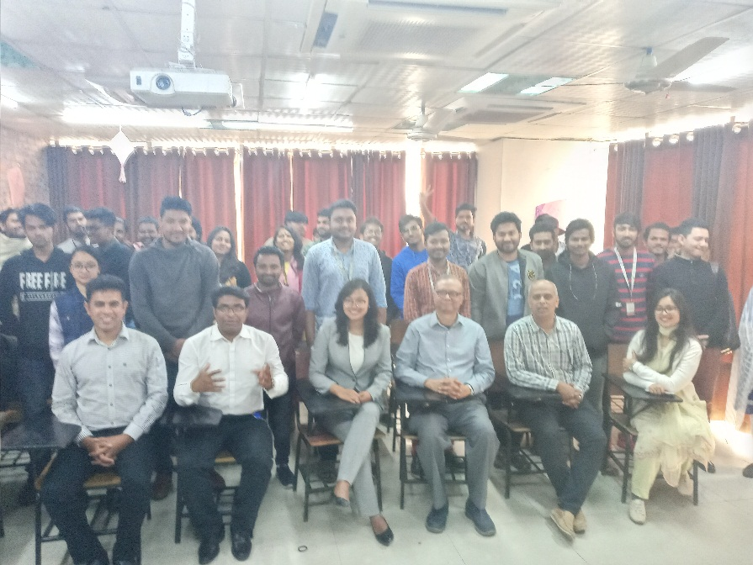Department of Journalism and Mass Communication (JMC) at Daffodil International University (DIU) organized the programme held at room no. 501at Daffodil Tower on 04 February 2020.

Eminent youth leader Alina Projapati, a Nepalese woman rights activist, delivered her motivational speeches to the youth gathered in the programme. Mr. Saleem Ahmed, Associate Professor & Head, JMC Department presided over the programme moderated by Dr. Sheikh Shafiul Islam, Associate Professor of the department.

Students, faculty members and the officials of the JMC and English department of DIU attended the programme and exchanged views with Elina. In the gathering, mutual cooperation and forming networks among the youths are stressed so that they can handle their issues smoothly in the era of digitization.

-----------------------------------------------------

**Public Relations Officer (PRO)**

Department of Journalism and Mass Communication (JMC)

Contact no:---------------------------------

E-mail:---------------------------------------