Transitional diets in Hospital

# Normal diet

*Description*:

Normal Diet forms the basis of all modifications of diets for age and sickness; but due attention must be paid to nutritional needs of the individual.

*Nutritional Adequacy*:

Normal diet is planned according to the recommended daily dietary intakes, which are designed to meet the needs of all healthy persons and may not meet the needs of sick persons. The nutritional requirements depend on the activity, the increased or decreased demands for certain nutrients, which need to be considered in planning the diet.

Modifications of Normal Diet: The normal diet may be modified to:

1. Provide change in consistency, e.g., soft and fluid diets;

2. Provide foods bland in flavour;

3. Modify intervals of feeding;

4. Increase or decrease energy content;

5. Increase or decrease other nutrients, e.g., protein;

6. Increase or decrease fibre.

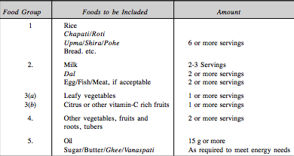

# Soft Diet:

Description:

It is a step between the full liquid and the normal diet.

Indications: It is served to persons suffering from acute infections, gastrointestinal disturbances or persons recovering from surgery. The diet consists of simple soft foods, which are easy to chew and easy to digest. Harsh fibre, fatty or highly spiced foods are avoided.

Nutrition Adequacy:

It is nutritionally adequate, when planned according to the Daily Food Guide. The soft diet includes:

• Soft cooked rice, soft chapati and bread—6 servings or more

• Milk, dahi (curd), buttermilk, paneer, soft cheese—2-3 servings

• Dals, well-cooked—2-3 servings

• Eggs poached, boiled, trader ground meat, fish and poultry—2-3 servings

• Vegetables and fruits made up of

1. Green leafy vegetables cooked and strained—2-3 servings

2. Citrus fruits or juice or mango (non-fibrous varieties)—2-3 servings

• Other vegetables and fruits, not mentioned above, such as:

* Other vegetables—tender, chopped and cooked—2-3 servings
* Other fruits—banana or cooked fruits without skin or seeds—2-3 servings.

# Liquid diet

Description:

The Clear Liquid Diet is designed to provide fluids mainly in the form of sugar and water to prevent over- stimulating extensive digestive processes, minimize colonic residue, relieve thirst, and provide oral feedings that promote the return to the normal ingestion of food.

Nutrition Adequacy:

The diet as served will yield 700 to 1,000 kcal when energy-containing clear liquids are served between meals. The Clear Liquid Diet is inadequate in all food nutrients and provides only fluids, energy, and some vitamin C. Long-term use of the Clear Liquid Diet may contribute to hospital malnutrition

Indications:

The Clear Liquid Diet is indicated for the following:

* short-term use when an acute illness or surgery causes an intolerance for foods (eg, abdominal distention, nausea, vomiting, and diarrhea)
* to temporarily restrict undigested material in the gastrointestinal tract or reintroduce foods following a period with no oral intake when poor tolerance to food , aspiration, or an anastomotic leak is anticipated
* to prepare the bowel for surgery or a gastrointestinal procedure

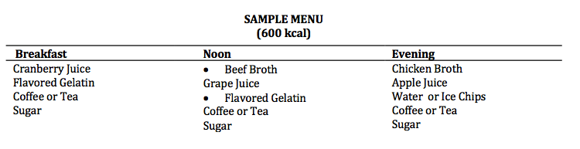

# FULL LIQUID DIET:

## Description

The Full Liquid Diet consists of foods that are liquid at body temperature, including gels and frozen liquids. The diet provides nourishment that is easy to consume and digest with very little stimulation to the gastrointestinal tract. It is different from the Full Liquid Diet, which is lower in energy and nutrients. The dietitian determines the amount and type of food or supplements to be served, based on patient acceptance, nutrient needs, and change in condition.

## Indication

The Full Liquid Diet may be indicated following oral surgery or plastic surgery of the face or neck area in the presence of chewing or swallowing dysfunction for acutely ill patients. The Full Liquid Diet has been traditionally used as a postoperative transitional diet. The diet is intended for short-term use only

## Nutrition adequacy

The diet as served meets the Dietary Reference Intakes (DRIs) for ascorbic acid, vitamin D, vitamin B12, calcium, phosphorus, and riboflavin. It may not meet the protein and caloric requirements of the individual. The diet as served will provide approximately 1200 kcal and 40 g of protein. When between-meal nourishment is added, the intake is increased to 1500 to 1800 kcal and 65 g of protein. Protein and caloric intake can be increased through the use of additional full liquid foods at meals and between meals. The diet can be nutritionally adequate when supplements are offered and consumed in sufficient amounts.

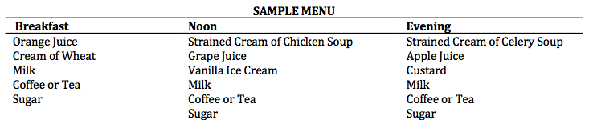

# FULL LIQUID BLENDERIZED DIET:

## Description:

The Full Liquid Blenderized diet consists of a variety of liquids, as well as semisolid foods that have been thinned to a consistency that can be consumed through a straw, fed by syringe, or sipped from a cup. The diet also includes foods that, if eaten by spoon, will turn to a liquid consistency in the mouth. The method of feeding will determine the desired viscosity of the liquid.

### Indications:

The objective of the diet is to provide oral nourishment in a form that requires no mastication. This diet is indicated for the following:

* patients following oral surgery or plastic surgery of the face or neck area in the presence of chewing or swallowing dysfunction (eg, a wired jaw or intermaxillary fixation surgery)
* acutely ill patients with oral esophageal disorders, neuromuscular disabilities advanced carcinoma of the oral cavity, facial or neck trauma
* patients who have received radiation therapy and find eating difficult

### Nutrition Adequacy:

The Full Liquid Blenderized Diet can meet the Dietary Reference Intakes (DRIs) if the proper amount and variety of food is consumed by the patient. Because some patients experience palatability problems or may have difficulty consuming an adequate volume of liquids, liquid supplements may be necessary to meet their nutrient and fluid needs.

