**What is Value?**

1. Liquidation value represents the amount of money that could be realized if an asset or group of assets is sold separately from its operating organization.
2. Going-concern value represents the amount a firm could be sold for as a continuing operating business.
3. Book value represents either

* *an asset*: the accounting value of an asset -- the asset’s cost minus its accumulated depreciation;
* *A firm*: total assets minus liabilities and preferred stock as listed on the balance sheet.

1. Market value represents the market price at which an asset trades.
2. Intrinsic value/Actual value represents the price a security “ought to have” based on all factors bearing on valuation.

**Justification**

* Overpriced = Market value > Intrinsic value= no buy and suggested to Sell
* Underpriced = Market value < Intrinsic value= no sell and suggested to buy

**Bond Valuation**

Bonds are long-term debt securities that are issued by corporations and government entities. Purchasers of bonds receive periodic interest payments, called coupon payments, until maturity at which time they receive the face value of the bond and the last coupon payment. Most bonds pay interest semiannually. The *Bond Indenture* or *Loan Contract* specifies the features of the bond issue. The following terms are used to describe bonds.

1. **Par or Face Value**

The par or face value of a bond is the amount of money that is paid to the bondholders at maturity. It also generally represents the amount of money borrowed by the bond issuer.

1. **Coupon Rate**

The coupon rate, which is generally fixed, determines the periodic coupon or interest payments. It is expressed as a percentage of the bond's face value. It also represents the interest cost of the bond issue to the issuer.

1. **Coupon Payments**

The coupon payments represent the periodic interest payments from the bond issuer to the bondholder. The annual coupon payment is calculated be multiplying the coupon rate by the bond's face value. Since most bonds pay interest semiannually, generally one half of the annual coupon is paid to the bondholders every six months.

1. **Maturity Date**

The maturity date represents the date on which the bond matures, *i.e.,* the date on which the face value is repaid. The last coupon payment is also paid on the maturity date.

1. **Original Maturity**

The time remaining until the maturity date when the bond was issued.

1. **Remaining Maturity**

The time currently remaining until the maturity date.

1. **Call Date**

For bonds which are callable, *i.e.,* bonds which can be redeemed by the issuer prior to maturity, the call date represents the date at which the bond can be called.

1. **Call Price**

The amount of money the issuer has to pay to call a callable bond. When a bond first becomes callable, *i.e.,* on the call date, the call price is often set to equal the face value plus one year's interest.

1. **Required Return**

The rate of return that investors currently require on a bond.

1. **Yield to Maturity**

The rate of return that an investor would earn if he bought the bond at its current market price and held it until maturity.

1. **Yield to Call**

The rate of return that an investor would earn if he bought a callable bond at its current market price and held it until the call date given that the bond was called on the call date.

1. **Bond price/ value**

The price or value of a bond is determined by discounting the bond's expected cash flows to the present using the appropriate discount rate.

* A **perpetual bond** is a bond that *never* matures. It has an infinite life.

V = I / k

Example: Bond P has a $1,000 face value and provides an 8% annual coupon. The appropriate discount rate is 10%. What is the value of the perpetual bond? If the Market value of this bond is $460, what will be your decision?

I = $1,000 (8%) = $80.

k = 10%=.10

V = I / k

= $80 / .10 = $800.

**Justification**

* Underpriced = Market value ($460)< Intrinsic value($800)= no sell and suggested to buy
* A **coupon-paying bond** /**non-zero coupon-paying bond** is a coupon paying bond with a finite life.

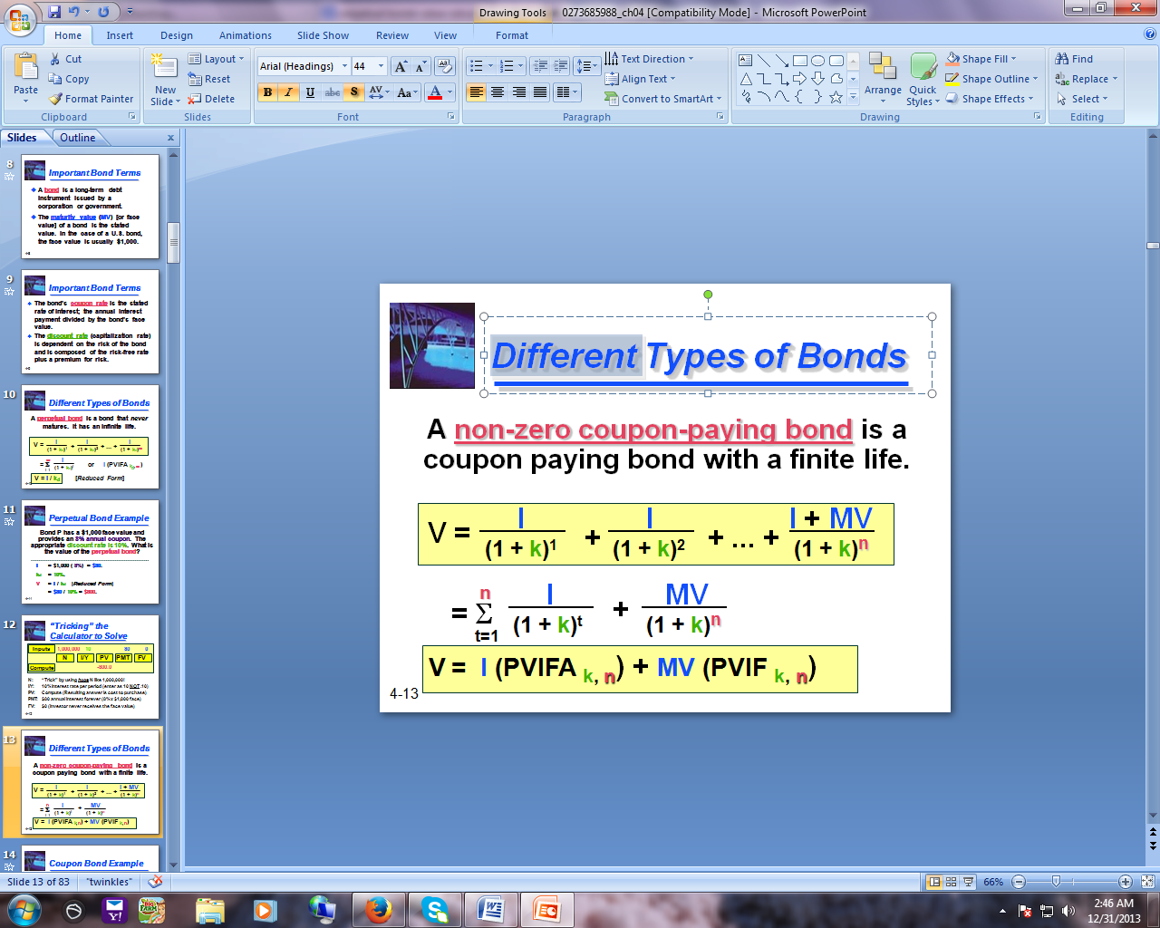

Example: Bond C has a $1,000 Face value and provides an 8% annual coupon for 30 years. The appropriate discount rate is 10%. What is the value of the *coupon bond*? If the Market value of this bond is $900, what will be your decision?

Face /Maturity value= $1000

I = $1,000 (8%)= $80.

V = $80 (PVIFA10%, 30) + $1,000 (PVIF10%, 30)

= $80 (9.427) + $1,000 (.057)

= $754.16 + $57.00

= $811.16.

**Justification:**

* A **zero coupon bond** is a bond that pays no interest but sells at a deep discount from its face value; it provides compensation to investors in the form of price appreciation.

V = Maturity Value/ (1 + k)n

or Maturity Value (PVIFk, n)

Example: Bond Z has a $1,000 Face value and a 30 year life. The appropriate discount rate is 10%. What is the value of the zero-coupon bond? If the Market value of this bond is $90, what will be your decision?

Face /Maturity value= $1000

V = $1,000 (PVIF10%, 30)

= $1,000 (.057)

= $57.00

**Justification:**

**Stock Valuation**

* A stock is a form of security that indicates the holder has proportionate ownership in the issuing corporation.
* Corporations issue (sell) stock to raise funds to operate their businesses.
* There are two main types of stock: **common** and **preferred**.

Firms obtain their long-term sources of equity financing by issuing **common** and **preferred** stock. The payments of the firm to the holders of these securities are in the form of dividends. Unlike interest payments on debt which are tax deductible, dividends must be paid out of after-tax income.

* **Common stock:** 
  + Common stock is a security that represents ownership in a corporation.
  + In liquidation, common stockholders receive whatever assets remain after creditors, bondholders, and preferred stockholders are paid.
* **Preferred Stock:** 
  + Preferred stockholders have a higher claim on distributions (e.g. dividends) than common stockholders.
  + Preferred stockholders usually have no or limited, voting rights in corporate governance.
  + In the event of liquidation, preferred stockholders claim on assets is greater than common stockholders but less than bondholders.

The common stockholders are the owners of the firm. They have the right to vote on important matters to the firm such as the election of the Board of Directors. Preferred stock, on the other hand, is a hybrid form of financing, sharing some features with debt and some with common equity. For example, preferred dividends like interest payments on debt are generally fixed. In addition, the claims against the assets of the firm of the preferred stockholders, like those of the debt holders, are also fixed.

The common stockholders have a residual claim against the assets and cash flows of the firm. That is, the common stockholders have a claim against whatever assets remain after the debt holders and preferred stockholders have been paid. Moreover, the cash flow that remains after interest and preferred dividends have been paid belongs to the common stockholders.

The priority of the claims against the assets of the firm belonging to debt holders, preferred stockholders, and common stockholders differ. The owners of the firm's debt securities have the first claim against the assets of the firm. This means that the debt holders must receive their scheduled interest and principal payments before any dividends can be paid to the equity holders. If these claims are not paid, the debt holders can force the firm into bankruptcy. The preferred stockholders have the next claim. They must be paid the full amount of their scheduled dividends before any dividends may be distributed to the common stockholders.

**Preferred Stock Valuation**

Preferred stock is defined as equity with priority over common stock with respect to the payment of dividends and the distribution of assets in liquidation. Preferred stock is a hybrid security which shares features with both common stock and debt.

Preferred stock is similar to common stock in that it entitles its owners to receive dividends which the firm must pay out of after-tax income. Moreover, the use of preferred stock as a source of financing does not increase the probability of bankruptcy for the firm.

However, like the coupon payments on debt, the dividends on preferred stock are generally fixed. Also, the claims of the preferred stockholders against the assets of the firm are fixed as are the claims of the debt holders.

Preferred stock has the following features:

**Par Value**

The par value represents the claim of the preferred stockholder against the value of the firm.

**Preferred Dividend / Preferred Dividend Rate**

The preferred dividend rate is expressed as a percentage of the par value of the preferred stock. The annual preferred dividend is determined by multiplying the preferred dividend rate times the par value of the preferred stock.

Since the preferred dividends are generally fixed, preferred stock can be valued as a constant growth stock with a dividend growth rate equal to zero. Thus, the price of a share of preferred stock can be determined using the following equation:

http://www.prenhall.com/divisions/bp/app/cfl/SV/images/PS.gif

* Pp = the preferred stock price,
* Dp = the preferred dividend amount, and
* r = the rate of required return on the stock

Example: Find the price of a share of preferred stock given that the par value is $100 per share, the preferred dividend rate is 8%, and the required return is 10%. If the Market value of this preferred stock is $75, what will be your decision?

D= dividend rate*par value=.08*100=8

http://www.prenhall.com/divisions/bp/app/cfl/SV/images/PSEx.gif

# Justification:

# Constant Growth Common Stock Valuation

Stock Valuation is more difficult than [Bond Valuation](http://www.prenhall.com/divisions/bp/app/cfl/BV/BondValuation.html) because stocks do not have a finite maturity and the future cash flows, *i.e.,* dividends, are not specified. Therefore, the techniques used for stock valuation must make some assumptions regarding the structure of the dividends.

A constant growth stock is a stock whose dividends are expected to grow at a constant rate in the foreseeable future. This condition fits many established firms, which tend to grow over the long run at the same rate as the economy, fairly well. The value of a constant growth stock can be determined using the following equation:

http://www.prenhall.com/divisions/bp/app/cfl/SV/images/CG.gif http://www.prenhall.com/divisions/bp/app/cfl/SV/images/ER.gif

* P0 = the stock price at time 0,
* D0 = the current year dividend,
* D1 = the next year dividend (*i.e.,* at time 1),
* g = the growth rate in dividends, and
* r = the required return on the stock,
* g < r.

|  |  |
| --- | --- |
|  |  |

Example: Find the stock price given that the current year dividend is $2 per share, dividends are expected to grow at a rate of 6% in the foreseeable future, and the required return is 12%. If the Market value of this stock is $200, what will be your decision?

http://www.prenhall.com/divisions/bp/app/cfl/SV/images/CGEx.gif

**Justification:**

|  |  |
| --- | --- |
|  |  |

Example: Find the stock price given that the next year dividend is $2 per share, dividends are expected to grow at a rate of 6% in the foreseeable future, and the required return is 12%. If the Market value of this stock is $50, what will be your decision?

D1=2

g=6%=.06

r=12%=.12

**P= 2/ (.12-.06)= ????**

**Justification:**

**No constant Growth Common** **Stock Valuation**

Many firms enjoy periods of rapid growth. These periods may result from the introduction of a new product, a new technology, or an innovative marketing strategy. However, the period of rapid growth cannot continue indefinitely. Eventually, competitors will enter the market and catch up with the firm.

These firms cannot be valued properly using the [Constant Growth Stock Valuation](http://www.prenhall.com/divisions/bp/app/cfl/SV/CGStock.html) approach. This section presents a more general approach which allows for the dividends/growth rates during the period of rapid growth to be forecast. Then, it assumes that dividends will grow from that point on at a constant rate which reflects the long-term growth rate in the economy.

Stocks which are experiencing the above pattern of growth are called no constant, supernormal, or erratic growth stocks.

The value of a no constant growth stock can be determined using the following equation:

http://www.prenhall.com/divisions/bp/app/cfl/SV/images/SG.gif

* P0 = the stock price at time 0,
* Dt = the expected dividend at time t,
* T = the number of years of no constant growth,
* gc = the long-term constant growth rate in dividends, and
* r = the required return on the stock, and
* gc < r.

**Example**: The current dividend on a stock is $2 per share and investors require a rate of return of 12%. Dividends are expected to grow at a rate of 20% per year over the next three years and then at a rate of 5% per year from that point on. Find the price of the stock.

**Solution:** There are 3 years of no constant growth, thus, T = 3. Before substituting into the formula given above it is necessary to calculate the expected dividends for years 1 through 4 using the provided growth rates.

