1. Create a database named 'university' and Make the following relation using Mysql or Sql Commands under this database.

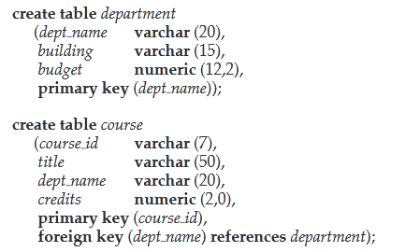

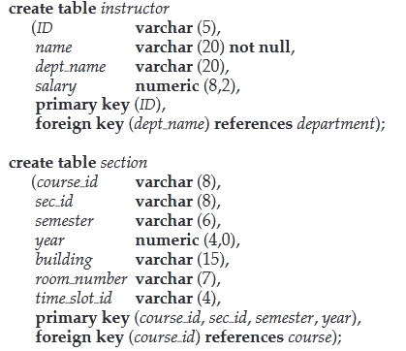

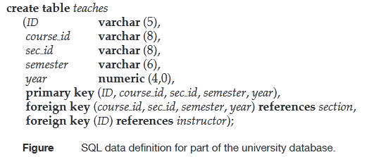

2. After making these relations insert at least 5 records into each table.