**Types of analysis**

1. SWOT analysis
2. Seasonal/ time series analysis
3. Sensitivity (what if) analysis
4. Statistical analysis - (regression, correlation)
5. Trend analysis
6. Break even analysis
7. Ratio analysis
8. Common size analysis
9. Index analysis

**SWOT analysis**

[Situation analysis](http://www.businessdictionary.com/definition/situation-analysis.html) in which internal [strengths and weaknesses](http://www.businessdictionary.com/definition/strengths-and-weaknesses.html) of an [organization](http://www.businessdictionary.com/definition/organization.html), and external [opportunities and threats](http://www.businessdictionary.com/definition/opportunities-and-threats.html) faced by it are closely examined to [chart](http://www.businessdictionary.com/definition/chart.html) a [strategy](http://www.businessdictionary.com/definition/strategy.html). SWOT stands for [strengths](http://www.businessdictionary.com/definition/strength.html), weaknesses, [opportunities](http://www.businessdictionary.com/definition/opportunity.html), and threats. See also [PEST analysis](http://www.businessdictionary.com/definition/PEST-analysis.html).

**Statistical analysis**

Statistical analysis is an aspect of business intelligence [(BI)](http://searchdatamanagement.techtarget.com/definition/business-intelligence) that involves the collection and scrutiny of business data and the reporting of trends. Statistical analysis examines every single data sample in a population (the set of items from which samples can be drawn), rather than a cross sectional representation of samples as less sophisticated methods do.

**Seasonal/ time series analysis (TSA)**

[Trend](http://www.businessdictionary.com/definition/trend.html) [forecasting](http://www.businessdictionary.com/definition/forecasting.html) ([extrapolation](http://www.businessdictionary.com/definition/extrapolation.html)) [techniques](http://www.businessdictionary.com/definition/technique.html) (such as [auto regression analysis](http://www.businessdictionary.com/definition/autoregression-analysis.html), [exponential smoothing](http://www.businessdictionary.com/definition/exponential-smoothing.html), [moving average](http://www.businessdictionary.com/definition/moving-average.html)) based on the [assumption](http://www.businessdictionary.com/definition/assumption.html) that 'the best [estimate](http://www.businessdictionary.com/definition/estimate.html) for tomorrow is the [continuation](http://www.businessdictionary.com/definition/continuation.html) of the yesterday's trend.' TSA is more suitable for [short-term](http://www.businessdictionary.com/definition/short-term.html) [projections](http://www.businessdictionary.com/definition/projection.html) and is used where (1) five to six year's [time series data](http://www.businessdictionary.com/definition/time-series-data.html) is available and (2) where [relationships](http://www.businessdictionary.com/definition/relationship.html) between different [values](http://www.businessdictionary.com/definition/values.html) of a [variable](http://www.businessdictionary.com/definition/variable.html) and their trend is clear and relatively [stable](http://www.businessdictionary.com/definition/stable.html). Instead of [building](http://www.businessdictionary.com/definition/building.html) a cause-and-effect (causal) model, TSA [aims](http://www.businessdictionary.com/definition/aim.html) to isolate the [sources](http://www.businessdictionary.com/definition/source.html) of [variations](http://www.businessdictionary.com/definition/variation.html) in a set of [data](http://www.businessdictionary.com/definition/data.html) so that their effect on a variable can be determined.

**Trend analysis**

[Method](http://www.businessdictionary.com/definition/method.html) of [time series data](http://www.businessdictionary.com/definition/time-series-data.html) ([information](http://www.businessdictionary.com/definition/information.html) in sequence [over time](http://www.businessdictionary.com/definition/overtime.html)) [analysis](http://www.businessdictionary.com/definition/analysis.html) involving comparison of the same item (such as monthly [sales revenue](http://www.businessdictionary.com/definition/sales-revenue.html) [figures](http://www.businessdictionary.com/definition/figure.html)) over a significantly [long](http://www.businessdictionary.com/definition/long-position.html) [period](http://www.businessdictionary.com/definition/period.html) to (1) detect [general](http://www.businessdictionary.com/definition/general.html) pattern of a [relationship](http://www.businessdictionary.com/definition/relationship.html) between [associated](http://www.businessdictionary.com/definition/associated.html) [factors](http://www.businessdictionary.com/definition/factor.html) or [variables](http://www.businessdictionary.com/definition/variable.html), and (2) [project](http://www.businessdictionary.com/definition/project.html) the future direction of this [pattern](http://www.businessdictionary.com/definition/pattern.html).

**Common size analysis**

An analysis of percentage financial statements where all balance sheet items are divided by total assets and all income statement items are divided by net sales or revenues

**Index analysis**

An analysis of *percentage* financial statements where all balance sheet or income statement figures for a base year equal 100.0 (percent) and subsequent financial statement items are expressed as percentages of their values in the base year.

**Sensitivity analysis**

Sensitivity analysis is the study of how the [uncertainty](http://en.wikipedia.org/wiki/Uncertainty) in the output of a [mathematical model](http://en.wikipedia.org/wiki/Mathematical_model) or system (numerical or otherwise) can be apportioned to different sources of [uncertainty](http://en.wikipedia.org/wiki/Uncertainty) in its inputs.

**Break even analysis**

|  |  |  |
| --- | --- | --- |
| An analysis to determine the point at which revenue received equals the costs associated with receiving the revenue. | Image result for Break even analysis | Image result for break even analysis formula |

**Ratio Analysis**

Ratio Analysis is a form of Financial Statement Analysis that is used to obtain a quick indication of a firm's financial performance in several key areas. The ratios are categorized as Short-term Solvency Ratios, Debt Management Ratios, Asset Management Ratios, Profitability Ratios, and Market Value Ratios.

Ratio Analysis as a tool possesses several important features. The data, which are provided by financial statements, are readily available. The computation of ratios facilitates the comparison of firms which differ in size. Ratios can be used to compare a firm's financial performance with industry averages. In addition, ratios can be used in a form of trend analysis to identify areas where performance has improved or deteriorated over time.

Because Ratio Analysis is based upon accounting information, its effectiveness is limited by the distortions which arise in financial statements due to such things as Historical Cost Accounting and inflation. Therefore, Ratio Analysis should only be used as a first step in financial analysis, to obtain a quick indication of a firm's performance and to identify areas which need to be investigated further.

The pages below present the most widely used ratios in each of the categories given above. Please keep in mind that there is not universal agreement as to how many of these ratios should be calculated. You may find that different books use slightly different formulas for the computation of many ratios. Therefore, if you are comparing a ratio that you calculated with a published ratio or an industry average, make sure that you use the same formula as used in the calculation of the published ratio.

1. Short-term Solvency or Liquidity Ratios
2. Asset Management Ratios
3. Debt Management Ratios
4. Profitability Ratios
5. Market Value Ratios

**Short-term Solvency or Liquidity Ratios**

Short-term Solvency Ratios attempt to measure the ability of a firm to meet its short-term financial obligations. In other words, these ratios seek to determine the ability of a firm to avoid financial distress in the short-run. The two most important Short-term Solvency Ratios are the Current Ratio and the Quick Ratio. (Note: the Quick Ratio is also known as the Acid-Test Ratio.)

**Current Ratio**

The Current Ratio is calculated by dividing Current Assets by Current Liabilities. Current Assets are the assets that the firm expects to convert into cash in the coming year and Current Liabilities represent the liabilities which have to be paid in cash in the coming year. The appropriate value for this ratio depends on the characteristics of the firm's industry and the composition of its Current Assets. However, at a minimum, the Current Ratio should be greater than one.

http://www.prenhall.com/divisions/bp/app/cfl/RA/Equations/CurrentRatio.gif

Top of Form

Bottom of Form

**Quick Ratio**

The Quick Ratio recognizes that, for many firms, Inventories can be rather illiquid. If these Inventories had to be sold off in a hurry to meet an obligation the firm might have difficulty in finding a buyer and the inventory items would likely have to be sold at a substantial discount from their fair market value.

This ratio attempts to measure the ability of the firm to meet its obligations relying solely on its more liquid Current Asset accounts such as Cash and Accounts Receivable. This ratio is calculated by dividing Current Assets less Inventories by Current Liabilities.

http://www.prenhall.com/divisions/bp/app/cfl/RA/Equations/QuickRatio.gif

Top of Form

Bottom of Form

**Asset Management Ratios**

Asset Management Ratios attempt to measure the firm's success in managing its assets to generate sales. For example, these ratios can provide insight into the success of the firm's credit policy and inventory management. These ratios are also known as Activity or Turnover Ratios.

**Receivables Turnover and Days' Receivables**

The Receivables Turnover and Days' Receivables Ratios assess the firm's management of its Accounts Receivables and, thus, its credit policy. In general, the higher the Receivables Turnover Ratio the better since this implies that the firm is collecting on its accounts receivables sooner. However, if the ratio is too high then the firm may be offering too large of a discount for early payment or may have too restrictive credit terms. The Receivables Turnover Ratio is calculated by dividing Sales by Accounts Receivables. (Note: since Accounts Receivables arise from Credit Sales it is more meaningful to use Credit Sales in the numerator if the data is available.)

http://www.prenhall.com/divisions/bp/app/cfl/RA/Equations/ReceivablesTurnover.gif

The Days' Receivables Ratio is calculated by dividing the number of days in a year, 365, by the Receivables Turnover Ratio. Therefore, the Days' Receivables indicates how long, on average, it takes for the firm to collect on its sales to customers on credit. This ratio is also known as the Days' Sales Outstanding (DSO) or Average Collection Period (ACP).

http://www.prenhall.com/divisions/bp/app/cfl/RA/Equations/DaysReceivables.gif

**Inventory Turnover and Days' Inventory**

The Inventory Turnover and Days' Inventory Ratios measure the firm's management of its Inventory. In general, a higher Inventory Turnover Ratio is indicative of better performance since this indicates that the firm's inventories are being sold more quickly. However, if the ratio is too high then the firm may be losing sales to competitors due to inventory shortages. The Inventory Turnover Ratio is calculated by dividing Cost of Goods Sold by Inventory. When comparing one firms’ Inventory Turnover ratio with that of another firm it is important to consider the inventory valuation method used by the firms. Some firms use a FIFO (first-in-first-out) method; others use a LIFO (last-in-first-out) method, while still others use a weighted average method.

http://www.prenhall.com/divisions/bp/app/cfl/RA/Equations/InventoryTurnover.gif

The Days' Inventory Ratio is calculated by dividing the number of days in a year, 365, by the Inventory Turnover Ratio. Therefore, the Days' Inventory indicates how long, on average, an inventory item sits on the shelf until it is sold.

http://www.prenhall.com/divisions/bp/app/cfl/RA/Equations/DaysInventory.gif

**Fixed Assets Turnover**

The Fixed Assets Turnover Ratio measures how productively the firm is managing its Fixed Assets to generate Sales. This ratio is calculated by dividing Sales by Net Fixed Assets. When comparing Fixed Assets Turnover Ratios of different firms it is important to keep in mind that the values for Net Fixed Assets reported on the firms' Balance Sheets are book values which can be very different from market values.

http://www.prenhall.com/divisions/bp/app/cfl/RA/Equations/FATurnover.gif

Total Assets Turnover

The Total Assets Turnover Ratio measures how productively the firm is managing all of its assets to generate Sales. This ratio is calculated by dividing Sales by Total Assets.

http://www.prenhall.com/divisions/bp/app/cfl/RA/Equations/TATurnover.gif

http://www.prenhall.com/divisions/bp/app/cfl/images/space.gif

**Debt Management Ratios**

Debt Management Ratios attempt to measure the firm's use of Financial Leverage and ability to avoid financial distress in the long run. These ratios are also known as Long-Term Solvency Ratios.

Debt is called Financial Leverage because the use of debt can improve returns to stockholders in good years and increase their losses in bad years. Debt generally represents a fixed cost of financing to a firm. Thus, if the firm can earn more on assets which are financed with debt than the cost of servicing the debt then these additional earnings will flow through to the stockholders. Moreover, our tax law favors debt as a source of financing since interest expense is tax deductible.

With the use of debt also comes the possibility of financial distress and bankruptcy. The amount of debt that a firm can utilize is dictated to a great extent by the characteristics of the firm's industry. Firms which are in industries with volatile sales and cash flows cannot utilize debt to the same extent as firms in industries with stable sales and cash flows. Thus, the optimal mix of debt for a firm involves a tradeoff between the benefits of leverage and possibility of financial distress.

**Interest coverage ratio/ times inters earned ratio**

The formula for the interest coverage ratio is used to measure a company's earnings relative to the amount of interest that it pays. The interest coverage ratio is considered to be a financial leverage ratio in that it analyzes one aspect of a company's financial viability regarding its debt.

One consideration of the interest coverage ratio is that earnings can fluctuate more than interest expense. It is important to look at prior trends of a particular company as the interest coverage ratio does not consider future projected earnings. In addition, as with any financial formula, no one ratio or formula should be used in isolation.

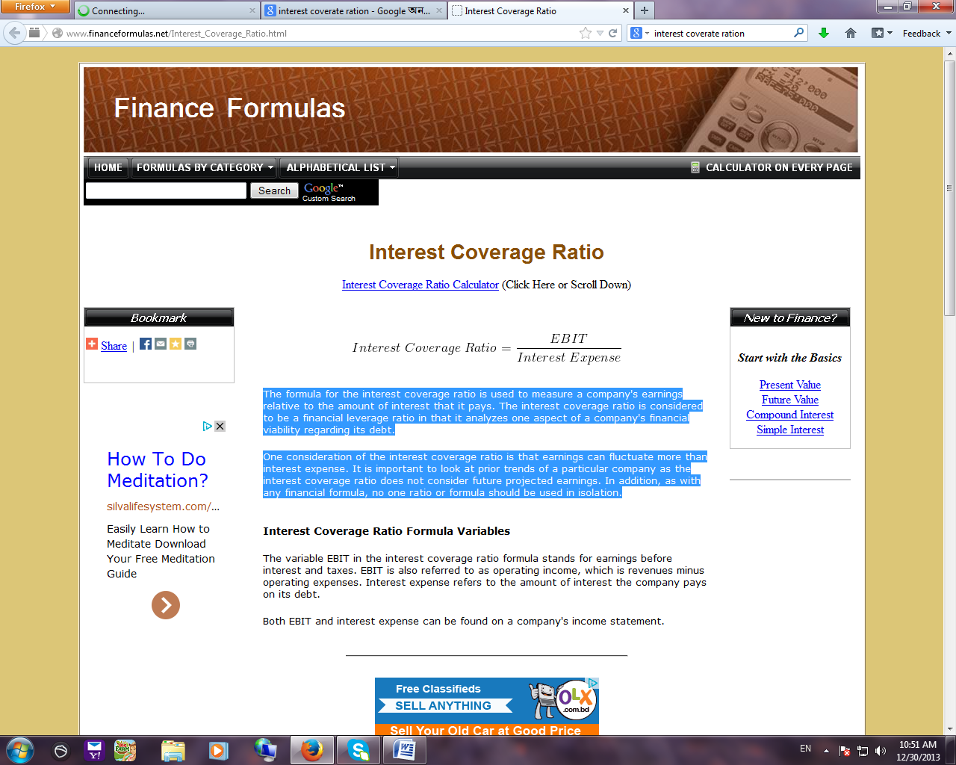

**Debt Ratio, Debt-Equity Ratio, and Equity Multiplier**

The Debt Ratio, Debt-Equity Ratio, and Equity Multiplier are essentially three ways of looking at the same thing: the firm's use of debt to finance its assets. The Debt Ratio is calculated by dividing Total Debt by Total Assets. The Debt-Equity Ratio is calculated by dividing Total Debt by Total Owners' Equity. The Equity Multiplier is calculated by dividing Total Assets by Total Owners' Equity.

http://www.prenhall.com/divisions/bp/app/cfl/RA/Equations/DebtRatio.gif

http://www.prenhall.com/divisions/bp/app/cfl/RA/Equations/DebtEquity.gif

http://www.prenhall.com/divisions/bp/app/cfl/RA/Equations/EquityMult.gif

**Profitability Ratios**

Profitability Ratios attempt to measure the firm's success in generating income. These ratios reflect the combined effects of the firm's asset and debt management.

**Profit Margin**

The Profit Margin indicates the dollars in income that the firm earns on each dollar of sales. This ratio is calculated by dividing Net Income by Sales.

http://www.prenhall.com/divisions/bp/app/cfl/RA/Equations/ProfitMargin.gif

**Return on Assets (ROA) and Return on Equity (ROE)**

The Return on Assets Ratio indicates the dollars in income earned by the firm on its assets and the Return on Equity Ratio indicates the dollars of income earned by the firm on its shareholders' equity. It is important to remember that these ratios are based on accounting book values and not on market values. Thus, it is not appropriate to compare these ratios with market rates of return such as the interest rate on Treasury bonds or the return earned on an investment in a stock.

http://www.prenhall.com/divisions/bp/app/cfl/RA/Equations/ROA.gif

http://www.prenhall.com/divisions/bp/app/cfl/RA/Equations/ROE.gif

***Du Pont Approach***

DuPont analysis (also known as the DuPont identity, DuPont equation, DuPont Model or the DuPont method) is an expression which breaks ROE into three parts & ROA into two parts

ROE = (Profit margin)*(Asset turnover)*(Equity multiplier)

= ([Net profit](http://en.wikipedia.org/wiki/Net_profit)/[Sales](http://en.wikipedia.org/wiki/Sales))*([Sales](http://en.wikipedia.org/wiki/Sales)/[Assets](http://en.wikipedia.org/wiki/Assets))*([Assets](http://en.wikipedia.org/wiki/Assets)/[Equity](http://en.wikipedia.org/wiki/Shareholders%27_equity))

= Net Profit/Equity

ROA = (Profit margin)*(Asset turnover)

= ([Net profit](http://en.wikipedia.org/wiki/Net_profit)/[Sales](http://en.wikipedia.org/wiki/Sales))*([Sales](http://en.wikipedia.org/wiki/Sales)/[Assets](http://en.wikipedia.org/wiki/Assets))

= Net Profit/Asset

**Market Value Ratios**

Market Value Ratios relate an observable market value, the stock price, to book values obtained from the firm's financial statements.

**Price-Earnings Ratio (P/E Ratio)**

The Price-Earnings Ratio is calculated by dividing the current market price per share of the stock by earnings per share (EPS). (Earnings per share are calculated by dividing net income by the number of shares outstanding.)

The P/E Ratio indicates how much investors are willing to pay per dollar of current earnings. As such, high P/E Ratios are associated with growth stocks. (Investors who are willing to pay a high price for a dollar of current earnings obviously expect high earnings in the future.) In this manner, the P/E Ratio also indicates how expensive a particular stock is. This ratio is not meaningful, however, if the firm has very little or negative earnings.

http://www.prenhall.com/divisions/bp/app/cfl/RA/Equations/PE.gif

Where

http://www.prenhall.com/divisions/bp/app/cfl/RA/Equations/EPS.gif

**Market-to-Book Ratio**

The Market-to-Book Ratio relates the firm's market value per share to its book value per share. Since a firm's book value reflects historical cost accounting, this ratio indicates management's success in creating value for its stockholders. This ratio is used by "value-based investors" to help to identify undervalued stocks.

http://www.prenhall.com/divisions/bp/app/cfl/RA/Equations/MarketBook.gif

Where

http://www.prenhall.com/divisions/bp/app/cfl/RA/Equations/BookValue.gif

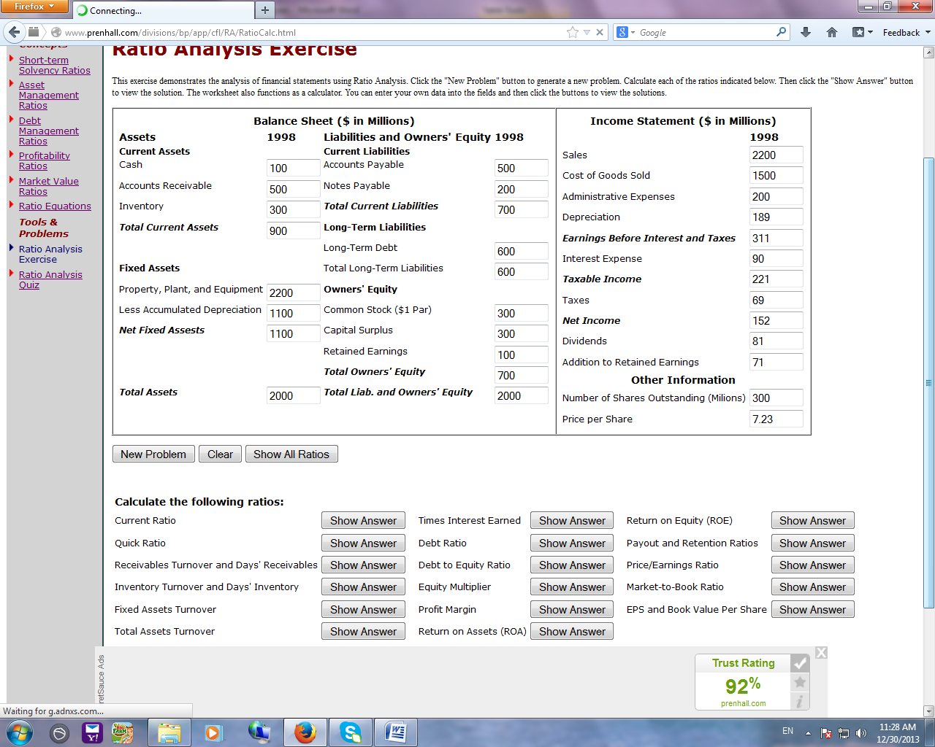

|  |  |  |  |  |  |  |
| --- | --- | --- | --- | --- | --- | --- |
| 1. Short-term Solvency Ratios | | | | | | |
| http://www.prenhall.com/divisions/bp/app/cfl/RA/Equations/CurrentRatio.gif | | | | | |
| http://www.prenhall.com/divisions/bp/app/cfl/RA/Equations/QuickRatio.gif | | | | | |
| 1. Asset Management Ratios | | | | | | |
| http://www.prenhall.com/divisions/bp/app/cfl/RA/Equations/ReceivablesTurnover.gif | | | |
| http://www.prenhall.com/divisions/bp/app/cfl/RA/Equations/DaysReceivables.gif | | | |
| http://www.prenhall.com/divisions/bp/app/cfl/RA/Equations/InventoryTurnover.gif | | | |
| http://www.prenhall.com/divisions/bp/app/cfl/RA/Equations/DaysInventory.gif | | | |
| http://www.prenhall.com/divisions/bp/app/cfl/RA/Equations/FATurnover.gif | | | |
| http://www.prenhall.com/divisions/bp/app/cfl/RA/Equations/TATurnover.gif | | | |
| 1. Debt Management Ratios | | | | | | |
| http://www.prenhall.com/divisions/bp/app/cfl/RA/Equations/DebtRatio.gif | | | | |
| http://www.prenhall.com/divisions/bp/app/cfl/RA/Equations/DebtEquity.gif | | | | |
| http://www.prenhall.com/divisions/bp/app/cfl/RA/Equations/EquityMult.gif | | | | |
| 1. Profitability Ratio | | | | | | |
| http://www.prenhall.com/divisions/bp/app/cfl/RA/Equations/ProfitMargin.gif | |
| http://www.prenhall.com/divisions/bp/app/cfl/RA/Equations/ROA.gif | |
| http://www.prenhall.com/divisions/bp/app/cfl/RA/Equations/ROE.gif | |
| 1. Market Value Ratios | | | | | | |
| http://www.prenhall.com/divisions/bp/app/cfl/RA/Equations/PE.gif |
| http://www.prenhall.com/divisions/bp/app/cfl/RA/Equations/MarketBook.gif |
| 1. Other Equations | | | | | | |
| http://www.prenhall.com/divisions/bp/app/cfl/RA/Equations/BookValue.gif | | | http://www.prenhall.com/divisions/bp/app/cfl/RA/Equations/EPS.gif | | | |

|  |  |
| --- | --- |
| **Current Ratio**  The Current Ratio is 1.29.  Explanation:  http://www.prenhall.com/divisions/bp/app/cfl/RA/Equations/CurrentRatio.gif  where: Total Current Assets = $900 Total Current Liabilities = $700 | **Quick Ratio**  The Quick Ratio is 0.86.  Explanation:  http://www.prenhall.com/divisions/bp/app/cfl/RA/Equations/QuickRatio.gif  where:  Total Current Assets = $900 Inventory = $300 Total Current Liabilities = $700 |
| **Receivables Turnover**  The Receivables Turnover is 4.4 times.  Explanation:  http://www.prenhall.com/divisions/bp/app/cfl/RA/Equations/ReceivablesTurnover.gif  where: Sales = $2200 Accounts Receivables = $500 | **Days' Receivables**  The Days' Receivables is 82.95 days.  Explanation:  http://www.prenhall.com/divisions/bp/app/cfl/RA/Equations/DaysReceivables.gif |
| **Inventory Turnover**  The Inventory Turnover is 5 times.  Explanation:  http://www.prenhall.com/divisions/bp/app/cfl/RA/Equations/InventoryTurnover.gif  where: COGS = $1500 Inventory = $300 | **Days' Inventory**  The Days' Inventory is 73 days.  Explanation:  http://www.prenhall.com/divisions/bp/app/cfl/RA/Equations/DaysInventory.gif  Where:  Inventory Turnover = 5 times (from above). |
| **Fixed Assets Turnover**  The Fixed Assets Turnover is 2 times.  Explanation:  http://www.prenhall.com/divisions/bp/app/cfl/RA/Equations/FATurnover.gif  where: Sales = $2200 Net Fixed Assets = $1100 | **Total Assets Turnover**  The Total Assets Turnover is 1.1 times.  Explanation:  http://www.prenhall.com/divisions/bp/app/cfl/RA/Equations/TATurnover.gif  where: Sales = $2200 Total Assets = $2000 |
| **Debt to Equity Ratio**  The Debt to Equity Ratio is 185.71%.  Explanation:  http://www.prenhall.com/divisions/bp/app/cfl/RA/Equations/DebtEquity.gif  where: Total Assets = $2000 Total Owners' Equity = $700  Note: Total Debt is computed by subtracting Total Owners' Equity from Total Assets. | **Debt to asset Ratio**  The Debt to asset Ratio is 65%.  Explanation:  http://www.prenhall.com/divisions/bp/app/cfl/RA/Equations/DebtRatio.gif  where: Total Assets = $2000 Total Owners' Equity = $700  Note: Total Debt is computed by subtracting Total Owners' Equity from Total Assets. |
| **Profit Margin**  The Profit Margin is 6.91%.  Explanation:  http://www.prenhall.com/divisions/bp/app/cfl/RA/Equations/ProfitMargin.gif  where: Net Income = $152 Sales = $2200 | **Equity Multiplier**  The Equity Multiplier is 2.86.  Explanation:  http://www.prenhall.com/divisions/bp/app/cfl/RA/Equations/EquityMult.gif  where: Total Assets = $2000 Total Owners' Equity = $700 |
| **Return on Equity (ROE)**  The ROE is 21.71%.  Explanation:  http://www.prenhall.com/divisions/bp/app/cfl/RA/Equations/ROE.gif  where: Net Income = $152 Total Owners' Equity = $700 | **Return on Assets (ROA)**  The ROA is 7.6%.  Explanation:  http://www.prenhall.com/divisions/bp/app/cfl/RA/Equations/ROA.gif  where:  Net Income = $152 Total Assets = $2000 |
| **Payout Ratio**  The Payout Ratio is 53.29%.  Explanation:  http://www.prenhall.com/divisions/bp/app/cfl/RA/Equations/Payout.gif  where: Net Income = $152 Dividends = $81 | **Retention Ratio**  The Retention Ratio is 46.71%.  Explanation:  http://www.prenhall.com/divisions/bp/app/cfl/RA/Equations/Retention.gif  where: Net Income = $152 Addition to RE = $71  Note: The sum of the Payout Ratio and the Retention Ratio is 100%. |
| **Price/Earnings Ratio (P/E)**  The Price/Earnings Ratio (P/E) is 14.27.  Explanation:  http://www.prenhall.com/divisions/bp/app/cfl/RA/Equations/PE.gif  where: Price Per Share = $7.23 Earnings Per Share (EPS) = $0.51  Note: See the EPS/Book Value Per Share calculation for additional information.  **Earnings Per Share**  The Earnings Per Share (EPS) is $0.51.  Explanation:  http://www.prenhall.com/divisions/bp/app/cfl/RA/Equations/EPS.gif  where: Net Income = $152 Number of Shares Outstanding = 300 | **Market-to-Book Ratio**  The Market-to-Book Ratio is 3.1.  Explanation:  http://www.prenhall.com/divisions/bp/app/cfl/RA/Equations/MarketBook.gif  where: Price Per Share = $7.23 Book Value Per Share = $2.33  Note: See the EPS/Book Value Per Share calculation for additional information.  **Book Value Per Share**  The Book Value Per Share is $2.33.  Explanation:  http://www.prenhall.com/divisions/bp/app/cfl/RA/Equations/BookValue.gif  where: Total Owners' Equity = $700 Number of Shares Outstanding = 300 |