Tensile properties of textile material

1. Tenacity
2. Breaking extension
3. Work of rupture
4. Initial modulus
5. Work factor
6. Work recovery
7. Elastic recovery
8. Yield stress
9. Yield strain
10. Yield point
11. Breaking load
12. Creep

Tenacity: The ratio of load required to break the specimen and the linear density of that specimen is called tenacity.
Mathematically, Tenacity = Load required to break the specimen / Linear density of the specimen
Unit: gm/denier, gm/Tex, N/Tex, CN/Tex etc.

Breaking extension: The elongation necessary to break a textile material is a useful quantity. It may be expressed by the actual percentage increase in length and is termed as breaking extension.
Mathematically, Breaking extension (%) = (Elongation at break / Initial length) × 100%

Work of rupture: Work of rupture is defined as the energy required to break a material or total work done to break that material.
Unit: Joule (J)

Initial modulus: The tangent of angle between the initial curve and the horizontal axis is equal to the ratio of stress and strain.
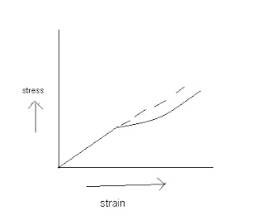

In engineering science the ratio is termed as Young’s Modulus and in textile we use the terms as Initial Young’s Modulus.
Initial modulus, tan α = stress / strain
Tan α ↑↓ → extension ↓↑

Work factor: The ratio between work of rupture and the product of breaking load and breaking elongation is called work factor.
Work factor = work of rupture / (breaking load × breaking elongation)

Work recovery: The ratio between work returned during recovery and total work done in total extension is called work recovery.
Total extension = Elastic extension + Plastic extension
Total work = work required to elastic extension + work required to plastic extension.

Elastic recovery: the power of recovery from a given extension is called elastic recovery. Elastic recovery depends on types of extension, fiber structure, types of molecular bonding and crystalline of fiber.
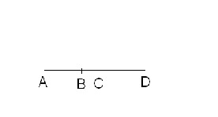
Here, AB = initial length of the specimen
AB = final length after recovery
BD = total extension
BC = elastic extension
CD = plastic extension

Total extension = Elastic extension + Plastic extension

So,
Elastic recovery (%) = (Elastic extension/total extension) ×100%
= (BC/BD) × 100%

So,
Plastic recovery = (plastic extension/total extension) ×100%
= (CD/BD) ×100%

# Stress-strain curve
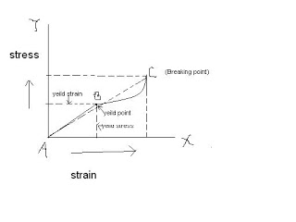

When fiber is deformed then the fiber follows the stress-strain curve.

Here, A to B → linear region. This region follows Hook’s law (stress ∞ strain). So, fiber comes to its original position after removal of load. So, the region is called elastic region and the deformation is called elastic deformation.

B to C → plastic region. In this region chain breaks but fiber do not break. Here the deformation is known as plastic deformation.

C → Breaking point. The fiber will be break at this point.

B → Yield point. The point up to which a fiber behaves elastic deformation and after which a fiber shows plastic deformation is called yield point.

Yield stress → The stress at yield point is called yield stress.

Yield strains: The strain at yield point is called yield strain.

Breaking load: The load which is required to break a specimen is called breaking load.

Creep: when a load is applied on the textile material an instantaneous strain is occurred, but after that the strain will be lower with the passing time. This behavior of the material is termed as creep.
There are two types of creep:
i. Temporary creep
ii. Permanent creep

Difference between temporary and permanent creep:

i. Recoverable | i. Non recoverable.
ii. Textile material comes back to its original position after removal of load. | ii. Textile material does not come back to its original position after removal of load.
iii. Elastic extension occurs. | Plastic extension occurs.
iv. Polymer chains slightly stretch. | iv. Polymer chains break.

Factors determined the result of tensile experiment:

1. The material and its condition-
a. The chemical treatment to which it has been subjected
b. The mechanical treatment that it has been received
c. On the amount of moisture that it contains
d. On the temperature
2. The arrangement and dimension of the specimen.

3. The nature and timing of the test.

Principles of tensile experiment or Method of tensile experiment:

1. CRL method ( constant rate of loading )
2. CRE method (constant rate of elongation)

CRL method: A specimen A is gripped between two jaws. J1 is fixed and bottom jaw J2 is movable to down-ward at constant velocity by mean of a screw mechanism. Initially the force on A is zero. The function of applied force is to extent the specimen until it eventually breaks down. Here the loading causes the elongation.
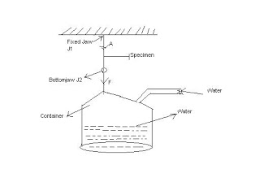

By adding constant rate of water flow in a container which is attached with the jaw J2 may increase the load gradually. Thus constant rate of flow gives constant rate of loading.
2.CRE method: A specimen A is gripped between two jaws. J1 is fixed and bottom jaw J2 is movable to down-ward at constant velocity by mean of a screw mechanism. Initially the tension on A is zero. But when the bottom jaw J2 moves down-ward at a constant rate the specimen is extended and an increasing tension is developed until it eventually breaks down. Here the elongation /tension causes loading.

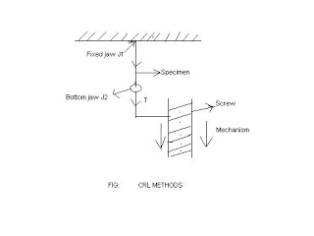

Difference between CRL & CRE methods:

1. CRL means Constant rate of loading. | 1. CRE means Constant rate of elongation.
2. This method contains container and water flow used to increase load gradually. | 2. This method contains screw mechanism.
3. In this method loading causes elongation. | 3. In this method elongation/ extension causes loading.

Tensile properties of different fibers:

Fiber | Tenacity(N/Tex) | Breaking extension (%)
Cotton | 0.19-0.45 | 5.6-7.1
Jute | 0.31 | 1.8
Silk | 0.38 | 23.4
Nylon | 0.47 | 26
Polyester | 0.47 | 15
Wool | 0.11-0.14 | 29.8-42.9

