**Electromagnetic induction:**

It is the production of an [electromotive force](https://en.wikipedia.org/wiki/Electromotive_force) (i.e., voltage) across an [electrical conductor](https://en.wikipedia.org/wiki/Electrical_conductor) in a changing [magnetic field](https://en.wikipedia.org/wiki/Magnetic_field).

Electromagnetic induction was discovered by Michael Faraday in the 1830s. Many electrical components and types of equipment work based on the principle of electromagnetic induction.

**Faraday’s Law:**

The magnitude of the induced e.m.f produced in a coil is directly proportional to the rate of change of the magnetic flux through the coil.

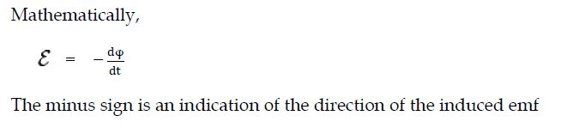

The minus sign is an indication of the direction of the induced emf.

For a coil having N turns, the induced emf,

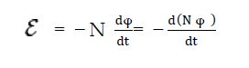

Where, N φB measures the so-called flux linkage.

**Mutual induction**:

It is the property of two coils by virtue of which each opposes any change in the strength of current flowing through the other by developing an induced emf.

If the current i in one circuit changes with time, the flux through the area bounded by the second circuit also changes. This phenomenon is called mutual induction.

A transformer is an example of a device that uses circuits with maximum mutual inductance.

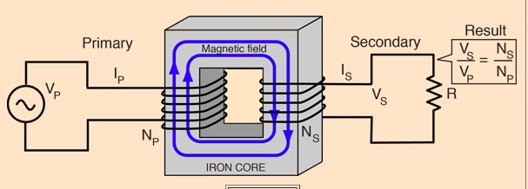

This coupling between the primary and secondary is most conveniently described in terms of [mutual inductance](http://hyperphysics.phy-astr.gsu.edu/hbase/magnetic/indmut.html#c2)

**Self Induction:**

When a current is established in a closed conducting loop, it produces a magnetic field. This magnetic field has its flux through the area bounded by the loop. If the current changes with time, the flux through the loop changes and hence an emf is induced in the loop. This process is called self induction.

**Self Inductance:**

Self-induction means the coils induce the emf themselves. There is a change in the magnetic flux through that coil and because of this, the current will be induced in the coil by itself.

So once the current get induced, the current tries to oppose the flux.

Here NΦ ∝ I

NΦ = LI ( L is the self-induction)

This is the self-induced emf. A coil having self-inductance ”L” is said to be the induction coil.