Newtonian mechanics incorporates the Newtonian concept of the complete separation of space and time. Einstein’s work on relativistic mechanics comprised two major advances. The first advance is the 1905 **Special Theory of Relativity**which refers to non accelerating frames of reference. The second major advance was the 1916 **General Theory of Relativity** which considers accelerating frames of reference and their relation to gravity. The Special Theory is a limiting case of the General Theory of Relativity. The mathematically complex General Theory of Relativity is required for describing accelerating frames, gravity, plus related topics like Black Holes, or extremely accurate time measurements inherent to the Global Positioning System.

**General relativity:**

It is also known as the **general theory of relativity**, is the [geometric](https://en.wikipedia.org/wiki/Differential_geometry) [theory](https://en.wikipedia.org/wiki/Scientific_theory) of [gravitation](https://en.wikipedia.org/wiki/Gravitation) published by [Albert Einstein](https://en.wikipedia.org/wiki/Albert_Einstein) in 1915 and is the current description of gravitation in [modern physics](https://en.wikipedia.org/wiki/Modern_physics). General [relativity](https://en.wikipedia.org/wiki/Theory_of_relativity) generalizes [special relativity](https://en.wikipedia.org/wiki/Special_relativity) and refines [Newton's law of universal gravitation](https://en.wikipedia.org/wiki/Newton%27s_law_of_universal_gravitation), providing a unified description of gravity as a geometric property of [space](https://en.wikipedia.org/wiki/Space) and [time](https://en.wikipedia.org/wiki/Time_in_physics) or [four-dimensional](https://en.wikipedia.org/wiki/Four-dimensional) [space time](https://en.wikipedia.org/wiki/Spacetime). In particular, the [*curvature*](https://en.wikipedia.org/wiki/Curvature)*of space time* is directly related to the [energy](https://en.wikipedia.org/wiki/Energy) and [momentum](https://en.wikipedia.org/wiki/Momentum) of whatever [matter](https://en.wikipedia.org/wiki/Matter) and [radiation](https://en.wikipedia.org/wiki/Radiation) are present. The relation is specified by the [Einstein field equations](https://en.wikipedia.org/wiki/Einstein_field_equations), a system of [partial differential equations](https://en.wikipedia.org/wiki/Partial_differential_equation).

General relativity also predicts the existence of [gravitational waves](https://en.wikipedia.org/wiki/Gravitational_wave), which have since been [observed directly](https://en.wikipedia.org/wiki/List_of_gravitational_wave_observations) by the physics collaboration [LIGO](https://en.wikipedia.org/wiki/Laser_Interferometer_Gravitational-Wave_Observatory). In addition, general relativity is the basis of current [cosmological](https://en.wikipedia.org/wiki/Physical_cosmology) models of a consistently [expanding universe](https://en.wikipedia.org/wiki/Metric_expansion_of_space).

Gravitational waves are 'ripples' in space-time caused by some of the most violent and energetic processes in the Universe. Albert Einstein predicted the existence of gravitational waves in 1916 in his general theory of relativity. Einstein's mathematics showed that massive accelerating objects (such as neutron stars or black holes orbiting each other) would disrupt space-time in such a way that 'waves' of undulating space-time would propagate in all directions away from the source. These cosmic ripples would travel at the speed of light, carrying with them information about their origins, as well as clues to the nature of gravity itself.

<https://www.ligo.caltech.edu/page/what-are-gw>

**Special theory of relativity:**

In [physics](https://en.wikipedia.org/wiki/Physics), the **special theory of relativity**, or **special relativity** for short, is a scientific theory regarding the relationship between [space and time](https://en.wikipedia.org/wiki/Spacetime). In [Albert Einstein](https://en.wikipedia.org/wiki/Albert_Einstein)'s original treatment, the theory is based on two [postulates](https://en.wikipedia.org/wiki/Axiom)

1. The [laws of physics](https://en.wikipedia.org/wiki/Laws_of_physics) are [invariant](https://en.wikipedia.org/wiki/Invariant_(physics)) (that is, identical) in all [inertial frames of reference](https://en.wikipedia.org/wiki/Inertial_frame_of_reference).
2. The [speed of light](https://en.wikipedia.org/wiki/Speed_of_light) in [vacuum](https://en.wikipedia.org/wiki/Vacuum) is the same for all observers, regardless of the motion of the light source or observer.

Special relativity has a wide range of consequences that have been experimentally verified. They include the relativity of simultaneity, [length contraction](https://en.wikipedia.org/wiki/Length_contraction), [time dilation](https://en.wikipedia.org/wiki/Time_dilation), the relativistic velocity addition formula, the relativistic Doppler effect, [relativistic mass](https://en.wikipedia.org/wiki/Mass_in_special_relativity), [a universal speed limit](https://en.wikipedia.org/wiki/Speed_of_light#Upper_limit_on_speeds), [mass–energy equivalence](https://en.wikipedia.org/wiki/Mass%E2%80%93energy_equivalence),

A defining feature of special relativity is the replacement of the [Galilean transformations](https://en.wikipedia.org/wiki/Galilean_transformation) of Newtonian mechanics with the [Lorentz transformations](https://en.wikipedia.org/wiki/Lorentz_transformation).

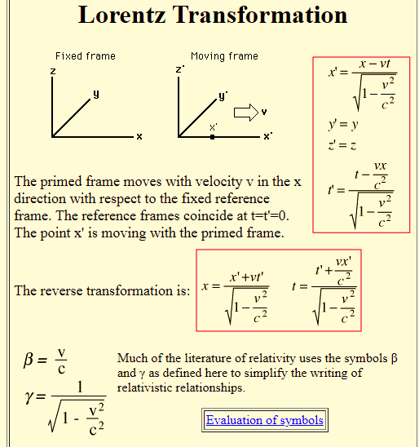

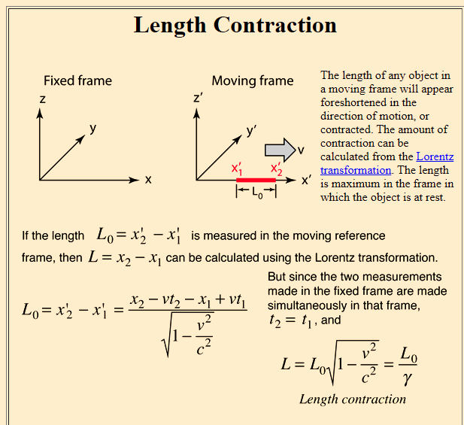

<https://physicsworld.com/a/the-invisibility-of-length%E2%80%AFcontraction/>

