**Chemistry of Materials**

**Properties of Water**

Water is known as the medium of life. Many organisms are comprised of 70- 90% water. The ability of water molecules to form hydrogen bonds explains the many properties of water that make it so important to living things.

**Molecular Structure of Water**

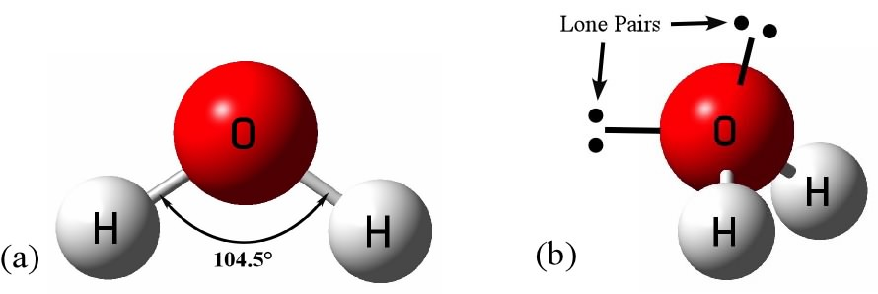1. Consist of one oxygen atom and two hydrogen atoms

2. Molecular Formula: H2O

3. Not symmetrical

4. Electrons spend more time near

5. The oxygen and less near the hydrogen

6. Water molecule is polar

**Physical Properties of Water**

**Physical Variables**

1. Salinity

2. Electrical conductance

3. Turbidity

4. Color

5. Total gas pressure

**Salinity (S)**

* Often considered a chemical attribute of water.
* **Salinity:** the measure of the concentration of dissolved ions in water (ppt, mg/L).
* Practical Salinity Units (psu)
* Major ions: Na+ and Cl-
* Substantial ions: Mg2+, Ca2+, K2+, SO4=, and bicarbonates HCO3-

**Chlorinity**

* “Chlorinity” is not the same as salinity.
* **Chlorinity**: A measure of the chloride content, by mass, of seawater (grams per kilogram of seawater, or per mille). Originally chlorinity was defined as the weight of chlorine in grams per kilogram of seawater after the bromides and iodides had been replaced by chlorides.

**Electrical Conductance**

Conductivity of a substance is defined as 'the ability or power to conduct or transmit heat, electricity, or sound'.

**Electrical Conductance of water**: The measurement of the dissolved mineral content (salinity) of water.

* Changes in direct proportion to salinity.
* Water ionizes slowly and, thus, is a poor conductor of electricity.
* Unit of measurement: micro ohm/cm
* Range: 20 - 1,500, much higher for salinity of water.

**Turbidity**

Turbidity is the measurement of light penetration in water.

* Produced by dissolved and suspended substances (clay, humics, silt, plankton, colored compounds).
* Typically measured with **secchi disk** or **turbidometer.**
* More dense = higher turbidity.



**Color**

* The reaction of incident light with impurities in the water.
* **Humics** (organic acids) = tea color, not directly harmful to aquaculture species.
* Phytoplankton: red, green, yellow, brown
* Often used as a management tool.
* Can be qualified by spectrophotometer.

**Total Gas Pressure**

* **Total Gas Pressure (TGP):** The sum of the partial pressures of all gases dissolved in water.
* **Barometric Pressure (BP):** weight of the atmosphere imparted on water surface.
* **equillibrium:**  TGP = BP
* When TGP > BP, gas goes from water to atmosphere.
* When BP > TGP, gas goes from atmosphere to water.

**Chemical Properties of Water**

**Variables**

1. Total Alkalinity

2. Total Hardness

3. pH

4. Carbon Dioxide

**Total Alkalinity**

* The total amount of titratable bases in water expressed as mg/L of equivalent CaCO3.
* “Alkalinity” is primarily composed of the following ions: CO3-. HCO3-. hydroxides. ammonium. borates. silicates. phosphates.
* Alkalinity in ponds is determined by both the quality of the water and bottom muds.
* Calcium is often added to water to increase its alkalinity. buffer against pH changes.

**Total Hardness**

* Total Hardness is thetotal concentration of metal ions expressed in terms of mg/L of equivalent CaCO3.
* Primary ions are Ca2+ and Mg2+ and also iron and manganese.
* Total Hardness approximates total alkalinity.
* Calcium is used for bone and exoskeleton formation and absorbed across gills.

**pH**

The level or intensity of a substance’s acidic or basic character.

* **pH**: the negative logarithm of the hydrogen ion concentration (activity) of a substance.
* pH = -log [H+]
* Neutral pH = similar levels of H+ and OH-

**Carbon dioxide**

Normal components of all natural waters.

**Sources:** Atmospheric diffusion. respiration of cultured species. biological oxidation of organic compounds.

As the level of CO2 in the medium increases, the gradient allowing diffusion is less.

CO2 is not particularly toxic to fish or invertebrates, given sufficient D. O. is available.

Maximum tolerance level appears to be around 50 mg/L for most species.

Good working level of around 15-20 mg/L.

**Solutions and their Properties**

In performing a chemical reaction, it is indeed necessary for a chemist to determine what amount of substance is to use as reactant and what amount of product and byproduct and unwanted substances are produced. Particularly, in chemical industries this calculation is a must for economic considerations. This is why the number of molecules and the number of atoms and ions in a molecule of reactant and product of a chemical reaction are to be calculated.

Molecules, ions and atoms are so small particles that, they cannot be calculated as pairs, fours, dozens, hundreds, thousands even not in corers. Chemists use a large number to count molecules, ions and atoms. The value of this number is 6.02 X 1023.

According to the name of Italian scientist Amedeo Avogadro this number is called the Avogadro number or Avogadro constant. The amount of a substance containing 6.02 x 1023 number of molecules, ions and atoms are called mole. In chemistry, calculation of molecule, atom, ion, reactant and product is known as Stoichiometry.

**Mole**

The amount of a chemical substance which contains the Avogadro number (6.02 x 1023) of molecules, ions or atoms is called the mole of the substance.

For example, one mole of water means 6.02 x 1023 number of water molecules. Though one dozen eggs or bananas can be measured by counting but one mole of substance cannot be calculated by counting. This amount of chemical substance is measured in mass. That is, there is a relation of unit of mass gram/milligram with mole.

The atomic mass or molecular mass of a chemical substance when expressed in gram unit is called the mole.

Relative molecular mass of water is 18. That is, there are 6.02 X 1023 numbers of molecules in one mole water, mass of which is 18 g.

|  |  |  |
| --- | --- | --- |
| 1 mole hydrogen atom | =1.008g | = 6.02 x 1023 number of atoms. |
| 1 mole oxygen atom | =16g | = 6.02 x 1023 number of atoms. |
| 1 mole oxygen molecule | = 32g | = 6.02 x 1023 number of molecules | | |
| 1 mole carbon dioxide molecule | = 44g | = 6.02 x 1023 number of molecules. | |
|  |  |  | |

**Mixture**

A combination of two or more pure substances in which each pure substances retains its individual chemical properties.

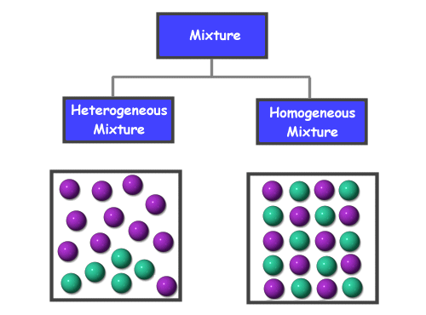

Figure: Types of mixture

**Homogeneous Vs Heterogeneous Mixture**

|  |  |
| --- | --- |
| Homogeneous Mixture | Heterogeneous Mixture |
| Homogeneous mixture have a uniform combination throughout the mixture | Heterogeneous mixture have a mixed composition which may vary from point to point |
| Components are not visible in naked eye | Components can be seen easily |
| The whole mixture is in the same phase | Substances can be of two phases and layers may separate. |
| Components cannot separate easily | Components can be separated easily |
| Particle size is often at atomic and molecular level. | Heterogeneous mixtures have large particle size. |

**Solution**

A solution is a homogeneous mixture of two or more substances (elements or compounds) in no definite ratio by mass. All homogeneous mixtures are solutions.

Generally solute and solvent are the basic part of solution. A solute is the dissolve in a solvent. For example sugar and water solution. Solute is the dissolve substances (sugar) and solvent is the dissolving medium in which the solute is dissolved (water)

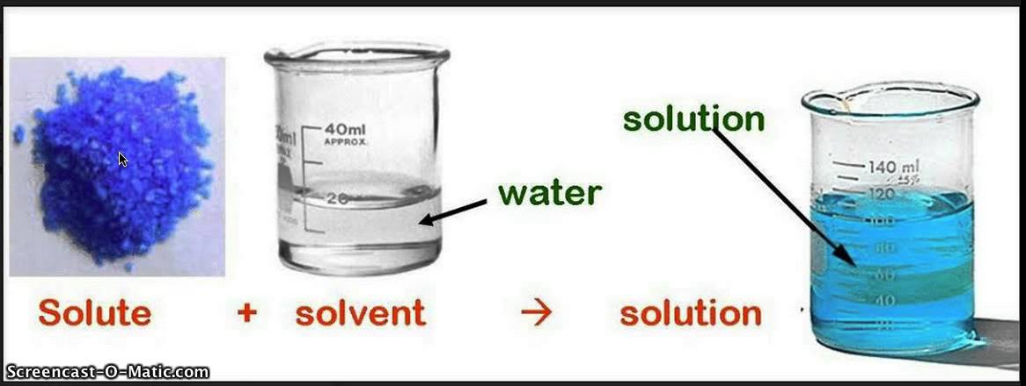

Figure: Preparation of solution

**Unsaturated solution**

An unsaturated solution contains less than the maximum quantity of solute that can dissolves at a particular temperature.

**Saturated solution**

A saturated solution that contains maximum amount of a solute in a given solvent at room temperature. No more solute can dissolve in it and there is a dynamic equilibrium between the undissolved and dissolved solute. This type of solution is called saturated solution

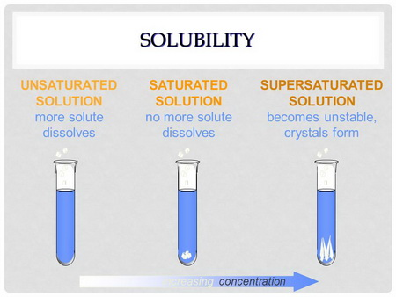

Figure: Unsaturated, saturated and supersaturated solution formation

**Supersaturated solution**

A supersaturated solution that contains more dissolved substances than a saturated solution is called supersaturated solution.

**Concentration of a solution**

The concentration of a solution is defined as : **the amount of solute present in a given amount of solution. Concentration is generally expressed as the quantity of solute in a unit volume of solution.**



A solution containing a relatively low concentration of solute is called **Dilute solution.** A solution of high concentration is called **Concentrated solution.**

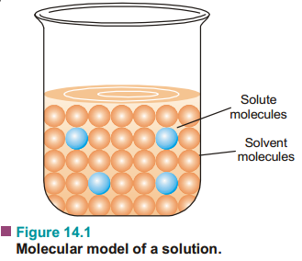

Types of solutions

The common solutions that we come across are those where the solute is a solid and the solvent  
is a liquid. In fact, substance in any three states of matter (solid, liquid, gas) can act as solute or  
solvent. Thus there are **seven types of solutions** whose examples are listed in Table.

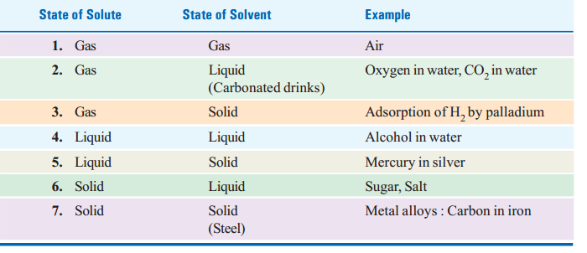

**Units of Concentration**

There are several ways of expressing concentration of a solution :  
(*a*) Per cent by weight  
(*b*) Mole fraction  
(*c*) Molarity  
(*d*) Molality  
(*e*) Normality

**(f)Parts Parts per billion (ppb)**

**(g) per million (ppm)**

**Per cent by Weight**

It is the **weight of the solute as a per cent of the total weight of the solution.** That is,



For example, if a solution of HCl contains 36 per cent HCl by weight, it has 36 g of HCl for 100  
g of solution.

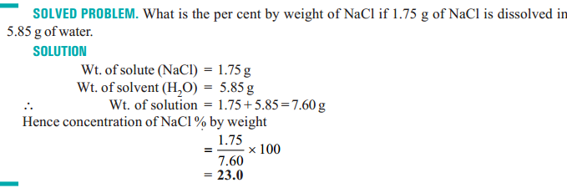

Mole fraction

A simple solution is made of two substances : one is the solute and the other solvent. Mole  
fraction, *X*, of solute is defined as **the ratio of the number of moles of solute and the total number of moles of solute and solvent.** Thus,



If *n* represents moles of solute and *N* number of moles of solvent,



Notice that mole fraction of solvent would be



Mole fraction is unitless and



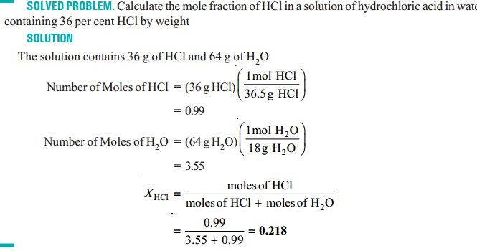

MOLARITYIn current practice, concentration is most often expressed as molarity. Molarity (symbol M) is  
defined as the number of moles of solute per litre of solution. If n is the number of moles of solute and *V* litres the volume of solution.

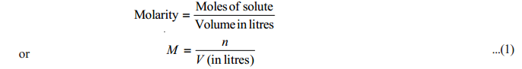

For one mole of solute dissolved in one litre of solution *M* = 1 *i*.*e*., molarity is one. Such a  
solution is called 1*M* (read “1 molar”). A solution containing two moles of solute in one litre is 2*M*(“two molar”); and so on. As evident from expression (1), **unit of molarity is mol litre–1.**

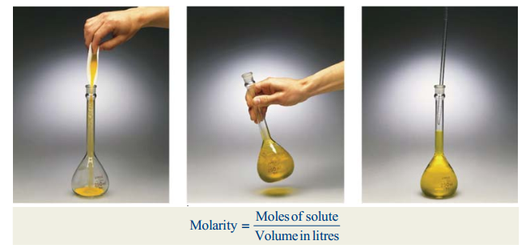

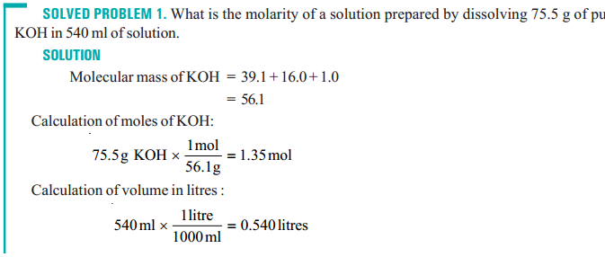

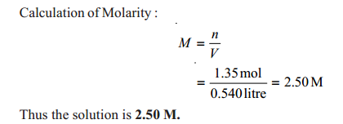

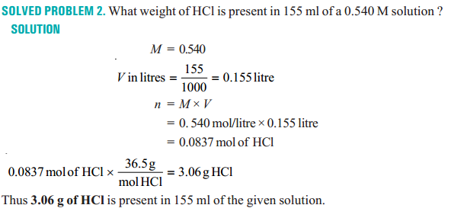

MOLALITY

Molality of a solution (symbol *m*) is defined as **the number of moles of solute per kilogram of  
solvent :**

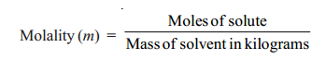

A solution obtained by dissolving one mole of the solute in 1000 g of solvent is called **one molal**or **1*m* solution.**

Notice the difference between molality and molarity. **Molality is defined in terms of mass of  
solvent while molarity is defined in terms of volume of solution.**

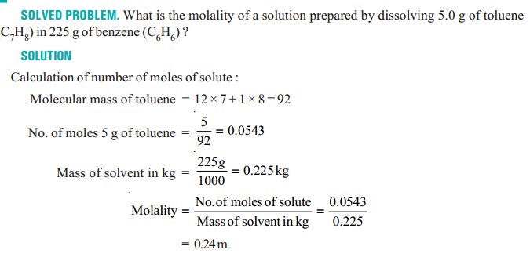

NORMALITY

Normality of a solution (symbol N) is defined as number of equivalents of solute per litre of thesolution :

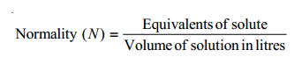

Thus, if 40 g of NaOH (eq. wt. = 40) be dissolved in one litre of solution, normality of the solution  
is one and the solution is called 1*N* (one-normal). A solution containing 4.0 g of NaOH is 1/10 *N* or 0.1 *N* or decinormal.

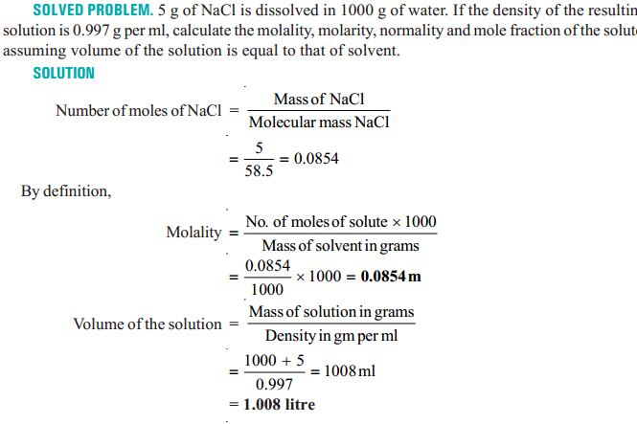

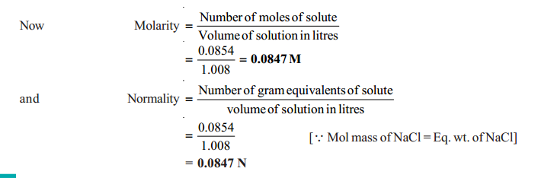

**Parts per million (ppm)**

A part per million is one part of solute per million parts of solution.

Perts per million (ppm) = $\frac{mass of component}{total mass of solution} X {10}^{6}$

**Parts per billion (ppb)**

A part per billion is one part of solute per billion parts of solution.

Perts per billion (ppb) = $\frac{mass of component}{total mass of solution} X {10}^{9}$

**Problem:**

What is the molality of a solution prepared by dissolving 0.385 g of cholesterol (C27H46O) in 40.0 g of chloroform (CHCl3)? Cholesterol = 386.7 amu ; chloroform = 119.4 amu

**Solution**

Molality = $\frac{moles ofcholesterol}{kg of chloroform}$ = $\frac{\frac{0.385 g}{386.7}}{.o4 Kg}$ = 0.0249 mol/kg

What is the mole fraction of cholesterol in the solution?

X (chlesterol) = = 2.96 x 10-3

**Problem:**

Assuming that seawater is an aqueous solution of NaCl what is its molarity? The density of seawater is 1.025 g/mL at 20C and the NaCl concentration is 3.50 mass %.

**Solution**

3.5 mass% = 35 g NaCl in 1 kg solution

We know, Density = mass/volume

1 kg solution = mass/density = 1000/1.025 = 975.6 mL

Molarity = $\frac{35 g / (23+35.5) }{0.9756 L}$ = $\frac{0.598}{0.9756}$ = 0.61 mol/L

**CHEMICAL EQUILIBRIUM**

The elements present in nature are changing gradually. There are different kinds of changes. Some of the changes are physical and some are chemical. Every change has some effects. Particularly chemical changes have both good and bad effects. So it is mandatory to have proper knowledge about the effects of chemical changes.

**Classification of Chemical Changes or Chemical Reactions**

**Irreversible Reaction**

A reaction that occurs only in one direction is called an irreversible reaction i.e., only the reactants are converted to products and the conversion of products to reactants is not possible. The equation of irreversible reaction is presented by using one way arrow sign ( ) between the reactants and products.

When limestone (calcium carbonate; CaCO3) is heated at high temperature, limestone dissociates to lime (calcium oxide; CaO) and carbon-di-oxide (CO2). This reaction occurred in open container is irreversible.

CaCO3(s) CaO (s) + CO2 (g) (in open container)

**Reversible Reaction**

A reaction that occurs in both forward and backward directions is called reversible reaction. In a reversible reaction, the reactants are converted into products and the products can also be converted back to the reactants***.***

***half headed arrows*** The half headed arrows ( ) are used to indicate the reversible reactions. The following reactions are reversible reactions since they occur in both directions.

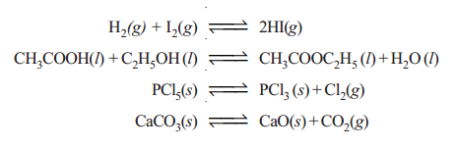

**Reaction Rate**

The rate of reaction defined as the change in concentration of any of reactant or product per unit time. The following reaction the rate of reaction may be equal to the rate of disappearance of A which is equal to the rate of appearance of B

**A B**

Rate of reaction = rate of disappearance of A

= rate of appearance of B

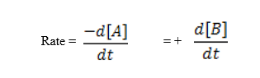

Where [ ] represents the concentration in moles per dm3. Negative sign shows the concentration of the reactant A decreases whereas the positive sign indicates the increase in concentration of the product B.

**Rate Laws**

The rate of reaction is directly proportional to the reactant concentration, each concentration being raised to some power.

For a reaction

2A + B Product

Hence, Rate ∝ [reactants]n

So, here, rate, r ∝ [A]2[B]

r = K [A]2[B]

Where, k is the rate constant.

**Example of rate law**

**Reaction Rate Law**

H2 + I2  rate = k [H2] × k [I2]

2 NO2 rate = k [NO2]2

**Units of rate of reaction**

The rate of a reaction is expressed in the units of concentration/time like: M sec-1 (or) M min-1 (or) mol.L-1 sec-1 (or) mol.L-1 min-1

For gases, the activities are expressed in terms of partial pressures. Therefore the unit for the rate of reaction may be atm.s-1 or atm min-1.

**Order of Reaction**

The order of reaction is defined as the sum of the powers of concentrations in the rate law.

Let us consider the example of a reaction which has the rate law

Rate = k [A]m [B]n

The order of such a reaction is (m + n)

|  |  |
| --- | --- |
| **Rate Law** | **Reaction Order** |
| Rate = k [N2O5] | 1 |
| Rate = k [NO2]2 | 2 |
| Rate = k[H2] + k[I2] | 2 |

Depending on the order of reaction, the chemical reactions can be divided into zero, first, second & third order reactions as follows.

**Molecularity of a Reaction**

The molecularity of an elementary reaction is defined as the number of reactant molecules involved in a reaction. The elementary reaction having molecularity 1, 2 and 3 are called unimolecular, bimolecular and termolecular reaction.

a) Unimolecular reactions (molecularity = 1)

A Product

b) Bimolecular reaction: (molecularity = 2)

A+B Product

c) Termolecular reaction: (molecularity = 3)

A+B+C product

**Chemical equilibrium**

The state at which the rate of forward reaction becomes equal to the rate of backward reaction is called chemical equilibrium.

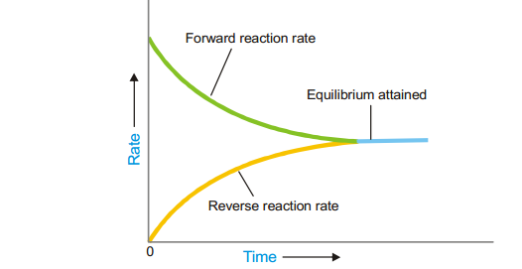

**Explanation:** Initially the rate of forward reaction is greater than the rate of backward reaction. However during the course of reaction, the concentration of reactants decreases and the concentration of products increases. Since the rate of a reaction is directly proportional to the concentration, the rate of forward reaction decreases with time, whereas the rate of backward reaction increases.

At certain stage, both the rates become equal. From this point onwards, there will be no change in the concentrations of both reactants and products with time. This state is called as equilibrium state.

**Characteristics of Chemical Equilibrium**

1. At equilibrium state, the rates of forward and backward reactions are equal.
2. The observable properties such as pressure, concentration, color, density, viscosity etc., of the system remain unchanged with time.
3. The chemical equilibrium is a **dynamic equilibrium**, because both the forward and backward reactions continue to occur even though it appears static externally.
4. The concentrations of reactants and products do not change with time but their inter conversion continue to occur.

5. The chemical equilibrium can be reached by starting the reaction either from the reactants side or from the products side

**Types of Chemical Equilibrium**

**1) Homogeneous equilibrium:** A chemical equilibrium is said to be homogeneous if all the substances (reactants and products) at equilibrium are in the same phase.E.g.

homogeneous equilibria

**2) Heterogeneous equilibrium:** A chemical equilibrium is said to be heterogeneous if all the substances at equilibrium are not in the same phase. E.g.

heterogeneous equilibria

**Law of Mass Action**

*The rate of a reaction at an instant of time is proportional to the product of active masses of the reactants at that instant of time under given conditions.*

The active masses for different substances and systems can be expressed as mentioned below.

1. For dilute solutions, the molar concentrations are taken as active masses.
2. For gases at low pressures, the partial pressures are taken as active masses. However the molar concentrations can also be taken as active masses.

E.g. For the reaction:  **N2(g) + 3H2(g)  2NH3(g)**

The rate of the reaction at an instant of time can be expressed as:

**r ∝ [N2] [H2]3**

**Or, r ∝ pN2.pH23**

Where: [N2] and [H2] are the molar concentrations of gases. pN2 and pH2 are the partial pressures of gases

**Equilibrium Constant (KC)**

The equilibrium constant Kc is the ratio of concentrations of the reactants and products.

The general equation for any homogeneous reaction at equilibrium is…

cC + dD



aA + bB

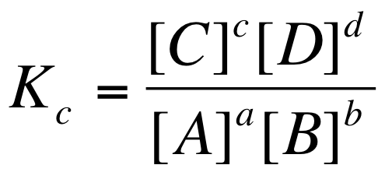

[ ] represents the equilibrium concentration in moldm-3. a, b, c & d are the numbers of moles of substances A, B, C & D

**Equilibrium Constant (Kp)**

Kp is the equilibrium constant in terms of partial pressures. Let A, B, C and D are gases in the following reaction.

half headed arrows

**cC(g) + dD (g)**

**aA(g) + bB(g)**

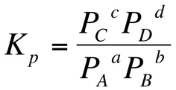

Then for the above reaction, the Kp can be written as:

Where PA, PB, PC and PD are the partial pressures of A, B, C and D at equilibrium.

**Relation between k*C*& k*P***

Consider the gaseous equation in a state of equilibrium

*a*A + *b*B *c*C + *d*D

Let PA, PB, PC & PD be the partial pressure of A, B, C and D respectively at equilibrium, then



And



We know that from the ideal gas equation;

P = $\frac{nRT}{V}$ = [M] RT = CRT

Therefore; P*A* = [A]RT; P*B* = [B]RT; P*C* = [C] RT and P*D* = [D]RT

Substituting the values of partial pressure in equilibrium constant K*p* equation, then

 …………………. (1)

From Kc equation we know that



Putting the value of Kc in equation- 1

K*P* = K*c* (RT)(c+d) - (a+b)

Hence; K*P*= K*c* (RT)∆n ………… (2)

Where,

∆n = (Total number of moles of gaseous products) – (Total number of moles of gaseous reactant).

R = Gas constant (o.83 litre bar k-1 mol-1).

T = Kelvin temperature.

The following conclusions can be drawn from above equation

K*P*= K*c* (RT)∆n

If Δng = 0 then K*P* = K*C*

If Δng > 0 then K*P* > K*C*

If Δng < 0 then K*P* < K*C*

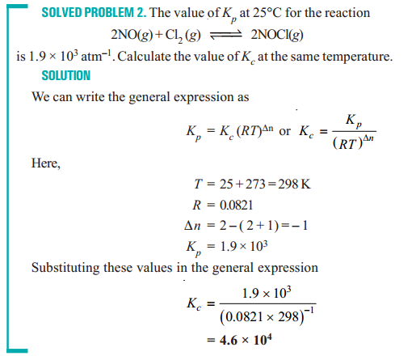

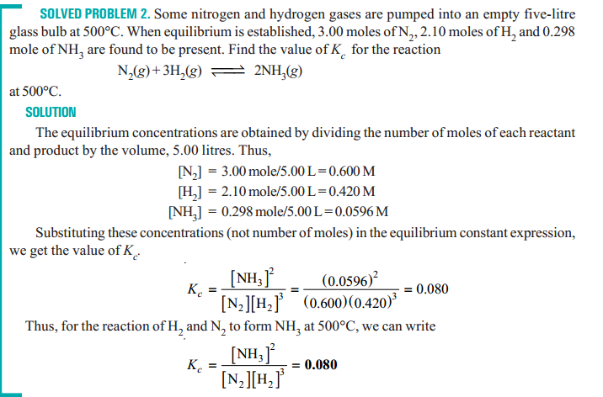

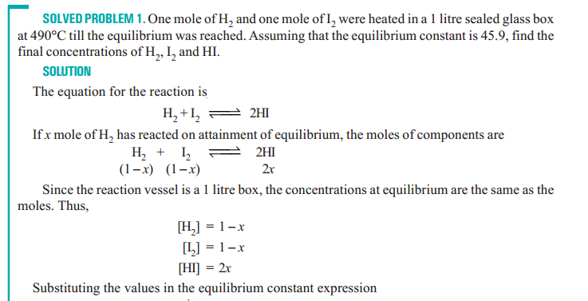

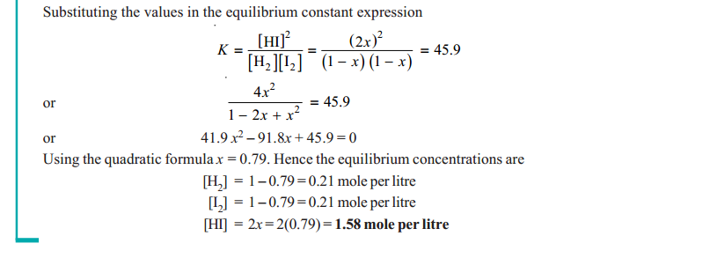

**Le Chatelier’s Principle**

When a stress is applied on a system in equilibrium, the system tends to adjust itself so as to reduce the stress.

There are three ways in which the stress can be caused on a chemical equilibrium:

1. Changing the concentration of a reactant or product

2. Changing the pressure of the system

3. Changing the temperature

Thus ***Le chatelier’s principle* can be stated as:** *If a change concentration, pressure or temperature is caused to a chemical reaction in equilibrium, the equilibrium will shift to the right or the left so as to minimize the change***.**

**Effect of Concentration**

When concentration of any of the reactants or products is changed, the equilibrium shifts in a direction so as to reduce the change in concentration that was made.

A change in the concentration of a reactant or product can be effected by the addition or removal of that species. Let us considering a general reaction

**A + B C**

When a reactant, say, A is added at equilibrium, its concentration is increased. The forward reaction alone occurs momentarily. According to Le Chatelier’s principle, a new equilibrium will be established so as to reduce the concentration of A. Thus the addition of A causes the equilibrium to shift to right. This increase the concentration (yield) of the product C.

A decrease in the concentration of A by its removal from the equilibrium mixture, will be undone by shift to the equilibrium position to the left. This reduces the concentration of the product C.

**Effect of a Change in Pressure**

The pressure of a gaseous reaction at equilibrium is determined by the total number of molecules it contains. If the forward reaction proceeds by the reduction of molecules, it will be accompanied by a decrease of pressure of the system and vice versa.

Let us considering a general reaction

**A + B C**

The combination of A and B produces a decrease of number of molecules while the decomposition of C into A and B results in the increase of molecules. Therefore, by the increase of pressure on the equilibrium it will shift to right and more C. A decrease in pressure will cause the opposite effect. The equilibrium will shift to the left when C will decompose to form more of A and B.

The reaction in which the number of product molecules is equal to the number of reactant molecules are unaffected by pressure changes.

**Effect of Change of Temperature**

When temperature of a reaction is increased, the equilibrium shifts in a direction in which heat is absorbed. Let us considering a exothermic reaction

**A + B C +** heat

When the temperature of the system is increased, heat is supplied to it from outside. According to Le-Chatelier’s principle, the equilibrium will shift to the left which involves the absorption of heat. This would result in the increase of the concentration of the reactants A and B.

In an endothermic reaction

**X + Y + heat  Z**

The increase of temperature will shift the equilibrium to the right as it involves the absorption of heat. This increases the concentration of the product Z.

We can say that the increase of temperature favors’ the reverse changes in an exothermic reaction and the forward changes in an endothermic reaction.

**Thermochemistry**

Thermochemistry is the branch of physical chemistry which deals with the thermal or heat changes caused by chemical reactions.

**Exothermic and endothermic reactions**

When the internal energy of reactants (Er) is greater than the internal energy of the products (Ep), the difference of internal energy, ΔE, is released as heat energy

  
Such a reaction is called **exothermic reaction.** If the internal energy of the products (*Ep*) is greater than that of the reactants (*Er*), heat is absorbed from the surroundings. Such a reaction is called **endothermic reaction.** The amount of heat released or absorbed in a chemical reaction is termed the **heat of reaction.**

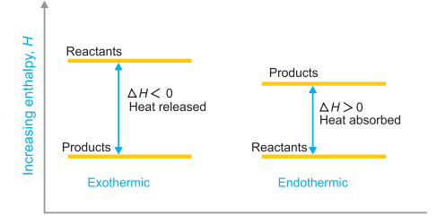

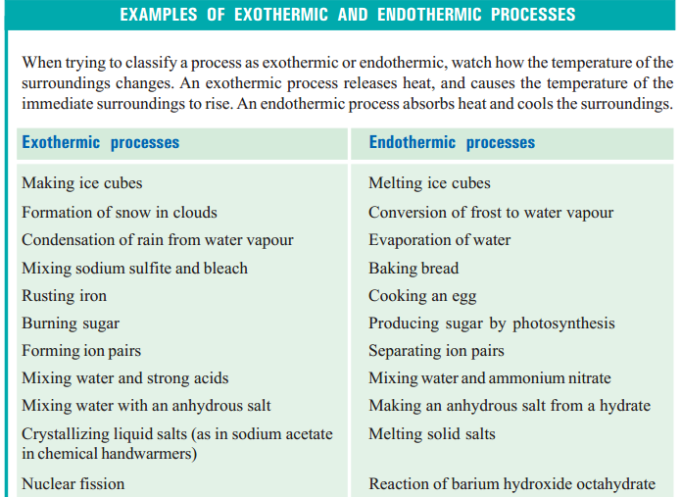

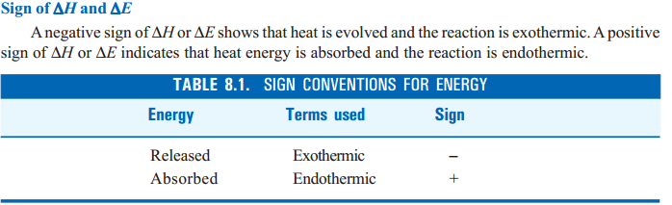

ENTHALPY OF A REACTION

**The enthalpy of a system is defined as the sum of the internal energy and the product of its  
pressure and volume.** That is,



Where *E* is the internal energy, *P* is the pressure and *V* is the volume of the system. It is also called  
**Heat content.**

Just like internal energy, enthalpy is also a function of the state and it is not possible to measure  
its absolute value. However a change in enthalpy (∆*H*) accompanying a process can be measured  
accurately and is given by the expression

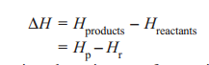

Thus if Δ*V* be the change in volume in case of a reaction at constant temperature and pressure,  
the thermal effect observed will be the sum of the change in internal energy (Δ*E*) and the work done in expansion or contraction. That is



**Heat of reaction or enthalpy of reaction**

**Heat of reaction may be defined as the amount of heat absorbed or evolved in a reaction when the number of moles of reactants as represented by the balanced chemical equation change completely into the products.**

For example, the heat change for the reaction of one mole of carbon monoxide with 0.5 mole of oxygen to form one mole of carbon dioxide is – 284.5 kJ. This means that 284.5 kJ of heat is evolved during the reaction and is the heat of reaction. It can be represented as



**Heat of formation**

**The change in enthalpy that takes place when one mole of the compound is formed from its  
elements.**It is denoted by ∆*Hf*. For example, the heat of formation of ferrous sulphide and acetylene may be  
expressed as :

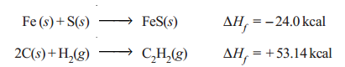

**Standard heat of formation**

The standard heat of formation of a compound is defined as :  
**The change in enthalpy that takes place when one mole of a compound is formed from its  
elements, all substances being in their standard states (298 K and 1 atm pressure).**

**Standard Heat of Reaction (**∆***H*º) from Standard Heat of Formation (**∆***H o f* )**

We can calculate the heat of reaction under standard conditions from the values of standard heat  
of formation of various reactants and products. **The standard heat of reaction is equal to the standard heat of formation of products minus the standard heat of formation of reactants.**

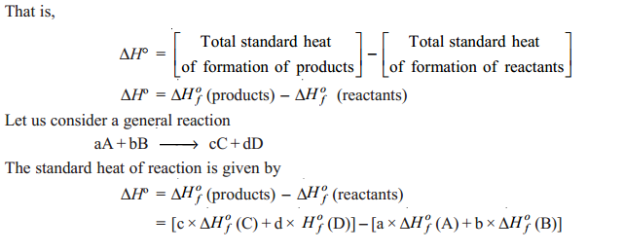

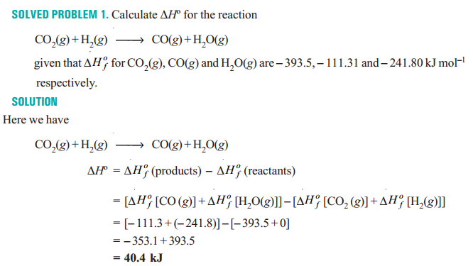

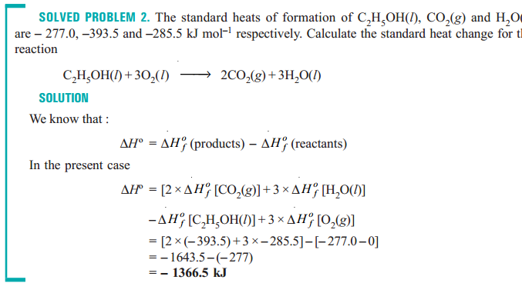

**Heat of combustion**

The heat of combustion of a substance is defined as : **the change in enthalpy of a system when  
one mole of the substance is completely burnt in excess of air or oxygen.**It is denoted by ∆*Hc*. As for example, heat of combustion of methane is – 21.0 kcal (= 87.78 kJ)

As shown by the equation

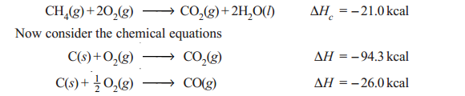

It should be noted clearly that the **heat of combustion of a substance (**∆***Hc*) is always negative.**Heat energy is evolved during the process of combustion *i.e.*, ∆*Hc* = – ve.

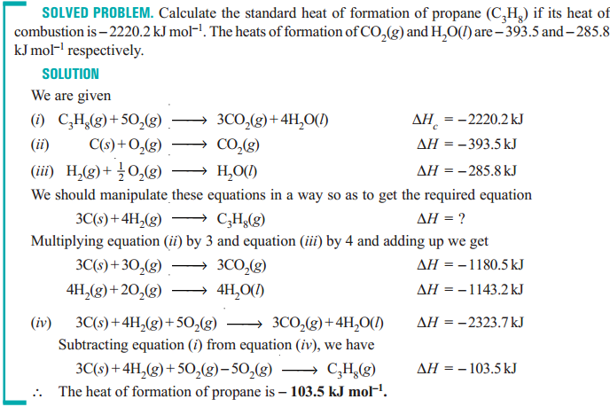

**Heat of solution**

The heat of solution is defined as : **the change in enthalpy when one mole of a substance is dissolved in a specified quantity of solvent at a given temperature.**

**The heat of solution is the change in enthalpy when one mole of a substance is dissolved in a solvent so that further dilution does not give any change in enthalpy.**

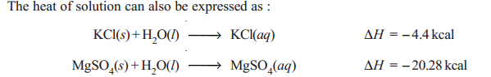

**Heat of neutralization**

The heat of neutralisation is defined as : **the change in heat content (enthalpy) of the system  
when one gram equivalent of an acid is neutralised by one gram equivalent of a base or *vice versa* in dilute solution.**

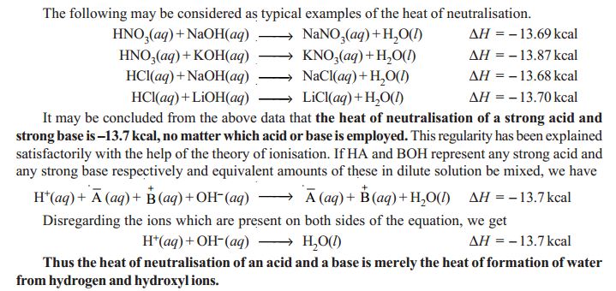

**Cement**

Cement is broadly described as material having adhesive and cohesive property with capacity to bond the material like stone, bricks, building blocks etc. Cement is a binder, a substance that sets and hardens independently, and can bind other materials together. Cements are inorganic material that shows the cementing properties of setting and hardening when mixed with water. Cement is prepared from calcareous (Ca) material and argillaceous (Al + Si) material.

Cement has property of setting and hardening under water by virtue of chemical reaction of hydrolysis and hydration**.**

**Properties of Good Cement**

It is always desirable to use the best [cement](https://civiltoday.com/civil-engineering-materials/cement/81-cement-definition-and-full-details)in constructions. Therefore, the [properties of cement](https://civiltoday.com/civil-engineering-materials/cement/111-properties-of-cement-physical-chemical-properties) must be investigated. Although desirable cement properties may vary depending on the type of construction, generally good cement possesses following properties (which depend upon its [composition](https://civiltoday.com/civil-engineering-materials/cement/10-cement-ingradients-with-functions), thoroughness of burning and fineness of grinding).

* Provides strength to masonry.
* Stiffens or hardens early.
* Possesses good plasticity.
* An excellent [building material](https://civiltoday.com/civil-engineering-materials).
* Easily workable.
* Good moisture-resistant.

**Cement according to hardening pattern**

Therefore, cements are generally divided into two types hydraulic and non-hydraulic that is on the basis of their setting and hardening pattern.

**Hydraulic cement**

Hydraulic cements harden because of hydration, chemical reactions that occur independently of the mixture's water content; they can harden even underwater or when constantly exposed to wet weather.

**Non-hydraulic cement**

Non-hydraulic cements must be kept dry in order to retain their strength. Portland cement is example of hydraulic cement material while ordinary lime and gypsum plaster are consider as example of non-hydraulic cement.

**Classification of Cement**

**Natural Cement**

Natural cement is obtained by burning and crushing of 20-40% clay, carbonate of lime and small amount of magnesium carbonate. It is brown in colour and best variety known as Roman cement. The natural cement resembles very costly element hydraulic lime and sets very quickly and strongly as compare to artificial cement. It finds very limited application.

**Artificial cement**

Artificial cement is obtained by burning of calcareous mixture at very high temperature. Mixture of ingredients should be intimate and they should be in correct proportion. Calcined product is known as Clinker. A small quantity of gypsum added to clinker and pulverized to fine powder is known as cement or ordinary cement or normal setting cement. After setting, this cements closely a variety of sandstone which is found in abundance in Portland in UK. Therefore, it is also known as Portland cement.

**Puzzolana cement**

It is the material which when mixed with lime without heating gives hydraulic cement. They mainly contains silicates of aluminum, iron and calcium natural Puzzolana which is found in deposits of volcanic ash consist of glassy material and simple mixing and grinding gives the cement. Similarly slaked lime also gives Puzzolana cement but they are the cement of ancient time and at present hardly used.

**Slag cement**

It is made by mixing blast furnace slag and hydrated lime. Furnace slag largely contains silicates of calcium and aluminum which is granulated by pouring it into cold water. Later it is dried and mixed with hydrated lime and the mixture is finally powdered to increase the rate of setting. Accelerator like clay, salt or caustic soda may be added.

**Portland cement**

It is refine powder of calcined product of clay and lime stone. It has controlled composition and therefore setting property. It is named after the paste of cement with water which resembled in colour and hardness to the Portland stone.

**Various form of cement according to application, appearance and constituent**

* Acid resistance cement
* Blast furnace cement
* Coloured cement
* White cement
* Rapid hardening cement
* High alumina cement
* Puzzolana cement
* Hydrophobic cement
* Expanding cement
* Low heat cement
* Quick setting cement
* Sulfate resisting cement

**Portland Cement**

Portland cement was invented in 1824 by Joseph Aspdin, an English mason. Joseph Aspdin named his patented product as “Portland cement” because it produced a concrete that resembled the color of the natural limestone quarried at Portland in England.

Portland cements are hydraulic cements primarily composed of hydraulic calcium silicates. Hydraulic cements set and harden by reacting chemically with water. Most of the hydration and strength development take place within the first month of mixing, but they continue, though more slowly, for a long time.

**Raw Materials for Portland Cement Production**

* Calcium oxide (CaO)

Sources: Limestone, Shale, Marl, Calcite, Argonite, Clay, Chalk, etc.

* Silica (SiO2)

Sources: Clay, Marl, Shale, Sand, Fly ash, Calcium silicate, etc.

* Alumina (Al2O3)

Sources: Aluminum-ore refuse, Clay, Fly ash, Shale, etc.

* Iron (Fe2O3)

Sources: Iron ore, Clay, Mill scale, Shale, etc.

* Magnesia (MgO)

Sources: Cement rock, Limestone, Slag, etc

* Gypsum (CaSO4.2H2O)

Sources: Calcium sulfate, Anhydrite, Gypsum, etc.

**Manufacturing Procedure for Portland Cement**

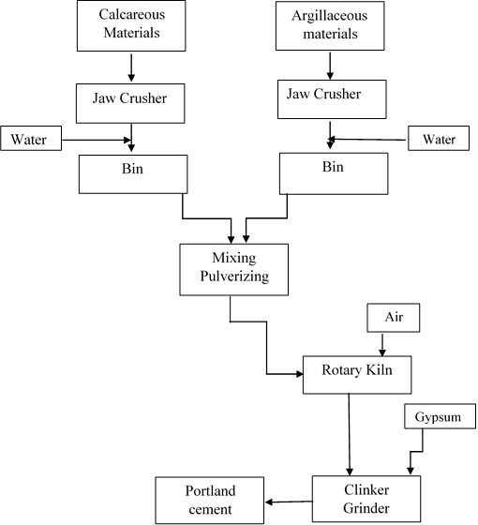

**Figure:** Flow chart for manufacturing process of Portland cement

**Procedure**

Raw materials stones in appropriate proportions are first crushed to 125 mm size, then to 20 mm, and stored. Crushed raw materials are ground to powder and either blended in dry condition (dry process or mixed with water to form slurry, and blended (wet process).

After blending the raw materials the same is sent to a rotating kiln for burning at a temperature in the range of 1350ºC to 1450ºC.Mixing the raw materials while burning in the kiln lead to the chemical reactions between oxides of the raw materials by fusion, forming cement clinker.

The clinker is cooled and then pulverized. During this operation a small amount of gypsum is added to regulate the setting time of the cement and to improve the shrinkage and strength properties.

Clinker with gypsum are mixed and ground to a desirable fineness, that passes through a 45 micrometer No. 325 mesh) sieve. This grounded product is the Portland cement.

**Final Component of Cement Clinker**

* Tricalcium Slicate (C3S)
* Dicalcium Silicate (C2S)
* Tricalcium Aluminate (C3A)
* Tetra calcium Aluminoferrite (C4AF)

[Here C = CaO, S = SiO2, A = Al2O3, F = Fe2O3]

**Composition of Clinker**

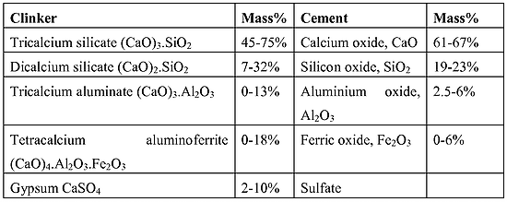

**Figure:** Composition of clinker

**Difference between Clinker and Cement**

Cement and clinker are not the same material. Cement is a binding material used in construction whereas clinker is primarily used to produce cement. The main differences between [clinker](https://civiltoday.com/civil-engineering-materials/cement/108-what-is-cement-clinker-clinker-definition-composition-types-uses)and [cement](https://civiltoday.com/civil-engineering-materials/cement/81-cement-definition-and-full-details) are given below.

|  | **Clinker** | **Cement** |
| --- | --- | --- |
| 1 | Clinker is a nodular material which is used as the binder in cement products. | Cement is a binding agent that sets and hardens to adhere to building units such as stones, bricks, tiles etc. |
| 2 | Clinker is a granular substance containing spherical pellets of diameter 3-25 mm. | Cement is such a fine powdery substance that each pound of cement contains 150 billion grains. |
| 3 | Clinker is produced inside the kiln during the [cement manufacturing process](https://civiltoday.com/civil-engineering-materials/cement/106-cement-manufacturing-process). Raw mix is heated and then rapidly cooled to produce the marble-sized pellets of clinker. | Cement is produced by grinding clinker (added with different active ingredients to achieve the desired properties of cement) into a fine powder. |
| 4 | Composition of typical good quality clinker for general use: 37-72% of 3CaO.SiO2; 6-47% 2CaO.SiO2; 2-20% 2CaO.Al2O3; 2-19% 4CaO. Al2O3.Fe2O3 | Composition of the most common type of cement: 85% clinker, 1.5-3.5% gypsum by SO3 content, and up to 15% admixtures. |
| 5 | The primary use of clinker is to manufacture cement. | [Cement is used](https://civiltoday.com/civil-engineering-materials/cement/46-uses-of-cement) in construction to make concrete as well as [mortar](https://civiltoday.com/civil-engineering-materials/mortar/66-what-is-mortar-mix-definition) and to secure the infrastructure by binding the building blocks. It is also used for water-proofing, filling or sealing gaps, and making decorative patterns. |

**Role of Gypsum in Portland cement**

Gypsum is added to Portland cement to regulate the extreme setting reaction which occurs in the presence of water. The gypsum content of cement is expressed in terms of its sulphate (SO3) content. Sulphate is a readily determined measure of gypsum in cement. Portland cement usually contains around 5% gypsum, which is equal to approximately 2.1% SO3. .

The presence of gypsum in cement slows the reaction of the C3A. When mixed with water, gypsum dissolves and reacts with C3A to form ettringite (3Ca0.Al203.3CaSO4.2H20). This ettringite is initially formed as very fine-grained crystals, which form a coating on the surface of the C3A particles .After the initial hydration reactions of cement, a dormant period occurs during which the rate of hydration of cement is greatly reduced.

**Hydration of Cement**

The water causes the hardening of concrete through a process called hydration. Hydration is a chemical reaction in which the major compounds in cement form chemical bonds with water molecules and become hydrates or hydration products.



**Hydrolysis of Cement**

Hydrolysis is the most important setps for setting and hardening process of cement. It is due to the dissociation of water to form H+ and OH- ions which chemically combined with clinker and bring about changes such as exchanges, decomposition of clinker materials and formation of new product.



**Setting and Hardening of Cement**

Although many theory have been proposed to explain the setting or hardening of cement. It is generally agreed that the takes place by hydration & hydrolysis. The following equations

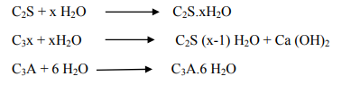

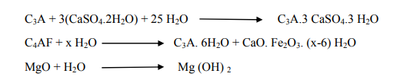

The hydration products have very low solubility in water if this were not true, concrete would be rapidly attacked in contact with water. In recent year much attention has been given to the heat evolved during the hydration of cement. The various compounds contribute to the heat of setting as follows.



Following table-1 shows why low heat of setting cement is made low in C3A & C3S but high in C2S. This is accomplished (1) by adding more Fe2O3 which takes the Al2O3 out of circulation as C4AF, thereby diminishing the amount of C3A & (2) by decreasing the CaO/SiO2 ratio.

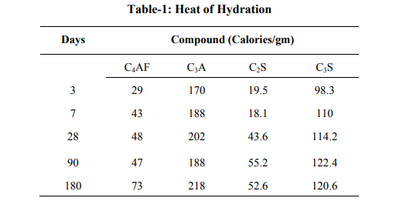

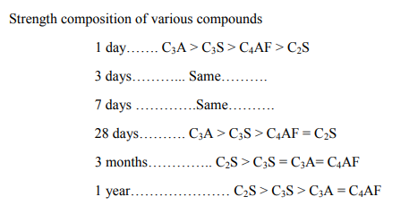

C2S.xH2O (amorphous), whose structure or nature is unknown, is the principal source of strength of the set of cement.

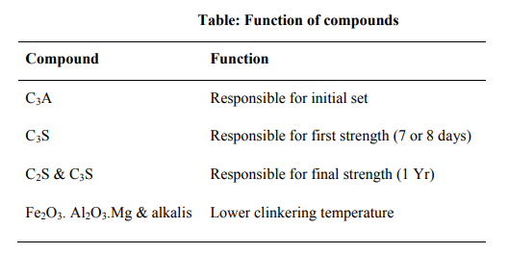

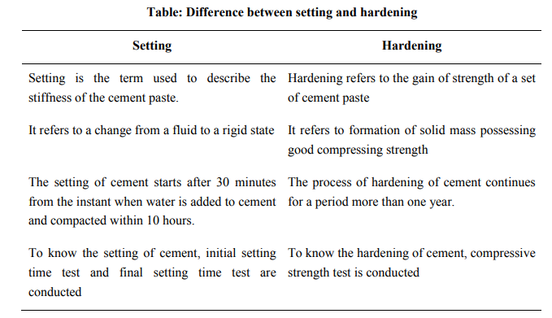

**Application of Cement**

Cement is a very useful binding material in construction. The applications of [cement](https://civiltoday.com/civil-engineering-materials/cement/10-cement-ingredients-with-functions) over various fields of construction have made it a very important [civil engineering material](https://civiltoday.com/civil-engineering-materials).

Some of the numerous functions of cement are given below.

1. It is used in [mortar](https://civiltoday.com/civil-engineering-materials/mortar/66-what-is-mortar-mix-definition) for plastering, masonry work, pointing, etc.
2. It is used for making joints for drains and pipes.
3. It is used for water tightness of structure.
4. It is used in concrete for laying floors, roofs and constructing lintels, beams, stairs, pillars etc.
5. It is used where a hard surface is required for the protection of exposed surfaces of structures against the destructive agents of the weather and certain organic or inorganic chemicals.
6. It is used for precast pipes manufacturing, piles, fencing posts etc.
7. It is used in the construction of important engineering structures such as bridges, culverts, [dams](https://civiltoday.com/civil-engineering-blog/11-dam-use), tunnels, lighthouses etc.
8. It is used in the preparation of [foundations](https://civiltoday.com/geotechnical-engineering/foundation-engineering), watertight floors, footpaths etc.
9. It is employed for the construction of wells, water tanks, tennis courts, lamp posts, telephone cabins, roads etc.

**ING OF CEMENT**